“Lab 5 — Cinema Management System”

# NAME : Hadia Islam

# REG.NO: SP25-BCS-038

# CLASS : BCS

# SECTION: B

# COURSE: OOP IN JAVA

# INSTRUCTOR: PROF.SHAHID BHATTI

**NAME OF CLASSES:**

1. **Seat**
2. **SeatDemo**
3. **Cinema**
4. **CinemaDemo**
5. **CityCinema**
6. **Screen**

**OUTPUTS:**

## DOUBLE BOOKING

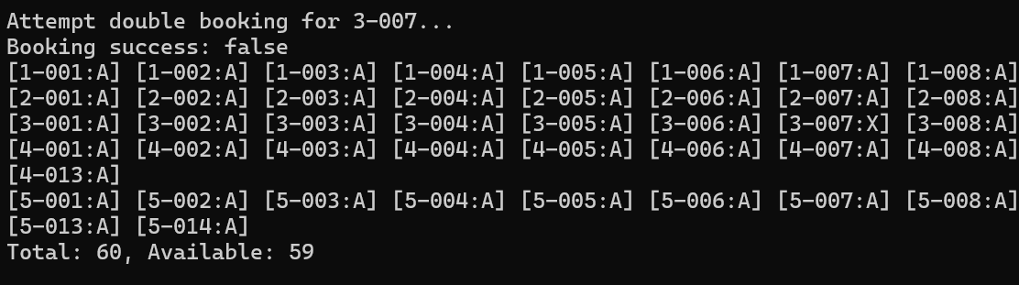

# 2.SCREEN LAYOUT

# 3.CANCEL BOOKING

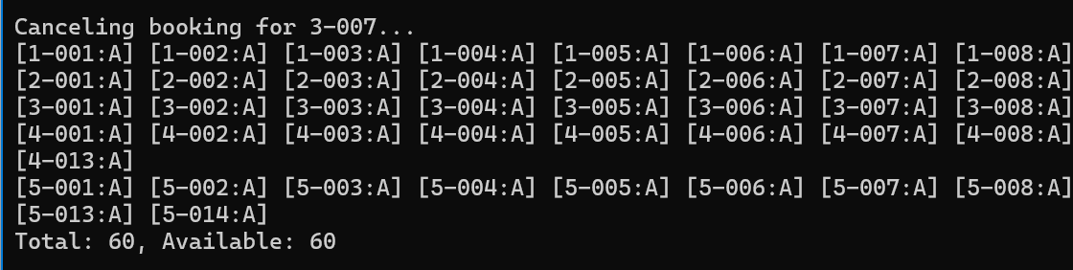

# 4.FINAL UPDATE STATE

