**Genetic Algorithms**

**Report:**

1. **Population Encoding:**

Population size = 100

Storage Structure = 1-dimensional array

Individual Storage Structure = Chromosome class object that has 2 values, the fitness of object and a 2-dimensional NumPy array to represent the image values.

1. **Fitness Function:**

Function: Total sum of the absolute difference between each element of the original greyscale image and the 2-dimensional array of our genetically engineered image.

Best Value: 7152 at 99% accuracy

1. **Crossover & Mutation:**

Crossover: Take 2 parent images and generate a child image with upper half of the rows being from parent 1, and lower half being from parent 2.

Mutation: Mutate any random child in crossover by generating a random number and a random pixel value between 0-255 for mutation.

1. **Population:**

Initial Population Size: 100

Individual does converge eventually, but convergence exponentially slows down after 99% accuracy

1. **Hyper Parameters:**

Selection: 20% or 0.2

Crossover: 70% or 0.7

Mutation: 10% or 0.1

1. **Cases:**

Case 1**:**

Selection: 20% of total population

Crossover & Mutation done from the 80% leftover population

Did not converge.

Best Fitness Value: 717759

Iterations: 0

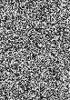

Case 2:

Selection: 20% of total population

Crossover & Mutation done from 100% of the population

Converges

Best Fitness Value: 7154

Iterations: 350,000

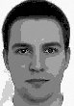

Case 3:

Selection: 20% of total population

Crossover & Mutation done on the 20% selected

Converges

Best Fitness Value: 7130

Iterations: 230789

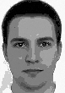

1. **Images:**

Case 1:



Case 2:

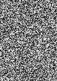 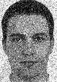 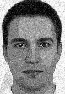 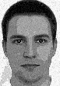 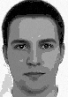



Case 3:

