# Supporting information (SI) to

Single-step genome-wide association analyses for selected infrared-predicted cheese-making traits in Walloon Holstein cows

H. Atashi1,2, Y. Chen1, H. Wilmot1,3, C. Bastin3, S. Vanderick1, X. Hubin4, N. Gengler1

1 TERRA Teaching and Research Center, Gembloux Agro-Bio Tech, University of Liège, 5030 Gembloux, Belgium.

2 Department of Animal Science, Shiraz University, 71441-13131 Shiraz, Iran.

3 National Fund for Scientific Research (F.R.S.-FNRS), Rue d’Egmont 5, B-1000 Brussels, Belgium

4 Elevéo asbl Awé Group, 5590 Ciney, Belgium

**Table S1**: Mean (SD) genetic correlations on the upper triangle for milk yield (MY1), fat percentage (FP2), protein percentage (PP3), casein percentage (CNP4), milk calcium content (CC5), somatic cell score (SCS6), coagulation time (CT7), curd firmness (a308), and titratable acidity (TA9) estimated on a daily basis across the first lactation in Walloon Holstein cows10.

|  |  |  |  |  |  |  |  |  |
| --- | --- | --- | --- | --- | --- | --- | --- | --- |
|  | FP | PP | CNP | CC | SCS | CT | a30 | TA |
| MY | -0.57 (0.12) | -0.57 (0.04) | -0.54 (0.05) | -0.43 (0.05) | -0.10 (0.11) | 0.17 (0.04) | -0.48 (0.06) | -0.29 (0.06) |
| FP |  | 0.68 (0.12) | 0.68 (0.11) | 0.56 (0.07) | -0.01 (0.03) | -0.36 (0.06) | 0.58 (0.12) | 0.41 (0.11) |
| PP |  |  | 0.97 (0.006) | 0.64 (0.04) | 0.02 (0.06) | -0.25 (0.03) | 0.84 (0.02) | 0.57 (0.04) |
| CNP |  |  |  | 0.68 (0.04) | -0.03 (0.02) | -0.38 (0.02) | 0.88 (0.02) | 0.60 (0.05) |
| CC |  |  |  |  | -0.10 (0.07) | -0.21 (0.16) | 0.57 (0.04) | 0.22 (0.07) |
| SCS |  |  |  |  |  | -0.13 (0.07) | -0.03 (0.09) | -0.01 (0.03) |
| CT |  |  |  |  |  |  | -0.59 (0.01) | -0.46 (0.01) |
| a30 |  |  |  |  |  |  |  | 0.62 (0.03) |

MY1 stands for milk yield; FP2 stands for fat percentage; PP3 stands for protein percentage; CNP4 stands for casein percentage; CC5 stands for calcium content (mg/kg milk); SCS6 stands for somatic cell score defined as : CT7 stands for coagulation time defined as the sum of the rennet coagulation time (RCT) plus the time to a curd firmness of 20 mm (k20) measured by the Computerized Renneting Meter; a308 stands for curd firmness defined as the curd firmness measured 30 min after enzyme addition by the Computerized Renneting Meter; and TA9 stands for milk titratable acidity measured in Dornic degree (°D).

10 The number of data were 485,218 test-day records on 78,073 animals in the first lactation.

**Table S2:** Mean (SD) genetic correlations on the upper triangle for milk yield (MY1), fat percentage (FP2), protein percentage (PP3), casein percentage (CNP4), milk calcium content (CC5), somatic cell score (SCS6), coagulation time (CT7), curd firmness (a308), and titratable acidity (TA9) estimated on a daily basis across the second lactation in Walloon Holstein cows10.

|  |  |  |  |  |  |  |  |  |
| --- | --- | --- | --- | --- | --- | --- | --- | --- |
|  | FP | PP | CNP | CC | SCS | CT | a30 | TA |
| MY | -0.47 (0.13) | -0.44 (0.06) | -0.49 (0.08) | -0.39 (0.09) | -0.14 (0.17) | 0.08 (0.12) | -0.43 (0.07) | -0.29 (0.11) |
| FP |  | 0.71 (0.08) | 0.72 (0.09) | 0.61 (0.08) | -0.06 (0.03) | -0.39 (0.07) | 0.57 (0.12) | 0.46 (0.13) |
| PP |  |  | 0.97 (0.006) | 0.68 (0.03) | 0.05 (0.06) | -0.26 (0.06) | 0.84 (0.04) | 0.60 (0.07) |
| CNP |  |  |  | 0.71 (0.04) | -0.02 (0.03) | -0.39 (0.05) | 0.87 (0.03) | 0.63 (0.07) |
| CC |  |  |  |  | -0.12 (0.03) | -0.19 (0.16) | 0.57 (0.05) | 0.30 (0.11) |
| SCS |  |  |  |  |  | -0.14 (0.09) | -0.02 (0.05) | -0.01 (0.5) |
| CT |  |  |  |  |  |  | -0.60 (0.01) | -0.46 (0.01) |
| a30 |  |  |  |  |  |  |  | 0.68 (0.04) |

MY1 stands for milk yield; FP2 stands for fat percentage; PP3 stands for protein percentage; CNP4 stands for casein percentage; CC5 stands for calcium content (mg/kg milk); SCS6 stands for somatic cell score defined as : CT7 stands for coagulation time defined as the sum of the rennet coagulation time (RCT) plus the time to a curd firmness of 20 mm (k20) measured by the Computerized Renneting Meter; a308 stands for curd firmness defined as the curd firmness measured 30 min after enzyme addition by the Computerized Renneting Meter; and TA9 stands for milk titratable acidity measured in Dornic degree (°D).

10 The number of data were 284,942 test-day records on 48,766 animals in the second lactation.

**Table S3**: Mean (SD) genetic correlations on the upper triangle for milk yield (MY1), fat percentage (FP2), protein percentage (PP3), casein percentage (CNP4), milk calcium content (CC5), somatic cell score (SCS6), coagulation time (CT7), curd firmness (a308), and titratable acidity (TA9) estimated on a daily basis across the third lactation in Walloon Holstein cows10.

|  |  |  |  |  |  |  |  |  |
| --- | --- | --- | --- | --- | --- | --- | --- | --- |
|  | FP | PP | CNP | CC | SCS | CT | a30 | TA |
| MY | -0.42 (0.15) | -0.49 (0.07) | -0.43 (0.10) | -0.34 (0.11) | -0.20 (0.14) | 0.04 (0.12) | -0.37 (0.07) | -0.26 (0.13) |
| FP |  | 0.68 (0.11) | 0.70 (0.11) | 0.58 (0.09) | -0.03 (0.02) | -0.40 (0.07) | 0.54 (0.14) | 0.46 (0.14) |
| PP |  |  | 0.97 (0.006) | 0.63 (0.05) | 0.06 (0.07) | -0.27 (0.07) | 0.83 (0.03) | 0.61 (0.08) |
| CNP |  |  |  | 0.68 (0.04) | -0.03 (0.03) | -0.42 (0.04) | 0.86 (0.03) | 0.63 (0.07) |
| CC |  |  |  |  | -0.07 (0.04) | -0.19 (0.16) | 0.52 (0.08) | 0.29 (0.14) |
| SCS |  |  |  |  |  | -0.14 (0.10) | -0.08 (0.04) | -0.05 (0.04) |
| CT |  |  |  |  |  |  | -0.60 (0.02) | -0.46 (0.01) |
| a30 |  |  |  |  |  |  |  | 0.68 (0.05) |

MY1 stands for milk yield; FP2 stands for fat percentage; PP3 stands for protein percentage; CNP4 stands for casein percentage; CC5 stands for calcium content (mg/kg milk); SCS6 stands for somatic cell score defined as : CT7 stands for coagulation time defined as the sum of the rennet coagulation time (RCT) plus the time to a curd firmness of 20 mm (k20) measured by the Computerized Renneting Meter; a308 stands for curd firmness defined as the curd firmness measured 30 min after enzyme addition by the Computerized Renneting Meter; and TA9 stands for milk titratable acidity measured in Dornic degree (°D).

10 The number of data were 105,112 test-day records on 21,948 animals in the third lactation.

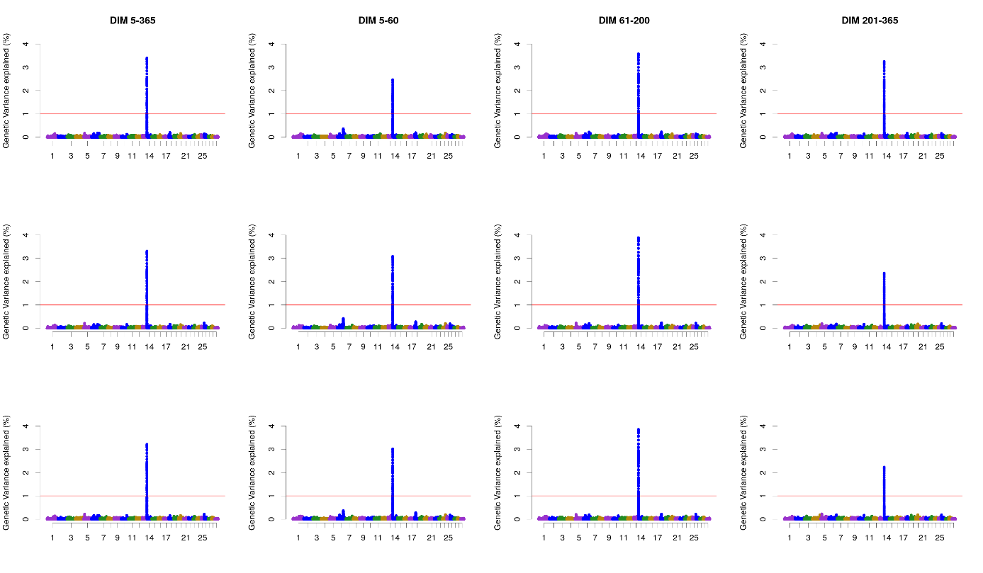

**Figure S1**. Additive genetic variance explained by windows of 50 adjacent SNP across chromosomes for milk yield in the different lactation stages in the first (first row), second (second row), and third parity (third row) in Walloon Holstein cows.

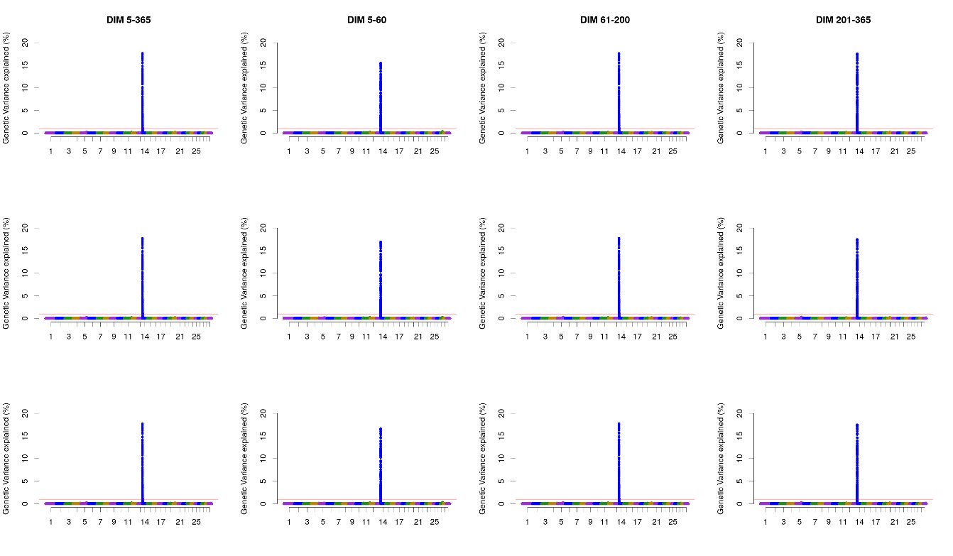

**Figure S2**. Additive genetic variance explained by windows of 50 adjacent SNP across chromosomes for milk fat percentage in the different lactation stages in the first (first row), second (second row), and third parity (third row) in Walloon Holstein cows.

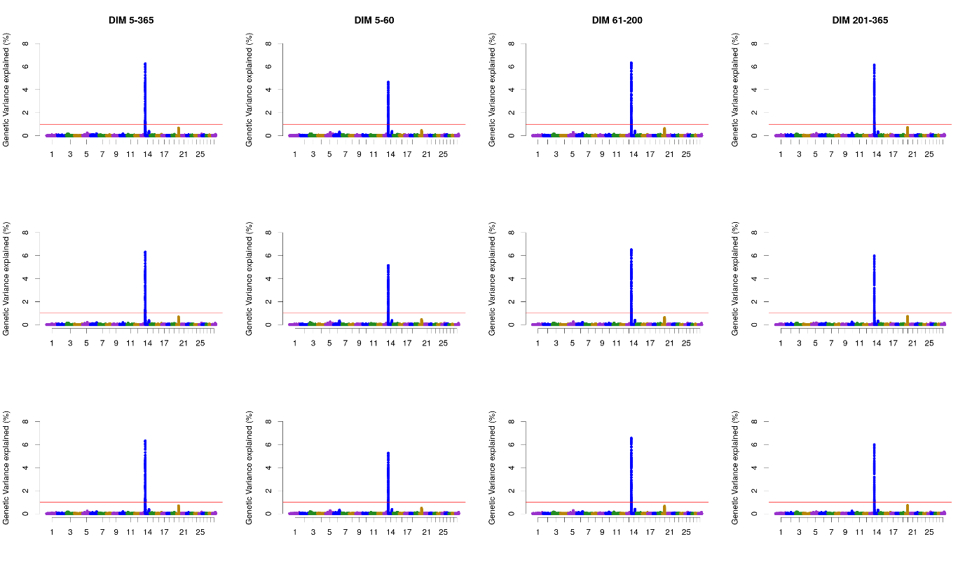

**Figure S3**. Additive genetic variance explained by windows of 50 adjacent SNP across chromosomes for milk protein percentage in the different lactation stages in the first (first row), second (second row), and third parity (third row) in Walloon Holstein cows.

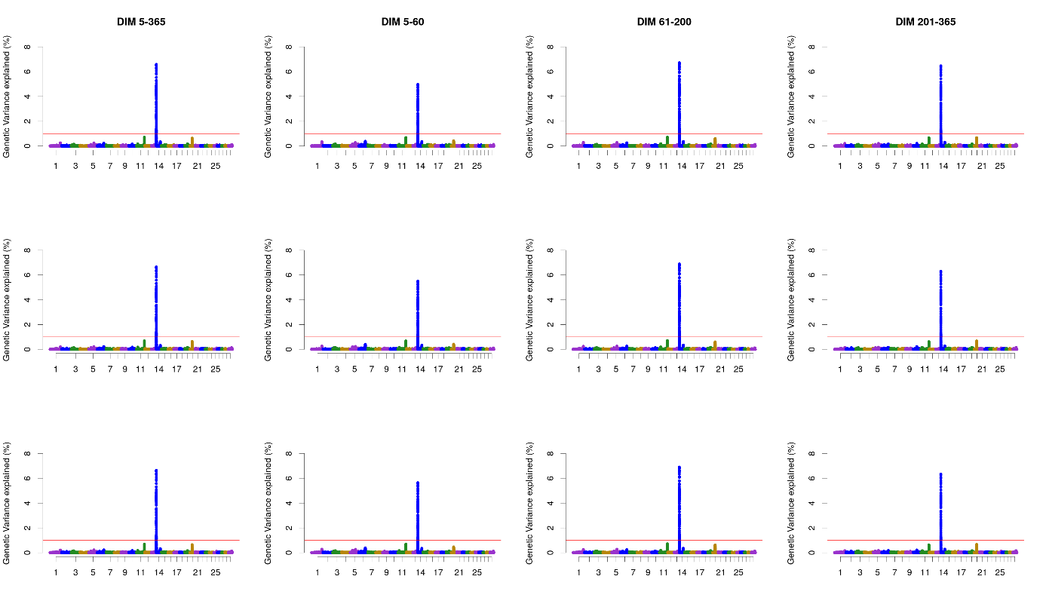

**Figure S4**. Additive genetic variance explained by windows of 50 adjacent SNP across chromosomes for milk casein percentage in the different lactation stages in the first (first row), second (second row), and third parity (third row) in Walloon Holstein cows.

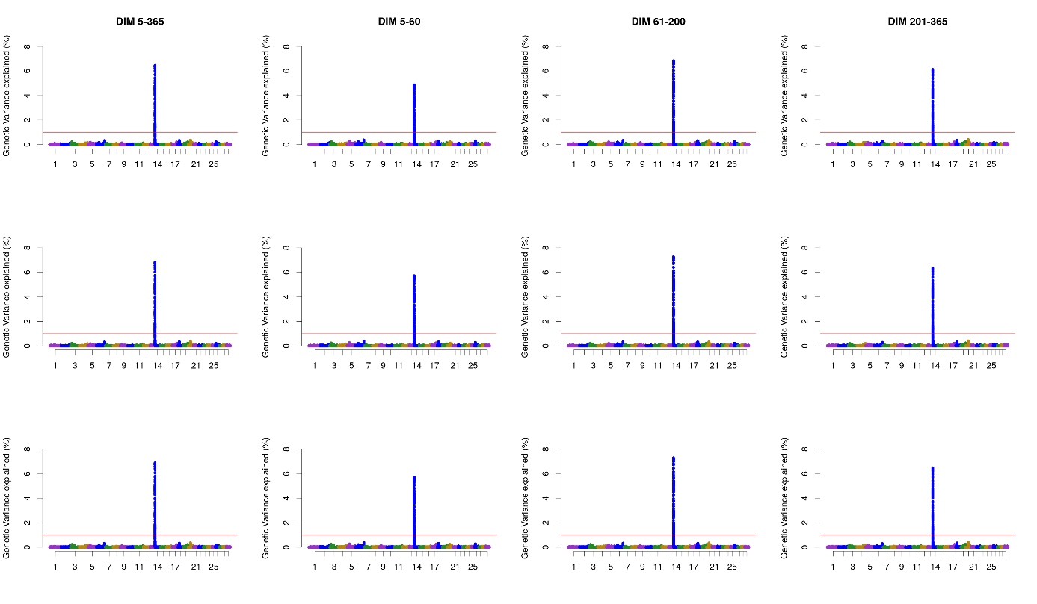

**Figure S5**. Additive genetic variance explained by windows of 50 adjacent SNP across chromosomes for milk calcium content in the different lactation stages in the first (first row), second (second row), and third parity (third row) in Walloon Holstein cows.

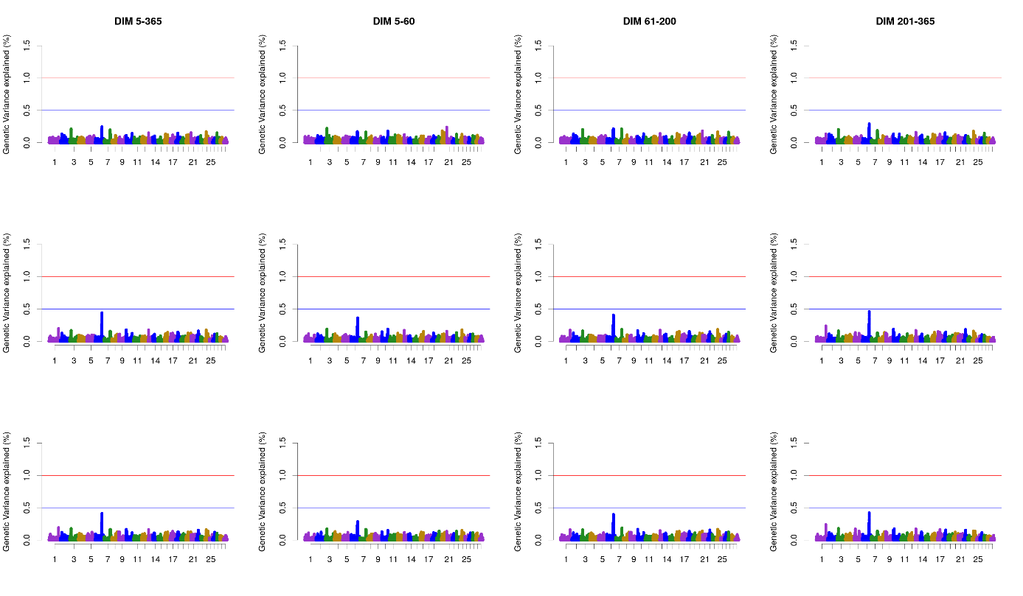

**Figure S6**. Additive genetic variance explained by windows of 50 adjacent SNP across chromosomes for milk somatic cell score in the different lactation stages in the first (first row), second (second row), and third parity (third row) in Walloon Holstein cows.

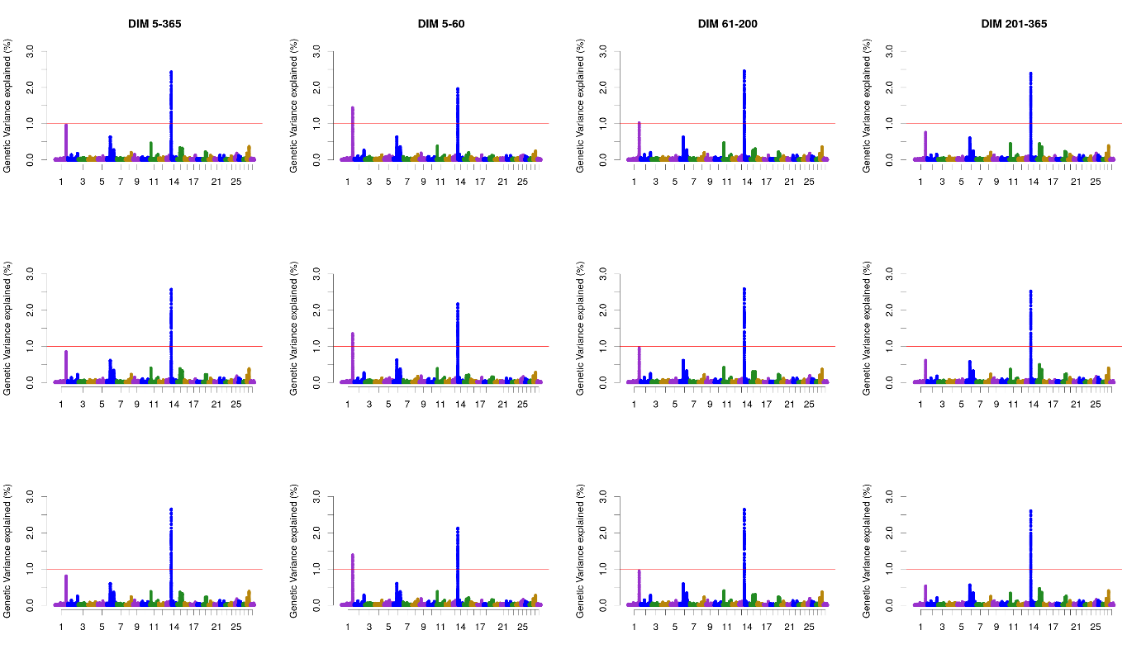

**Figure S7**. Additive genetic variance explained by windows of 50 adjacent SNP across chromosomes for the coagulation time (CT) in the different lactation stages in the first (first row), second (second row), and third parity (third row) in Walloon Holstein cows.

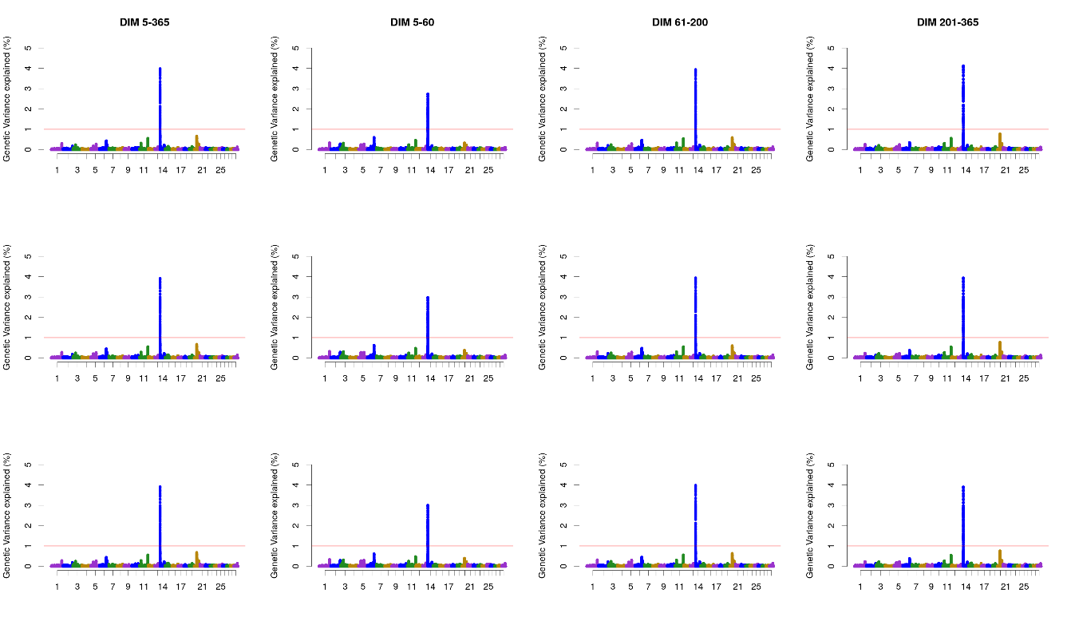

**Figure S8**. Additive genetic variance explained by windows of 50 adjacent SNP across chromosomes for the curd firmness (a30) the different lactation stages in the first (first row), second (second row), and third parity (third row) in Walloon Holstein cows.

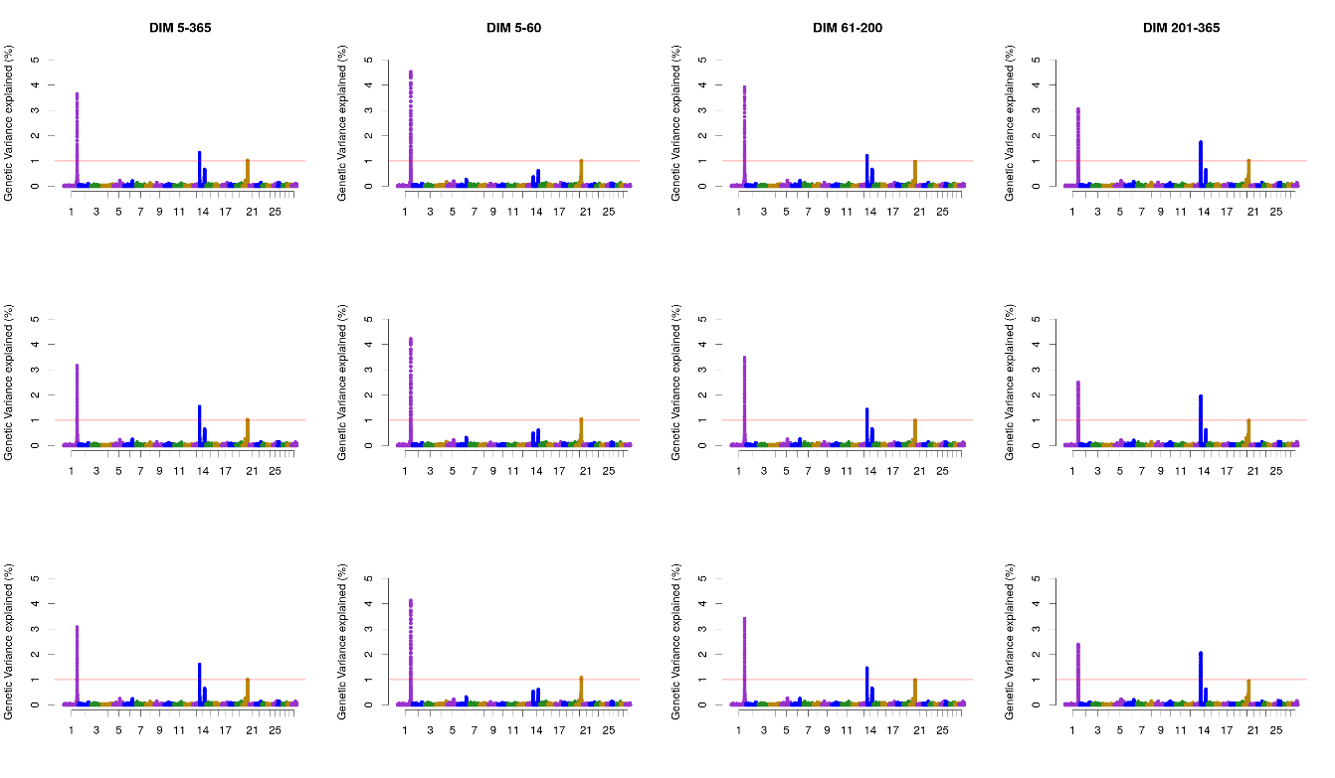

**Figure S9**. Additive genetic variance explained by windows of 50 adjacent SNP across chromosomes for titratable acidity (TA) in the different lactation stages in the first (first row), second (second row), and third parity (third row) in Walloon Holstein cows.

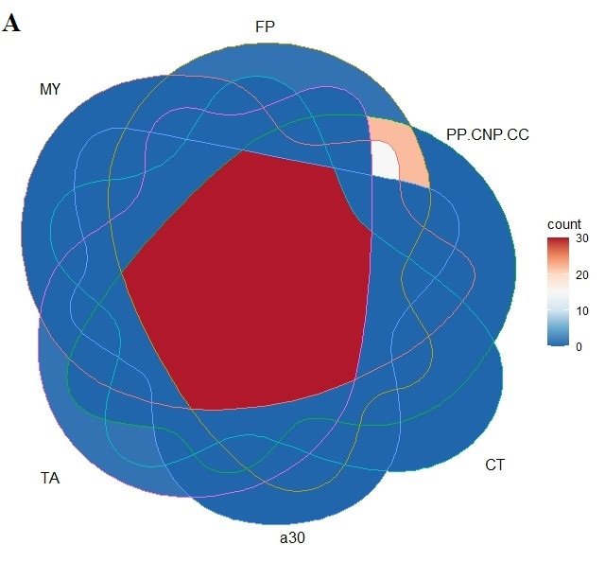

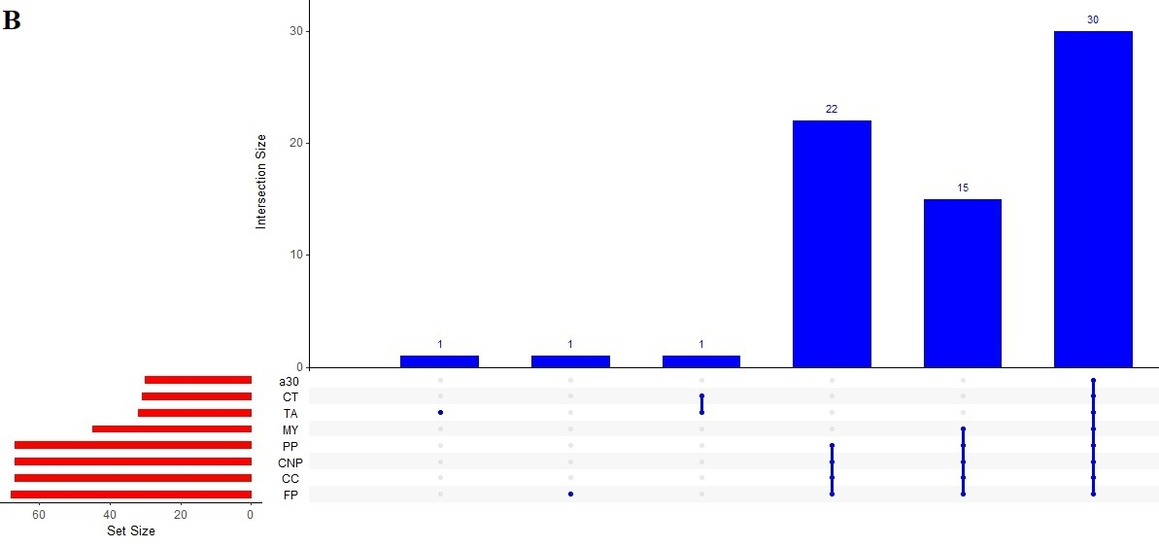

**Figure S10**: The number (percent) of identified genes shared between eight traits milk yield (MY), fat percentage (FP), protein percentage (PP), casein percentage (CNP), calcium content (CC), coagulation time (CT), crude firmness (a30), and titratable acidity (TA).