LifeLink
A Web Application for Connecting Blood Donors and Receivers

Phase 3: Tool Integration & Project Launch
In this final phase, the team moved from planning into execution by setting up industry-standard collaboration tools: Jira for tracking the project workflow, and GitHub for managing the source code.

Part 1: Project Tracking (Jira)
A Jira Online project (“lifelinl”, key: KAN) was created and both team members were added as collaborators on the board. The ten tasks scheduled during Phase 2 (Section “Gantt Schedule”) were entered onto the Backlog/Board, each assigned to its corresponding owner from the Phase 2 resource allocation table, and marked as work progressed.
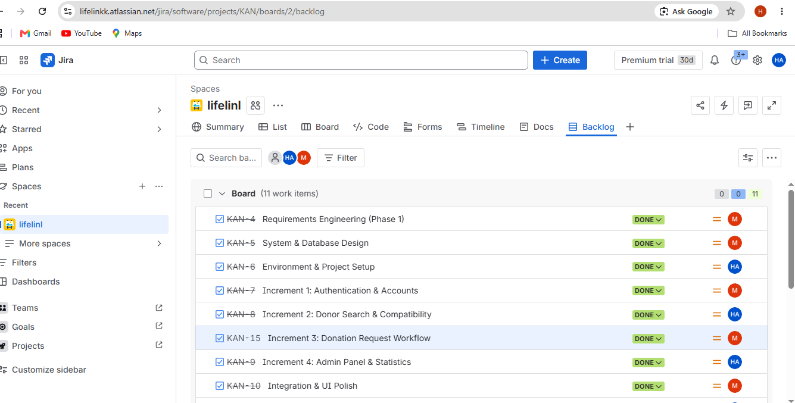
Figure 1 — Jira Backlog view showing tasks KAN-4 through KAN-10, each assigned to its owner (M = Mohammad Jawad Abbas, HA = Hadi Awdi) and marked Done.
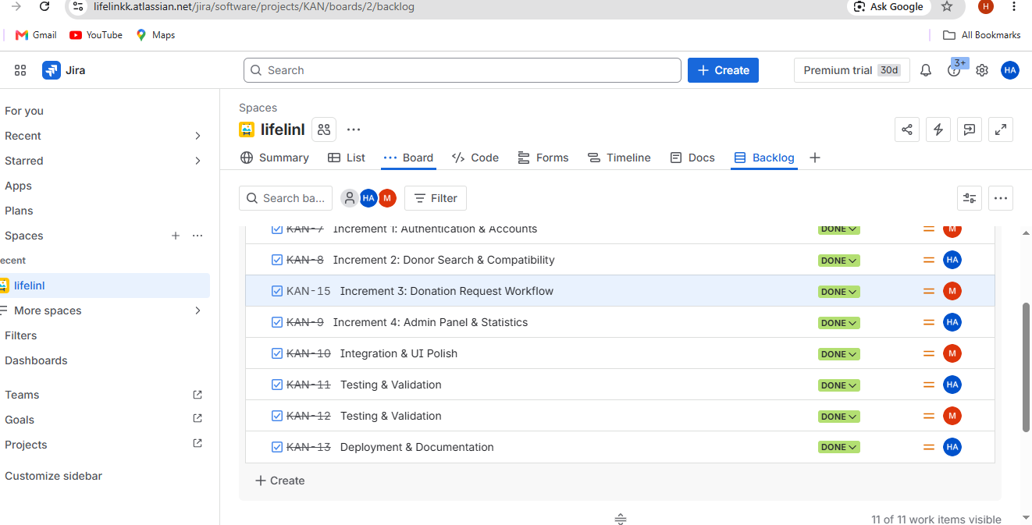
Figure 2 — Jira Backlog view (scrolled) showing the remaining tasks KAN-7 through KAN-13, confirming all 11 work items are visible and assigned.
Together, the two screenshots show all Phase 2 activities represented as Jira tasks, each tagged with its responsible team member, matching the Resource Allocation table produced in Phase 2.

Part 2: Version Control (GitHub)
A single GitHub repository, LifeLink (github.com/hadiawdi89/LifeLink), was created to hold the application's source code. The repository is public, and the second team member (Mohammad Abbas) was added as an official collaborator through the repository's Settings → Collaborators page.
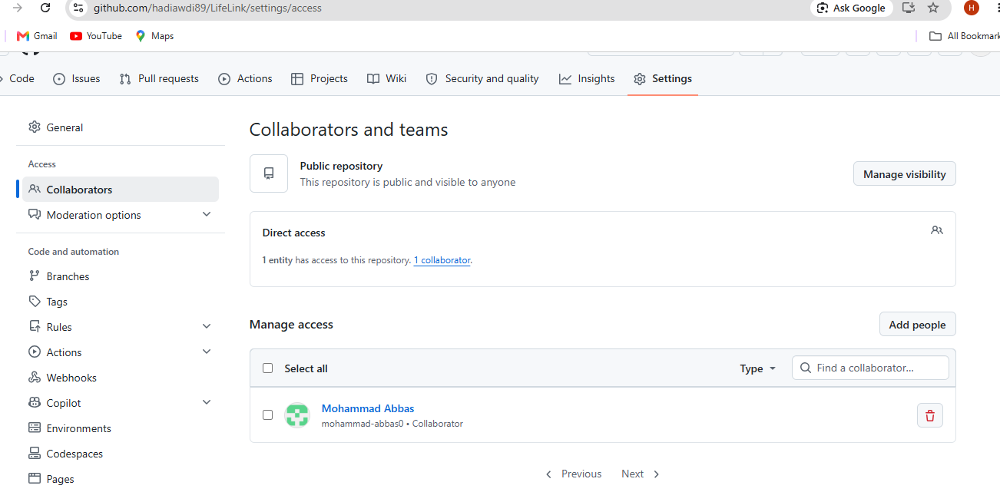
Figure 3 — GitHub repository Settings → Collaborators page, confirming Mohammad Abbas has been added as a collaborator with direct access to the LifeLink repository.
Repository main page — project files and code deployment:
Once the initial project code has been pushed to the remote repository, a screenshot of the repository's main page (showing the file/folder structure, including the pushed phase documentation) should be inserted below.
[ Space reserved for screenshot ]
GitHub repository main page — showing all pushed project files and phase documents
Figure 4 — GitHub repository main page (to be inserted after code and documentation are pushed).

Summary
Tool | Status
Jira project | Created (“lifelinl”, key KAN); 11 tasks entered and assigned; screenshots captured.
GitHub repository | Created (LifeLink); collaborator added; screenshot captured.
Code & docs push | Pending — initial code and all phase documents to be pushed, then repository main-page screenshot inserted above.

