Phase 2: Project Management and Scheduling
Building on the finalized requirements and the Incremental SDLC model from Phase 1, this phase turns the plan into a schedule. We broke the work into ten activities, estimated each one in working days, mapped the dependencies between them, and used a PERT chart and a Gantt chart to find the critical path and lay out the timeline. The two charts use the same tasks and durations, so they line up exactly.
The activities follow the increments defined in Phase 1 — authentication first, then donor search, then the request workflow, then the admin panel — wrapped by design at the start and integration, testing, and deployment at the end:
Task | Activity | Duration (days) | Depends on
A | Requirements Engineering (Phase 1) | 5 | —
B | System & Database Design | 4 | A
C | Environment & Project Setup | 2 | A
D | Increment 1: Authentication & Accounts | 6 | B, C
E | Increment 2: Donor Search & Compatibility | 5 | D
F | Increment 3: Donation Request Workflow | 6 | D
G | Increment 4: Admin Panel & Statistics | 4 | E, F
H | Integration & UI Polish | 3 | G
I | Testing & Validation | 4 | H
J | Deployment & Documentation | 2 | I
Estimated total duration: 34 working days (about 7 weeks).

1. PERT Analysis
The PERT chart below models the project as an activity-on-node network. Each box shows the task and its earliest start (ES), duration, earliest finish (EF), latest start (LS), slack, and latest finish (LF). The values come from a forward pass (to get ES/EF) and a backward pass (to get LS/LF); any task whose slack is zero lies on the critical path, drawn in red.
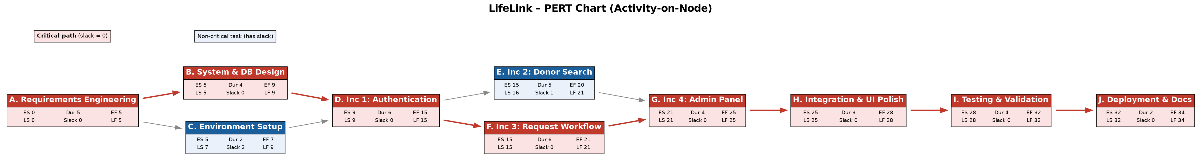
Figure 5 — LifeLink PERT Chart with the critical path highlighted.

Critical Path
The critical path is A → B → D → F → G → H → I → J, with a length of 34 days. These eight activities have zero slack, so any delay on any one of them pushes the whole project back by the same amount. Notably, the request-workflow increment (F) is on the critical path while the donor-search increment (E) is not: even though E and F both start after authentication, F takes longer (6 days vs 5) and feeds the admin panel, so it sets the pace.
Only two activities have slack and are therefore not critical: Environment & Project Setup (C) has 2 days of slack because it runs in parallel with the longer Design task, and Donor Search (E) has 1 day of slack because it finishes a day before the Request Workflow it waits alongside. This small amount of float is the only scheduling flexibility we have.

Risk Areas
- Authentication (D) is the first real risk. It is on the critical path, it is the longest single increment at the start, and everything else depends on it. We scheduled it first deliberately so that any trouble surfaces early rather than late.
- The Request Workflow (F) is the second. It is the most complex feature (sending, status changes, approve/reject) and it sits on the critical path, so it has no room to slip.
- Testing (I) is often squeezed. Because it is near the end of the critical path, any earlier delay eats into testing time. We kept a realistic four-day block for it to avoid that trap.
- Two-person resourcing. With only two people, the parallel branches (E and F) are worked at the same time by different members; if one member falls behind, the other branch cannot easily absorb the work.
The non-critical tasks (C and E) give us a little buffer: if needed, their people can briefly help on a critical task without delaying the project, since C and E can each afford a short slip.

2. Gantt Schedule
The Gantt chart places the same ten activities on a calendar of working days. Each bar starts at the task’s earliest start and runs for its duration, so the staircase shape mirrors the PERT dependencies exactly — a task’s bar only begins once the bars it depends on have finished. Critical-path tasks are red and the two tasks with slack are blue.
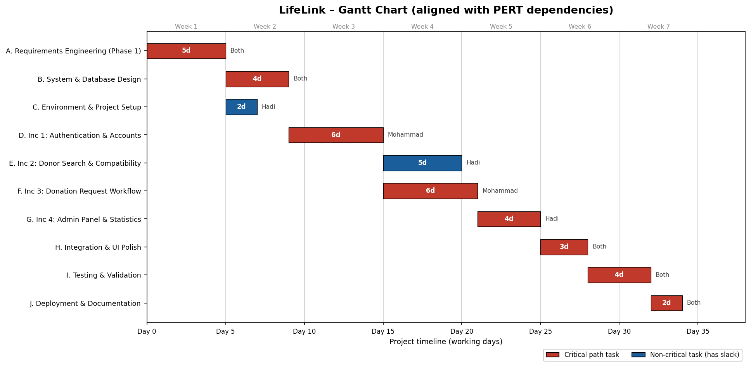
Figure 6 — LifeLink Gantt Chart, aligned with the PERT dependencies.
Reading across, the project runs over roughly seven weeks. The parallel stretch in weeks 4–5 (Donor Search alongside the Request Workflow) is where both team members work simultaneously on separate increments, which is what keeps the overall timeline at 34 days rather than longer.

Resource Allocation
The two team members split the work so that the parallel increments can run at the same time, while the shared milestones (design, integration, testing, deployment) are done together. The table below maps each activity to who owns it.
Activity | Primary owner | Responsibility
A. Requirements Engineering | Both | Elicit, specify, and validate the requirements; produce the Phase 1 SRS.
B. System & Database Design | Both | Design the three data models (User, DonationRequest, Donation) and the page/route structure.
C. Environment & Project Setup | Hadi Awdi | Set up Flask, the database, the repository, and the base project skeleton.
D. Inc 1: Authentication & Accounts | Mohammad Jawad Abbas | Build registration, login/logout, password hashing, and role-based redirection.
E. Inc 2: Donor Search & Compatibility | Hadi Awdi | Build the Find-Donor page, filters, and the blood-type compatibility checker.
F. Inc 3: Donation Request Workflow | Mohammad Jawad Abbas | Build sending requests, the pending/approve/reject flow, and status tracking.
G. Inc 4: Admin Panel & Statistics | Hadi Awdi | Build the admin dashboard, user management, and donor statistics.
H. Integration & UI Polish | Both | Connect the increments, fix flash messages and error pages, and tidy the interface.
I. Testing & Validation | Both | Test each requirement, check the workflows end to end, and fix defects.
J. Deployment & Documentation | Both | Deploy the application and finalize the project documentation.
Rationale. One member (Mohammad) owns the two critical-path increments (authentication and the request workflow) so a single person carries the riskiest, sequential work; the other (Hadi) owns setup, search, and the admin panel, which include the tasks with slack. Whenever the path narrows to one shared task — design, integration, testing, deployment — both work together to get past it quickly.

