University of Sciences and Arts in Lebanon (USAL)
Faculty of Arts and Science — Computer Science


LifeLink
A Web Application for Connecting Blood Donors and Receivers
Project — Phase #1: Requirements Engineering & System Blueprints

Prepared by
Mohammad Jawad Abbas | Hadi Awdi
ID 1123152 | ID 1123272
Instructor: Mr. Mohammad Nader
June 2026

1. Introduction
LifeLink is a web application that connects people who need blood with people willing to donate it. It replaces the slow, unsearchable way families currently find donors (scattered WhatsApp and Facebook posts) with one platform where an urgent request can reach an available, compatible donor in minutes.
This document applies requirements engineering to LifeLink. It follows the four phases of discovering, analyzing, documenting, and validating requirements, and is organised using the standard SRS outline.

1.1 Purpose
The purpose of this Software Requirements Specification (SRS) is to describe the functional and non-functional requirements of LifeLink clearly and completely, so that design, implementation, and testing can all be traced back to it.

1.2 Intended Audience
It is written for the project team (developers), the course instructor who evaluates it, the testers who derive test cases from the functional requirements, and any future maintainer who needs to understand the system before changing it.

1.3 Product Scope
LifeLink is a role-based web application built with Python (Flask), SQLite, and HTML/CSS/JavaScript. In scope: visitors browse and check blood-type compatibility; members search for donors and send donation requests; donors approve or reject requests and record donations; an administrator manages users, oversees requests, and views statistics.
Out of scope: payments or rewards, GPS tracking, SMS integration, medical verification of blood tests, and a native mobile app. The core goal is to reduce the time between an urgent request and a matched, available donor.

2. Requirements Engineering Process
This section covers the requirements engineering process applied to LifeLink: the feasibility study, the chosen SDLC model and its justification, elicitation, and validation.

2.1 Feasibility Study
A feasibility study decides whether the system is worth building. We checked LifeLink from four angles and found it feasible on all of them:
- Technical — all the tools (Flask, Flask-Login, SQLAlchemy, SQLite, Werkzeug) are free, well-supported, and within our skills. No feature needs experimental technology, and passwords are kept safe by hashing.
- Economic — the stack is open-source, so the only real cost is our time; hosting a small Flask app is cheap. The benefit (faster donor matching) clearly outweighs that.
- Operational — the system fits how people already behave, using familiar website patterns (sign up, search, send) that need no training. Without it, people would keep relying on scattered social-media posts.
- Schedule & legal — the scope is deliberately sized to fit one academic term. Because it stores personal data, passwords are never stored in plain form, and a real deployment would add a privacy policy and consent.
Conclusion: LifeLink is technically buildable, economically cheap, operationally natural, and deliverable in our timeframe, so we proceeded.

2.2 Chosen SDLC Model and Justification
We chose the Incremental (iterative) model. Waterfall was rejected because it freezes requirements up front, which is unrealistic for features we expected to refine after building a first version. Full Agile/Scrum was rejected because its sprint ceremonies and roles are too heavy for a two-person student project graded on one documented deliverable.
Justification. The Incremental model lets us build the system in working slices while still producing clear, documented requirements. It fits LifeLink because:
- The features split naturally into increments — authentication, then donor search, then the request workflow, then the admin panel — which is exactly how the codebase is already organised (separate route modules per feature).
- Each working slice exposes what is missing and feeds the next, so requirements improve as we learn (this is how the request-status flow grew).
- The hardest part (accounts and login) is built first, reducing risk early.
- There is always a runnable system to demonstrate and validate against the requirements.

2.3 Requirements Elicitation and Analysis
We gathered requirements from three sources: studying how people currently find donors on social media (which revealed the lack of search, availability info, and request tracking); looking at comparable blood-bank and donor-matching sites for the expected feature set; and prototyping small pieces to expose gaps. During analysis we classified each requirement as functional, non-functional, or domain, removed conflicts, and prioritised the core matching workflow ahead of secondary features. Vague needs like “find a donor fast” were turned into the concrete, checkable requirements in Section 4.

2.4 Requirements Validation
We reviewed the requirements as a team against the five standard checks: validity (each requirement traces to a real user need), consistency (no conflicts, e.g. between the member, admin, and visitor capabilities), completeness (the full journey — register, search, request, respond, record, administer — is covered), realism (everything maps to what Flask/SQLite can do in the term), and verifiability (each functional requirement can be confirmed by a concrete action and observable result).

3. Overall Description

3.1 Product Perspective
LifeLink is a new, self-contained web application: a server that handles the logic and a database that stores users, donation requests, and donation records. It depends on no external service, so a user only needs a browser and an internet connection.

3.2 User Classes (User Needs)
LifeLink has three classes of user:
- Visitor (Guest) — not logged in; needs to browse, check blood-type compatibility, and sign up quickly. Low technical skill assumed.
- Member (Donor / Receiver) — a registered user who is both donor and receiver. As a receiver they search and send requests; as a donor they handle incoming requests, manage their profile, and record donations. The primary user.
- Administrator — a trusted operator who manages users, oversees all requests, and views donor statistics.

3.3 Operating Environment
- Server: Python 3 with Flask, SQLAlchemy, and Flask-Login.
- Database: SQLite (a single file).
- Client: any modern desktop or mobile browser (HTML, CSS, JavaScript).
- Times are stored in UTC and shown in Lebanon (Asia/Beirut) local time.

3.4 Assumptions and Dependencies
- Users provide honest information, especially a correct blood type (the system does not medically verify it).
- The actual donation happens in person at a clinic; LifeLink only coordinates the connection.
- At least one administrator account exists for moderation.
- The system depends on the Flask, Flask-Login, Flask-SQLAlchemy, SQLAlchemy, and Werkzeug libraries.

4. System Features and Requirements
This section lists the functional, interface, and non-functional requirements, grouped by feature area so they can be referenced from the diagrams and from test cases.

4.1 User Stories
- As a receiver, I want to filter donors by blood type and city so that I only see people who can help me nearby.
- As a receiver, I want to send a request to a specific donor so that I can reach them directly instead of posting publicly.
- As a donor, I want to approve or reject incoming requests so that I stay in control of who I help.
- As a visitor, I want to check blood-type compatibility before signing up.
- As an administrator, I want to see donors grouped by blood type so that I can spot shortages.

4.2 Functional Requirements

4.2.1 Account and Authentication
Requirement
A visitor shall register an account with at least a full name, a unique email, and a password; blood type, city, and phone are optional.
The system shall reject registration if the email is already in use or if name, email, or password is missing.
Passwords shall be stored only as secure hashes, never as plain text.
A registered user shall log in with email and password, with an optional “remember me” option.
On wrong credentials the system shall show one generic error that does not reveal which field was wrong.
A logged-in user shall be able to log out, ending their session.
After login, an administrator shall go to the admin dashboard and a member to their profile.

4.2.2 Profile Management
Requirement
A member shall view their own profile together with their donation history.
A member shall update their name, phone, city, and blood type.
A member shall delete their own account, which logs them out and removes their data.

4.2.3 Finding Donors
Requirement
Any user shall open the Find-Donor page and see the list of registered donors.
The user shall filter the donor list by blood type, city, and urgency/availability.
The page shall show each donor’s blood type, availability, average response time, and rapid-donor badge where applicable.
Any user shall use a blood-type compatibility checker showing which types can give to or receive from a selected type.

4.2.4 Donation Requests
Requirement
A logged-in member shall send a donation request to a chosen donor, with the blood type needed and an optional message.
The system shall save each new request with status “pending” and a timestamp.
A donor shall view requests addressed to them, separated into pending and history.
A donor shall approve or reject a pending request; only the targeted donor (or an admin) may do so.
The receiver shall see the current status of requests they have sent.
Request times shall be displayed in Lebanon local time.

4.2.5 Recording Donations
Requirement
A donor shall record a completed donation; the system shall create a donation record and update the donor’s total-donations count and last-donation date.
A donor (or an admin) shall update a donation’s status among pending, approved, and completed.

4.2.6 Administration
Requirement
An administrator shall view a dashboard summarising the number of donors, receivers, and admins.
An administrator shall list all users, create a user with a chosen role, and delete a user.
An administrator shall view statistics of donors grouped by blood type.
An administrator shall list all donation requests and approve or reject any of them.
Admin pages shall be reachable only by authenticated administrators; everyone else gets a 403 error.

4.3 External Interface Requirements
- User interface — a responsive website with pages for home/dashboard, sign-up, login, find-donor, profile, my-requests, and admin; feedback via flash messages. Usable on phone and desktop.
- Hardware interface — none special; any device with a browser and network access.
- Software interface — talks to SQLite through SQLAlchemy; relies on Flask, Flask-Login, and Werkzeug; runs on any OS with Python 3.
- Communication interface — HTTP/HTTPS between browser and server, with sessions kept in a signed cookie; HTTPS required in production.

4.4 Non-Functional Requirements
Category | Requirement
Performance | Common pages (Find-Donor, login) should respond within about two seconds under normal load.
Usability | A first-time visitor should register and send their first request without instructions.
Security | Passwords hashed; admin areas access-controlled; login errors must not leak which field was wrong.
Reliability | The system shows friendly 403, 404, and 500 pages instead of crashing.
Availability | The site should be reachable any time, so an urgent request can be made whenever needed.
Portability | Using Python and SQLite, it should run on Windows, macOS, or Linux without code changes.

4.5 Domain Requirement
One key requirement comes from the domain itself: the matching and the compatibility checker must follow the real blood-type compatibility rules (for example, O− is the universal donor and AB+ the universal recipient). Getting this wrong would make the system untrustworthy, so it is stated explicitly.

5. Architectural Diagrams (System Blueprint)
The requirements are modelled with four standard diagrams. Each is followed by a short explanation linking it to the requirements.

5.1 Use Case Diagram
The use case diagram identifies the three actors (Visitor, Member, Administrator) and the core use cases inside the system boundary.
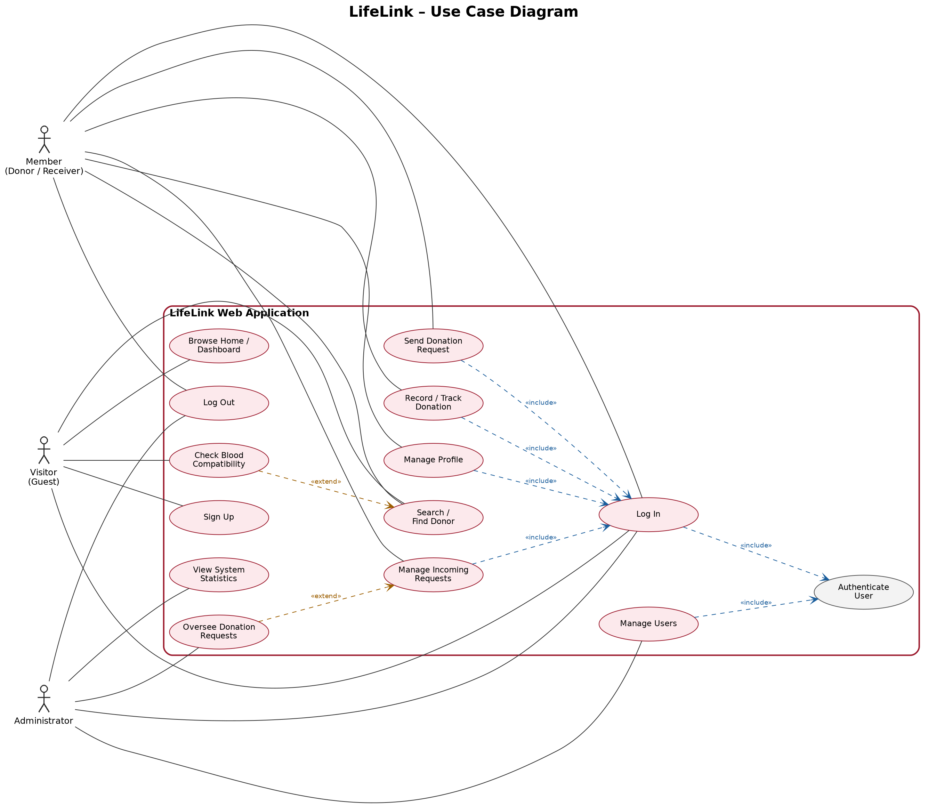
Figure 1 — LifeLink Use Case Diagram.
A Visitor can browse, check compatibility, sign up, log in, and search. A Member drives the request workflow — searching, sending and handling requests, recording donations, and managing their profile. An Administrator manages users, oversees requests, and views statistics. The dashed «include» links show secured actions reuse authentication, and «extend» links show optional behaviour such as the compatibility check extending search.

5.2 Activity Diagram
The activity diagram models the main workflow: a receiver finding a donor, sending a request, and the donor responding. Diamonds are decision points where the flow branches.
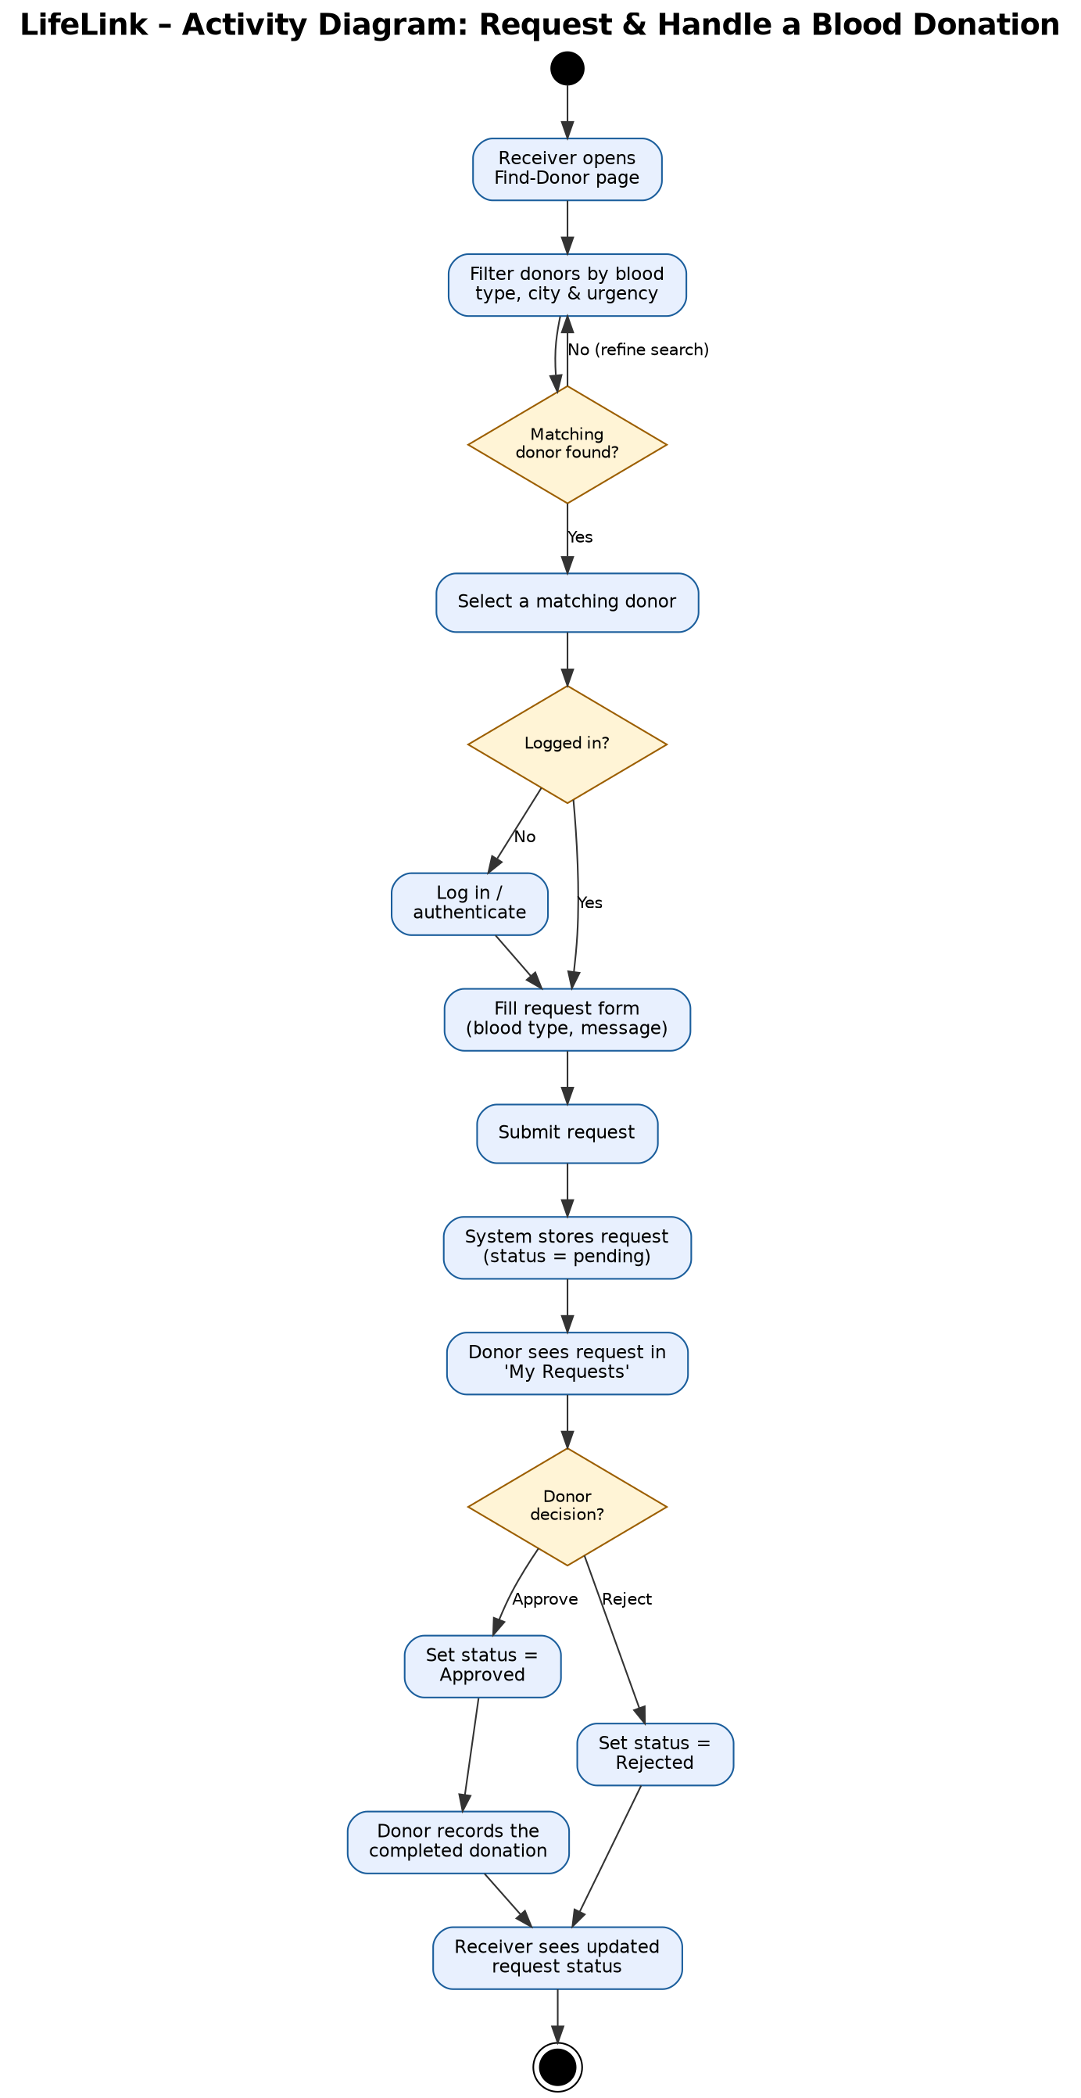
Figure 2 — Activity Diagram: requesting and handling a donation.
The receiver filters donors until a match is found, logs in if needed, then submits a request that the system stores as “pending.” The donor approves (leading to recording the donation) or rejects; either way the receiver sees the final status. This mirrors the donor-search and request-handling requirements above.

5.3 Class Diagram
The class diagram shows the static structure. LifeLink has three classes taken directly from the data model — User, DonationRequest, and Donation. Rather than separate Donor and Receiver classes, the design keeps one User that carries role flags (is_donor, is_receiver, is_admin).
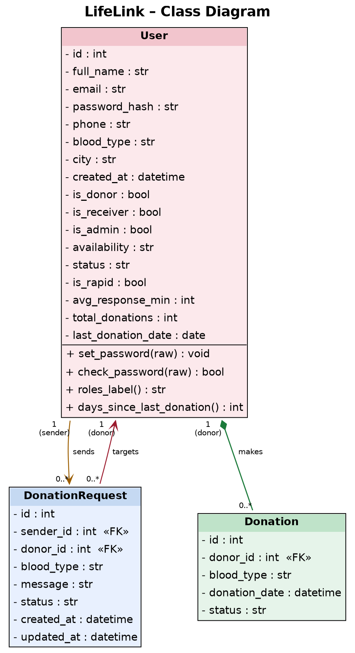
Figure 3 — LifeLink Class Diagram.
The diagram shows the relationships in the design:
- Composition (filled diamond): a Donation cannot exist without the donor who made it — removing a User removes their Donation records (delete-orphan cascade).
- Association — “sends” (plain arrow): one User can send many DonationRequests (1 to 0..*).
- Association — “targets” (plain arrow): one User can be the targeted donor of many DonationRequests (0..* to 1).
The two associations correspond to the sender_id and donor_id foreign keys. The design uses one flexible User class rather than an inheritance hierarchy, so it does not use generalization or aggregation.

5.4 Data Flow Diagram (DFD)
The DFD shows how data moves through the system: external entities (squares), processes (numbered ellipses), data stores (open boxes), and the data flows between them.
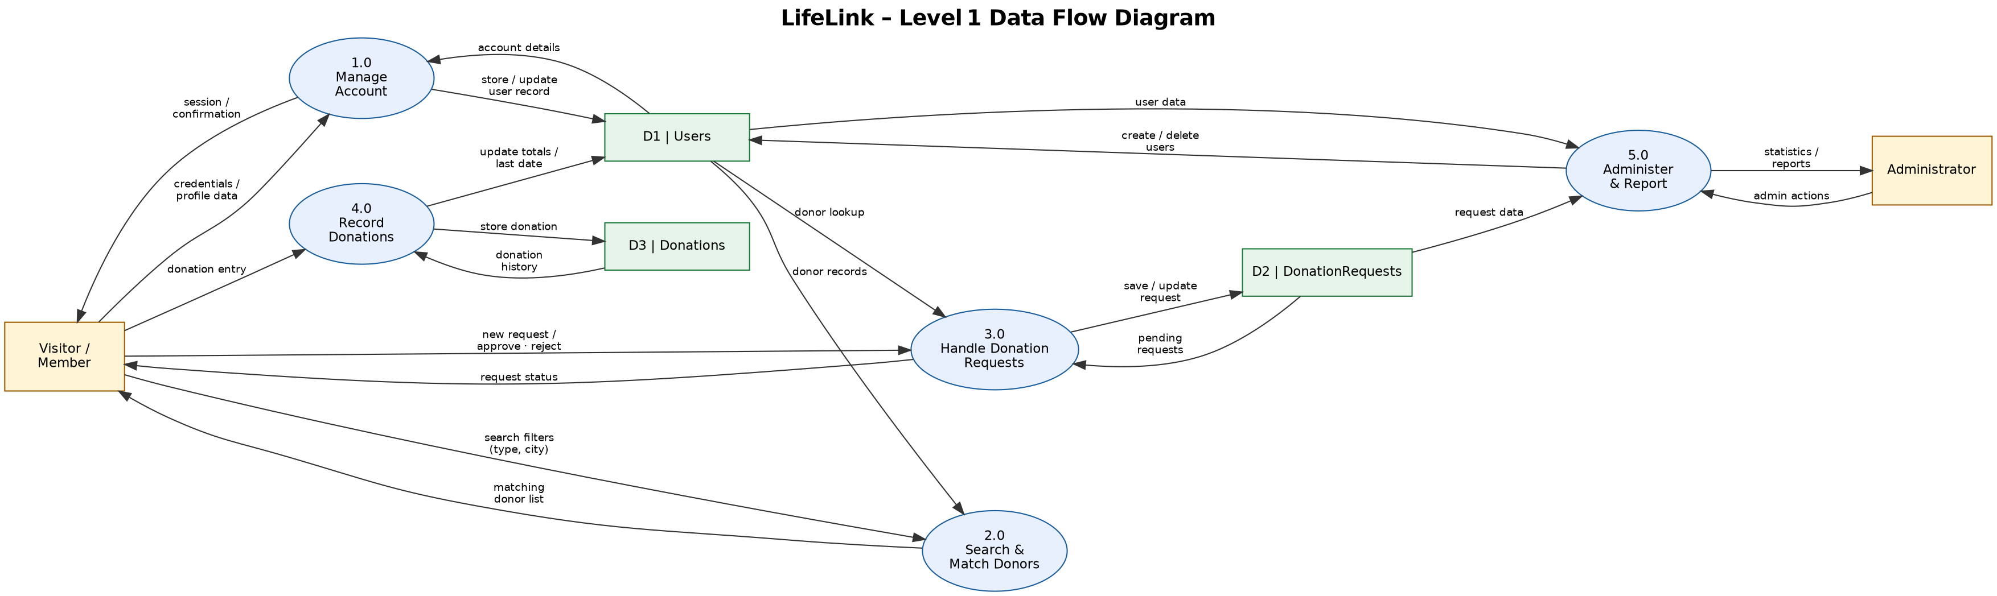
Figure 4 — LifeLink Level-1 Data Flow Diagram.
Two external entities (Visitor/Member and Administrator) interact with five processes — manage accounts, search and match donors, handle requests, record donations, and administer and report — over three data stores: D1 Users, D2 DonationRequests, and D3 Donations. For example, search reads donor records from D1 to return a match, while the request process reads from and writes to D2.

6. Conclusion
We applied requirements engineering to LifeLink end to end: a feasibility study confirmed the project is worth doing, the Incremental SDLC model was chosen and justified, requirements were elicited, specified as functional and non-functional requirements, and validated. These were then translated into four blueprints — use case, activity, class, and data flow diagrams — giving a solid foundation for design and implementation.

