Software Requirements Specification
KURIC Web Portal
Khulna University Research and Innovation Center
An Information & Research-Proposal Management Platform
Version: 1.0
Date: 18 August 2026
Prepared By
Hadidur Rahman Jion — Student ID: 220215
Sadia Afrin Tamanna — Student ID: 220240
Supervised By
Engr. Prof. Dr. Kazi Masudul Alam
Computer Science and Engineering Discipline,
Khulna University

1. Introduction

1.1 Purpose
This document specifies the requirements for the KURIC Web Portal — an online platform for the Khulna University Research and Innovation Center (KURIC). The portal will serve as both a public information website and an operational system for managing research proposal submission and review.

1.2 Project Scope
KURIC currently has no online presence. This project will build a single, unified platform that (a) presents general information about KURIC to the public, and (b) provides an interactive workflow through which researchers submit proposals, reviewers evaluate them, and KURIC officers manage the overall process and site content.

1.3 Team
Name | Student ID | Responsibility
Hadidur Rahman Jion | 220215 | Full-stack development, backend & database design
Sadia Afrin Tamanna | 220240 | Full-stack development, UI/UX & documentation
Both members will jointly contribute to design, development, testing, and documentation of the complete system.

2. User Roles
The system supports four categories of users, each with a distinct level of access:
Role | Access Level | Purpose
Public / Visitor | No login required | Browse general KURIC information, research, events, and news
Researcher (Teacher/Student) | Registered login | Submit and track research proposals
Reviewer | Assigned login | Evaluate proposals and give decisions/suggestions
KURIC Officer (Admin) | Admin login | Manage content, users, proposals, and appeals

3. Functional Requirements

3.1 Public Website (Visitor)
- FR-01: Display Home, About, Research Areas, Publications, Events/News, and Contact pages.
- FR-02: Provide a search feature across research and publication content.

3.2 Researcher Portal
- FR-03: Allow researchers to register/login securely.
- FR-04: Provide a proposal submission form (title, abstract, budget, co-researchers, file attachment).
- FR-05: Allow researchers to track proposal status (Pending / Under Review / Accepted / Revision Needed / Rejected).
- FR-06: Allow researchers to view reviewer comments and resubmit revised proposals.
- FR-07: Allow researchers to appeal a rejected proposal.

3.3 Reviewer Portal
- FR-08: Allow reviewers to log in and view only the proposals assigned to them.
- FR-09: Allow reviewers to Accept, Deny, or request Revision on a proposal, with written comments.
- FR-10: Notify the researcher automatically once a review decision is submitted.

3.4 KURIC Officer (Admin) Portal
- FR-11: Allow officers to assign proposals to specific reviewers.
- FR-12: Allow officers to monitor the status of all proposals in the system.
- FR-13: Allow officers to manage public website content (post events, news, publications).
- FR-14: Allow officers to review and resolve appeals on rejected proposals.
- FR-15: Allow officers to manage user and reviewer accounts.

4. Non-Functional Requirements
Category | Requirement
Security | Role-based access control; passwords stored securely (hashed).
Usability | Responsive design; simple, intuitive dashboards for each role.
Performance | Pages should load within 3 seconds under normal conditions.
Reliability | Proposal data must not be lost; all actions logged for accountability.
Maintainability | Codebase organized and version-controlled for future updates.

5. System Architecture Overview

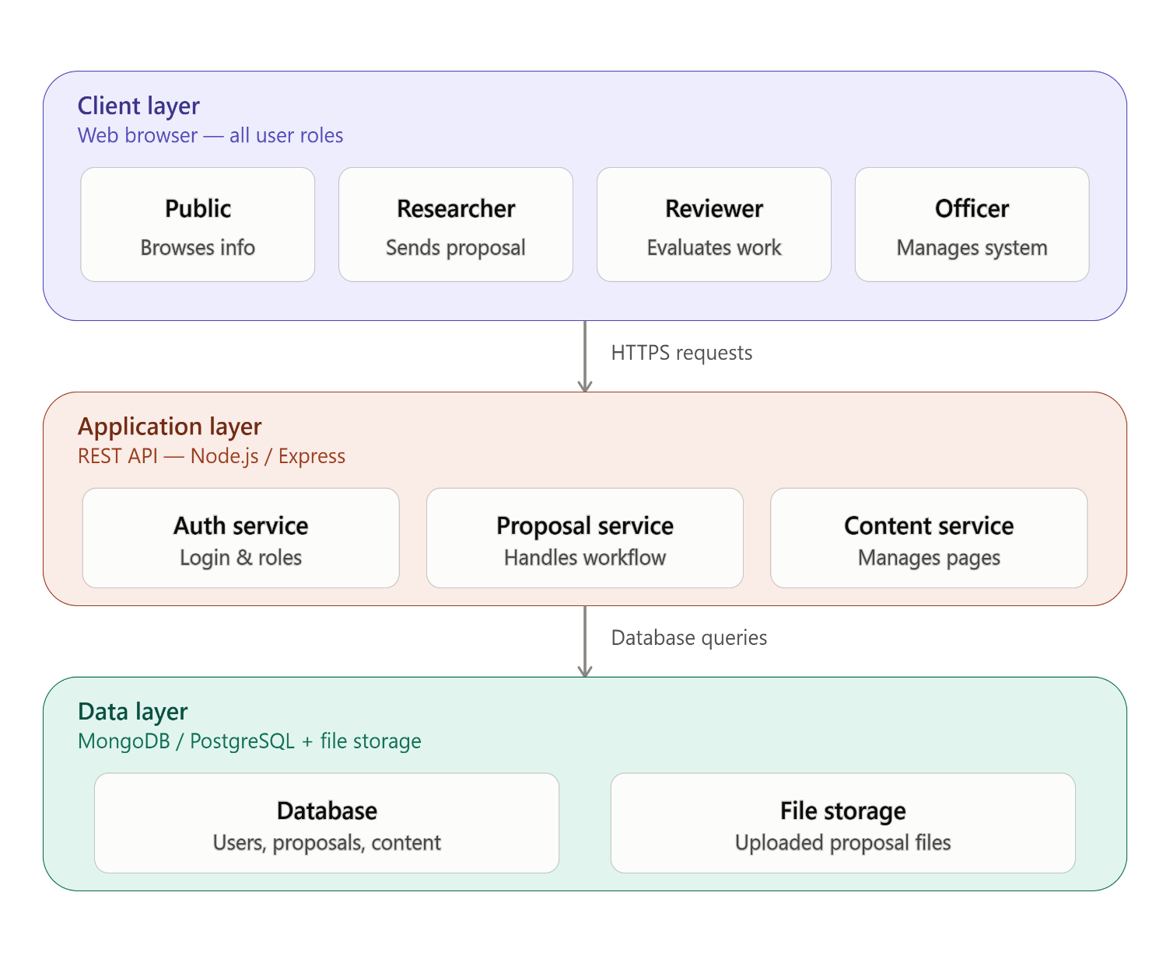

The KURIC Web Portal follows a three-layer architecture:

- Client Layer – The web browser interface used by all four user types (Public, Researcher, Reviewer, and Officer). Each role sees a different view/dashboard based on their login.
- Application Layer – The backend server (built with Node.js/Express) that handles all logic through REST APIs. It has three main services:
  - Auth Service – manages login and role verification
  - Proposal Service – handles the full proposal submission and review workflow
  - Content Service – manages public content like events, news, and publications
- Data Layer – Stores all information permanently, using a Database (MongoDB/PostgreSQL) for users, proposals, and content, and File Storage for uploaded documents (e.g., proposal PDFs).

The client sends HTTPS requests to the application layer, which then queries the database to fetch or update data, and returns the response back to the user.

This layered design allows the frontend and backend to be developed independently and communicate only through APIs, making teamwork and future updates easier.

6. KURIC Project Timeline — 6 Weeks
Week | Focus | Key Tasks
Week 1 | Initiation & SRS | Define scope/objectives/roles · Draft SRS document (with role-based requirements) · Set up GitHub repo + README + CONTRIBUTING guidelines
Week 2 | Design & Planning | Create wireframes for all 4 roles (Public site, Researcher dashboard, Reviewer dashboard, Officer admin panel) · Design ER Diagram (Users, Proposals, Reviews, Content tables) · System Architecture · Set up GitHub Projects board
Week 3–4 | Development Sprint 1 | Build Auth module (role-based login/register using JWT) · Build static public website pages (Home, About, Research, Contact) · Navigation/layout · Build Researcher's proposal submission form (first core feature) · Write unit tests · First round of PR reviews
Week 5–6 | Development Sprint 2 | Build Reviewer dashboard (view assigned proposals, Accept/Revise/Deny + comments) · Build Officer admin panel (assign reviewers, manage content — events/news/publications, handle appeals) · Connect frontend to backend APIs · Notification system · Final testing & sprint retrospective

7. Technology Summary
The system will be built using a standard modern web development stack, chosen for reliability, community support, and ease of collaborative development between two team members:
- Frontend: React (or Next.js) with Tailwind CSS for a responsive, role-based user interface.
- Backend: Node.js with Express.js, providing REST APIs for authentication, proposal workflow, and content management.
- Database: MongoDB (or PostgreSQL) to store users, proposals, reviews, and site content.
- Authentication: JWT-based role authentication (Public / Researcher / Reviewer / Officer).
- Version Control & Collaboration: GitHub, for source code management, task tracking (Projects board), and Pull Request based review between the two team members.
- AI-Assisted Development: Claude and GitHub Copilot used for requirement drafting, documentation, code scaffolding, and test generation throughout the project.

8. Acknowledgement
We would like to thank our course instructor for the guidance and the opportunity to design a real, practical system for Khulna University Research and Innovation Center. We studied some previous websites on RIC of BUET(RISE), KUET and MIT. Then with the help of Claude we organized our requirements for KURIC.
GitHub is used as the central platform for this project's version control and team collaboration. Since we are a two-member team, GitHub allows us to work on different modules in parallel using separate branches, track every change through commit history, and review each other's code through Pull Requests before merging — ensuring that both members remain synchronized on the same, error-free codebase throughout development.
In addition, AI tools (Claude, ChatGPT) were used responsibly to accelerate documentation, while all core design decisions, requirements, and final implementation remain the work and understanding of the project team.

