Name: Hadijah Kyampeire
Registration #: 618990
GITHUB LINK: https://github.com/hadijahkyampeire/eClinician
eClinician Management System/Software Requirements Specifications (SRS)
The eClinician Clinical Management System is a web-based application designed to support healthcare facilities in managing patient registration, appointments, medical records, prescriptions, laboratory requests, and user accounts through a centralized platform. The system aims to improve the efficiency and accuracy of clinical operations by reducing manual record keeping and providing secure, role-based access for healthcare personnel.
This Software/System Requirements Specification (SRS) presents the system requirements using a Use-Case Model, consisting of a Use-Case Diagram and detailed Use-Case Descriptions. These use cases define how the different users of the system interact with the application and serve as a foundation for the subsequent design and implementation phases of the project.
USE-CASE DIAGRAM:
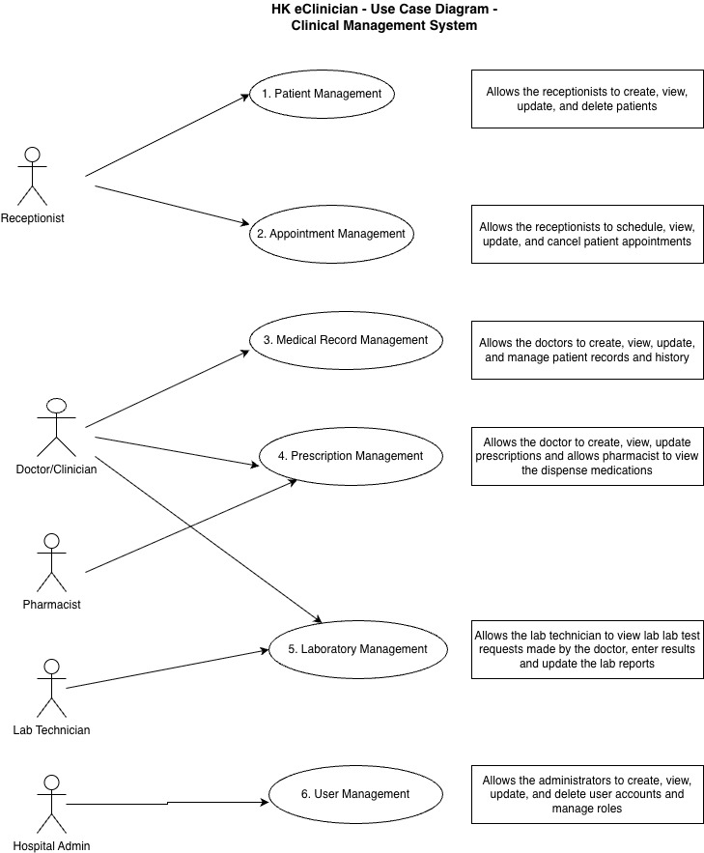
USE-CASE DESCRIPTIONS:
Use Case Number: 1
Name: Patient Management
Brief description: This use case allows the receptionist to create, view, update, and delete patient profiles.
Actors: Receptionist
Preconditions: The receptionist must be logged in to the system.
Flows of Events:
1. Basic Flows

1.0 Create Patient Profile
Step | User Actions | System Actions
1 | The receptionist calls the create patient profile command. | The system displays the patient profile form with the fields for firstname, lastname, date of birth, gender, phone number, national ID / passport number, email and address.
2 | The receptionist fills out the form and requests the system to save the details. | The system verifies that no other patient exists in the database with the same national ID / passport number or phone number, saves the patient and returns a success message on success or a fail message in case of failure. In case another profile exists with the same identifier, the system returns a message indicating a duplicate entry exists.
Postconditions:
The patient profile is persisted in the system.
Business Rules:
No duplicate patient profiles. A unique patient is identified by patient ID, phone number, or national ID / passport number.

1.1 Read/View Patient Profile
Step | User Actions | System Actions
1 | The receptionist selects to view a list of patient profiles. | The system returns a list of all patient profiles.
2 | The receptionist selects to view the profile of one of the patients from the list. | The system returns the profile of the patient as a string with the names (firstname and lastname), date of birth, gender, phone number, national ID / passport number, email and address.

1.2 Update Patient Profile
Step | User Actions | System Actions
1 | The receptionist selects to view a list of patient profiles. | The system returns a list of all patient profiles.
2 | The receptionist selects the profile of the patient they want to update. | The system displays an editable patient profile form pre-populated with the patient profile details.
3 | The receptionist updates the fields they want to update and requests the system to save the new details. | The system updates the record and returns a success message or a fail message on exception.
Postconditions: The patient profile will be updated.
Business Rules: The national ID / passport number field should be unwritable.

1.3 Delete Patient Profile
Step | User Actions | System Actions
1 | The receptionist selects to view a list of patient profiles. | The system returns a list of all patient profiles.
2 | The receptionist selects to delete a patient profile from the list of patient profiles. | The system displays a confirmation dialogue window.
3 | The receptionist selects OK on the confirmation dialog window to confirm deleting the profile. | The system confirms the patient is not linked to any appointments, medical records or prescriptions and deletes the profile. The system returns a success message on success or a failure message. The system should return a message indicating the profile could not be deleted because it is linked to existing records.
Postconditions: The patient profile will be deleted.
Business Rules:
Only a patient profile that is not linked to any appointments, medical records or prescriptions can be deleted.
Use Case Number: 2
Name: Appointment Management
Brief description: This use case provides functionality for managing patient appointments.
Actors: Receptionist
Preconditions: The receptionist must be logged in to the system.
Flows of Events:
1. Basic Flows

1.0 Schedule Appointment
Step | User Actions | System Actions
1 | The receptionist calls the schedule appointment command. | The system displays the appointment form with the fields for patient, doctor, appointment date, appointment time and reason for visit.
2 | The receptionist fills out the form and requests the system to save the details. | The system verifies that the selected doctor does not already have an appointment at the same date and time, and that the patient does not have a duplicate appointment with the same doctor at the same time, then saves the appointment and returns a success message. The system returns a fail message on exception or a conflict message in case of a scheduling clash.
Postconditions: The appointment is persisted in the system.
Business Rules:
A doctor should not have two appointments scheduled at the same date and time.
A patient should not have duplicate appointments for the same doctor and time.

1.1 View Appointment
Step | User Actions | System Actions
1 | The receptionist requests a list of appointments. | The system returns a list of all appointments.
2 | The receptionist selects to view an appointment they want from the list. | The system returns the appointment object as a string with the patient name, doctor name, appointment date, appointment time and status.

1.2 Update Appointment
Step | User Actions | System Actions
1 | The receptionist requests a list of appointments. | The system returns a list of all appointments.
2 | The receptionist selects the appointment they want to update. | The system displays an editable appointment form pre-populated with the appointment details.
3 | The receptionist changes the parts they want to update and requests the system to save the new details. | The system re-checks for scheduling conflicts, updates the appointment and returns a success message or a fail message on exception.
Postconditions:
The appointment details will be updated.

1.3 Cancel Appointment
Step | User Actions | System Actions
1 | The receptionist requests a list of appointments. | The system returns a list of all appointments.
2 | The receptionist selects to cancel an appointment from the list. | The system displays a confirmation dialogue window.
3 | The receptionist selects OK on the confirmation dialog window to confirm cancelling the appointment. | The system marks the appointment as cancelled and returns a success message or a fail message on exception.
Postconditions: The appointment will be cancelled.
Business Rules: An appointment that has already taken place cannot be cancelled.
Use Case Number: 3
Name: Medical Record Management
Brief description: This use case provides functionality for managing patient consultation records.
Actors: Doctor / Clinician
Preconditions: The clinician must be logged in to the system.
Flows of Events:
1. Basic Flows

1.0 Create Consultation Record
Step | User Actions | System Actions
1 | The clinician calls the create consultation record command. | The system displays the consultation record form with the fields for patient, symptoms, diagnosis, notes and consultation date.
2 | The clinician fills out the form and requests the system to save the details. | The system verifies that the record is linked to an existing patient, saves the consultation record and returns a success message or a fail message on exception.
Postconditions: The consultation record is persisted in the system.
Business Rules: Only clinicians can create or update medical records.
Medical records should be linked to an existing patient.

1.1 View Patient Medical History
Step | User Actions | System Actions
1 | The clinician selects a patient and requests their medical history. | The system returns a list of all consultation records linked to the selected patient.
2 | The clinician selects a consultation record they want to view from the list. | The system returns the consultation record as a string with the patient name, symptoms, diagnosis, notes and consultation date.

1.2 Update Consultation Record
Step | User Actions | System Actions
1 | The clinician selects a patient and requests their medical history. | The system returns a list of all consultation records linked to the patient.
2 | The clinician selects the consultation record they want to update. | The system displays an editable consultation record form pre-populated with the record details.
3 | The clinician changes the parts they want to update and requests the system to save the new details. | The system updates the record and returns a success message or a fail message on exception.
Postconditions: The consultation record will be updated.
Business Rules: A consultation record can only be updated by a clinician.
Use Case Number: 4
Name: Prescription Management
Brief description: This use case allows a doctor to issue prescriptions and a pharmacist to view and dispense the prescribed medication.
Actors: Doctor, Pharmacist
Preconditions: The doctor or pharmacist must be logged in to the system.
Flows of Events:
1. Basic Flows

1.0 Create Prescription
Step | User Actions | System Actions
1 | The doctor calls the create prescription command. | The system displays the prescription form with the fields for patient, consultation, medication, dosage, frequency and duration.
2 | The doctor fills out the form and requests the system to save the details. | The system verifies that the prescription is linked to an existing patient and consultation, saves the prescription and returns a success message or a fail message on exception.
Postconditions: The prescription is persisted in the system.
Business Rules: Only doctors can issue prescriptions.
A prescription must be linked to a patient and a consultation.

1.1 View Prescription
Step | User Actions | System Actions
1 | The doctor or pharmacist requests a list of prescriptions. | The system returns a list of all prescriptions.
2 | The doctor or pharmacist selects a prescription they want to view from the list. | The system returns the prescription object as a string with the patient name, medication, dosage, frequency, duration and dispensed status.

1.2 Dispense Medication
Step | User Actions | System Actions
1 | The pharmacist requests a list of prescriptions. | The system returns a list of all prescriptions that are not yet dispensed.
2 | The pharmacist selects a prescription and marks the medication as dispensed. | The system updates the prescription status to dispensed and returns a success message or a fail message on exception.
Postconditions: The prescription will be marked as dispensed.
Business Rules: Only pharmacists can mark medication as dispensed.
Use Case Number: 5
Name: Laboratory Management
Brief description: This use case allows a doctor to request laboratory tests and a laboratory technician to record the results.
Actors: Doctor, Laboratory Technician
Preconditions: The doctor or laboratory technician must be logged in to the system.
Flows of Events:
1. Basic Flows

1.0 Create Laboratory Request
Step | User Actions | System Actions
1 | The doctor calls the create laboratory request command. | The system displays the laboratory request form with the fields for patient, consultation, test type and notes.
2 | The doctor fills out the form and requests the system to save the details. | The system verifies that the request is linked to an existing patient, saves the laboratory request and returns a success message or a fail message on exception.
Postconditions: The laboratory request is persisted in the system.
Business Rules: A laboratory request must be linked to an existing patient.

1.1 View Laboratory Request
Step | User Actions | System Actions
1 | The doctor or laboratory technician requests a list of laboratory requests. | The system returns a list of all laboratory requests.
2 | The user selects a laboratory request they want to view from the list. | The system returns the laboratory request object as a string with the patient name, test type, notes and status.

1.2 Record Laboratory Results
Step | User Actions | System Actions
1 | The laboratory technician requests a list of pending laboratory requests. | The system returns a list of all laboratory requests that do not yet have results.
2 | The laboratory technician selects a request and enters the results, then requests the system to save. | The system verifies the results are linked to an existing laboratory request, saves the results and returns a success message or a fail message on exception.
Postconditions: The laboratory results are persisted in the system.
Business Rules: Lab results must be linked to a lab request.
Only laboratory technicians can record laboratory results.

1.3 View Laboratory Results
Step | User Actions | System Actions
1 | The doctor selects a patient and requests their laboratory results. | The system returns a list of all laboratory results linked to the patient.
2 | The doctor selects a laboratory result they want to view from the list. | The system returns the laboratory result as a string with the patient name, test type, results and result date.
Business Rules: Doctors can view laboratory results for their patients.
Use Case Number: 6
Name: User Management
Brief description: This use case provides functionality for managing system users and their roles.
Actors: Administrator
Preconditions: The administrator must be logged in to the system.
Flows of Events:
1. Basic Flows

1.0 Create User
Step | User Actions | System Actions
1 | The administrator calls the create user command. | The system displays the user form with the fields for firstname, lastname, email / username, password and role.
2 | The administrator fills out the form and requests the system to save the details. | The system verifies that no other user exists with the same email / username, saves the user and returns a success message. The system returns a fail message on exception or a duplicate entry message in case of a duplicate.
Postconditions: The user account is persisted in the system.
Business Rules: No duplicate user accounts. - Email / username must be unique.

1.1 View User
Step | User Actions | System Actions
1 | The administrator requests a list of users. | The system returns a list of all users.
2 | The administrator selects a user they want to view from the list. | The system returns the user object as a string with the names (firstname, lastname), email / username and role.

1.2 Update User
Step | User Actions | System Actions
1 | The administrator requests a list of users. | The system returns a list of all users.
2 | The administrator selects the user they want to update. | The system displays an editable user form pre-populated with the user details.
3 | The administrator changes the parts they want to update and requests the system to save the new details. | The system updates the record and returns a success message or a fail message on exception.
Postconditions: The user details will be updated.
Business Rules: The email / username field should be unwritable.

1.3 Delete / Deactivate User
Step | User Actions | System Actions
1 | The administrator requests a list of users. | The system returns a list of all users.
2 | The administrator selects to delete or deactivate a user from the list. | The system displays a confirmation dialogue window.
3 | The administrator selects OK on the confirmation dialog window to confirm the action. | The system deactivates or deletes the user account and returns a success message or a fail message on exception.
Postconditions: The user account will be deleted or deactivated.
Business Rules: Users should only access features allowed by their role.

