
The Arab American University
FACULTY OF ENGINEERING
INTRODUCTION TO DATABASE SYSTEMS (230213230)
COURSE PROJECT I

Project Title
Humanitarian Aid Tracking System in Palestinian Camps

Team Members
[Akram Zakarna], [202211029] | [Hadi Kmail],  [202211076]

Total | /100

Good Luck!
Mr. Hussein Younis

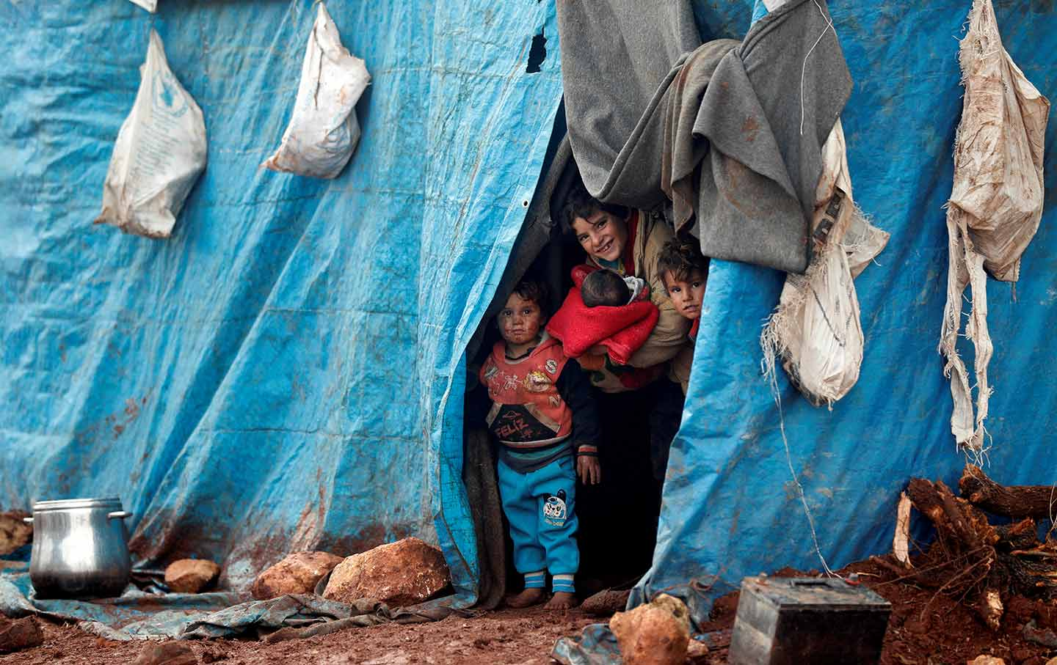
Reason for Choosing This Project
We chose the "Humanitarian Aid Tracking System in Palestinian Camps" project due to a strong feeling of responsibility to the complex humanitarian situation endured by Palestinian camp refugees especially amid persistent crises, closures, displacement, and insecurity. Thousands of Palestinian refugees live in overcrowded and poorly equipped camps without any digital system to ensure equitable, efficient, and transparent humanitarian aid delivery.
According to the most recent UNRWA reports, there are over 5.9 million registered Palestinian refugees, and over 1.5 million reside in 58 recognized camps in Palestine, Jordan, Lebanon, and Syria. In Gaza alone, there are approximately 1.42 million refugees in the Strip, and approximately 594,000 of them (41.8%) are concentrated in the eight main camps. In the West Bank, there are around 847,000 registered refugees, out of which more than 256,000 reside in 19 camps. Further, more than 80% of the Palestinian refugees in Lebanon are in poverty, and more than 420,000 in Syria rely on regular support because of conflict and displacement. In the aftermath of the latest Gaza war, more than 1.9 million people were displaced internally, and nearly 500,000 are facing famine as of 2024.
We saw that most of the aid delivery systems in these environments remain manual or isolated and have the tendency to result in disorganization, duplication of effort, or exclusion of the most vulnerable. This erodes donor trust and overall humanitarian efficiency. Accordingly, we were driven by urgency to develop an integrated, credible database system capable of helping stakeholders—NGOs, workers, and donors—better organize and unveil aid activities so that the right recipients receive the aid.
When you look at numbers like these and take into account the scope of suffering they cover, you can't help but pause. Being Palestinian ourselves, we feel it's our responsibility to act—to do something, anything. This project is our humble attempt at doing what we can. Beyond its technical scope, we hope it will be the basis for more sweeping, more helpful solutions in the field of humanitarianism, applying information technology to national resilience and justice

Introduction
Palestinian refugee camps face ongoing humanitarian challenges that require well-organized and efficient aid interventions from both local and international organizations. As the number of beneficiaries grows and the types of aid become more diverse—ranging from food and healthcare to financial and educational support—it becomes essential to develop a structured system for tracking and managing humanitarian assistance.
This project presents a significant step toward digitizing humanitarian aid management by designing a relational database that records beneficiary data, tracks aid types and quantities, links distributions to donors, campaigns, staff, and locations, and provides a centralized source of accurate and up-to-date information.
The importance of this database lies in its ability to support data-driven decision-making. It allows for the generation of meaningful reports and realistic estimations about aid needs, distribution gaps, and beneficiary coverage. As a result, aid organizations can better prioritize and coordinate their efforts, ensuring fair and effective delivery of resources.
Moreover, this system provides a historical record of distributions and feedback, enhancing transparency and accountability to donors and stakeholders. It also enables future research, planning, and performance evaluations, helping to build a more resilient and responsive humanitarian framework in Palestinian camps.

Problem Statement
In many Palestinian refugee camps, the process of distributing humanitarian aid is plagued by several critical challenges. These include the absence of a centralized tracking system, reliance on manual or fragmented records, lack of coordination between aid providers, and insufficient documentation of beneficiary needs. As a result, aid distribution often suffers from inefficiencies, duplication of efforts, resource wastage, and in some cases, the exclusion of vulnerable individuals or families.
Without an organized digital system, it becomes difficult to monitor aid flow, assess the real needs of each camp, or generate meaningful reports for donors and decision-makers. Furthermore, the lack of accurate historical records limits the ability to evaluate the effectiveness of aid campaigns and make informed future planning decisions.
This project addresses these issues by developing a comprehensive database system designed to manage and track humanitarian aid operations in Palestinian camps. By providing a structured, transparent, and scalable solution, the system aims to improve aid delivery, ensure fairness, and support data-driven humanitarian response strategies.

Requirements

Functional Requirements
- Beneficiary Registration
  - Record personal information for each beneficiary, including full name, gender, date of birth, phone number, and address.
  - Link each beneficiary to a specific camp and family.

- Family Management
  - Define family profiles, including head of family, number of members, and notes.
  - Associate multiple beneficiaries with their respective family.

- Camp Management
  - Store details about each camp (name, location, population).

- Aid Type Definition
  - Define various aid types (e.g., food, medicine, cash, clothes) with descriptions.

- Aid Provider Registration
  - Register aid providers (e.g., NGOs, local/international organizations) and their contact information.

- Campaign Management
  - Create aid campaigns with title, start/end dates, and description.

- Donation Recording
  - Log donations, linking them to specific campaigns and providers, along with amount and date.

- Aid Distribution Tracking
  - Track each aid delivery, including who received it, what was delivered, by which provider, under which campaign, by which staff member, and at what location.

- Inventory Management
  - Manage available stock of each aid type, track quantities, and log last update.

- Staff Management
- Maintain records of staff members, their roles, contact info, and link them to distributions and feedback handling.

- Distribution Location Management
- Define and manage physical locations where aid is distributed.

- Feedback Collection
- Allow beneficiaries to submit complaints or suggestions, and track how staff handle these reports.

Non-Functional Requirements
- Offline Access
  - The system should work without internet connectivity due to unstable infrastructure in camps.

- Data Security
  - Personal and aid-related data should be securely stored and only accessible to authorized users.

- User-Friendly Interface
  - The interface should be simple and intuitive for NGO staff and volunteers with minimal technical knowledge.

- Scalability
  - The system should support multiple camps, large numbers of beneficiaries, and growing data over time.

- Data Integrity
  - The system must ensure consistent and accurate linking of beneficiaries, aid records, and donations

ER Diagram

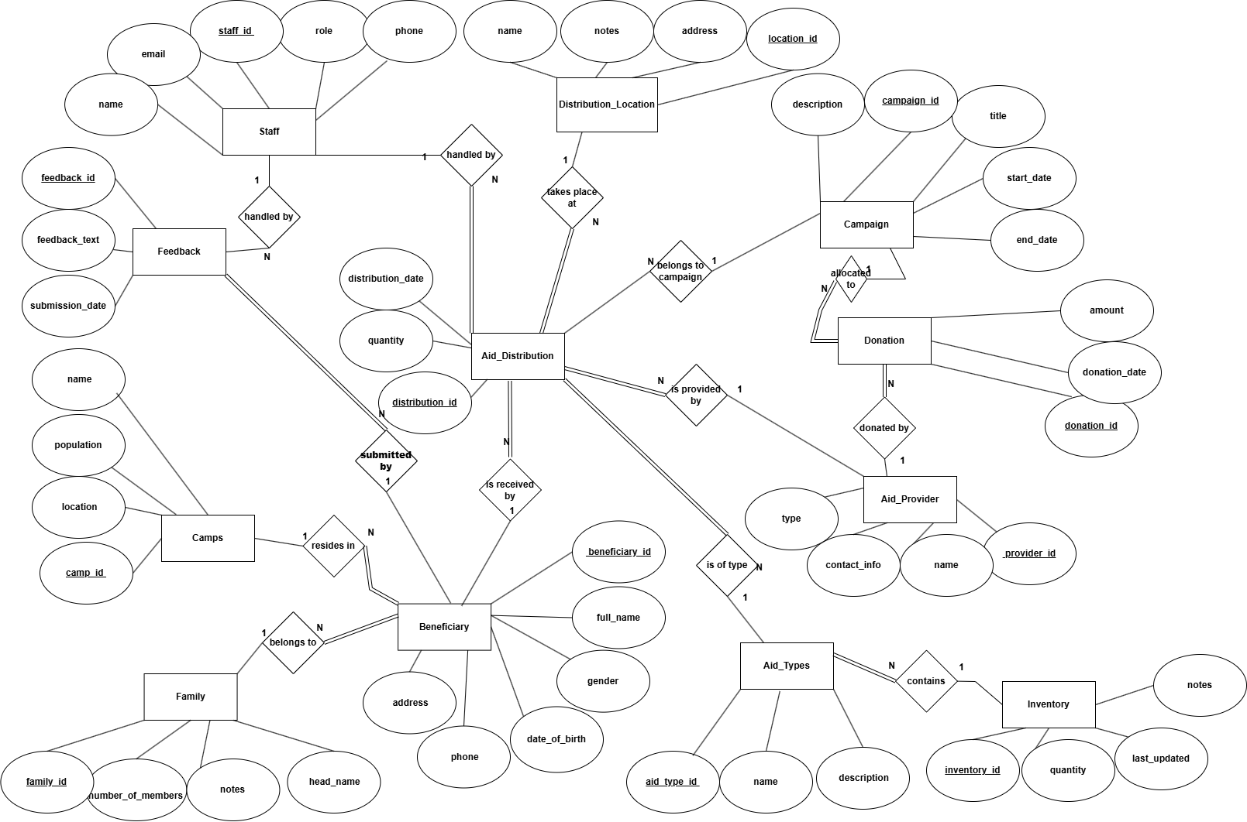

Relational Schema
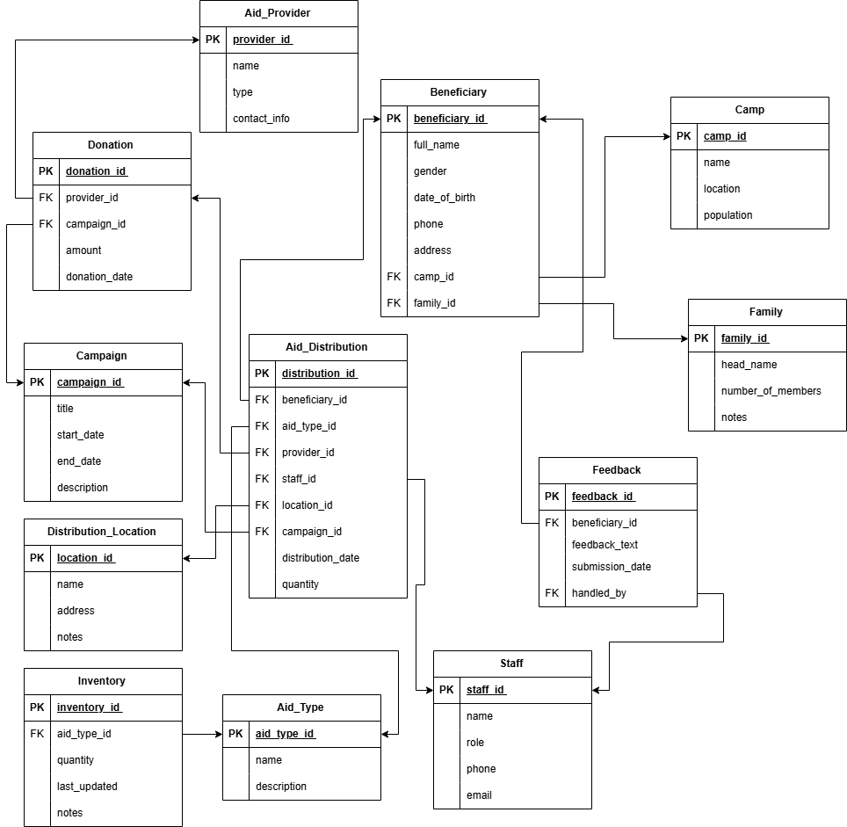

Functional Dependency:
Table Name | Primary Key | Full Functional Dependencies (FD) | Partial Dependency
Aid_Provider | provider_id | provider_id → name, type, contact_info | None (No Partial)
Donation | donation_id | donation_id → provider_id, campaign_id, amount, donation_date | None (No Partial)
Campaign | campaign_id | campaign_id → title, start_date, end_date, description | None (No Partial)
Distribution_Location | location_id | location_id → name, address, notes | None (No Partial)
Inventory | inventory_id | inventory_id → aid_type_id, quantity, last_updated, notes | None (No Partial)
Aid_Type | aid_type_id | aid_type_id → name, description | None (No Partial)
Beneficiary | beneficiary_id | beneficiary_id → full_name, gender, date_of_birth, phone, address, camp_id, family_id | None (No Partial)
Family | family_id | family_id → head_name, number_of_members, notes | None (No Partial)
Camp | camp_id | camp_id → name, location, population | None (No Partial)
Aid_Distribution | distribution_id | distribution_id → beneficiary_id, aid_type_id, provider_id, staff_id, location_id, campaign_id, distribution_date, quantity | None (No Partial)
Feedback | feedback_id | feedback_id → beneficiary_id, feedback_text, submission_date, handled_by | None (No Partial)
Staff | staff_id | staff_id → name, role, phone, email | None (No Partial)

Normalization
Normalization is the process of arranging data in a database to avoid duplication and keep the data accurate and organized. The most common normal forms are:
- First Normal Form (1NF):
Ensures that each column contains only single, simple values and that every row is unique using a primary key.
- Second Normal Form (2NF):
Achieved when the table is in 1NF and all columns fully depend on the entire primary key, not just a part of it.
- Third Normal Form (3NF):
Reached when the table is in 2NF and all columns depend directly on the primary key, without relying on other non-key columns.
In our project, there was no need to manually normalize the data because each table was organized and there were no duplications between tables.

Challenges
A number of challenges were encountered in the course of designing the Humanitarian Aid Tracking System for Palestinian camps that would affect the implementation and sustainability of the system over the long term.

Collection Challenges: Collection of accurate and timely information on the beneficiaries within refugee camps is typically hindered by the lack of documentation, population movement, or privacy.

Limited Internet Connectivity: All the camps have limited or no internet connectivity, and therefore the system must have the ability to function in an offline situation or accommodate local storage.

Resource Limitations: Humanitarian NGOs operate with limited technical capacity, budget, and manpower, and therefore mass adoption of a system may be subject to time lag.

Data Confidentiality and Security: Since the system holds sensitive information about people and families, adequate data protection and control over access are of utmost priority.

Stakeholder Coordination: Coordination between different NGOs, donors, and camp staff has to be standardized procedures, which might not yet exist in most field operations.

Despite such limitations, the system outlined here establishes a good foundation for strengthening aid delivery and offers an answer that is scalable and can evolve with increasing future resources and demands

Future Enhancements
Although the current Humanitarian Aid Tracking System provides a solid foundation for managing aid distribution in Palestinian camps, there are many opportunities for improvement and development in the future:

- Mobile Application Integration: Developing a mobile app that enables field staff and volunteers to record distribution activities and beneficiary data in real-time, even in offline mode, which enhances data accuracy and updates.

- Advanced Reporting and Analytics: Implementing dashboards and data visualization tools that provide deeper insights into aid distribution patterns, resource utilization, and beneficiary needs, aiding decision-makers.

- Integration of Location Tracking on Maps: Adding the ability to identify the locations where aid has been delivered through pins on digital maps, facilitating geographic tracking of distributions and precise analysis of targeted areas.

Conclusion
The Humanitarian Aid Tracking System for Palestinian refugee camps provides a concrete, scalable solution to chronic problems of aid distribution and beneficiary management. Utilizing a relational database architecture, the system allows for open tracking of aid deliveries, accurate documentation of beneficiaries, and increased coordination among aid providers and staff.

With this system, stakeholders can prepare real-time reports, identify distribution gaps, and plan future campaigns based on sound data. It enhances operation effectiveness as well as facilitates accountability and credibility with donors and the general population.

In a world where resources are limited but demands are high, this project demonstrates the importance of leveraging technology and structured data towards spearheading fair, efficient, and effective humanitarian action.

