FastAPI - Salesforce AI Builder Interview Cheat Sheet
Only what you are likely to need in a customer-scenario Builder Lab

1. Mental model
FastAPI is the HTTP layer. It receives requests, validates inputs through Pydantic, calls your application logic, and returns JSON responses.
HTTP request
↓
FastAPI route
↓
Pydantic validation
↓
service / business logic
↓
CRM / tool / LLM
↓
HTTP response

2. Minimal application
from fastapi import FastAPI
app = FastAPI()
@app.get("/")
def root():
return {"message": "Hello"}
Run:
uvicorn app.main:app --reload
Interactive docs: http://127.0.0.1:8000/docs

3. HTTP methods
Method | Typical use
GET | Read data
POST | Create or trigger an action
PATCH | Partially update
PUT | Replace
DELETE | Delete

4. Path parameters
@app.get("/customers/{customer_id}")
def get_customer(customer_id: str):
return {"customer_id": customer_id}
A value inside { } in the route is a path parameter.

5. Query parameters
@app.get("/customers")
def list_customers(limit: int = 10, active: bool = True):
...
Example: /customers?limit=20&active=true

6. Request body with Pydantic
from pydantic import BaseModel
class UpgradeRequest(BaseModel):
customer_id: str
new_plan: str
@app.post("/upgrade")
def upgrade(request: UpgradeRequest):
return {
"customer_id": request.customer_id,
"new_plan": request.new_plan,
}
Rule of thumb: path value -> path parameter; simple parameter not in the path -> query parameter; BaseModel -> JSON body.

7. Response models
class UpgradeResponse(BaseModel):
success: bool
customer_id: str
plan: str
@app.post("/upgrade", response_model=UpgradeResponse)
def upgrade(request: UpgradeRequest):
...
A response model documents and validates the output contract.

8. HTTPException
from fastapi import HTTPException
if customer is None:
raise HTTPException(
status_code=404,
detail="Customer not found",
)
Use raise HTTPException(...), not return HTTPException(...).

9. Status codes to know
Code | Meaning
200 | Success
201 | Created
204 | Success, no body
400 | Bad request
401 | Not authenticated
403 | Forbidden
404 | Not found
409 | Conflict
422 | Validation error
500 | Internal server error

10. Keep business logic out of routes
# main.py
@app.post("/upgrade")
def upgrade(request: UpgradeRequest):
success = upgrade_customer_plan(
request.customer_id,
request.new_plan,
)
...
main.py -> HTTP layer
models.py -> Pydantic contracts
services.py -> business rules
crm.py -> data access
agent.py -> AI reasoning / tool selection

11. def vs async def
@app.get("/")
def sync_endpoint():
...
@app.get("/external")
async def async_endpoint():
result = await external_api_call()
return result
Use async def when you actually await asynchronous I/O. A simple in-memory dictionary does not need async.
Async def = fonction qui peut suspendre son exécution pendant qu’elle attend une opération lente, pour laisser le serveur faire autre chose entre-temps.
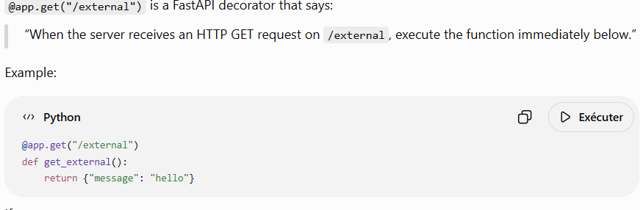

12. Depends: dependency injection
from fastapi import Depends
def get_current_user():
...
@app.get("/profile")
def profile(user = Depends(get_current_user)):
...
Typical uses: authentication, database sessions, current user, shared services, API keys. back

13. Testing with TestClient
from fastapi.testclient import TestClient
from app.main import app
client = TestClient(app)
def test_get_plan():
response = client.get("/customers/C01/plan")
assert response.status_code == 200
data = response.json()
assert data["customer_id"] == "C01"
response = client.post(
"/upgrade",
json={
"customer_id": "C01",
"new_plan": "Plus",
},
)
In a timed lab, a few focused tests are much better than no tests.

14. FastAPI + LLM / agent pattern
Customer request
↓
FastAPI endpoint
↓
Pydantic request model
↓
Agent / LLM decides action
↓
Pydantic validates tool arguments
↓
service enforces business rules
↓
CRM / external API
Key interview point: the LLM may select an action, but authorization and business invariants should remain deterministic.

15. Typical AI endpoint
class ChatRequest(BaseModel):
customer_id: str
message: str
class ChatResponse(BaseModel):
success: bool
message: str
@app.post("/chat", response_model=ChatResponse)
def chat(request: ChatRequest):
return agent.handle(request)

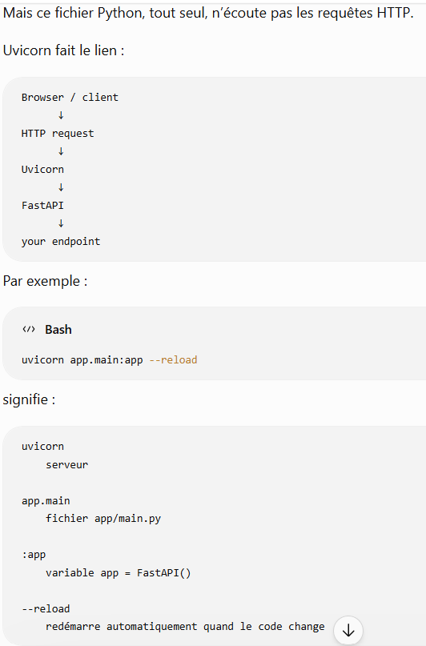
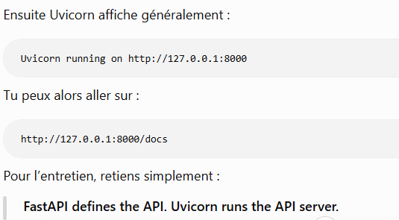

16. Common timed-lab mistakes
- Putting all business logic directly inside main.py.
- Returning {"error": ...} with HTTP 200 instead of using an appropriate error code.
- Trusting raw LLM output before validation.
- Using async everywhere without actually awaiting I/O.
- Over-engineering with routers or middleware before the happy path works.
- Forgetting to test the 404 / invalid-input path.

17. What to memorize
from fastapi import FastAPI, HTTPException
app = FastAPI()
@app.get("/customers/{customer_id}")
def get_customer(customer_id: str):
...
@app.post("/upgrade")
def upgrade(request: UpgradeRequest):
...
raise HTTPException(status_code=404, detail="Not found")
uvicorn app.main:app --reload
from fastapi.testclient import TestClient
client = TestClient(app)

18. Interview questions
What is FastAPI responsible for?
The HTTP/API boundary: routing, parsing requests, integrating validation, and producing responses.
Why Pydantic with FastAPI?
To define explicit request/response contracts and validate external data before it reaches business logic.
Path vs query vs body?
Path identifies a resource, query modifies or filters a request, and a Pydantic model usually represents a JSON body.
Why keep services.py separate?
So HTTP concerns stay separate from deterministic business rules, making the code easier to test and reuse.
Why validate LLM tool calls?
Because LLM output is non-deterministic; malformed or unsupported arguments must not reach real tools unchecked.

19. Priority for this Builder Lab
Know well:
- FastAPI()
- @app.get / @app.post
- path and query parameters
- Pydantic request bodies
- response models
- HTTPException
- common status codes
- /docs
- TestClient
Understand conceptually:
- async / await
- Depends
- APIRouter
- CORS
Not a priority unless explicitly needed:
- WebSockets
- custom middleware
- OAuth2 flows
- custom OpenAPI
- advanced background tasks

