



Department of Computer Science
Due date: 21/02/2023
Imam Mohammad Ibn Saud Islamic University
Project#1
Ministry of Higher Education
AI640 – Advanced Computational Tools

Name: Hadeel Abdullah Alshehri | 444008923

Arabic Sentiment Analysis Using different version of BERT
Abstract
Arabic sentiment analysis is the process of computationally identifying and categorizing opinions expressed in a piece of arabic text, especially in order to determine whether the writer's attitude towards a particular topic, product, etc. is positive, negative, or neutral.
1- Introduction
During the last two decades, work on subjective language processing has been very common in literature. The work on sentiment analysis was a major theme that was pursued during this time. Sentiment analysis is a task of natural language processing which has recently attracted increasing attention. Arabic sentiment analysis is the process of computationally identifying and categorizing opinions expressed in a piece of arabic text, especially in order to determine whether the writer's attitude towards a particular topic, product, etc. is positive, negative, or neutral.
The reoprt ordered in the following manner: The problem statement, along with details of the ArSarcasm-v2 dataset are presented in Section 2. The methodology that we propose as our solution is described in Section 3. The experiments which were carried out, dataset statistics, system settings and results of the experiments are provided in Section 4.

2 - Task Definition
The sentiment Analysis is based on a text classification problem, the aim is to identify the sentiment of a tweet by assigning one of three labels (Positive, Negative, Neutral). Given a tweet, the task is to return POS if the tweet has a positive sentiment, NEG if the tweet has a negative sentiment or NEU if the tweet has a neutral sentiment. This is a multiclass classification problem. Precision/Recall/F-score/Accuracy are the evaluation metrics. On this task three data set have been used ArSarcasm-v2, Saudi data and SemEval 2017.

The ArSarcasm-v2 based on identifying sentiment and sarcasm in Arabic tweets. The data set contain five dialect (MSA, Gulf, Egypt , levant and Magreb ) The provided datasets have a total of 12,548 tweets respectively. https://github.com/iabufarha/ArSarcasm-v2
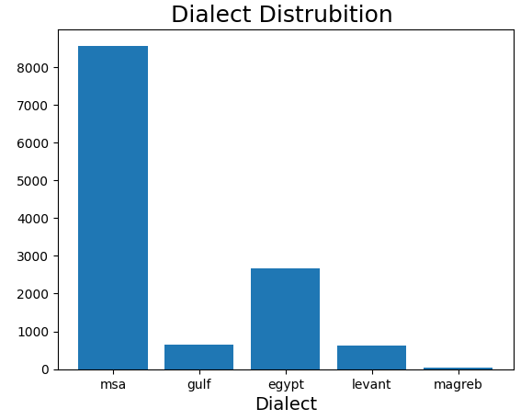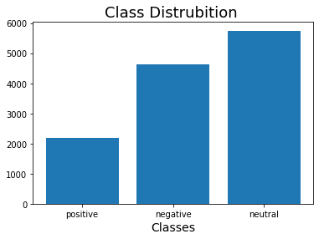

The Saudi data The Saudi banks' corpus data were collected from Twitter using Tweepy python library. We used the banks' Twitter account mentions of the four Saudi banks to retrieve the tweets. This dataset contains customers’ sentiments on Twitter toward four Saudi Banks (AlRajhi bank, Alinma bank, Saudi National Bank (SNB), and Saudi Investment Bank (SAIB)) . A total of 12k tweets 8,669 of them is labeled as "Negative", 2,143 is labeled as "Positive", and 1,236 tweets is labeled as "Neutral". https://github.com/iwan-rg/Saudi-Bank-Sentiment-Dataset

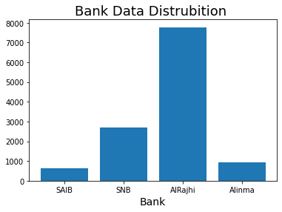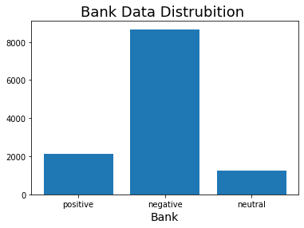
3 - Methodology
This section describes the process we employed to tackle the task. The process is divided into two
steps: data preprocessing and transformer based models application. The first step involves processing
the provided ArSarcasm-v2 dataset to convert it into a format better processed by the models.
The second step involves experimenting with different BERT version models to decide which model performs the best for the ArSarcasm-v2 dataset. Details about these steps have been provided in the following sub-sections.

3.1 Data Pre-Processing
Employing different preprocessing techniques to clear the noise on data, So that the transformer based models only receive the relevant features. These techniques are as follows:
- Cleaning the data
- Remove HTML line breaks and markup, unwanted characters like symbols (? : . )
- Insert whitespace on all non- Arabic digits or English Digits and Alphabet.
- remove all Hashtags symbols with [#].

Before | After

- Segmentation
Perform ArabertPreprocessor segmentation.

Before | After

3.2 Transformer Based Models
Transformer and BERT fases -----

3.2.1 AraBERT
Pre trained to handle Arabic text, AraBERT is a language model that is inspired from the Google’s BERT architecture. AraBERT uses the same BERT-Base config. Two Arabic bert have been used fast AraBERt and mini AraBERT

  - Fast AraBERT

  - Mini Ara BERT
Arabic-bert-mini model was pretrained on ~8.2 Billion words: Arabic version of OSCAR - filtered from Common Crawl, Recent dump of Arabic Wikipedia
and other Arabic resources which sum up to ~95GB of text.

3.2.2 MarBERT

MARBERT is a large-scale pre-trained masked language model focused on both Dialectal Arabic (DA) and MSA. Arabic has multiple varieties. To train MARBERT, we randomly sample 1B Arabic tweets from a large in-house dataset of about 6B tweets. We only include tweets with at least 3 Arabic words, based on character string matching, regardless whether the tweet has non-Arabic string or not. That is, we do not remove non-Arabic so long as the tweet meets the 3 Arabic word criterion. The dataset makes up 128GB of text (15.6B tokens). We use the same network architecture as ARBERT (BERT-base), but without the next sentence prediction (NSP) objective since tweets are short.

4- Experiments

The AraSarcasesm data have been split to three set train (80 %) , evaluation (10%) and test(10 %).This is followed by experimenting with three transformer based models, for which performance on
the testing predication is compared. The pre-trained models are fine-tuned on the training split and metrics
for the testing set are calculated. After fine tune the fast AraBert on AraSarcasesm we will prediact the Saudi data with same parameter .This section includes the dataset distribution, system settings, results and a brief analysis of the system.
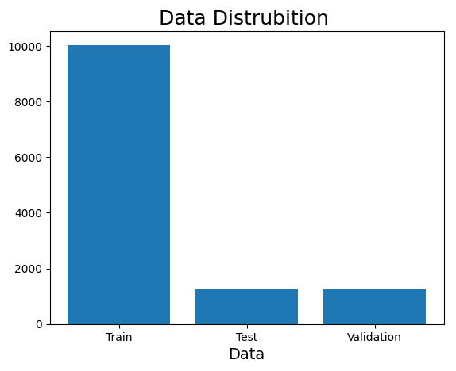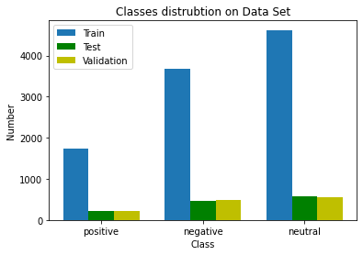

4.1 Dataset
Tables 2 and 3 show the class wise distribution of the 80:10:10 train, val and Test splits created from
the provided ArSarcasm-v2 dataset, for the sentiment detection which has classlabels negative, neural and positive.
Figure --- shows the class distribution for saudi Dataset.

4.2 System Settings
We make use of hugging-face1 API to fetch the pre-trained AraBERT and min Ara BERT models.

Parameter | Fast AraBERt | Mar Arbert | Mini AraBert
Optimizer | AdamW | AdamW | AdamW
Epsilon (Adam optimizer) |  | 1e-8 | 1e-8
Learning Rate | 2e-5 | 1.215e-05 | 5e-5
Batch Size | 16 | 16 | 16
#Epochs | 5 | 5 | 4
Logging steps |  | 200

4.3 Results and Analysis
This section provides the detailed results obtained on the on AraSarcasesm test sets and Saudi data set.

4.3.1 AraSarcasesm Test data set
------------------------ Accuracy/loss def and Equation

Matrix | Fast Ara BERT | Mar BERT | Mini AraBert
Accuracy | 71 % | 62 % | 61 %
Loss | 0.4191 | 0.967 | 0.7179

Confusion matrix

Fast Ara BERT | Mar BERT | Mini AraBert
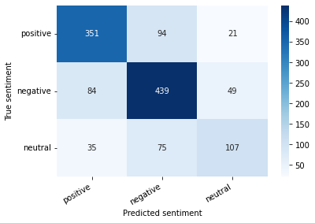 | 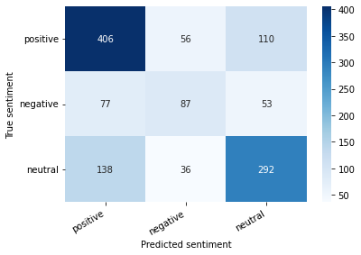 | 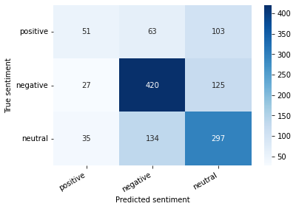
MISS Match Cases
Positive Cases labeled as Negative | Neutral cases labeled as Positive | Positive Cases labeled as Neutral
" اللهم لا ترحم كل من ساهم ب إيذاء أطفال سوري... | " فيديو حصري ملكةالمسرح ميريامف ارس من حفل زفاف...
Negative Cases labeled as Positive | Positive Cases labeled as Neutral | Negative Cases labeled as Neutral
" من قايل لجراح الهبيده انك حلو ؟... | مع ال شخص ال صح

4.3.2 Saudi Data Set vs Aracsesm Data Set

------------------------
Matrix | Aracsesm | Saudi Data
Accuracy | 71 % | 68 %
Loss | 0.4191 | 0.4657

