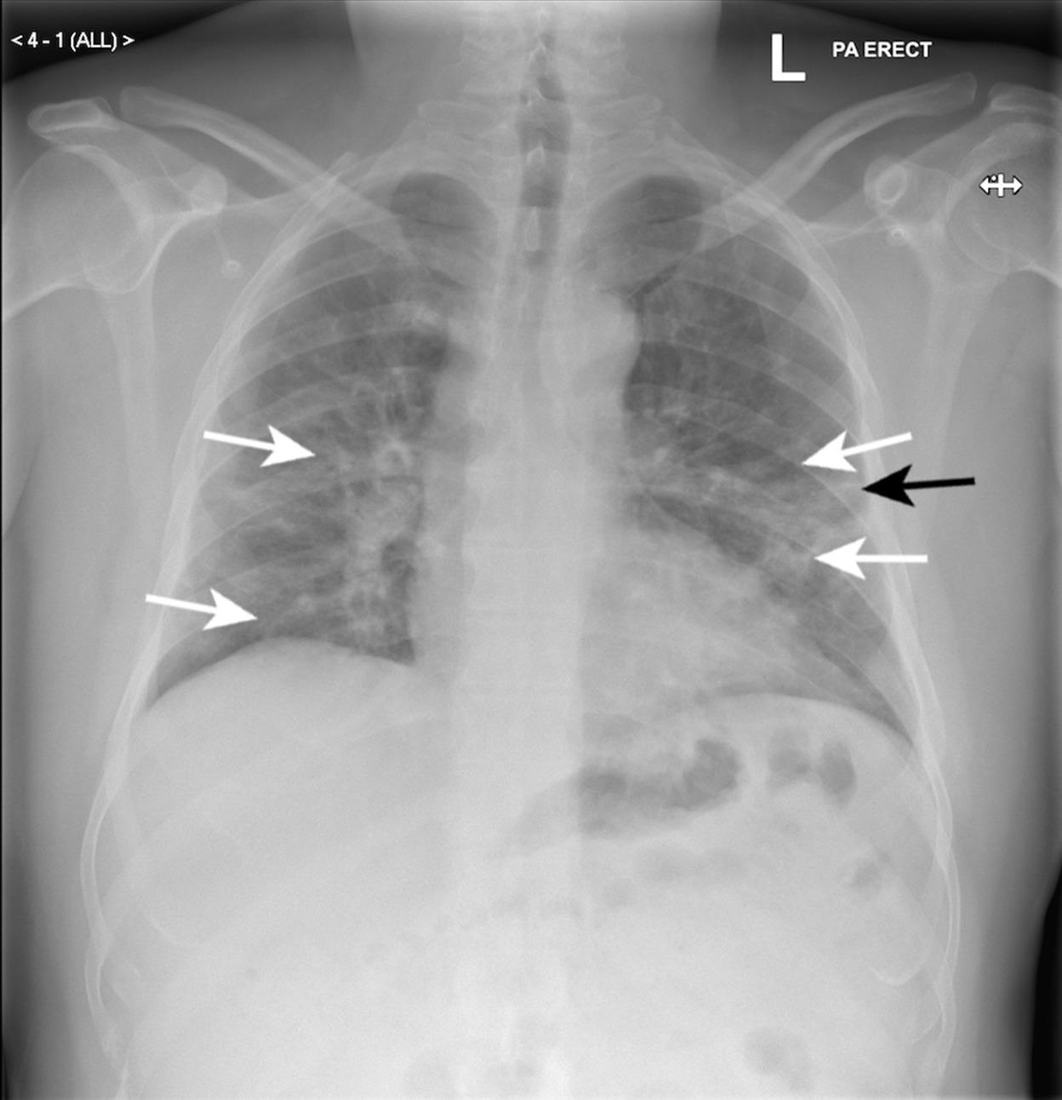

# Indications

Correlation with the patient's clinical presentation and laboratory findings is recommended.  
  
Further evaluation, including a clinical examination and appropriate microbiological studies, should be performed to confirm the diagnosis and guide management.

# Findings

The chest X-ray demonstrates patchy opacities and consolidation in the right middle and lower lung zones. These opacities are characterized by increased density and blurred margins, suggestive of airspace consolidation. No pleural effusion is noted. The heart size and pulmonary vasculature appear within normal limits.

# Impression

Chest X-ray findings highly suggestive of right middle and lower lobe pneumonia.  
  
No evidence of pleural effusion or other significant complications identified.

# Recommendations

Consultation with a pulmonologist or infectious disease specialist for further evaluation and management.  
  
Initiation of appropriate antibiotic therapy based on the suspected etiology and local resistance patterns.  
  
Repeat imaging (e.g., chest X-ray or CT scan) may be considered to monitor response to treatment or detect complications if warranted.

# AI Pneumonia Diagnosis

The classification of the scan is "PNEUMONIA" with "99.69925880432129" % confidence