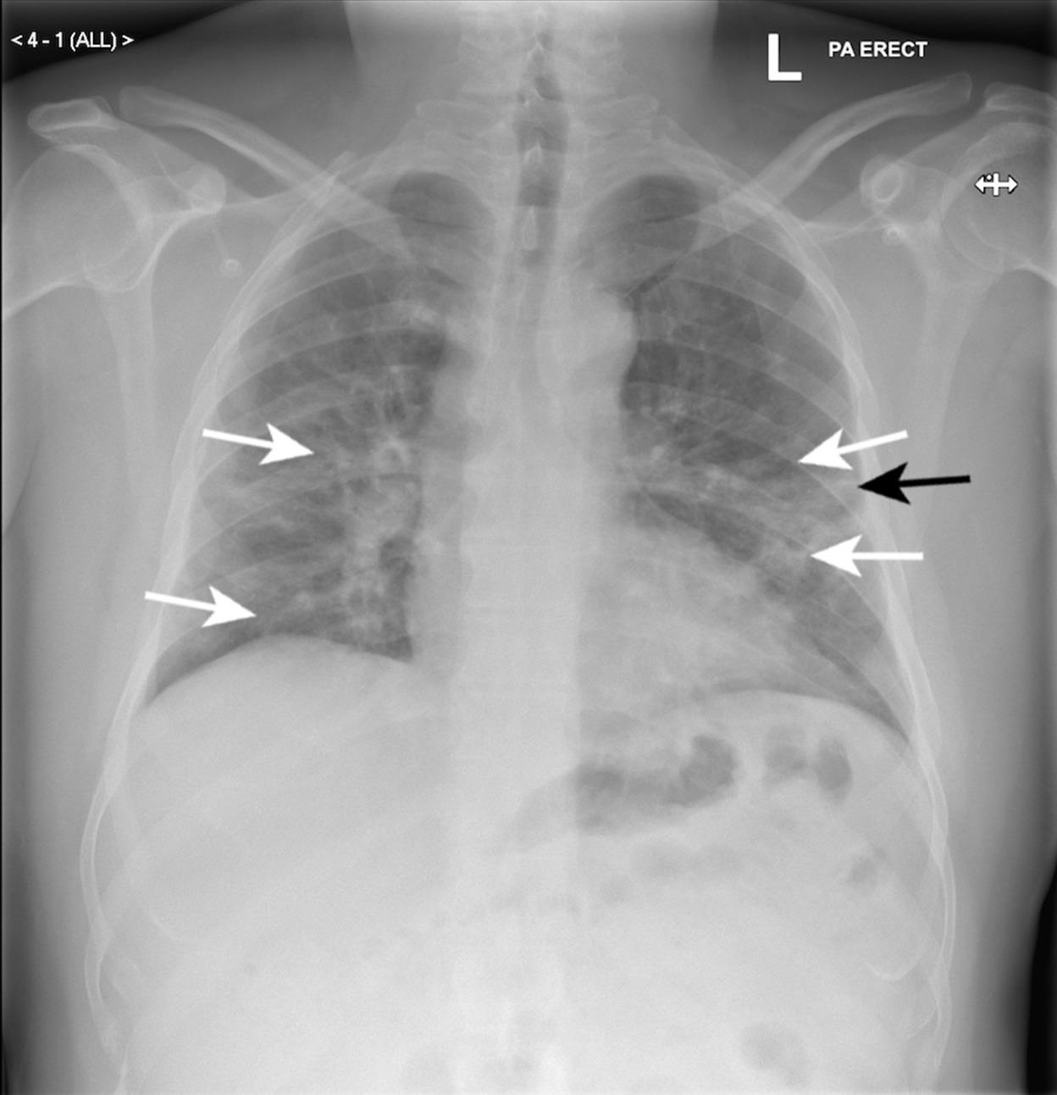

# Indications

The patient presents with a persistent cough, shortness of breath, and fever for the past three days.

# Findings

On physical examination, the patient appears fatigued and has a temperature of 101.2°F. The lungs exhibit decreased breath sounds and dullness to percussion at the right base. There are crackles audible on inspiration, and the oxygen saturation level is 92% on room air. The chest X-ray reveals consolidation of the right lower lobe with air bronchograms, which is indicative of pneumonia.

# Impression

The clinical presentation, physical examination, and radiographic findings suggest that the patient has community-acquired pneumonia, likely caused by a bacterial infection. The patient should be closely monitored for signs of respiratory distress, and follow-up evaluation should be performed to assess response to therapy and the need for further intervention.

# Recommendations

The patient should undergo further diagnostic testing, including a complete blood count and blood cultures, to identify the causative organism. Empiric antibiotic therapy should be initiated with amoxicillin/clavulanate or levofloxacin. The patient should also receive supportive care, including oxygen supplementation, hydration, and pain management.

# AI Pneumonia Diagnosis

The classification of the scan is "PNEUMONIA" with "99.69925880432129" % confidence