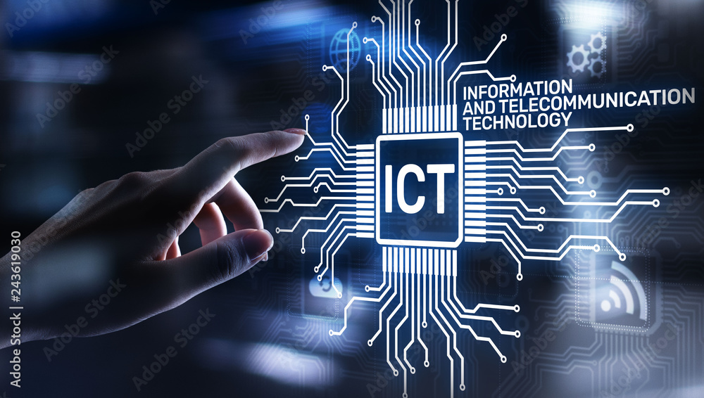

Exploring Information and Communication Technologies (TIC)

An In-depth Analysis of Google Services, Microsoft Tools, Git, and GitHub

Created by :

* Hadil DEBBA

Table of content

1.2|Overview of Information and Communication Technologies : 4

▪ 2.1 Telecommunication Systems 7

▪ 2.2 Data Networks and Internet Technologies 7

▪ 2.3 Computing Technologies 7

3.1 Impact on Communication 8

3.2 TIC in Business and Industry 8

3.3 Educational Applications 8

3.4 Healthcare and TIC 8

4.1.Infrastructure of ICT Systems: 9

4.2.Architecture of ICT Systems: 9

Characterizing ICT 10

Description 10

Advancements 10

Speed 10

Miniaturization 10

Affordability (Cost, User-Friendliness) 10

5.Characterizing ICT as a General Phenomenon: 10

Power and Capability 10

Multichannel 10

6.1 Google Services 11

6.1.1 Introduction to Google Services 11

6.2 Microsoft Tools 12

6.2.1 Overview of Microsoft Tools 12

6.2.2 Role in Productivity and Collaboration 12

6.2.3 Importance in Business Environments 12

6.2.4Updates and Recent Developments 12

6.3 Git and GitHub 13

6.3.1 Introduction to Version Control with Git 13

6.3.2 Collaborative Software Development using GitHub 13

6.3.3 Importance in Open Source Projects 13

6.3.4 Git Workflow and Best Practices 13

7.1 Emerging Technologies in TIC 14

7.2 Artificial Intelligence and Machine Learning 14

7.3 IoT (Internet of Things) Integration with TIC 14

7.4 Predictions for the Future of TIC 14

" Our technology has exceeded our humanity."

Albert Einstein

1.Introduction :

1.1|Definition :

1.1.1. Information:

From a technical standpoint, information is a sign, a symbol, an element that can be transmitted and stored. In terms of intelligence, it refers to data that provides knowledge or information about an object or an event.

1.1.2. Communication:

Communication is the way information circulates. It occurs through a network that includes at least a sender, a transmission channel, and a recipient

1.1.3. Technology:

Technology is the application of a design technique to the realization of a product.

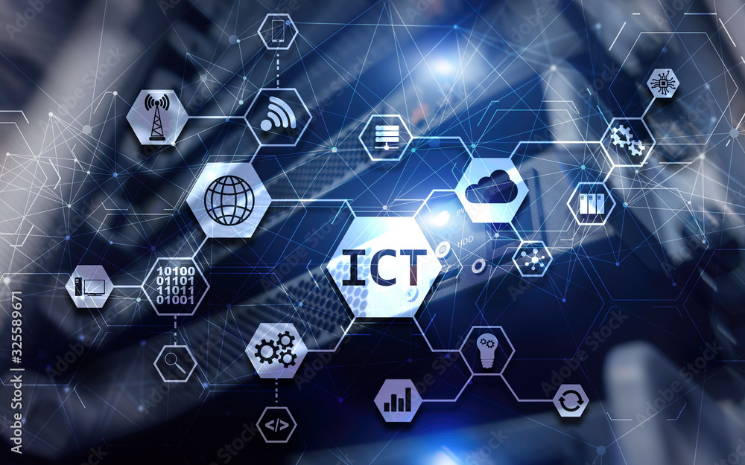

Information and Communication Technologies (ICT) represent a broad spectrum of technologies that play a pivotal role in shaping the modern world. At its core, ICT encompasses the convergence of telecommunication, computing, and information systems to facilitate the acquisition, storage, processing, and dissemination of information. In the contemporary landscape, the seamless integration of these technologies has transformed the way individuals, businesses, and societies interact and function.

**1.2|Overview of Information and Communication Technologies :**

**1.3|Significance and Impact on Modern Society 1.4|** The evolution of Information and Communication Technologies (ICT) :

The evolution of Information and Communication Technologies (ICT) is a fascinating story that spans several decades. Here is a detailed overview of the history of ICT, from its beginnings to the present day:

**The Beginnings (1940s-1950s):**

The first electronic computers were developed during World War II. ENIAC, completed in 1945, was one of the first programmable computers.

Communication was primarily based on analog transmission systems, such as telephone lines.

**The Rise of Personal Computing (1960s-1970s):**

The 1960s witnessed the emergence of mini-computers, allowing some companies to have their own computer systems.

The 1970s saw the creation of the first personal computers, such as the Altair 8800.

**The Era of Microcomputing (1980s):**

The introduction of microprocessors led to the miniaturization of computers, making technology more accessible to the general public.

The advent of Graphical User Interfaces (GUI) facilitated computer usage.

**The Internet Revolution (1990s):**

The 1990s marked the popularization of the Internet, making global communication faster and more accessible.

The emergence of the World Wide Web (WWW) transformed how information was shared.

**The Rise of Digital Technologies (2000s):**

Digital technologies took precedence, with the proliferation of mobile devices, digital cameras, and electronic storage systems.

The advent of broadband improved data transmission speed.

**The Era of Social Media and Cloud Computing (2010s):**

Social media transformed personal and professional communication.

Cloud storage provided a convenient alternative for storing and accessing data from any Internet-connected device.

**Artificial Intelligence and the Internet of Things (2020s and Beyond):**

AI gained prominence, fueling applications such as voice recognition, automatic translation, and chatbots.

The Internet of Things (IoT) connected physical devices to the Internet, paving the way for greater automation and interconnectivity.

This historical journey showcases the continuous advancement of ICT, shaping the way we communicate, work, and interact with technology in an ever-evolving digital landscape.

The significance of ICT in contemporary society cannot be overstated. These technologies serve as the backbone of the digital age, fostering connectivity, innovation, and efficiency across various domains. From revolutionizing communication channels to empowering industries with data-driven insights, ICT has become an indispensable force driving societal progress. The ubiquity of smartphones, high-speed internet, and digital platforms has created a global network, fundamentally altering the way information is accessed, shared, and leveraged.

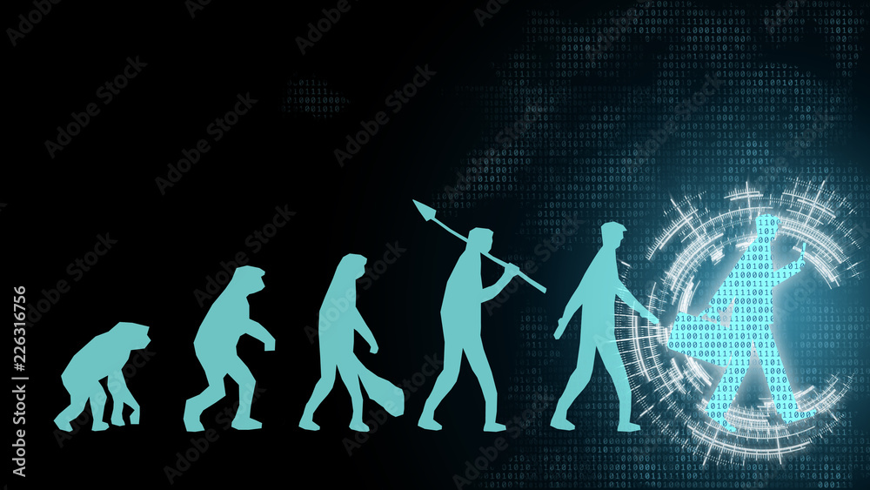

**The Rise of Digital Technologies (2000s):**

Digital technologies took precedence, with the proliferation of mobile devices, digital cameras, and electronic storage systems.

The advent of broadband improved data transmission speed.

**The Era of Social Media and Cloud Computing (2010s):**

Social media transformed personal and professional communication.

Cloud storage provided a convenient alternative for storing and accessing data from any Internet-connected device.

**Artificial Intelligence and the Internet of Things (2020s and Beyond):**

AI gained prominence, fueling applications such as voice recognition, automatic translation, and chatbots.

The Internet of Things (IoT) connected physical devices to the Internet, paving the way for greater automation and interconnectivity.

This historical journey showcases the continuous advancement of ICT, shaping the way we communicate, work, and interact with technology in an ever-evolving digital landscape.

2. Key Technologies in Information and

Communication

In the dynamic landscape of Information and Communication Technologies (TIC), several key technologies serve as the backbone, enabling the seamless flow of information across the globe. This section delves into three pivotal components: Telecommunication Systems, Data Networks and Internet Technologies, and Computing Technologies.

* 2.1 Telecommunication Systems
* Telecommunication systems are the foundation of modern communication, facilitating the exchange of voice, data, and multimedia over vast distances. These systems encompass a variety of technologies, including traditional telephony, mobile networks, and emerging technologies like 5G. The evolution from analog to digital transmission has significantly increased the efficiency and capacity of telecommunication networks. Fiber-optic cables, satellites, and wireless transmission play crucial roles in creating a robust and interconnected global communication infrastructure.
* 2.2 Data Networks and Internet Technologies
* Data networks and Internet technologies form the backbone of the digital age, providing the infrastructure for sharing information on a global scale. The Internet, a culmination of interconnected networks, has revolutionized how individuals access and exchange data. Protocols such as TCP/IP ensure reliable transmission, while routers and switches manage the flow of information. The advent of cloud computing has further transformed data storage and accessibility, allowing users to store and retrieve information seamlessly from remote servers.
* 2.3 Computing Technologies
* Computing technologies are at the heart of processing, analyzing, and managing vast amounts of data generated by various applications. This includes both hardware and software components. In recent years, the shift towards distributed computing, parallel processing, and edge computing has enhanced the capabilities of computing systems. Quantum computing, with its potential to solve complex problems exponentially faster than classical computers, represents the cutting edge of computational technology. Software developments, including artificial intelligence and machine learning algorithms, are reshaping how computers interpret and respond to data, opening new frontiers in automation and decision-making.

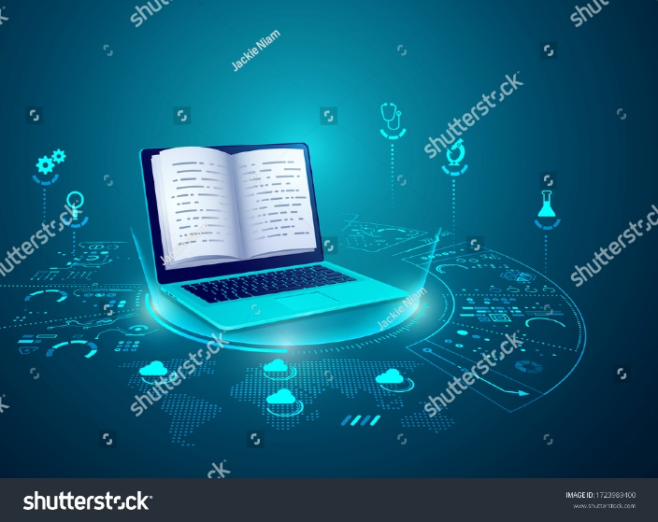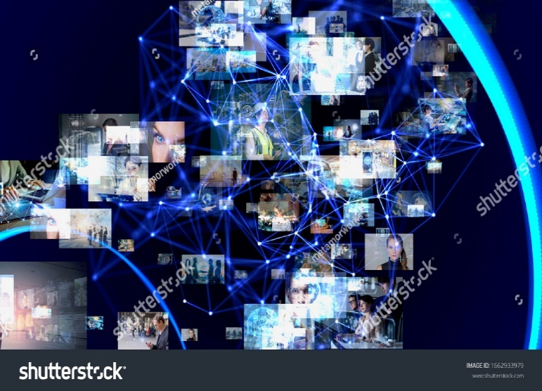

3. Applications of TIC in Society

3.1 Impact on Communication

TIC has transformed communication,

enabling global connectivity through

instant messaging, social media,

and video conferencing. It empowers

individuals to share ideas and experiences,

fostering cultural exchange.

3.2 TIC in Business and Industry

In business, TIC enhances efficiency

through ERP systems, reduces costs with

cloud computing, and improves

decision-making with big data analytics.

Technologies like IoT optimize supply chains,

ushering in a new era of smart industries.

3.3 Educational Applications

TIC revolutionizes education with e-learning

platforms, virtual classrooms, and adaptive

learning systems. It facilitates distance education,

collaboration, and personalized learning

experiences, expanding access to quality education.

3.4 Healthcare and TIC

In healthcare, TIC improves patient care through electronic health records,

telemedicine, and wearable devices. It enhances diagnostics and drug discovery.

treatment plans through the integration of artificial intelligence.

4. Infrastructure and Architecture of ICT Systems:

4.1.Infrastructure of ICT Systems:

The infrastructure of ICT systems comprises all the hardware, software, network, and services necessary for the proper functioning of information and communication technologies.

Hardware components include servers, computers, peripherals, storage devices, etc.

Software components encompass operating systems, applications, databases, and other software needed for information processing.

Networks are crucial to enable communication between different components of the infrastructure.

4.2.Architecture of ICT Systems:

The architecture of ICT systems involves the overall design and organization of components to meet the specific needs of the organization.

Well-designed architecture ensures optimal performance, adequate security, and scalability to adapt to future changes.

Architectures can be centralized, distributed, cloud-based, or hybrid depending on the requirements and goals of the organization.

The integration of ICT systems often involves development, implementation, and maintenance processes to ensure efficient operation.

5.Characterizing ICT as a General Phenomenon:

|  |  |
| --- | --- |
| Characterizing ICT | Description |
| Advancements | Additional Means: ICT brings us new means in addition to those we already had; new ways of communicating, expressing ourselves, creating, working, and learning. |
| Speed | Faster: What could be done before without Information and Communication Technologies (ICT) can now be done much more quickly with ICT, and still, always faster. |
| Miniaturization | Smaller: Miniaturization is an important characteristic of ICT; this is evident at both the device and information carrier levels, for example. |
| Affordability (Cost, User-Friendliness) | More Affordable: The cost of acquiring and using ICT seems to be constantly decreasing for a given level of usage, making them accessible to an ever-growing portion of the population, thereby providing powerful means to everyone (democratization of media). |
| Power and Capability | More Powerful, Larger: The capabilities of ICT tools (devices and software) are constantly expanding, allowing for maximum effect and output |
| Multichannel | Multichannel Nature: ICT utilizes three channels, namely the textual channel, the image channel, and the sound channel. The latter is less common. Textual Channel: Information regarding the use of CDs or websites, expositional type, narrative, articles, literary texts. Image Channel: Static, animated, synthetic, icons. Sound Channel: Music, songs,. |

6.Core technologies

 From the ubiquitous influence of Google Services and the productivity arsenal of Microsoft Tools to the collaborative prowess of Git and GitHub, we delve into the core technologies shaping our digital landscape.

6.1 Google Services

### 6.1.1 Introduction to Google Services

Google Services represent a comprehensive suite of web-based applications and tools offered by Google. These services are designed to enhance various aspects of digital life, providing users with innovative solutions for communication, productivity, and information retrieval.

**6.1.2 Key Offerings**

**a. Google Search**

Google Search is the cornerstone of Google's services, offering a powerful and intuitive search engine. It enables users to access a vast array of information, from websites to images and videos, making it an indispensable tool for knowledge retrieval.

**b. Gmail**

Gmail, Google's email service, has become a ubiquitous platform for electronic communication. Known for its user-friendly interface and robust features, Gmail facilitates efficient email management, communication, and collaboration.

**c. Google Drive**

Google Drive is a cloud-based storage solution that allows users to store, share, and collaborate on documents, spreadsheets, presentations, and more. Its integration with other Google services fosters seamless collaboration in real-time.

6.1.3 Integration Capabilities

One of the strengths of Google Services lies in their seamless integration. The interconnectedness of Google's ecosystem allows users to transition effortlessly between services, enhancing the overall user experience. For example, a document created in Google Docs can be easily shared via Gmail and stored on Google Drive.

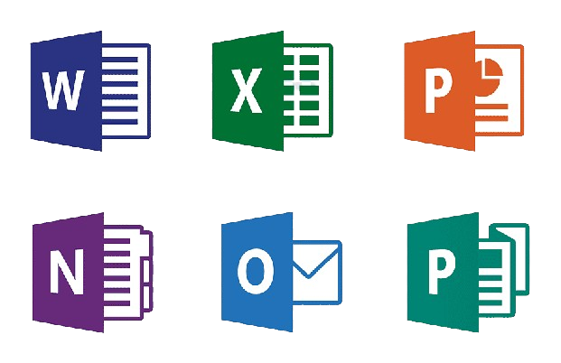

6.2 Microsoft Tools

6.2.1 Overview of Microsoft Tools

Microsoft Tools encompass a diverse range of software applications designed to enhance productivity, collaboration, and business operations. These tools, developed by Microsoft, are widely used in professional settings and have become integral to various industries.

6.2.2 Role in Productivity and Collaboration

Microsoft Tools, including the Office Suite (Word, Excel, PowerPoint, etc.) and Microsoft Teams, play a vital role in boosting productivity and fostering collaboration. The Office Suite provides a versatile platform for document creation, data analysis, and presentation design. Microsoft Teams facilitates seamless communication and collaboration among team members, offering features like chat, video conferencing, and document sharing.

6.2.3 Importance in Business Environments

In business environments, Microsoft Tools are often the go-to choice for creating, editing, and sharing documents. The standardized formats of Microsoft Office files contribute to interoperability and compatibility across different devices and platforms. Additionally, Microsoft's enterprise solutions, such as SharePoint and Azure, cater to the diverse needs of businesses, offering scalable and secure infrastructure.

6.2.4Updates and Recent Developments

Microsoft consistently updates and enhances its suite of tools to meet evolving user needs and technological advancements. Regular updates introduce new features, improve security, and enhance the overall user experience. The move towards cloud-based services, exemplified by Microsoft 365, reflects the company's commitment to modernizing its offerings and embracing the benefits of cloud computing.

6.3 Git and GitHub

6.3.1 Introduction to Version Control with Git

Git, a distributed version control system, plays a fundamental role in software development. It enables developers to track changes in their codebase, collaborate efficiently, and maintain a structured version history. Git's decentralized nature allows multiple contributors to work simultaneously without conflicts.

6.3.2 Collaborative Software Development using GitHub

GitHub, a web-based platform built around Git, provides a collaborative environment for software development. Developers can host repositories, track issues, and propose changes through pull requests. GitHub's social features facilitate community collaboration, making it a hub for open source projects and private repositories alike.

6.3.3 Importance in Open Source Projects

Git and GitHub have significantly contributed to the popularity of open source development. The decentralized nature of Git allows developers from around the world to contribute to projects, fostering innovation and creating a diverse community of collaborators. GitHub serves as a centralized platform for hosting and discovering open source projects, promoting transparency and collaboration.

6.3.4 Git Workflow and Best Practices

Understanding Git workflows and best practices is crucial for efficient collaboration. Branching strategies, pull request etiquette, and code review processes are integral components of a successful Git workflow. Embracing best practices ensures a streamlined development process, reducing conflicts and enhancing the overall quality of software projects.

7. TIC and Future Trends

7.1 Emerging Technologies in TIC

The future of TIC is shaped by emerging technologies that hold the potential to redefine the digital landscape. Technologies such as blockchain, quantum computing, and edge computing are gaining prominence. Blockchain introduces decentralized and secure data management, quantum computing promises unprecedented computational power, and edge computing addresses the need for real-time processing at the network's edge.

7.2 Artificial Intelligence and Machine Learning

Artificial Intelligence (AI) and Machine Learning (ML) continue to be at the forefront of TIC innovation. AI applications range from natural language processing to image recognition, enhancing automation and decision-making processes. Machine Learning algorithms enable systems to learn from data, contributing to predictive analytics, personalized user experiences, and autonomous systems.

7.3 IoT (Internet of Things) Integration with TIC

The integration of the Internet of Things (IoT) with TIC is expanding the network of interconnected devices. IoT devices, ranging from smart home devices to industrial sensors, generate vast amounts of data. TIC leverages this data for real-time monitoring, analysis, and automation, fostering a more connected and responsive environment.

7.4 Predictions for the Future of TIC

Predicting the future of TIC involves envisioning a world where technological advancements continue to shape human experiences. The rise of 6G networks, enhanced virtual and augmented reality experiences, and the further integration of AI into everyday life are among the predictions. Additionally, the ethical considerations surrounding TIC, including data privacy and security, will likely become central themes in future discussions.

8.Conclusion

Information and Communication Technologies (ICT) have profoundly impacted society by changing how we communicate, learn, work, and interact. They have introduced new opportunities and facilitated global connectivity. Emerging technologies, such as Artificial Intelligence and the Internet of Things (IoT), have brought innovative concepts. ICT is omnipresent, spanning from education to healthcare, commerce to administration, facilitating mobility and collaboration.

However, the widespread use of ICT poses challenges in terms of security, privacy, ethics, and equitable access. Managing these challenges is crucial for responsible use. Future perspectives of ICT include the evolution of artificial intelligence, the deployment of 5G for advanced connectivity, a strengthened focus on cybersecurity, the development of sustainable technologies, and ongoing innovation.

In conclusion, ICT has already brought significant changes and promises exciting future developments that will influence our way of life, work, and interaction.