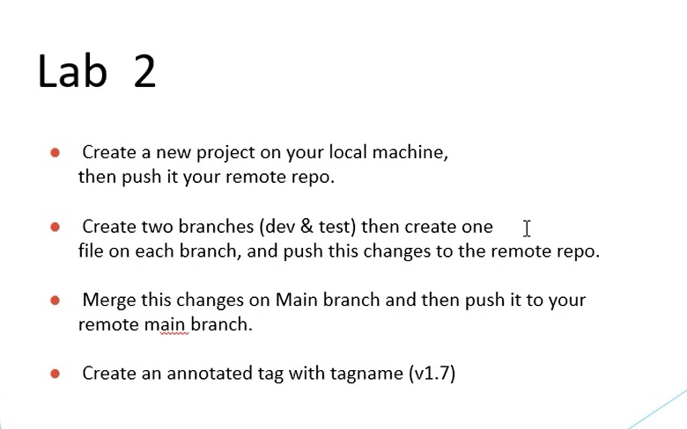
A. Create new project , push it.
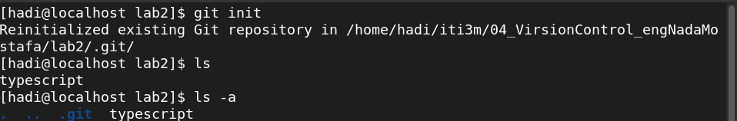
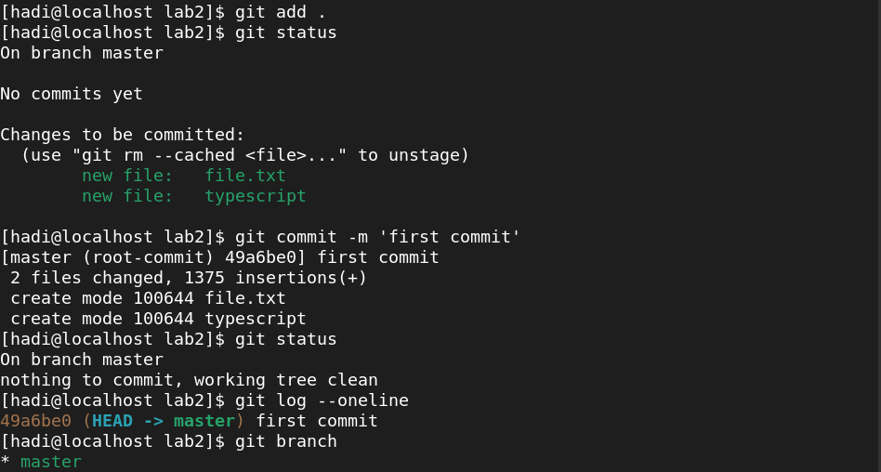
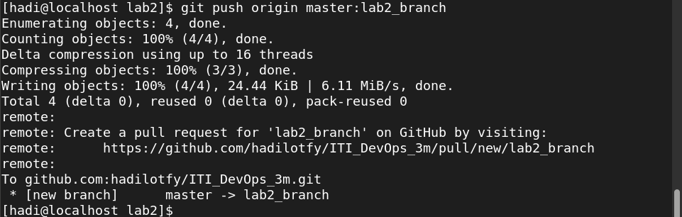
B. Create two branches ‘dev’ ‘test’ with a file for each and push all.
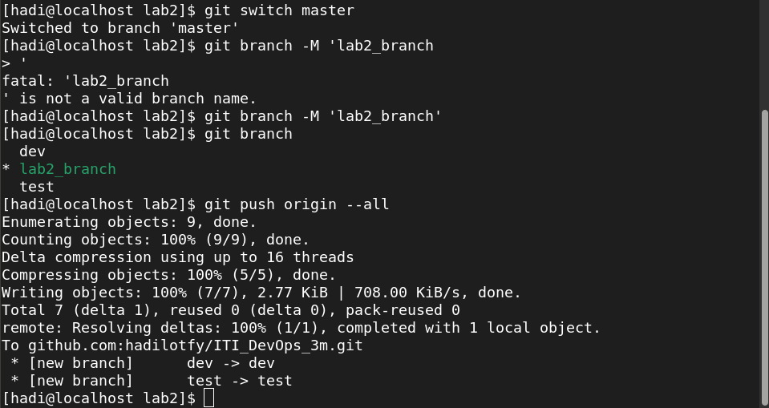

C.Mege with main branch(in my case lab2_branch) and push to remote repo.
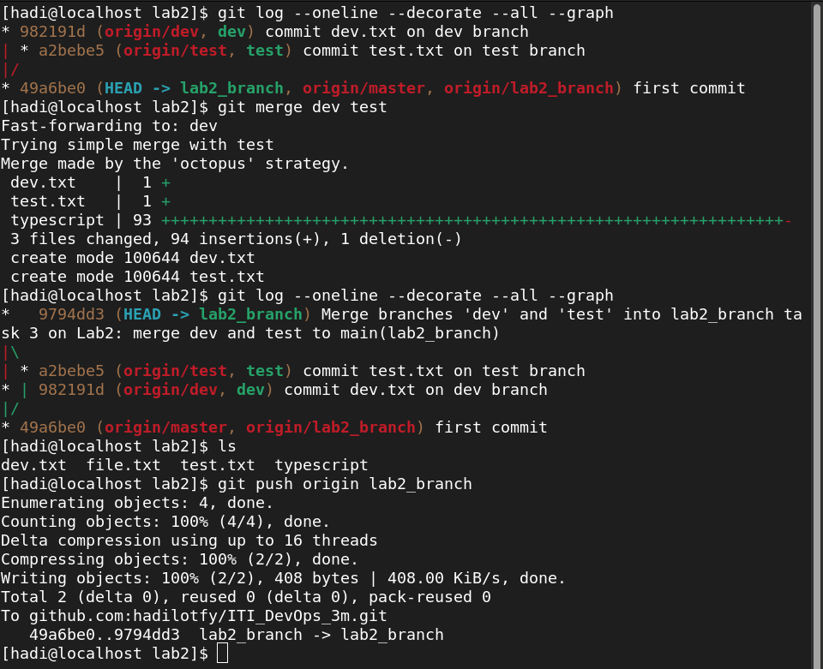
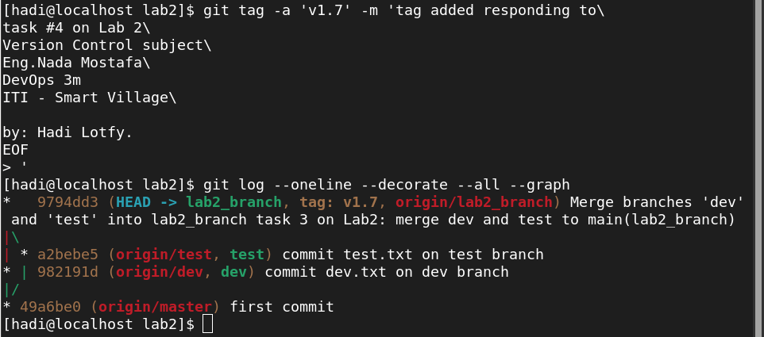
D. Create an annoted tag ‘v1.7’

