BA COMPASS
Business Analysis Co-Pilot

USE CASE DIAGRAM
UML Use Case Model · Version 1.0

Prepared by: Hadi Mercer
March 2026

Version | Details
1.0 | Initial release — pre-build sign-off
Source | Derived from FRD v1.0 and Product Definition Document v1.0

Table of Contents

1. Overview
This document presents the UML Use Case Diagram for BA Compass — Business Analysis Co-Pilot. The diagram identifies all actors that interact with the system, the use cases each actor participates in, and the system boundary within which those use cases operate.
The use cases are derived directly from the Functional Requirements Document (FRD v1.0). Each use case maps to one or more functional requirements and represents a distinct, observable interaction between an actor and the system.

1.1 Actors
Three actors interact with the BA Compass system.
Actor | Type | Description
User (Junior BA) | Primary / Human | The business analyst using BA Compass. Initiates all workflows, provides domain knowledge, reviews and edits AI-generated content, and makes all decisions.
AI Engine (GPT-4o) | System / External | The OpenAI GPT-4o model accessed via API. Performs classification, guides module conversations, generates artifact content, runs gap analysis, and provides recommendations. Never acts autonomously — always in response to user actions or system triggers.
Database (Neon DB) | System / Internal | PostgreSQL database via Neon DB. Stores all persistent data: user accounts, projects, dimensions, roadmaps, conversation history, and artifacts. Provides data to all other actors.

1.2 System Boundary
The system boundary encompasses all functionality delivered by the BA Compass web application. External actors (AI Engine, Database) sit outside the boundary but participate in use cases within it. The User interacts with the system through the Streamlit web interface.

2. Use Case Diagram
The following diagram shows all actors, use cases, and their associations. Use cases with blue fill are AI-driven. Solid lines indicate user associations, dashed blue lines indicate AI associations, and dotted grey lines indicate database persistence.

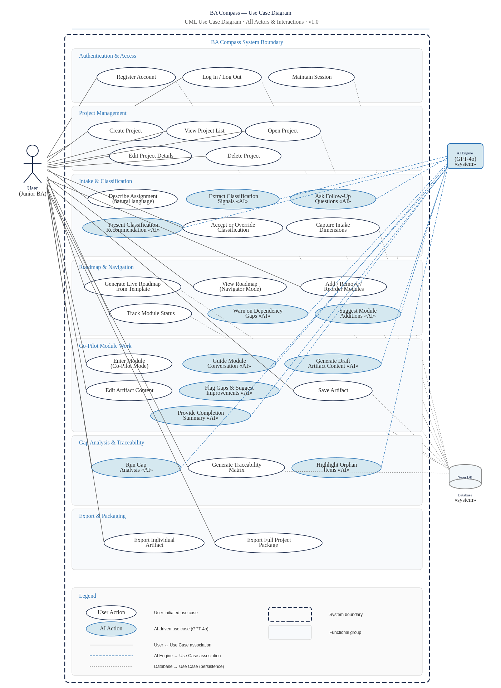

3. Use Case Catalog
Detailed reference for each use case. Organized by functional group matching the FRD structure. Each entry includes the actors involved, a brief description, preconditions, postconditions, and the FRs it traces to.

3.1 Authentication & Access
Use Case | Detail | Description
Register Account | Actors | User, Database
 | Description | A new user creates an account by providing an email address and password. The system validates the input, hashes the password with bcrypt, and stores the credentials in Neon DB.
 | Preconditions | User is on the registration page. No account exists for the email.
 | Postconditions | A new user record exists in the database. The user is logged in and redirected to the dashboard.
 | Related FRs | FR-101

Use Case | Detail | Description
Log In / Log Out | Actors | User, Database
 | Description | A returning user authenticates with their email and password. The system verifies credentials against Neon DB and creates a session token. Logout terminates the session.
 | Preconditions | User has a registered account.
 | Postconditions | Login: authenticated session created. Logout: session terminated, user returned to login page.
 | Related FRs | FR-102, FR-105, FR-106

Use Case | Detail | Description
Maintain Session | Actors | Database
 | Description | The system maintains the user’s authenticated session across page reloads and Streamlit reruns. Session tokens are validated on each request.
 | Preconditions | User is authenticated.
 | Postconditions | Session persists until explicit logout or expiry.
 | Related FRs | FR-104

3.2 Project Management
Use Case | Detail | Description
Create Project | Actors | User, Database
 | Description | The user creates a new project by providing a name and free-text description. The project is persisted to the database with status and timestamps.
 | Preconditions | User is authenticated and on the dashboard.
 | Postconditions | A new project record exists. The user is directed to the intake flow.
 | Related FRs | FR-201, FR-207

Use Case | Detail | Description
View Project List | Actors | User, Database
 | Description | The dashboard displays all projects belonging to the authenticated user with key metadata: name, engagement type, scale tier, status, and last modified date.
 | Preconditions | User is authenticated.
 | Postconditions | Project list is displayed with current data.
 | Related FRs | FR-202, FR-208

Use Case | Detail | Description
Open Project | Actors | User, Database
 | Description | The user selects a project from the list and enters the project workspace. The roadmap view loads as the default landing page.
 | Preconditions | At least one project exists.
 | Postconditions | Project workspace is displayed with roadmap view.
 | Related FRs | FR-203, FR-501

Use Case | Detail | Description
Edit Project Details | Actors | User, Database
 | Description | The user modifies a project’s name or description after creation.
 | Preconditions | Project exists and is open.
 | Postconditions | Updated metadata is persisted. Last modified timestamp updated.
 | Related FRs | FR-204, FR-207

Use Case | Detail | Description
Delete Project | Actors | User, Database
 | Description | The user permanently removes a project after explicit confirmation. All associated data (dimensions, roadmap, artifacts) is deleted.
 | Preconditions | Project exists. User confirms deletion.
 | Postconditions | Project and all child records are removed from the database.
 | Related FRs | FR-205

3.3 Intake & Classification
Use Case | Detail | Description
Describe Assignment | Actors | User
 | Description | The user provides natural language input describing their assignment. This can be typed text, a pasted email, a brief, or any free-text description of the work they have been given.
 | Preconditions | A new project has been created and the intake flow has started.
 | Postconditions | The AI has raw input to begin classification signal extraction.
 | Related FRs | FR-301

Use Case | Detail | Description
Extract Classification Signals | Actors | AI Engine
 | Description | The AI analyzes the user’s natural language input to identify signals for the four Must-Know dimensions: Engagement Type, Scale Tier, Trigger/Origin, and Solution Clarity. This happens internally before any classification is presented.
 | Preconditions | User has provided initial input.
 | Postconditions | The AI has a confidence assessment for each Must-Know dimension.
 | Related FRs | FR-302

Use Case | Detail | Description
Ask Follow-Up Questions | Actors | AI Engine, User
 | Description | When the AI lacks sufficient signal for one or more Must-Know dimensions, it asks targeted follow-up questions. No more than two questions per turn. Questions are non-repetitive and build on what has already been captured.
 | Preconditions | Initial input has been analyzed. One or more dimensions lack sufficient signal.
 | Postconditions | Additional signal captured. Classification confidence improved.
 | Related FRs | FR-303, FR-315

Use Case | Detail | Description
Present Classification Recommendation | Actors | AI Engine
 | Description | Once the AI has sufficient confidence, it presents its recommended Engagement Type and Scale Tier with a plain-language explanation of why each was selected.
 | Preconditions | All Must-Know dimensions have sufficient signal.
 | Postconditions | The user sees the recommendation and can act on it.
 | Related FRs | FR-304, FR-305, FR-306

Use Case | Detail | Description
Accept or Override Classification | Actors | User
 | Description | The user reviews the AI’s recommendation and either accepts it or overrides it by selecting a different engagement type and/or scale tier. This triggers roadmap generation.
 | Preconditions | Classification recommendation has been presented.
 | Postconditions | Engagement type and scale tier are confirmed. Roadmap generation is triggered.
 | Related FRs | FR-307, FR-308

Use Case | Detail | Description
Capture Intake Dimensions | Actors | User, AI Engine, Database
 | Description | The system captures all ten intake dimensions across three tiers: Must-Know at intake, Should-Know Early in the first session, and Emerges During Work progressively. Each value is persisted with a capture timestamp.
 | Preconditions | Project exists. Intake has started.
 | Postconditions | Dimension values are stored in project_dimensions with timestamps.
 | Related FRs | FR-309, FR-310, FR-311, FR-312, FR-313

3.4 Roadmap & Navigation
Use Case | Detail | Description
Generate Live Roadmap from Template | Actors | Database
 | Description | The system copies the module sequence from the matching roadmap template (Engagement Type × Scale Tier) into the project’s live roadmap. All modules start with status Not Started.
 | Preconditions | Classification has been confirmed by the user.
 | Postconditions | A live roadmap exists in project_roadmap with all template modules.
 | Related FRs | FR-401, FR-402, FR-403

Use Case | Detail | Description
View Roadmap (Navigator Mode) | Actors | User, Database
 | Description | The user sees the full roadmap with every module displayed, showing name, knowledge area, status, and overall completion percentage. Modules are visually distinguished by status. This is the project home base.
 | Preconditions | A live roadmap exists for the project.
 | Postconditions | Roadmap is rendered with current status data.
 | Related FRs | FR-501, FR-502, FR-503, FR-504, FR-508

Use Case | Detail | Description
Add / Remove / Reorder Modules | Actors | User, Database
 | Description | The user modifies their live roadmap by adding modules from the library, removing existing modules, or changing the sequence order. Removed modules’ artifacts are preserved as orphaned.
 | Preconditions | A live roadmap exists.
 | Postconditions | Live roadmap is updated. Changes persisted to database.
 | Related FRs | FR-404, FR-405, FR-406

Use Case | Detail | Description
Track Module Status | Actors | User, Database
 | Description | Module statuses update as the user works: auto-transition to In Progress on entry, manual marking as Complete or Skipped. Re-entering a completed module reverts it to In Progress.
 | Preconditions | Modules exist in the live roadmap.
 | Postconditions | Status is updated and persisted.
 | Related FRs | FR-407, FR-408, FR-409

Use Case | Detail | Description
Warn on Dependency Gaps | Actors | AI Engine
 | Description | When a user enters a module whose logical prerequisites are incomplete, the AI displays an advisory warning identifying the missing dependencies. The warning does not block the user.
 | Preconditions | User attempts to enter a module with incomplete dependencies.
 | Postconditions | Warning is displayed. User can dismiss and proceed.
 | Related FRs | FR-410

Use Case | Detail | Description
Suggest Module Additions | Actors | AI Engine
 | Description | As new intake dimensions are captured, the AI evaluates whether the current roadmap has gaps and suggests additional modules if needed.
 | Preconditions | New dimension information reveals a gap in the roadmap.
 | Postconditions | Suggestion is presented to the user for acceptance or dismissal.
 | Related FRs | FR-412

3.5 Co-Pilot Module Work
Use Case | Detail | Description
Enter Module (Co-Pilot Mode) | Actors | User, Database
 | Description | The user clicks a module in the roadmap to enter co-pilot mode. The system displays the module header (name, knowledge area, description, inputs, outputs) and loads any existing conversation history.
 | Preconditions | The module exists in the live roadmap.
 | Postconditions | Module view is rendered. Status updates to In Progress if it was Not Started.
 | Related FRs | FR-505, FR-601, FR-408

Use Case | Detail | Description
Guide Module Conversation | Actors | AI Engine, User
 | Description | The AI initiates and maintains a structured conversation tailored to the module type. It asks targeted questions, uses project context to avoid redundancy, and builds toward the module’s expected outputs.
 | Preconditions | User has entered co-pilot mode for a module.
 | Postconditions | User has provided enough input for artifact generation.
 | Related FRs | FR-602, FR-603

Use Case | Detail | Description
Generate Draft Artifact Content | Actors | AI Engine
 | Description | Based on the user’s responses, the AI generates a structured draft of the module’s artifact. The draft is presented for review, not saved automatically.
 | Preconditions | Sufficient user input has been captured in the conversation.
 | Postconditions | Draft artifact content is displayed for user review.
 | Related FRs | FR-604

Use Case | Detail | Description
Edit Artifact Content | Actors | User
 | Description | The user reviews and modifies any AI-generated content before saving. Edits can be made inline or through continued conversation with the AI.
 | Preconditions | Draft artifact content has been generated.
 | Postconditions | Content reflects the user’s revisions.
 | Related FRs | FR-605, FR-705

Use Case | Detail | Description
Flag Gaps & Suggest Improvements | Actors | AI Engine
 | Description | The AI reviews the user’s responses and draft content for weaknesses: missing stakeholders, vague requirements, unaddressed risks. It suggests specific improvements based on BABOK best practices.
 | Preconditions | Draft content exists or the conversation is in progress.
 | Postconditions | Gap findings and suggestions are presented to the user.
 | Related FRs | FR-606, FR-607

Use Case | Detail | Description
Save Artifact | Actors | User, Database
 | Description | The user saves the finalized artifact content. The system creates a versioned record linked to the project and module. Previous versions are preserved.
 | Preconditions | Artifact content has been reviewed and approved by the user.
 | Postconditions | Artifact record created in the database with version number.
 | Related FRs | FR-701, FR-703, FR-706

Use Case | Detail | Description
Provide Completion Summary | Actors | AI Engine
 | Description | When the user indicates they are done with a module, the AI provides a summary of what was produced and flags any remaining gaps or areas that could be strengthened.
 | Preconditions | User signals module completion.
 | Postconditions | Summary displayed. User can mark the module Complete or continue working.
 | Related FRs | FR-610

3.6 Gap Analysis & Traceability
Use Case | Detail | Description
Run Gap Analysis | Actors | User, AI Engine, Database
 | Description | The user triggers an on-demand gap analysis. The AI reviews all completed artifacts for weaknesses, missing sections, vague language, and cross-artifact inconsistencies. Findings are presented as a prioritized, actionable list.
 | Preconditions | At least one artifact has been completed.
 | Postconditions | Gap analysis report is generated and displayed.
 | Related FRs | FR-801, FR-802, FR-806

Use Case | Detail | Description
Generate Traceability Matrix | Actors | User, AI Engine, Database
 | Description | The system generates a traceability matrix linking business objectives to requirements, requirements to user stories, and user stories to acceptance criteria. The matrix auto-updates as artifacts change.
 | Preconditions | Requirements and related artifacts exist.
 | Postconditions | Traceability matrix is generated and displayed.
 | Related FRs | FR-803, FR-804

Use Case | Detail | Description
Highlight Orphan Items | Actors | AI Engine
 | Description | The AI identifies items in the traceability matrix that lack linkage: requirements without user stories, acceptance criteria without parent requirements, and similar orphans.
 | Preconditions | Traceability matrix exists.
 | Postconditions | Orphan items are flagged in the matrix view.
 | Related FRs | FR-805

3.7 Export & Packaging
Use Case | Detail | Description
Export Individual Artifact | Actors | User
 | Description | The user exports a single artifact in a professional format (Markdown, PDF, or Word) with consistent branding including project name, engagement type, date, and artifact type.
 | Preconditions | The artifact exists and has at least one saved version.
 | Postconditions | A formatted document is downloaded to the user’s device.
 | Related FRs | FR-901, FR-902, FR-904

Use Case | Detail | Description
Export Full Project Package | Actors | User, Database
 | Description | The user exports a complete deliverable package containing all selected artifacts, the traceability matrix, and a project summary cover page.
 | Preconditions | At least one artifact exists. User selects which artifacts to include.
 | Postconditions | A packaged deliverable is downloaded.
 | Related FRs | FR-903, FR-905

4. Use Case to FR Cross-Reference
Summary mapping from each use case to its implementing functional requirements for traceability verification.
Use Case | Related FRs
Register Account | FR-101
Log In / Log Out | FR-102, FR-105, FR-106
Maintain Session | FR-104
Create Project | FR-201, FR-207
View Project List | FR-202, FR-208
Open Project | FR-203, FR-501
Edit Project Details | FR-204, FR-207
Delete Project | FR-205
Describe Assignment | FR-301
Extract Classification Signals | FR-302
Ask Follow-Up Questions | FR-303, FR-315
Present Classification Recommendation | FR-304, FR-305, FR-306
Accept or Override Classification | FR-307, FR-308
Capture Intake Dimensions | FR-309–313
Generate Live Roadmap from Template | FR-401–403
View Roadmap (Navigator Mode) | FR-501–504, FR-508
Add / Remove / Reorder Modules | FR-404–406
Track Module Status | FR-407–409
Warn on Dependency Gaps | FR-410
Suggest Module Additions | FR-412
Enter Module (Co-Pilot Mode) | FR-505, FR-601, FR-408
Guide Module Conversation | FR-602, FR-603
Generate Draft Artifact Content | FR-604
Edit Artifact Content | FR-605, FR-705
Flag Gaps & Suggest Improvements | FR-606, FR-607
Save Artifact | FR-701, FR-703, FR-706
Provide Completion Summary | FR-610
Run Gap Analysis | FR-801, FR-802, FR-806
Generate Traceability Matrix | FR-803, FR-804
Highlight Orphan Items | FR-805
Export Individual Artifact | FR-901, FR-902, FR-904
Export Full Project Package | FR-903, FR-905

5. Document Sign-Off
This document represents the complete Use Case Model for BA Compass — Business Analysis Co-Pilot, Version 1.

Review Item | Status
Actor definitions confirmed | □ Pending
Use Case Diagram confirmed | □ Pending
Use Case Catalog confirmed | □ Pending
FR Cross-Reference confirmed | □ Pending

Approved by: ____________________________ Date: ________________

Hadi Mercer — Project Owner & Builder

