National Textile University

Department of Computer Science

Name

Hadi Muhammad

Reg No:

# 23-NTU-CS-FL-1160

Semester:

5th

Lab:

06

Submitted to:

Sir Nasir Mehmood

# LAB-06

In this LAB we discuss some programs about synchronous using Peterson and Mutex Algorithm

|  |  |
| --- | --- |
| PeterSon Algorithm | Mutex Algorithm |
| * In this we use While Loop for the iteration and check the Synchronization. * In this we write all code by hand * The steps include o Flag [2] o Turn   o While loop | * In this we use a built-In Function Pthread_mutex_t object * In this all computation will be by the Built-in Function * The function we use are o Pthread_mutex_t o Pthread_mutex_init   o Pthread_mutex_destroy |

Program1-Multi-Threading

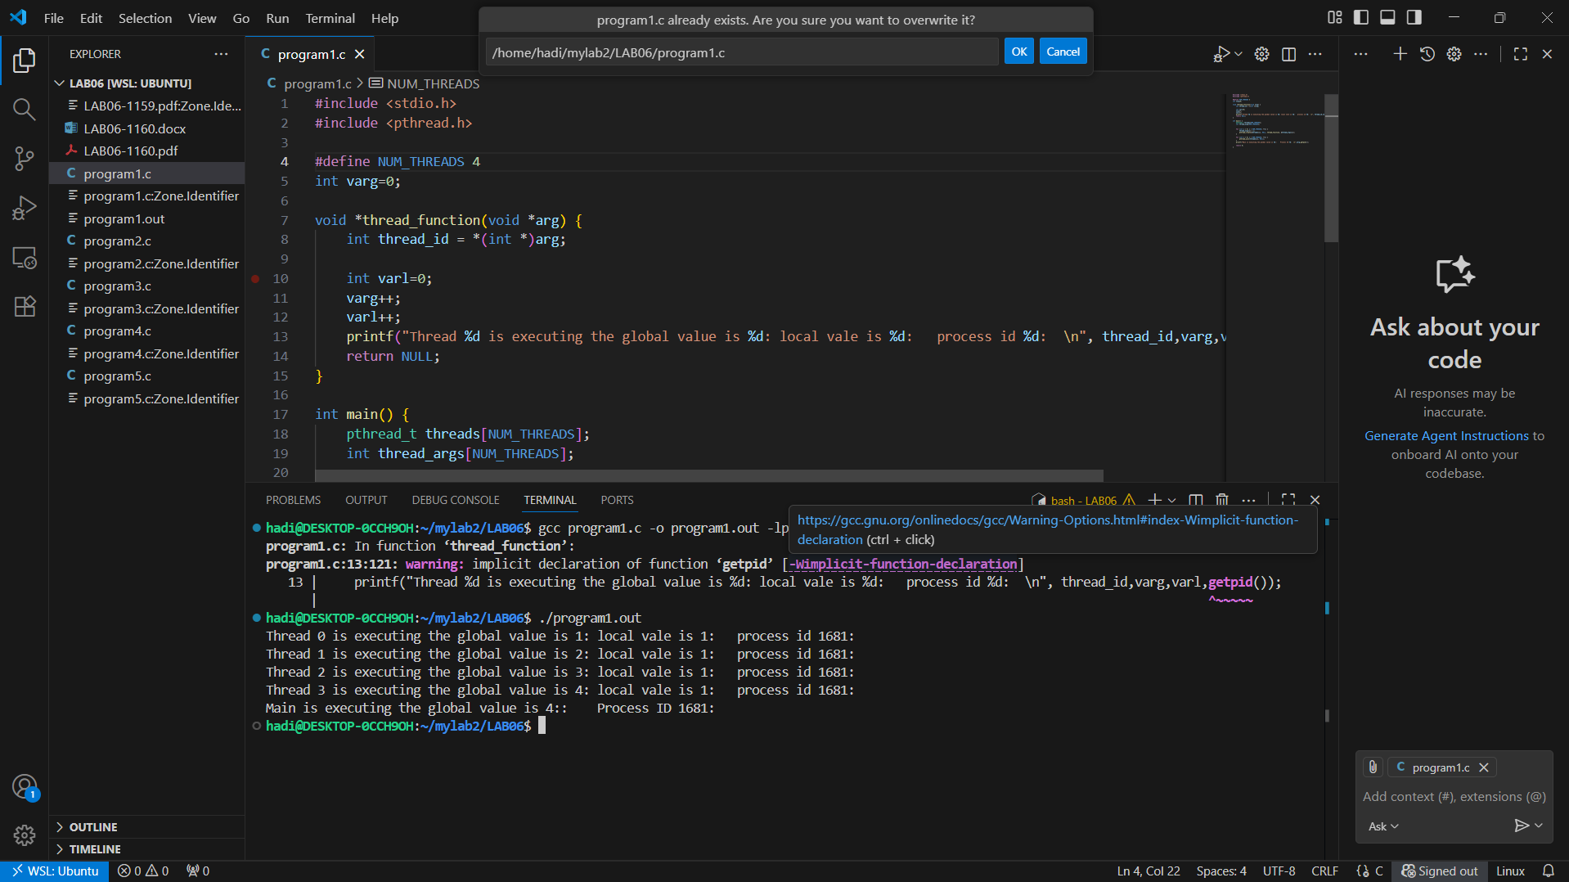

Program2 – Multi_Processing without synchronization

Program3- Multi_Processing with PeterSon Algorithm

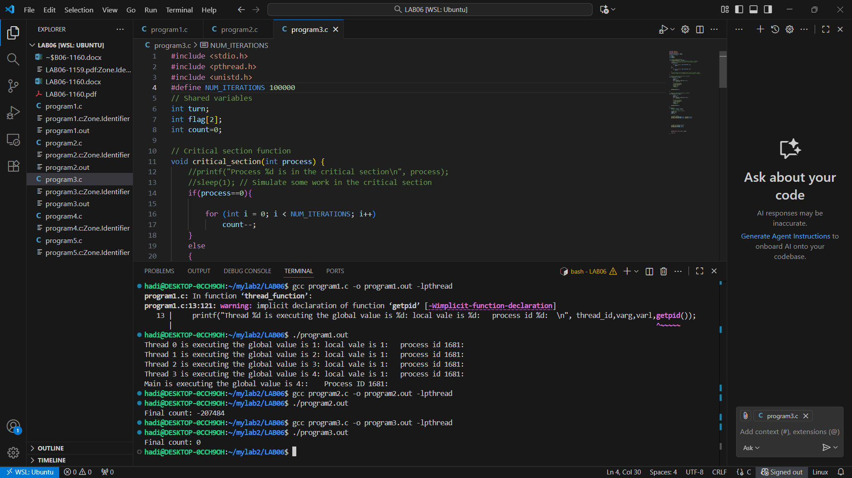

Program 4 – Multiprocessing with Mutex

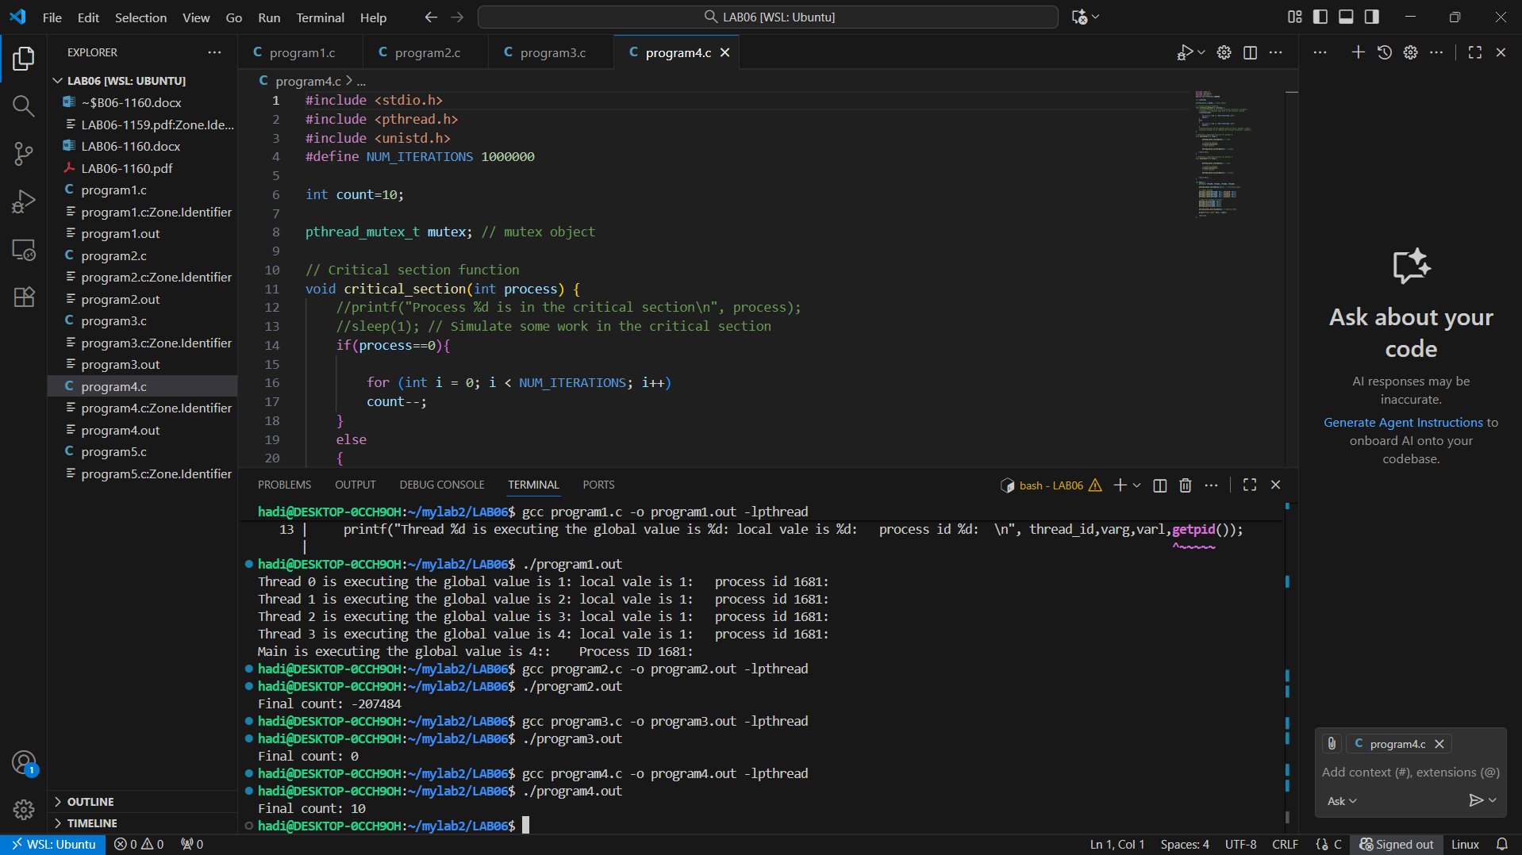

Program 5 – Multiprocessing (4 process) with mutex

