

National Textile University

Department of Computer Science

Subject:

Operating System

Submitted to:

Sir Nasir Mehmood

Submitted by:

Hadi muhammad

Reg number:

23-NTU-CS-1160

Lab no:

1st

Semester:

5th

# Task 1: Installation

● Install WSL using Powershell.

● Install Ubuntu24.04 using Powershell

● Add User (gulam) in Ubuntu  Integrate Ubuntu with VS code.

● Install extension of WSL in VS code.

● Connect WSL with Ubuntu in VS code.

● Run Some Basic Commands Screenshot:

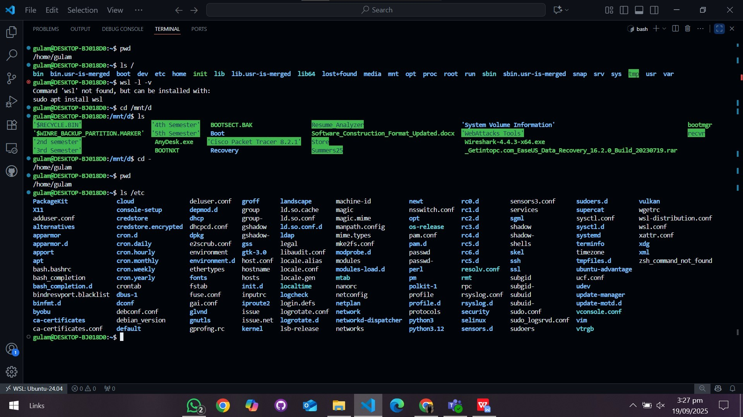

# Task 2: Install GCC Build Tools

● Install Build-Essentials Using the Following Commands.

◆ 1. sudo apt update && sudo apt upgrade -y

◆ 2. sudo apt install build-essential -y

● Check Gcc Version through VS Code using following Command.

◆ gcc --version Screenshot:

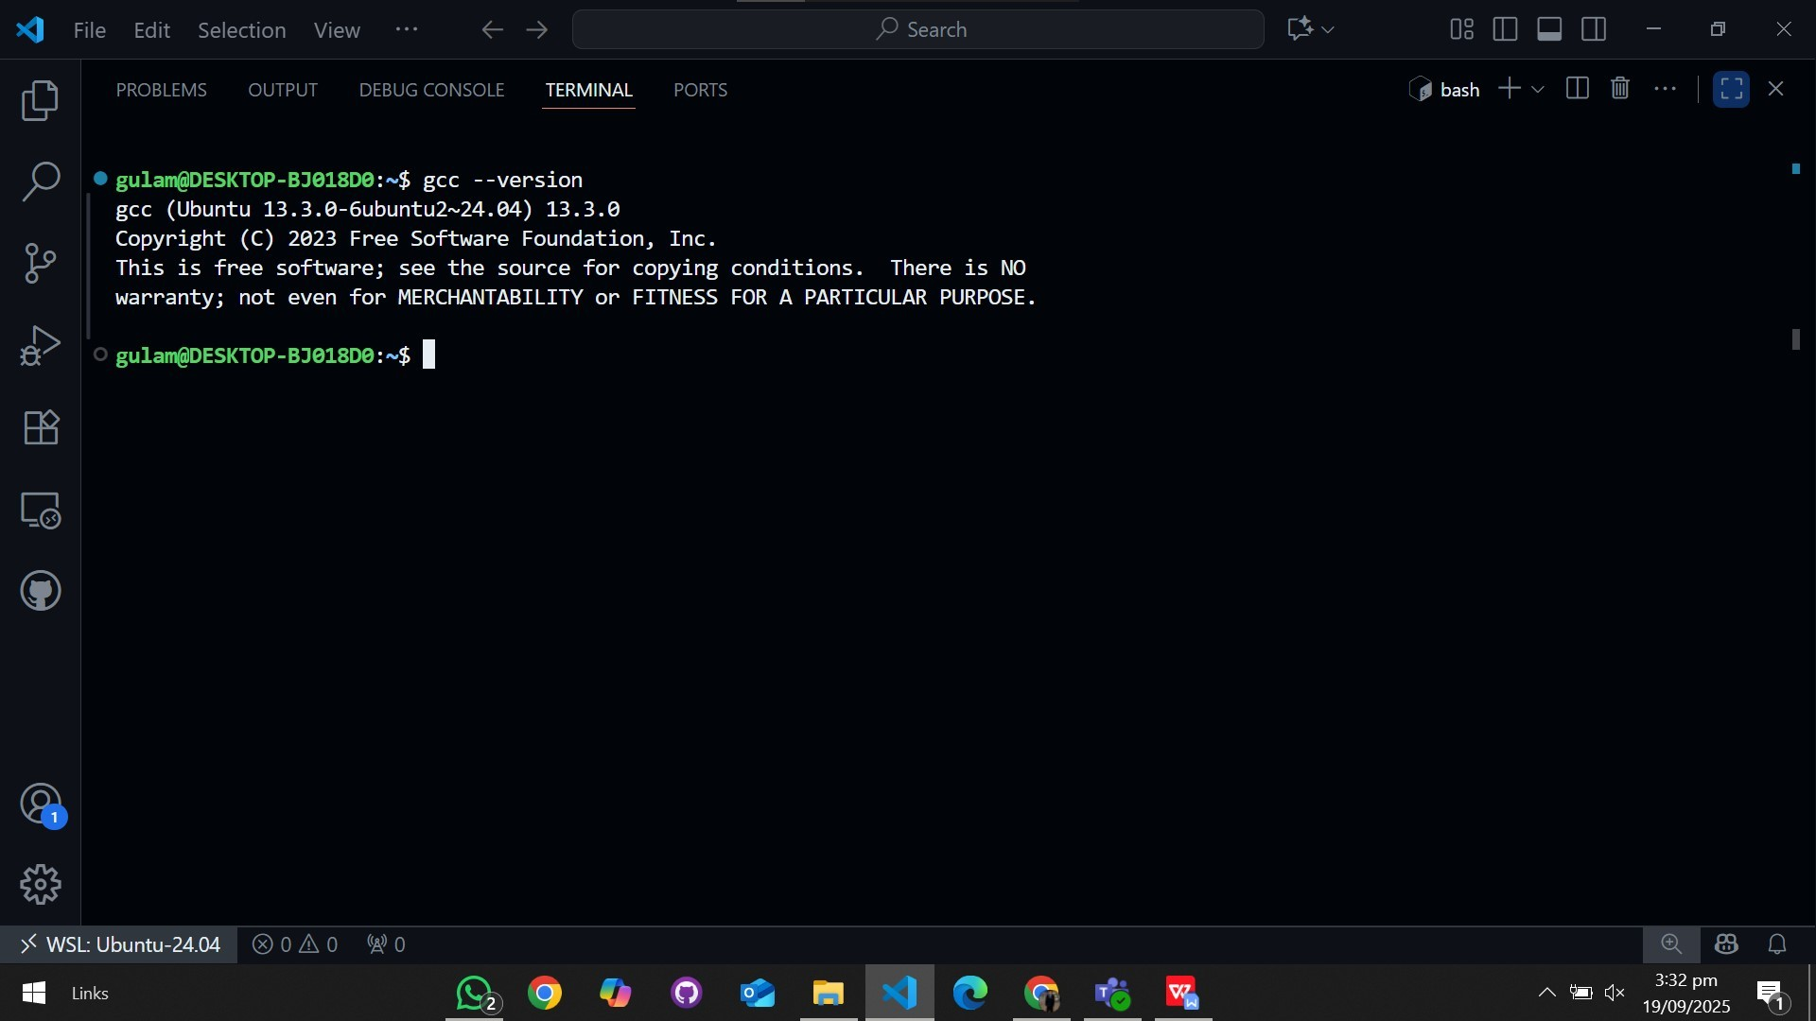

# Task 3: Run Basic Commands

● ls (to list all the Directories available)

● ls / (to show the Root Directories)

● cd (to change directory)

● pwd (for current directory)  cd - (to move to previous directory)

ScreenShot:

