Lunar QA Automation: Authentication Feature
Target: http://localhost:5173/login | Status: PASSED (100%) | Date: 2026-09-29

Test Scenarios & Results
1. Initial Login Screen - Passed
2. Client-Side Field Validation on Empty Submit - Passed
3. Populated Credentials with Remember Me - Passed
4. Authenticated Transition to Operations Overview - Passed

Visual Evidence
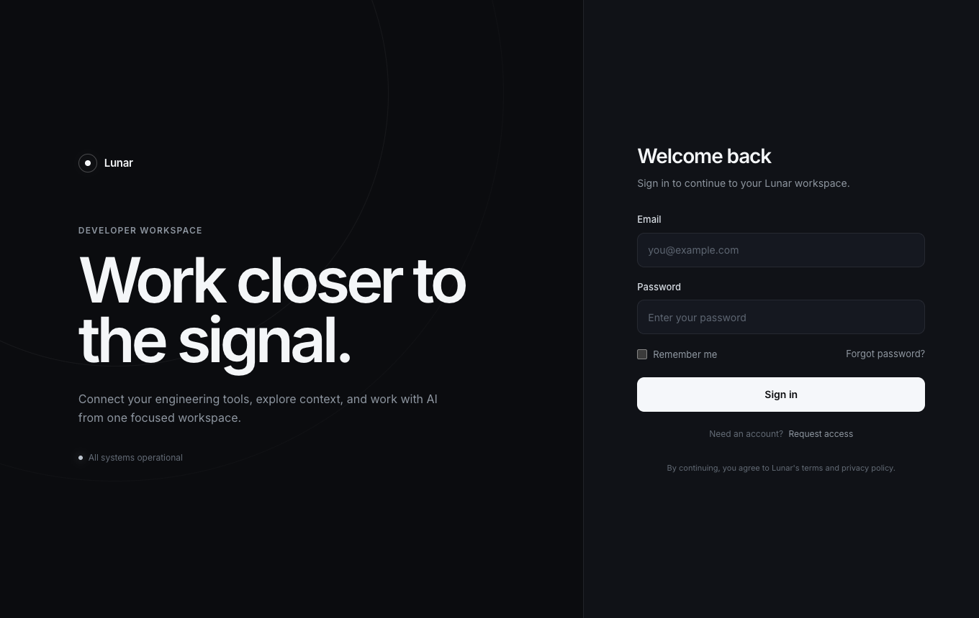
Figure 1: Initial Login Page with Ambient Theme
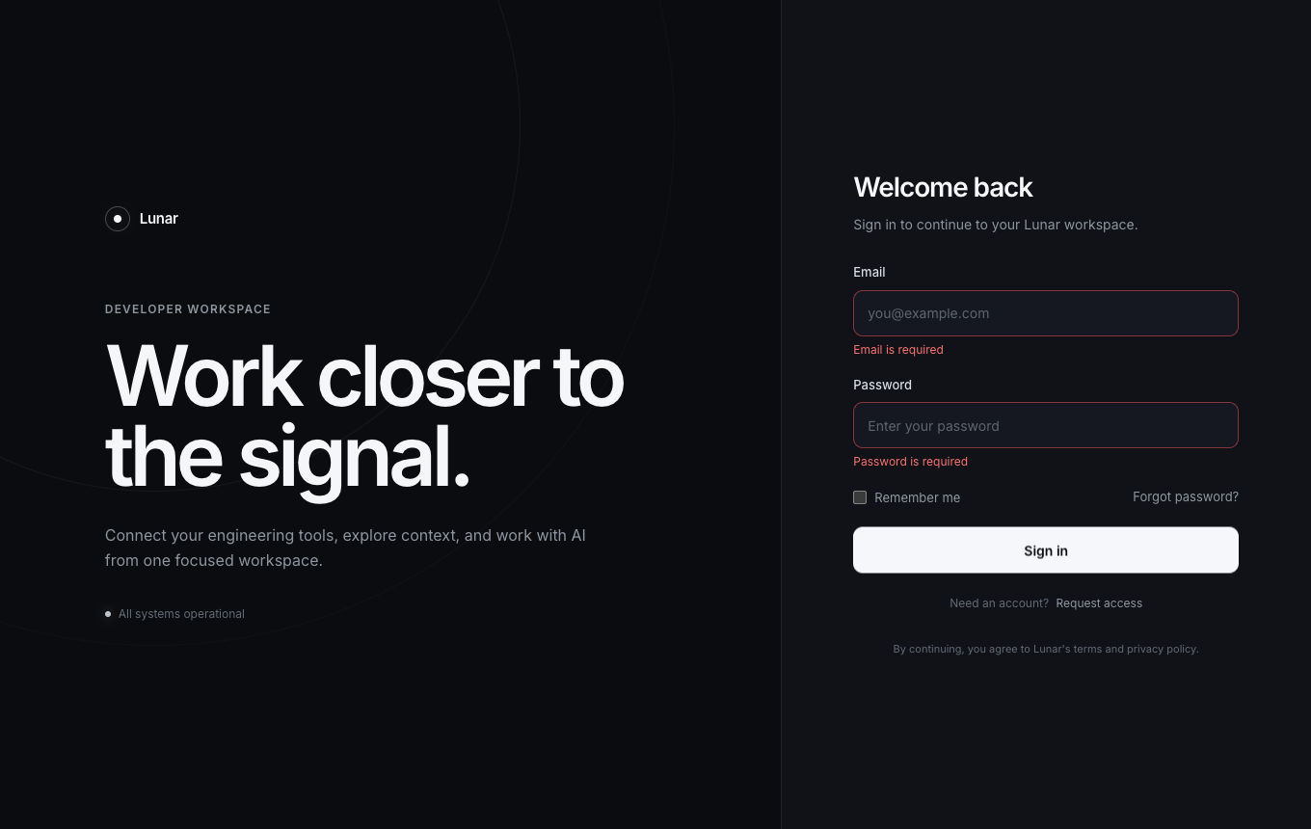
Figure 2: Client-side Validation Error State
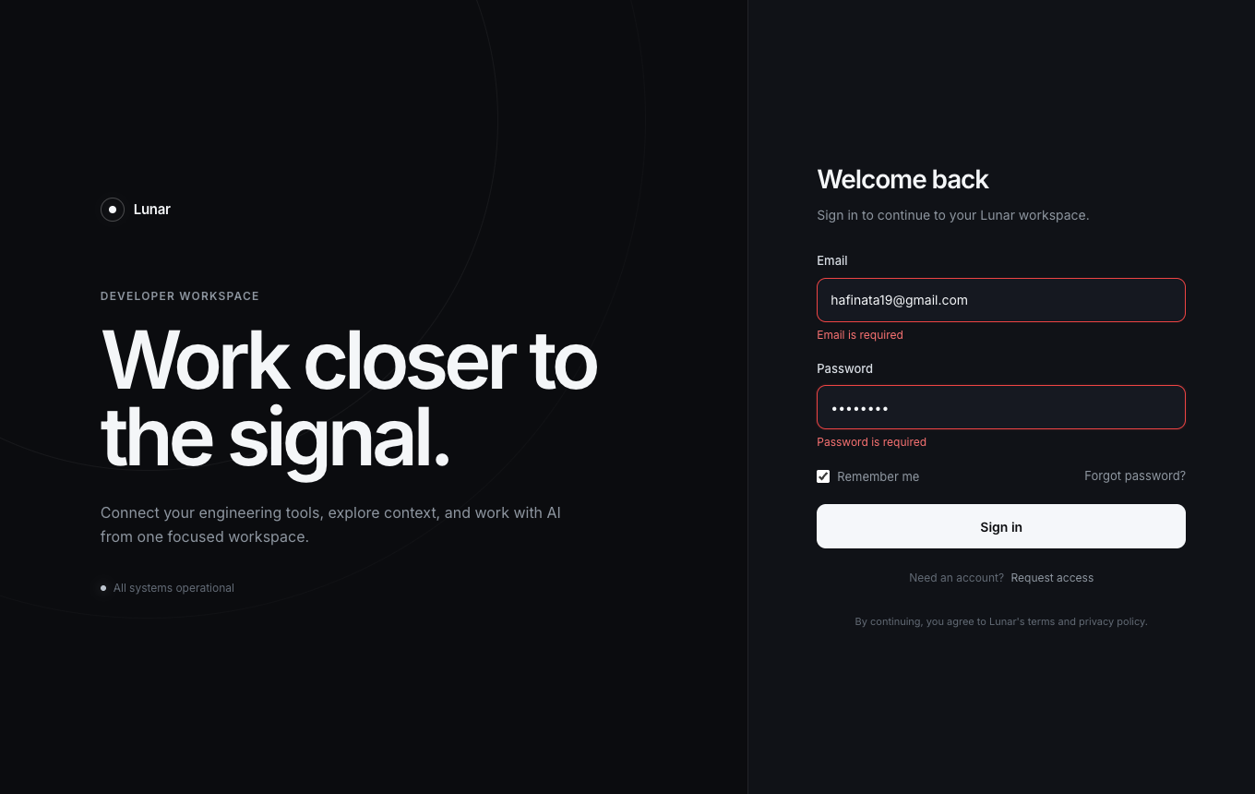
Figure 3: Form with Credentials and Remember Me
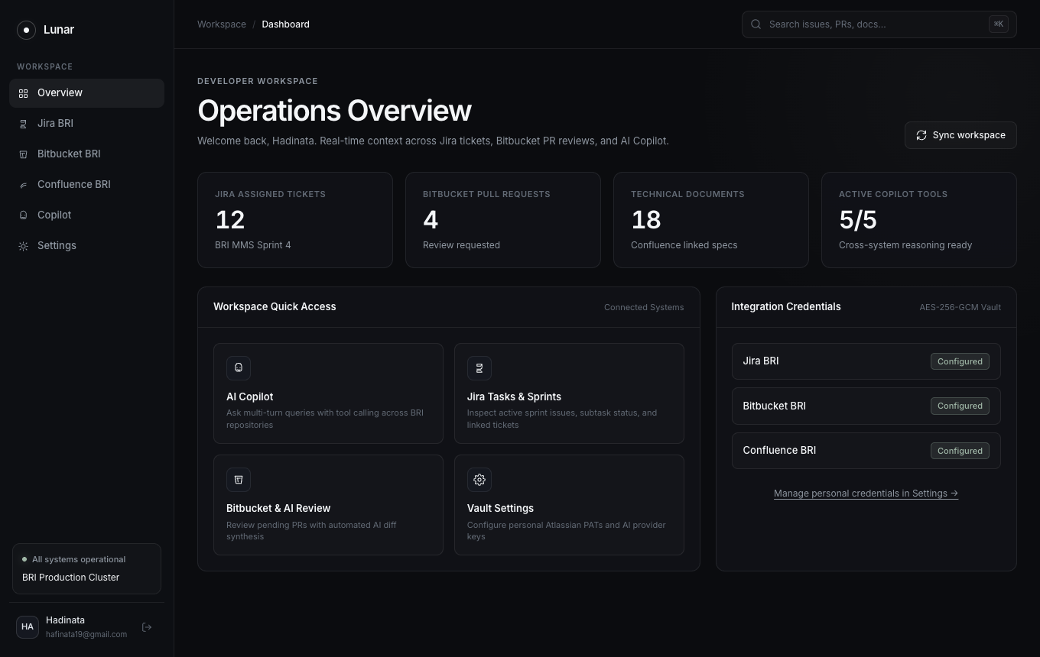
Figure 4: Operations Overview Dashboard Transition

