Lunar QA Automation: Bitbucket Code Review Workspace
Target: http://localhost:5173/bitbucket | Status: PASSED (100%) | Date: 2026-09-29

Test Scenarios & Results
1. Bitbucket Code Review Workspace Overview Rendering - Passed
2. Pushed Branches Filtering (Ready, Stale, All) - Passed
3. Open Pull Requests Filtering (Assigned to me, AI Flagged, All) - Passed
4. Create Pull Request Modal Submission & Toast Notification - Passed
5. PR Review Modal, Git Diff Inspection, AI Review Synthesis & Comment Prefill - Passed
6. PR Review Status Actions (Approve, Needs Work, Decline) - Passed
7. Custom Comment Submission & Confirmation Toast - Passed
8. Clean Empty States (Zero Pushes, Zero PRs) - Passed
9. [Negative] Invalid or Expired Bitbucket PAT (HTTP 401) Error Banner & Settings Link - Passed
10. [Negative] VPN Disconnect / Gateway Timeout (HTTP 502) Guidance Banner - Passed
11. [Negative] Repository Access Forbidden (HTTP 403) Permission Warning - Passed
12. [Negative] PAT Unconfigured Warning Banner with Settings Redirection - Passed

Visual Evidence
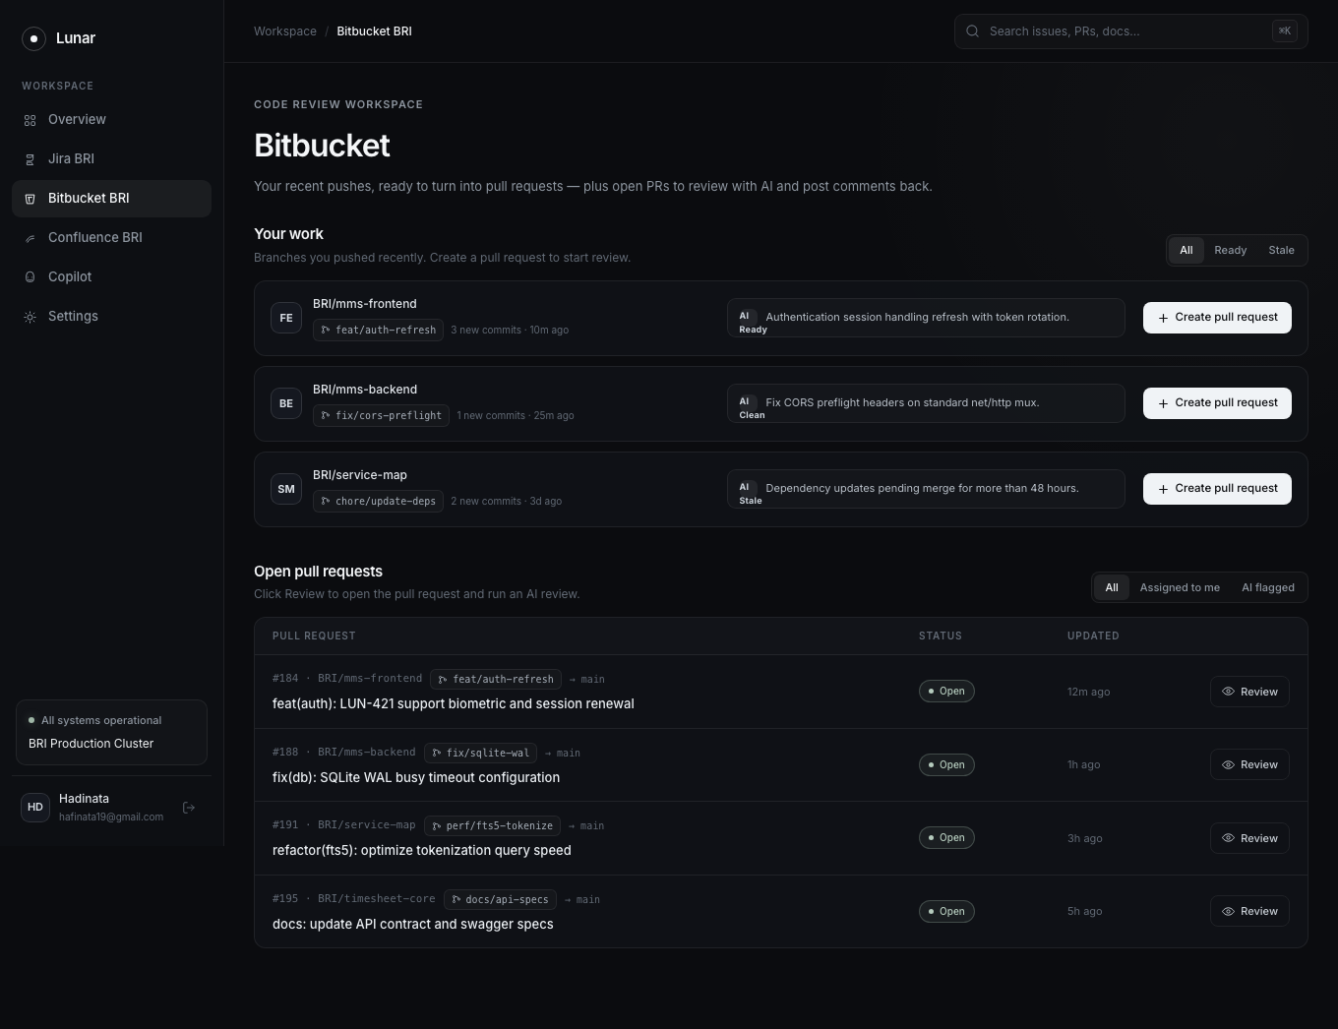
Figure 1: Bitbucket Workspace Overview
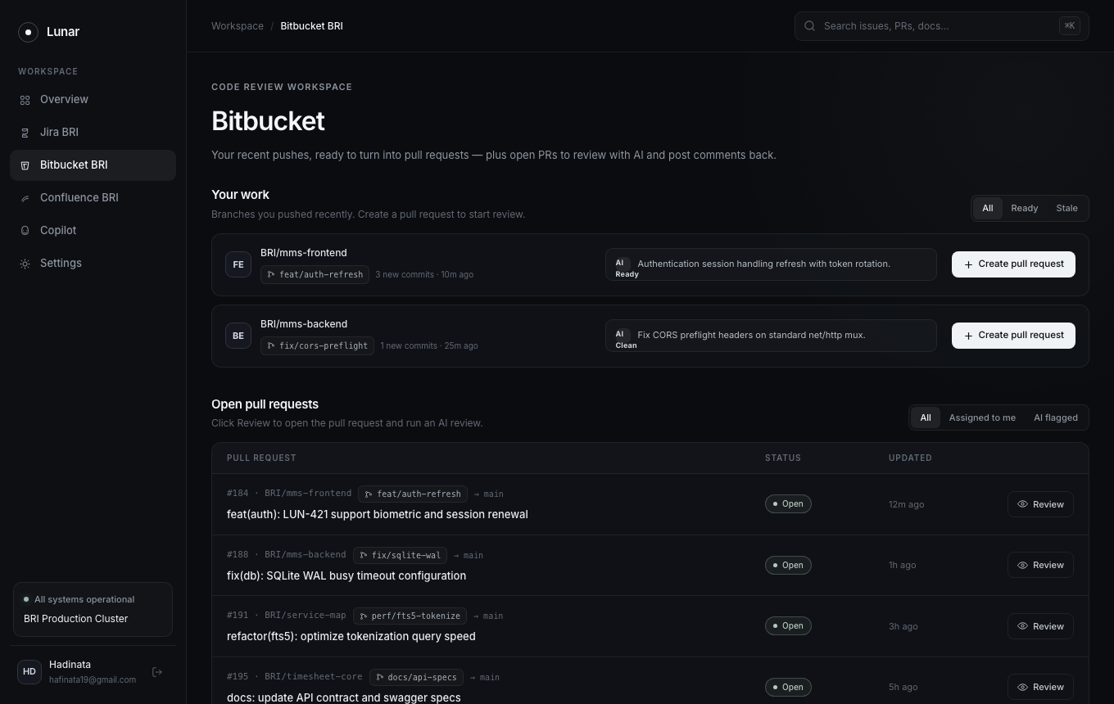
Figure 2: Filter Pushed Branches: Ready Only
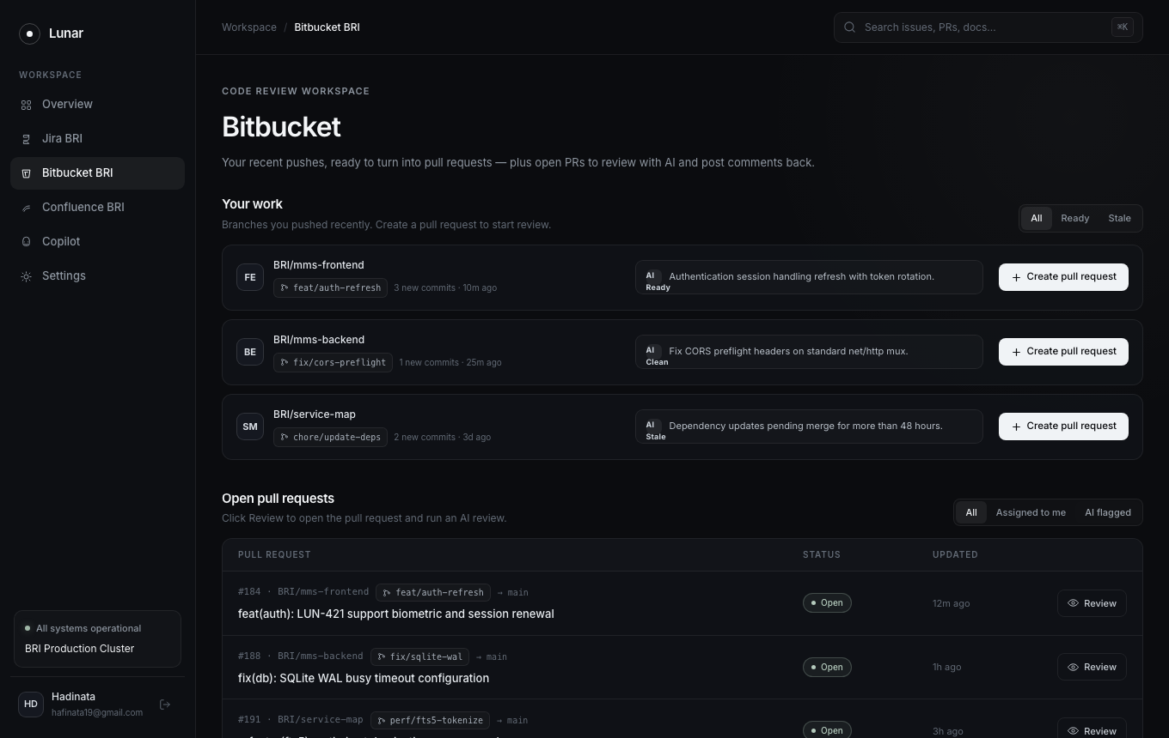
Figure 3: Filter Pull Requests: AI Flagged
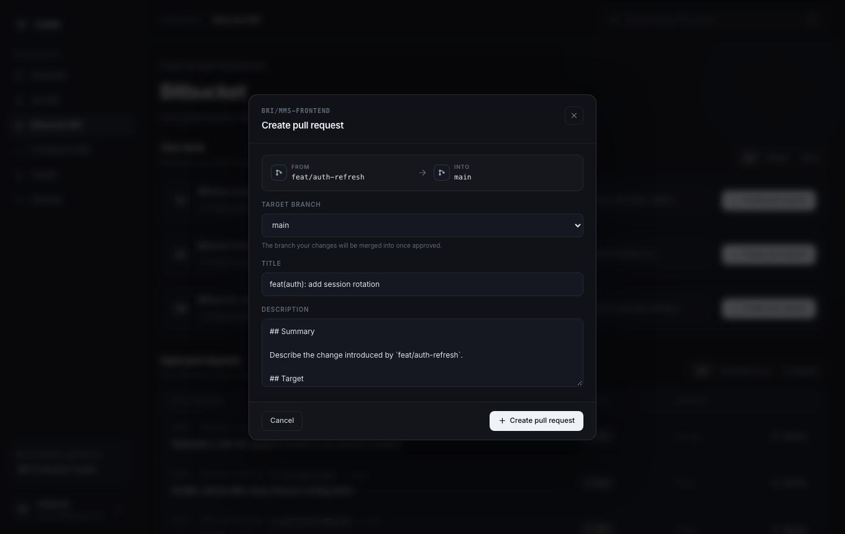
Figure 4: Create Pull Request Modal
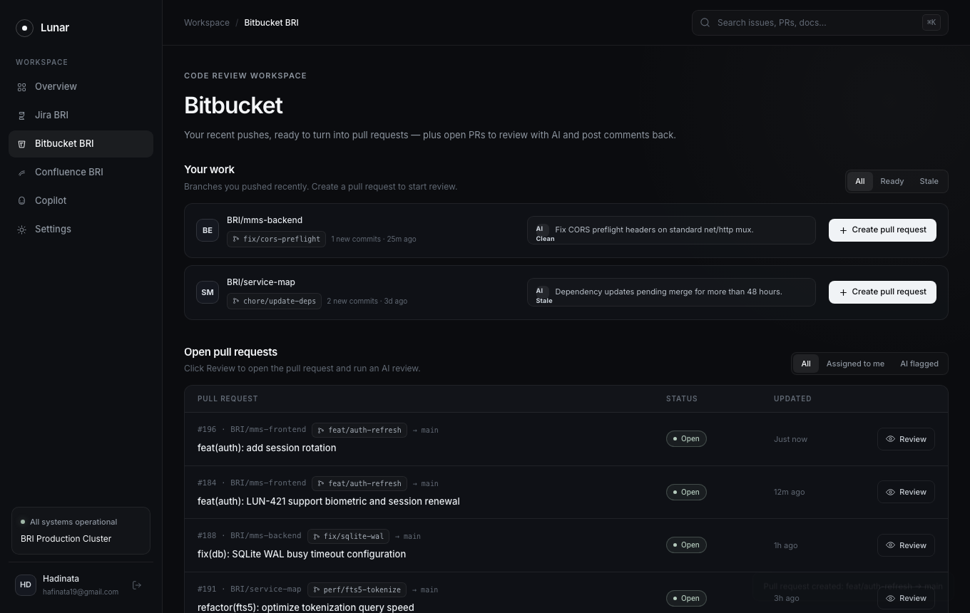
Figure 5: Pull Request Created Toast Notification
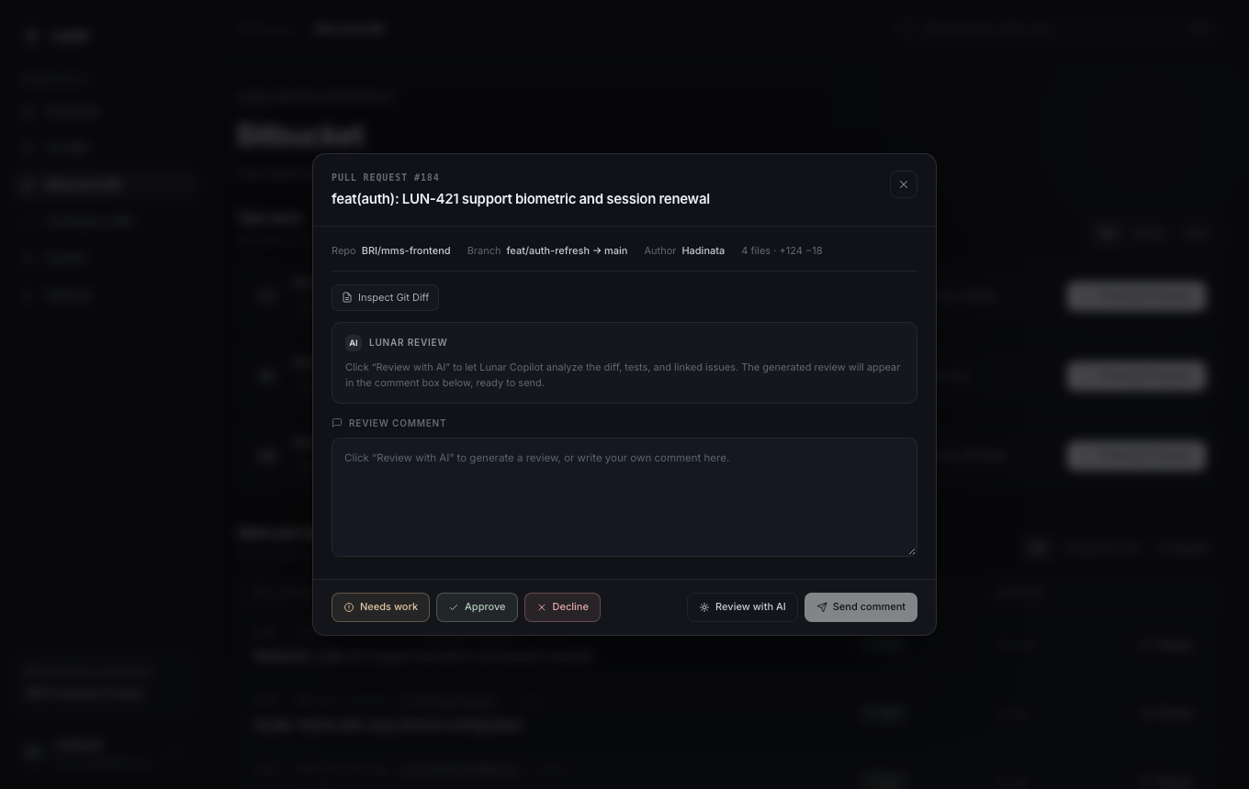
Figure 6: PR Review Modal (Initial State)
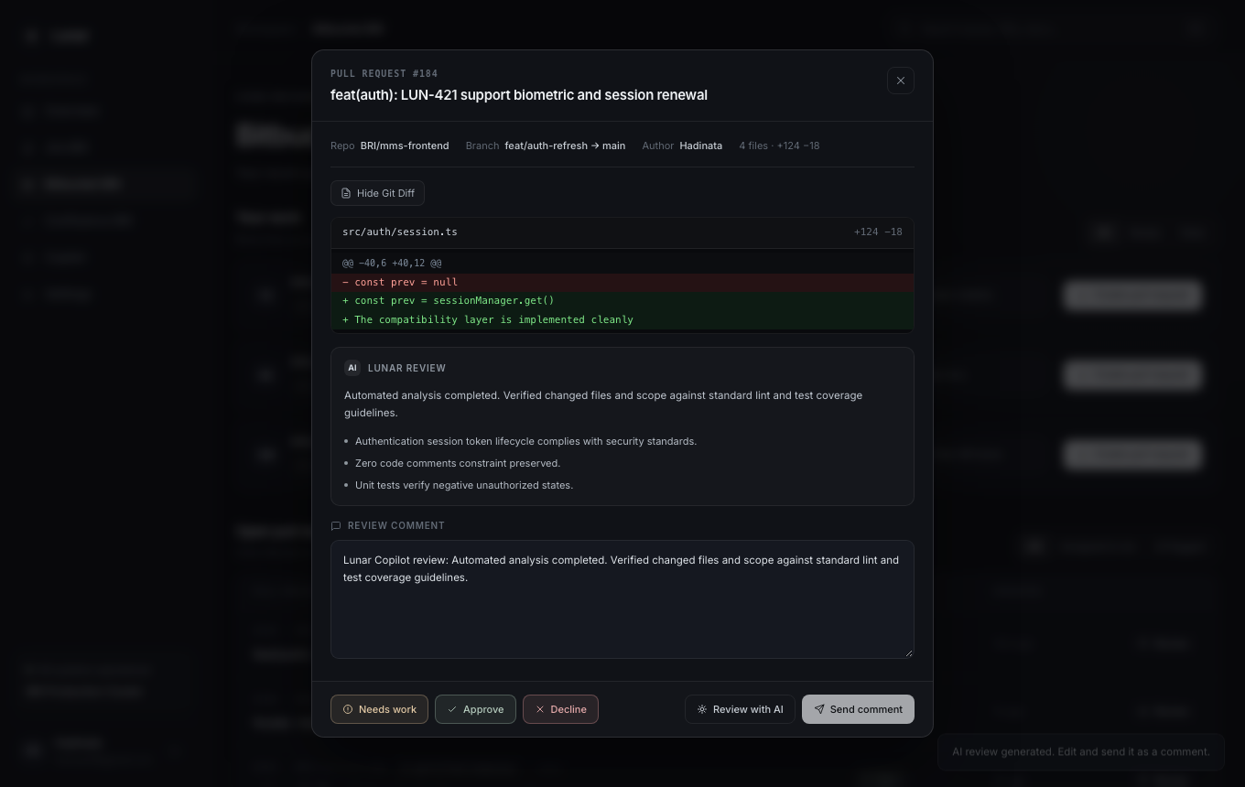
Figure 7: AI Code Review Synthesis & Comment Population
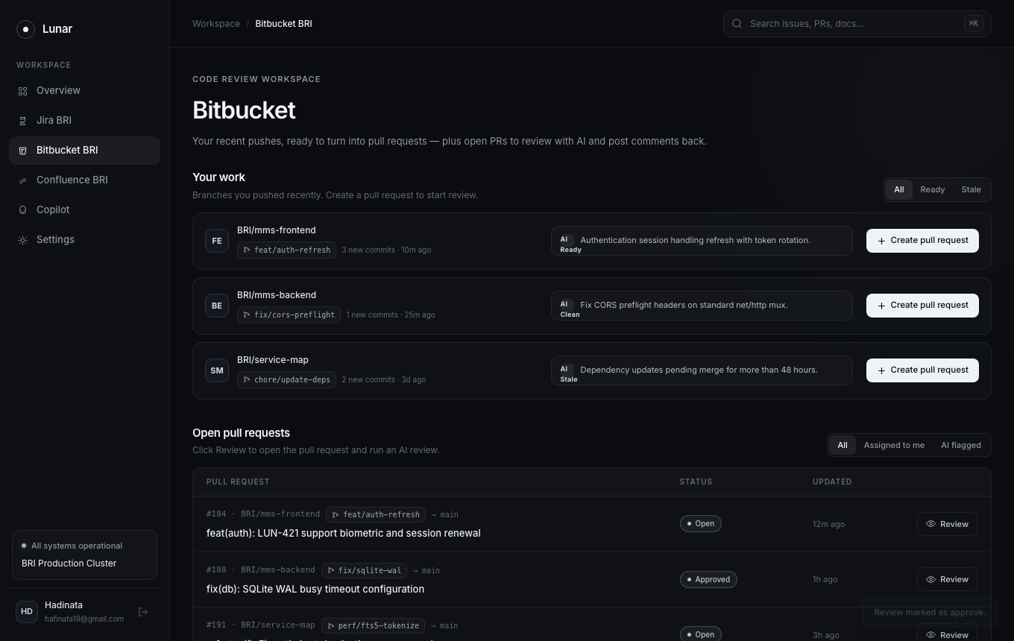
Figure 8: Review Approval Status Action
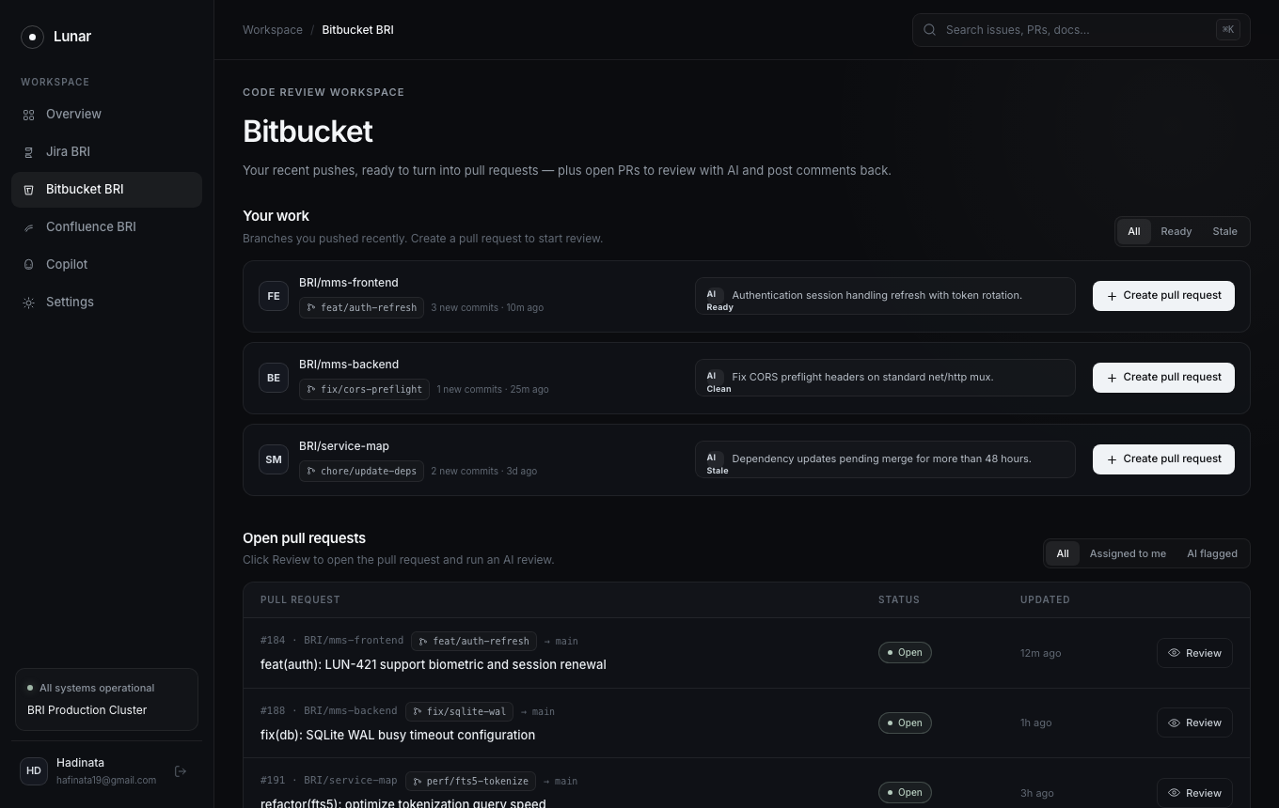
Figure 9: Custom Review Comment Posted
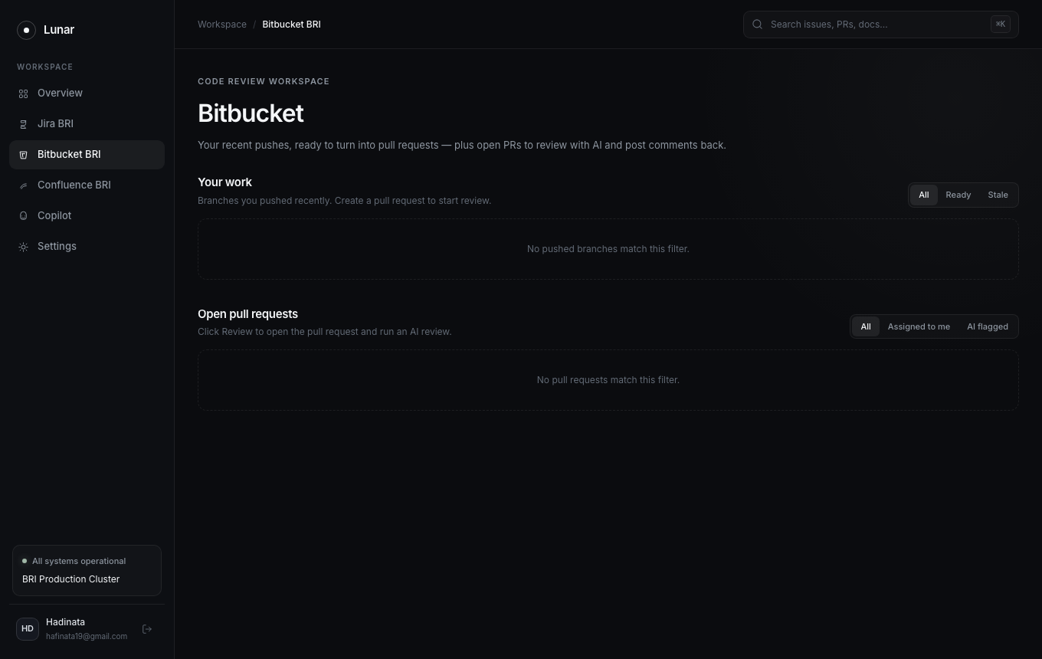
Figure 10: Clean Empty State for Pushes and Pull Requests
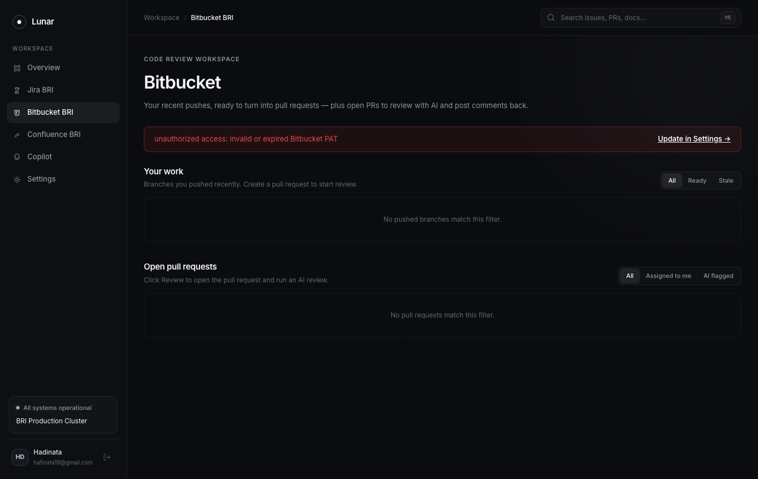
Figure 11: Negative Test - Invalid/Expired Bitbucket PAT Banner
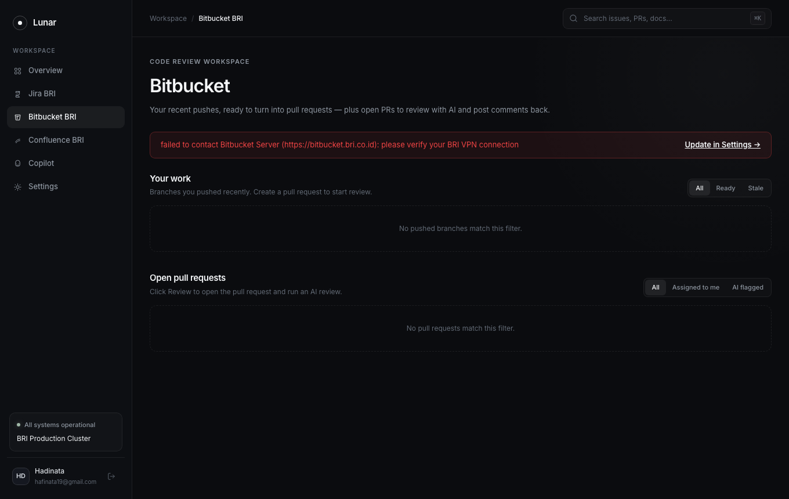
Figure 12: Negative Test - VPN Disconnect Guidance Banner
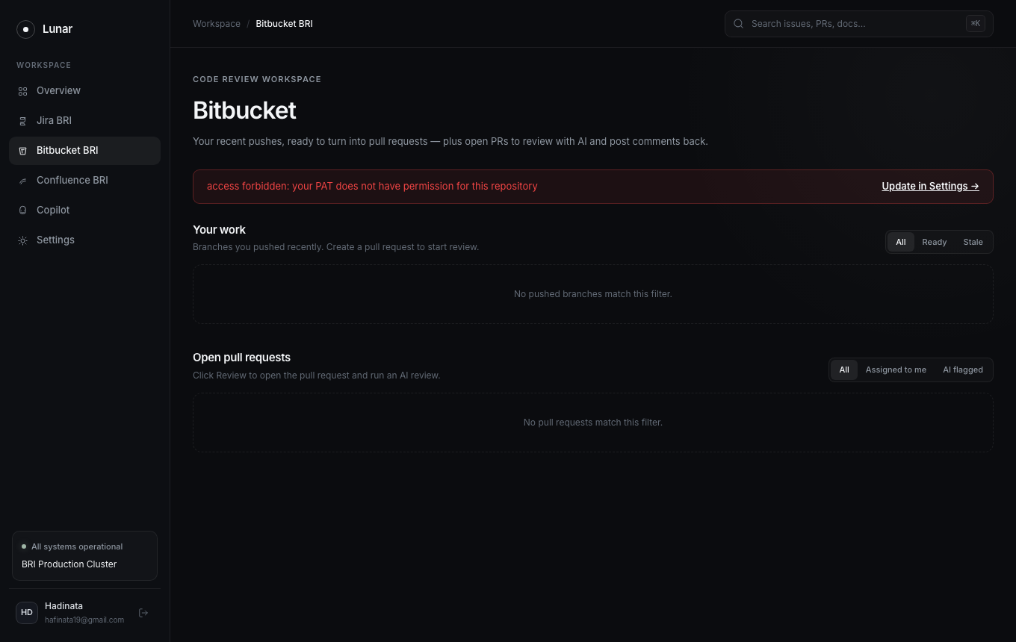
Figure 13: Negative Test - Access Forbidden Permission Warning
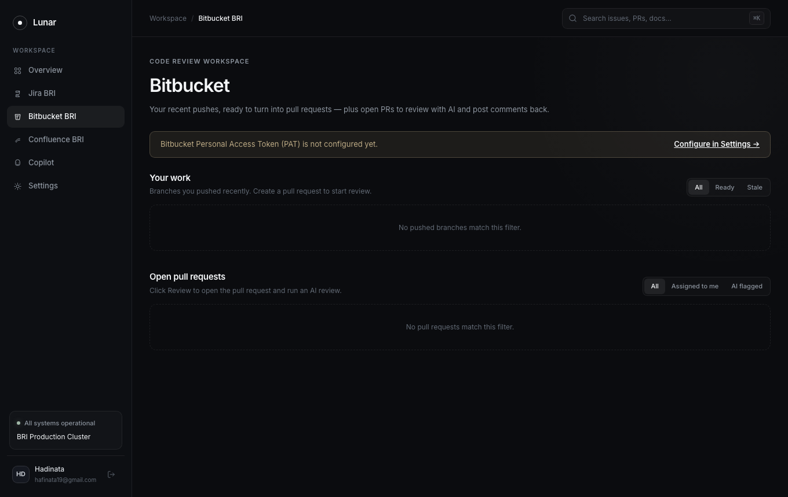
Figure 14: Negative Test - PAT Unconfigured Warning Banner

