Lunar QA Automation: AI Copilot & Active Tools
Target: http://localhost:5173/copilot | Status: PASSED (100%) | Date: 2026-09-29

Test Scenarios & Results
1. Clean Empty History Initial State - Passed
2. Active Copilot Tools Modal Triggered via Sidebar Gear Icon - Passed
3. Active Tool Gating Toggled - Passed
4. Thinking Mode Toggle & Reasoning Effort Selector (High Effort) - Passed
5. Dynamic AI Engine Selection (DeepSeek-V4 Pro) - Passed
6. Assistant Response Synthesis with Collapsible Chain-of-Thought (CoT) - Passed
7. Sidebar Conversation Entry & Delete Button on Hover - Passed
8. Deleting Conversation & Resetting to Empty State - Passed

Visual Evidence
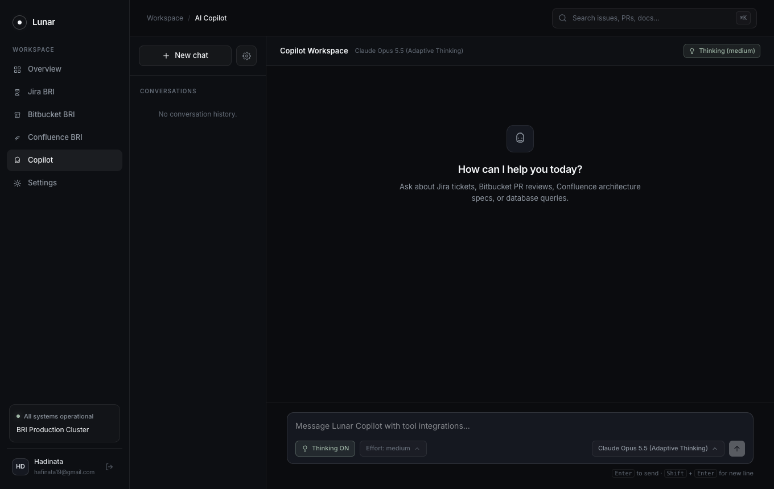
Figure 1: Copilot Clean Empty State
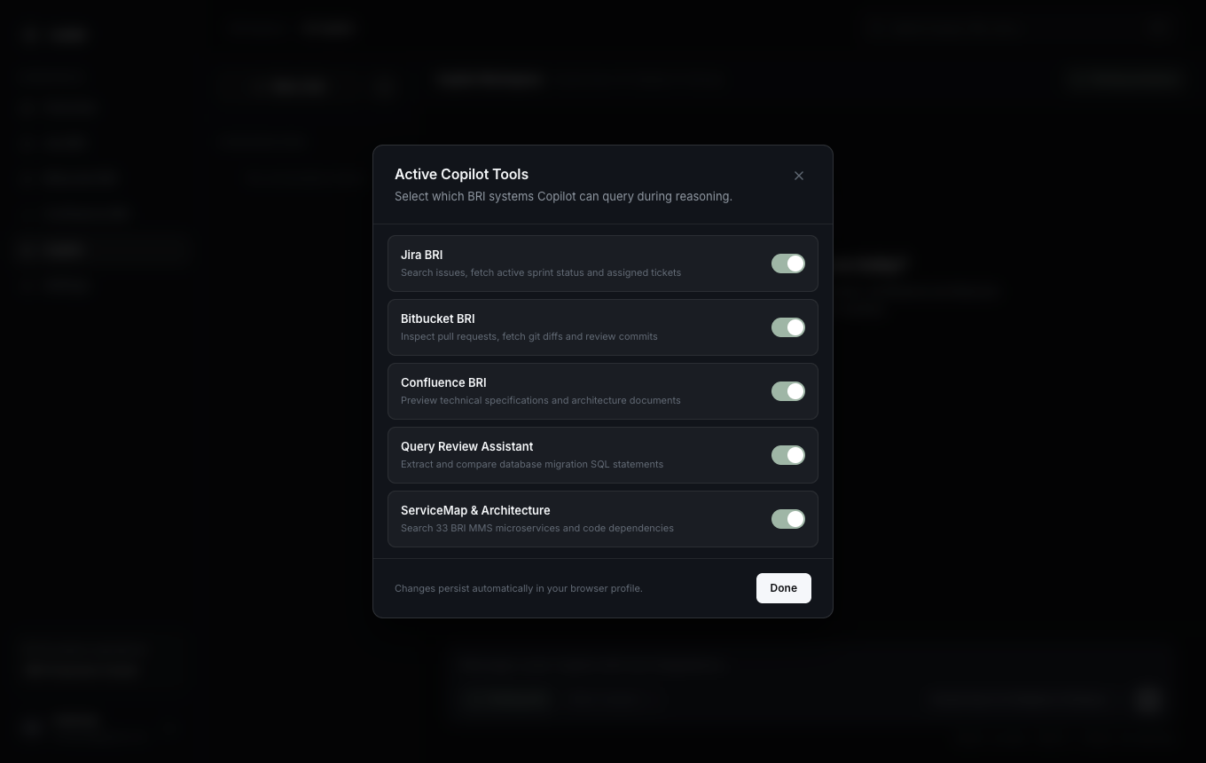
Figure 2: Active Tools Configuration Modal
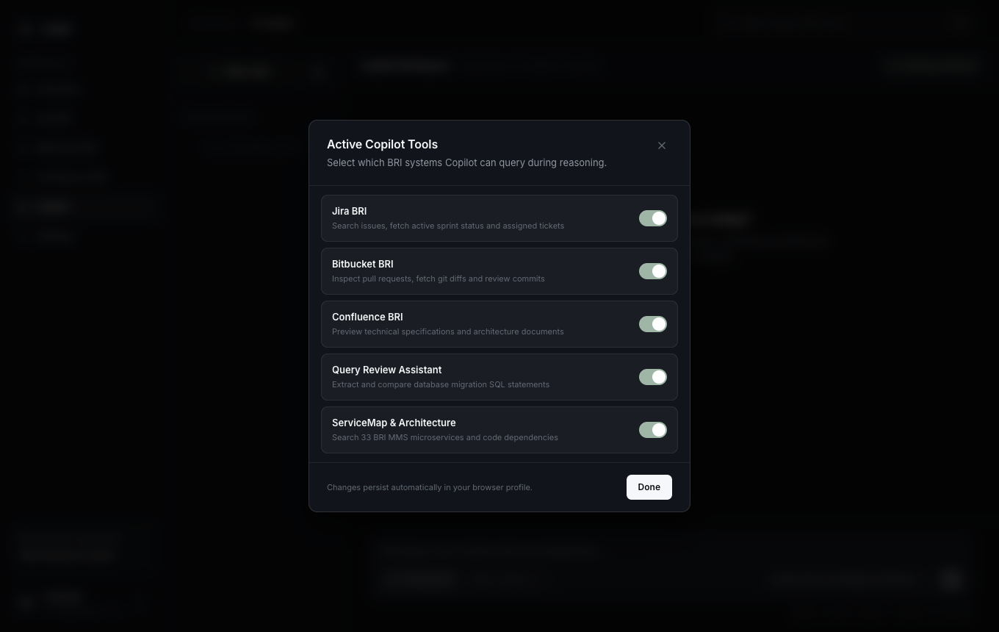
Figure 3: Tool Selection Toggled State
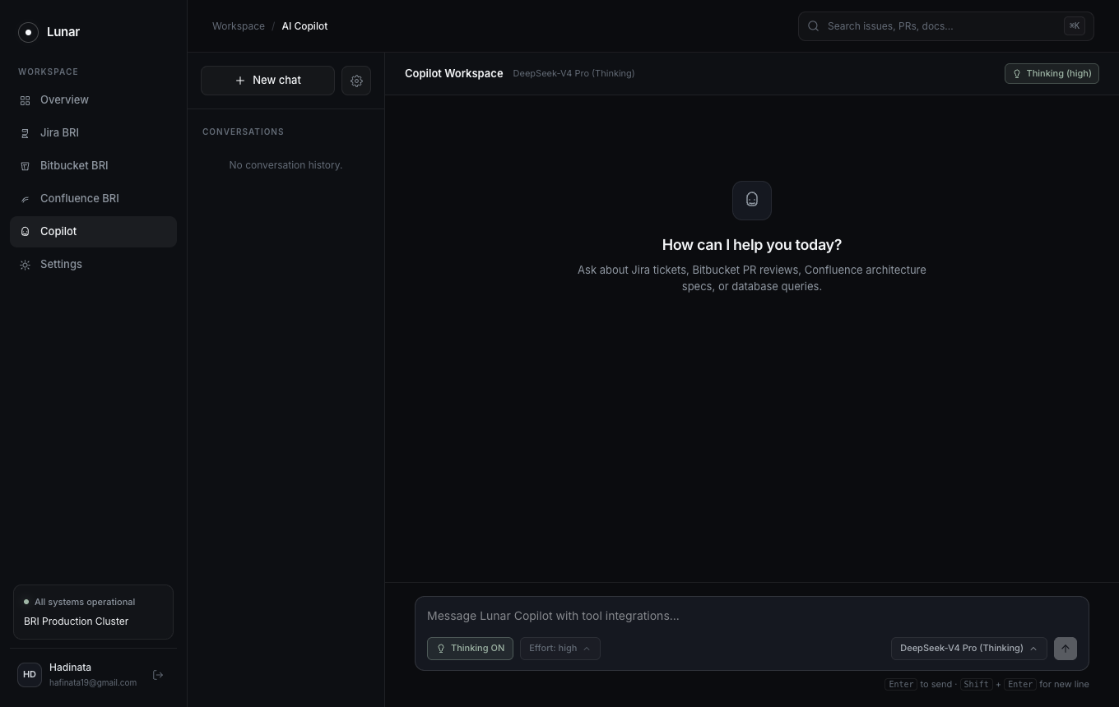
Figure 4: DeepSeek-V4 Pro with High Effort Selected
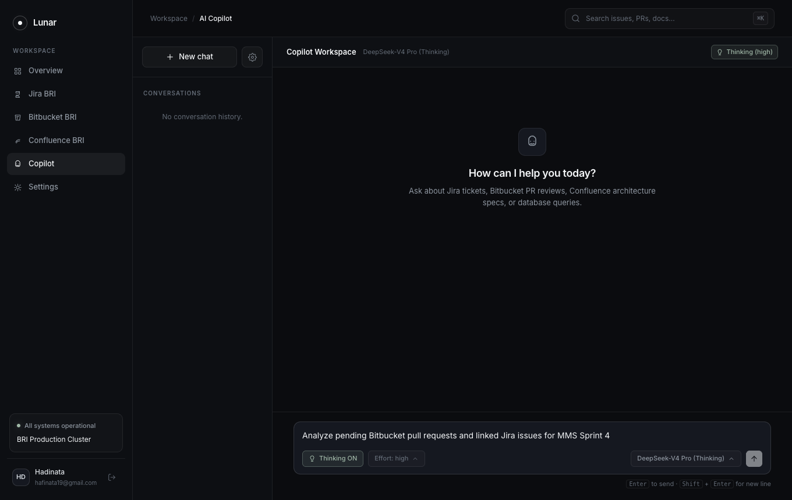
Figure 5: Query Prompt Composed
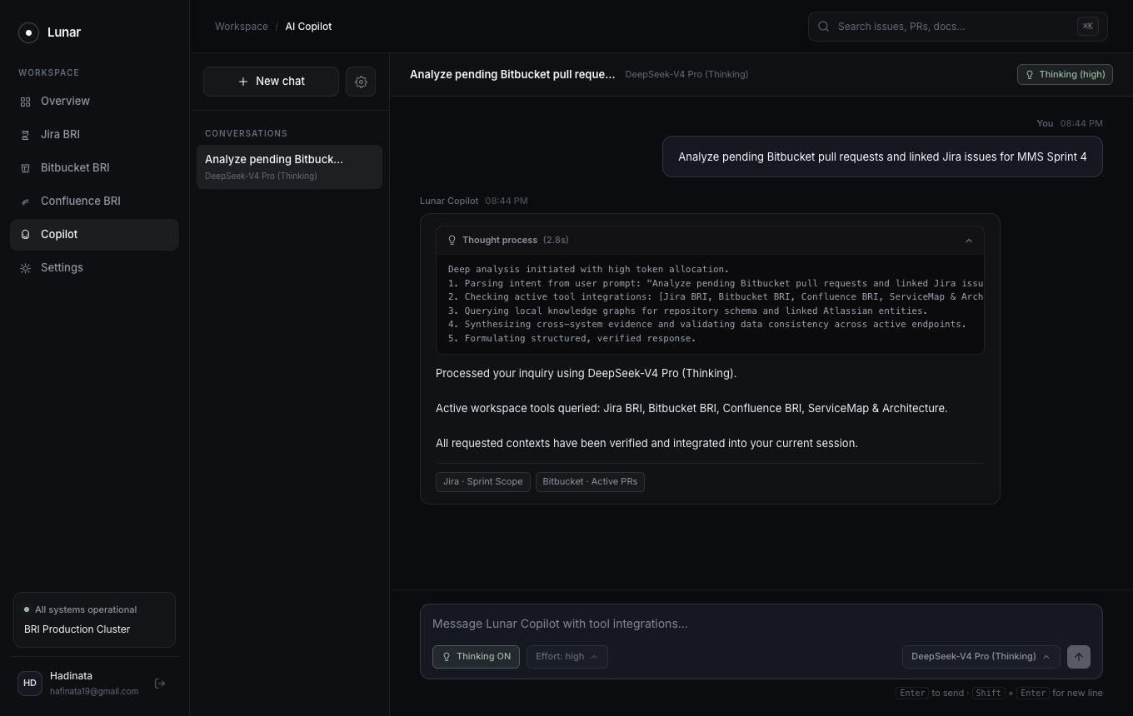
Figure 6: Synthesized Response with Collapsible CoT Thought Process
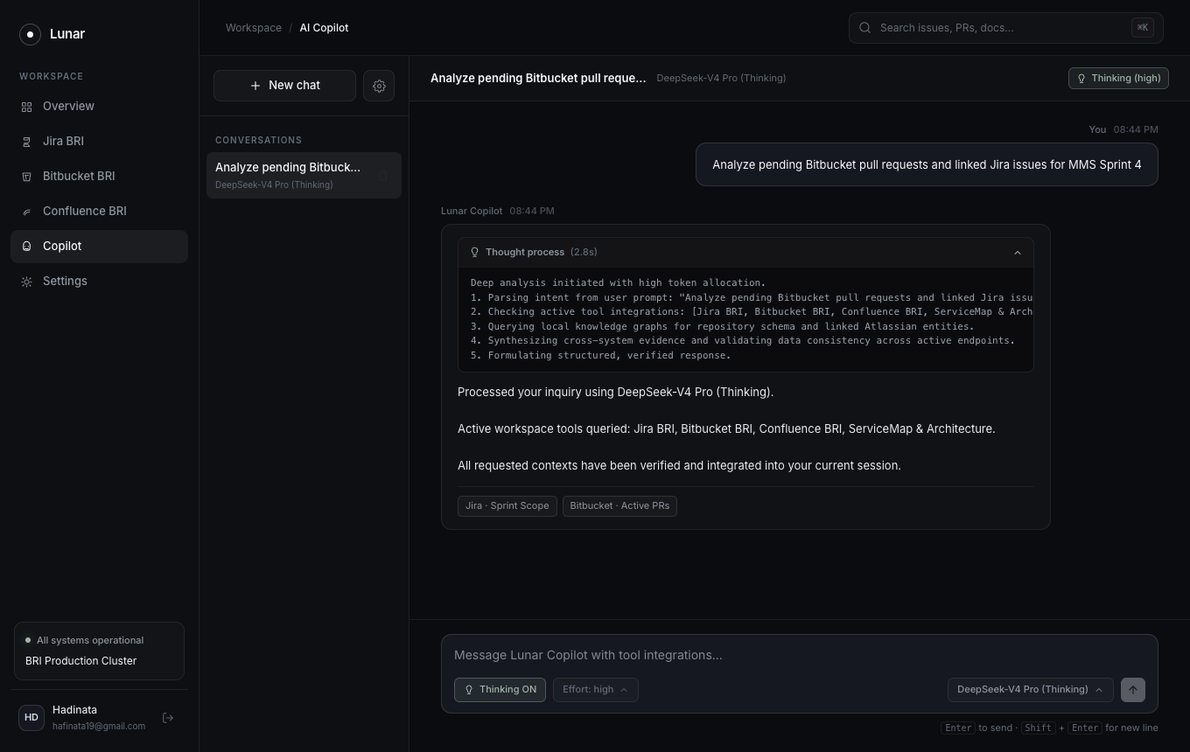
Figure 7: Sidebar Session with Delete Button on Hover
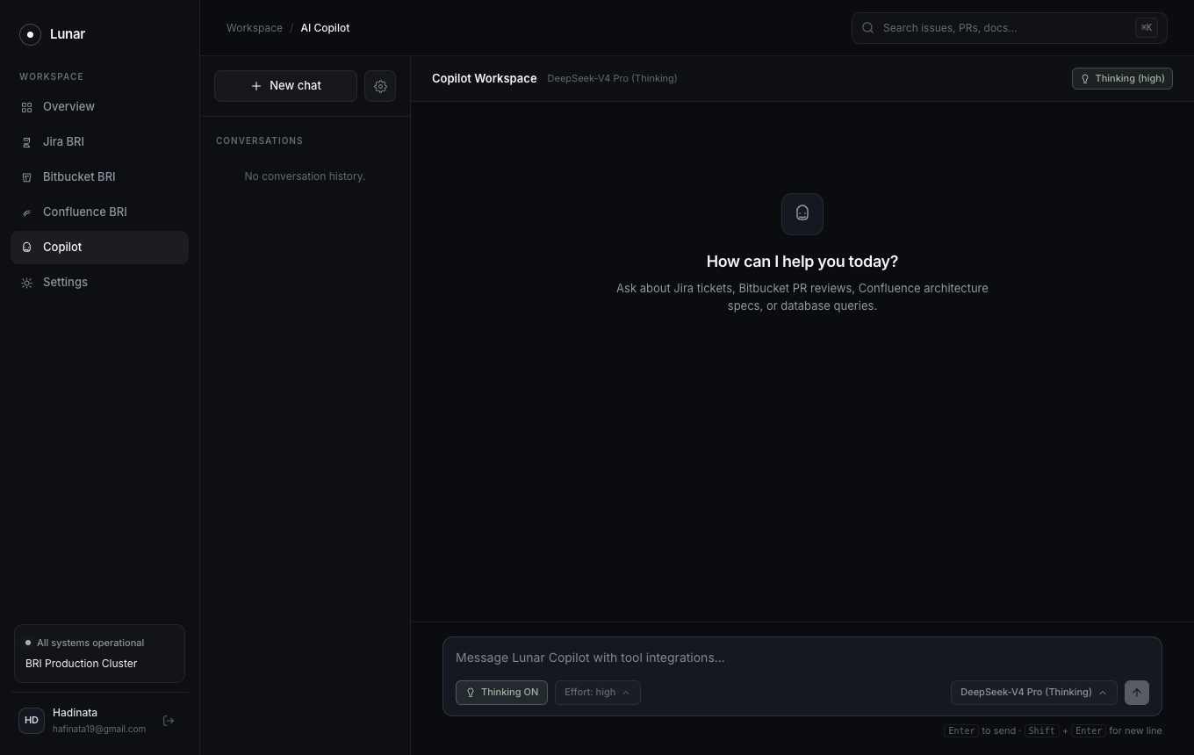
Figure 8: Session Deleted Returning to Empty History State

