Lunar QA Automation: Operations Overview Dashboard
Target: http://localhost:5173/dashboard | Status: PASSED (100%) | Date: 2026-09-29

Test Scenarios & Results
1. Real-time Metric Cards Rendering (Tickets, PRs, Docs, Tools) - Passed
2. Workspace Synchronization Trigger & State Transition - Passed
3. Workspace Quick Access Action Tiles (Copilot, Jira, Bitbucket, Vault) - Passed

Visual Evidence
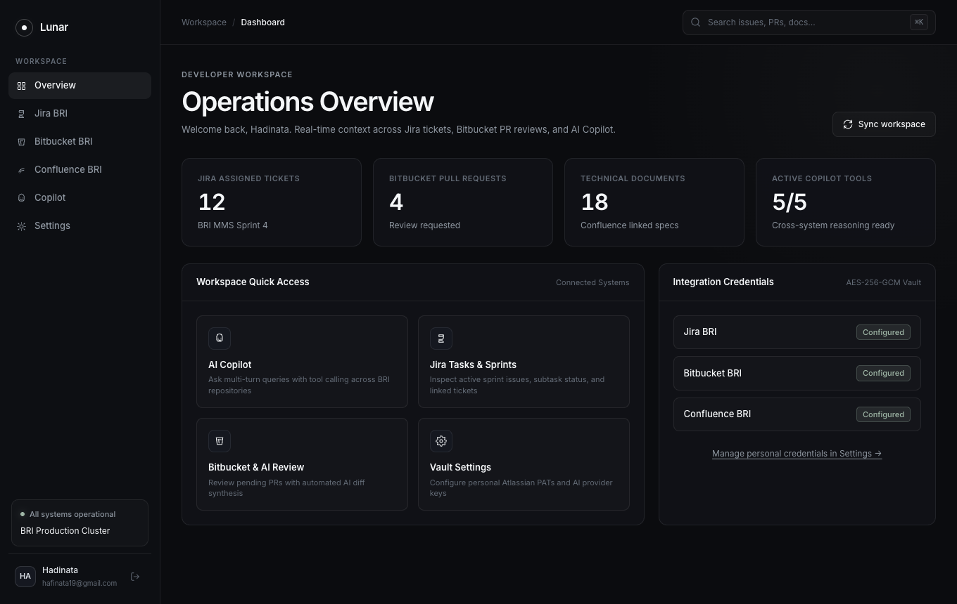
Figure 1: Real-time Metric Cards
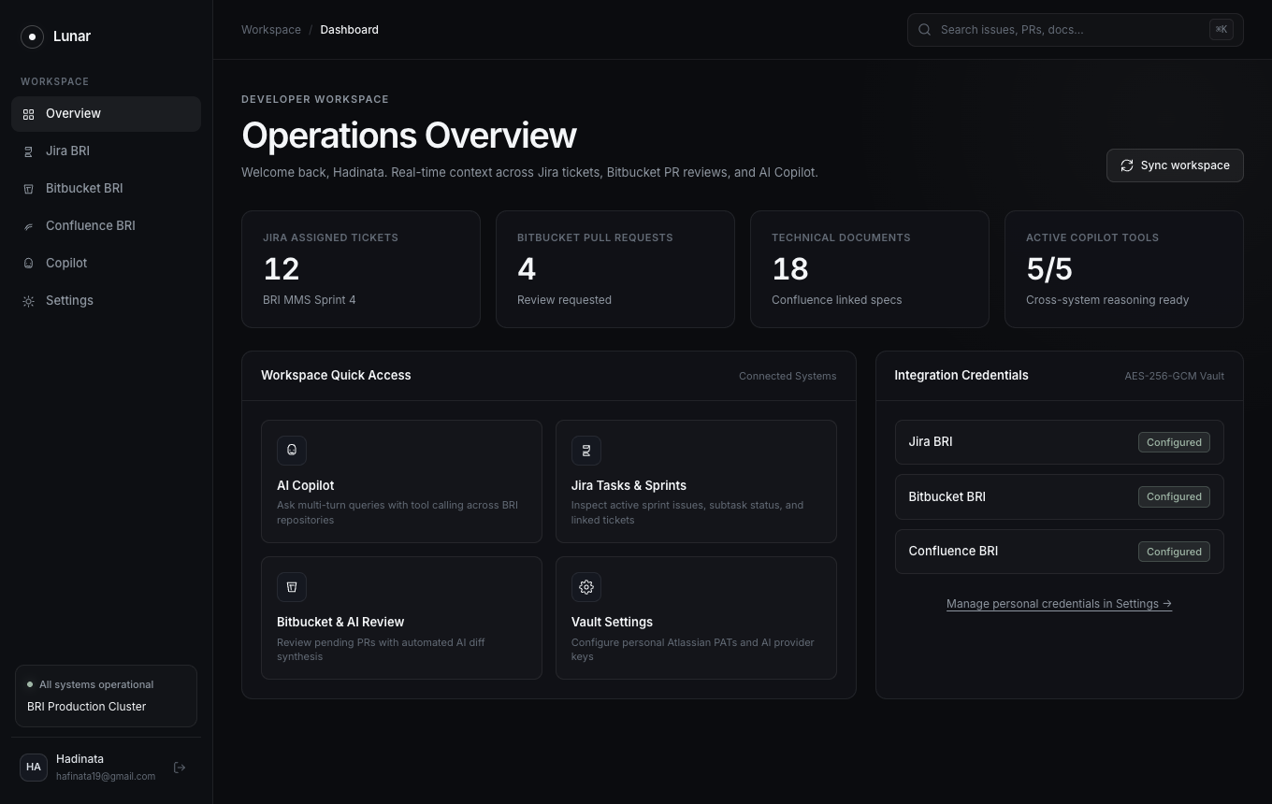
Figure 2: Workspace Synchronization State
Figure 3: Quick Access Action Tiles

