Lunar QA Automation: Settings & Credential Vault
Target: http://localhost:5173/settings | Status: PASSED (100%) | Date: 2026-09-29

Test Scenarios & Results
1. Integrations Settings Tab Initial State - Passed
2. Populating Jira, Bitbucket, and Confluence PATs - Passed
3. Saving Integration Credentials to AES-256-GCM Vault - Passed
4. Official AI Providers Validation (GPT-6 Astra, Claude Opus 5.5, Gemini 3.8 Flash, deepseek-v4-pro, mimo-v2.5-pro) - Passed
5. Standardized Placeholders & Saving Gemini and DeepSeek Keys - Passed
6. Security & Encryption Details Overview - Passed

Visual Evidence
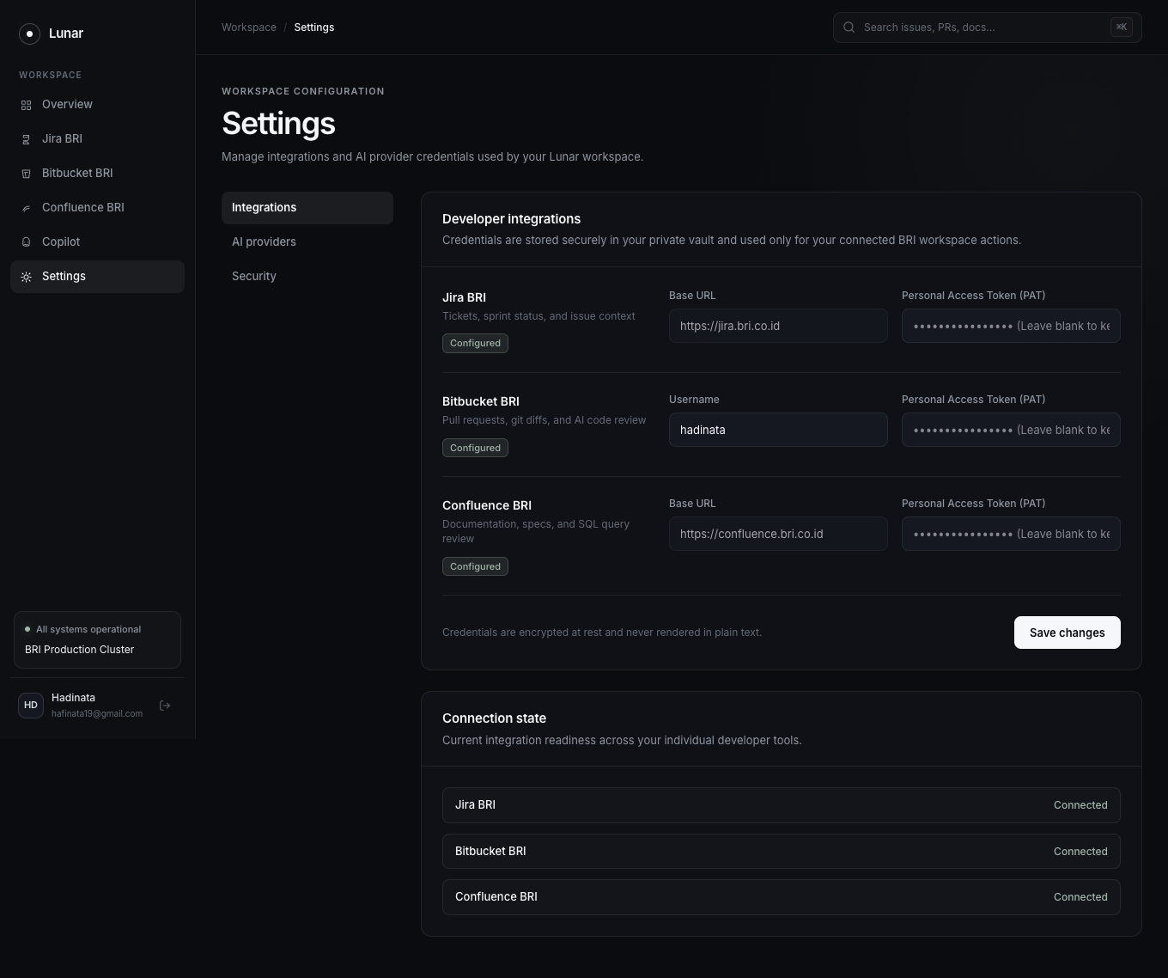
Figure 1: Integrations Tab Initial State
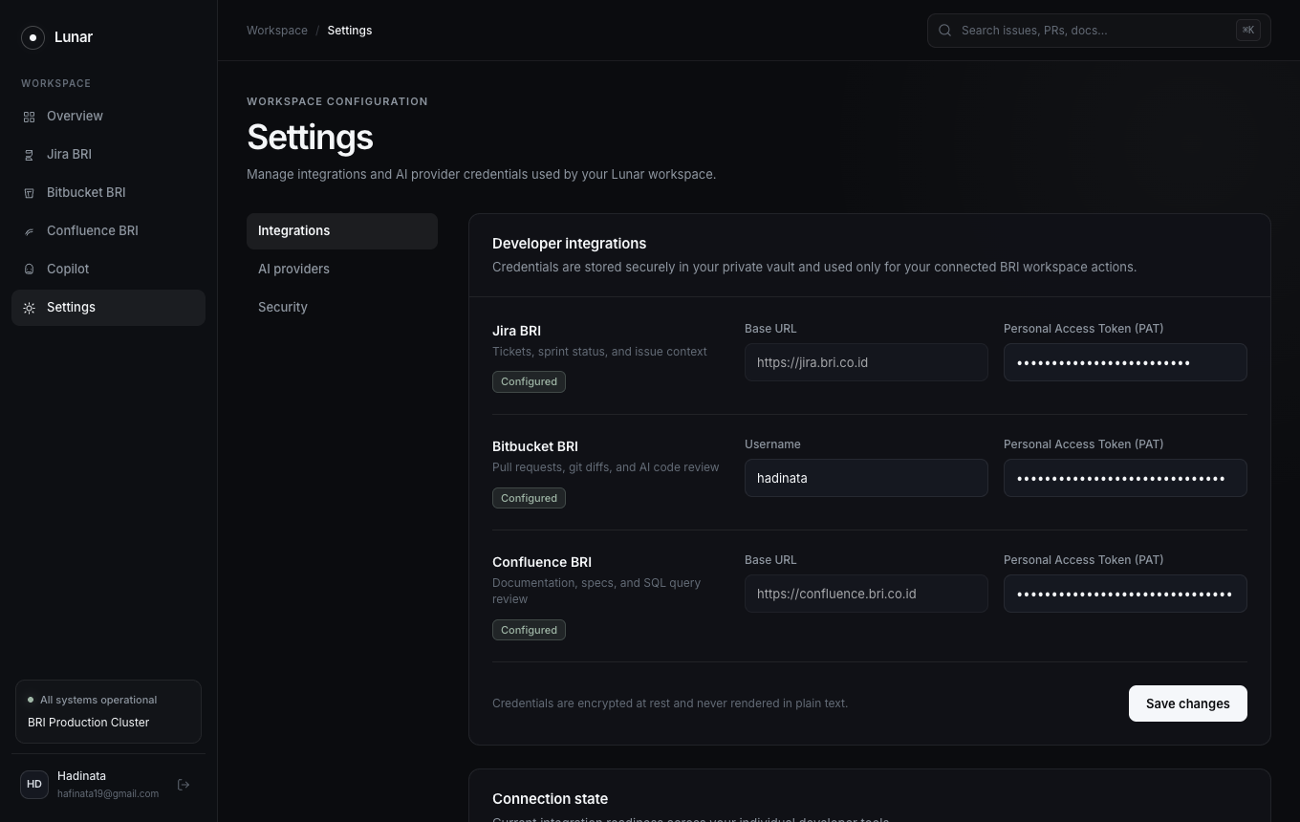
Figure 2: Populated Atlassian Credentials
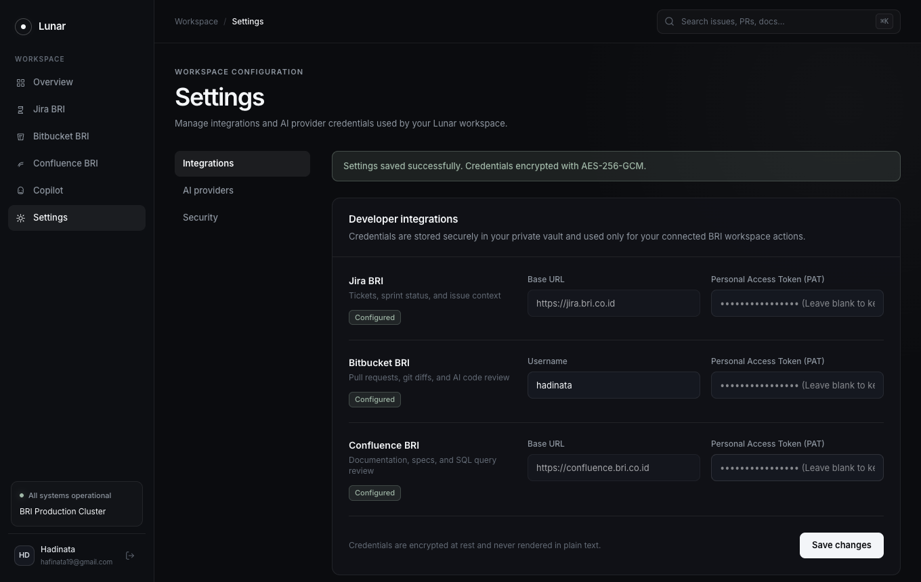
Figure 3: Encrypted Credentials Saved Toast
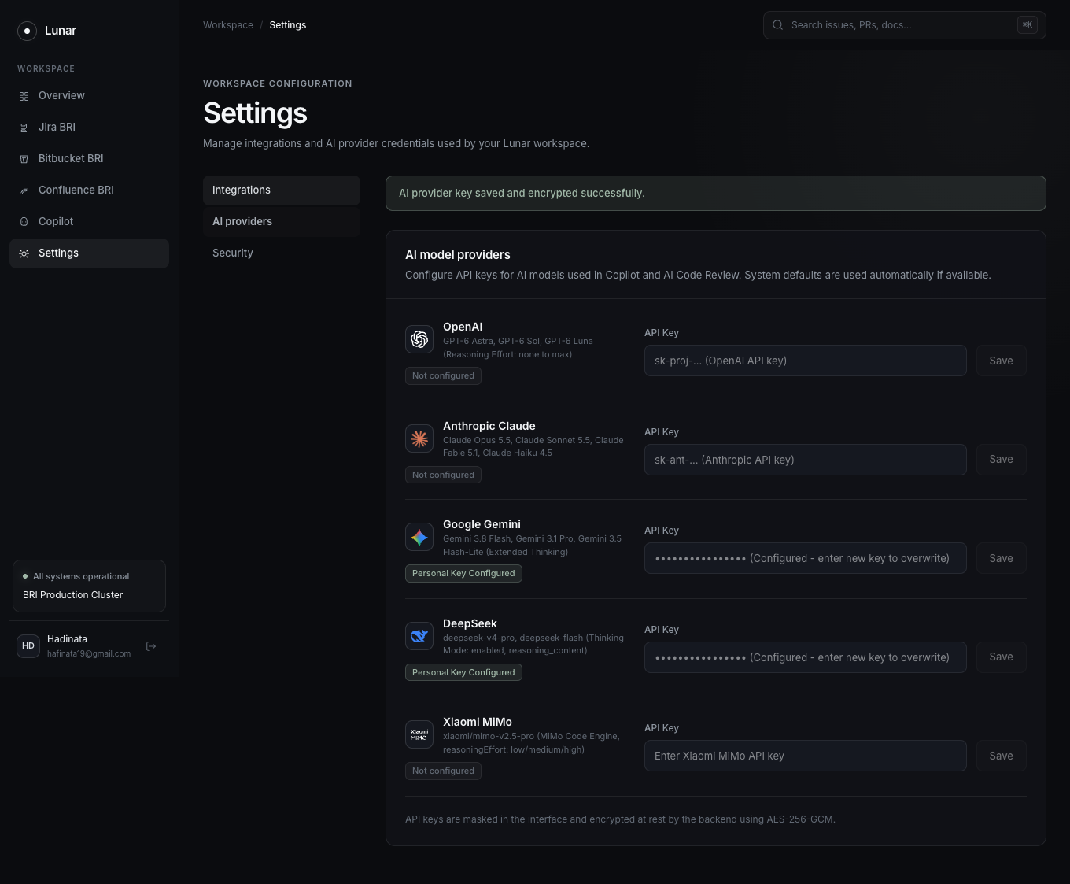
Figure 4: Official AI Providers Management Tab
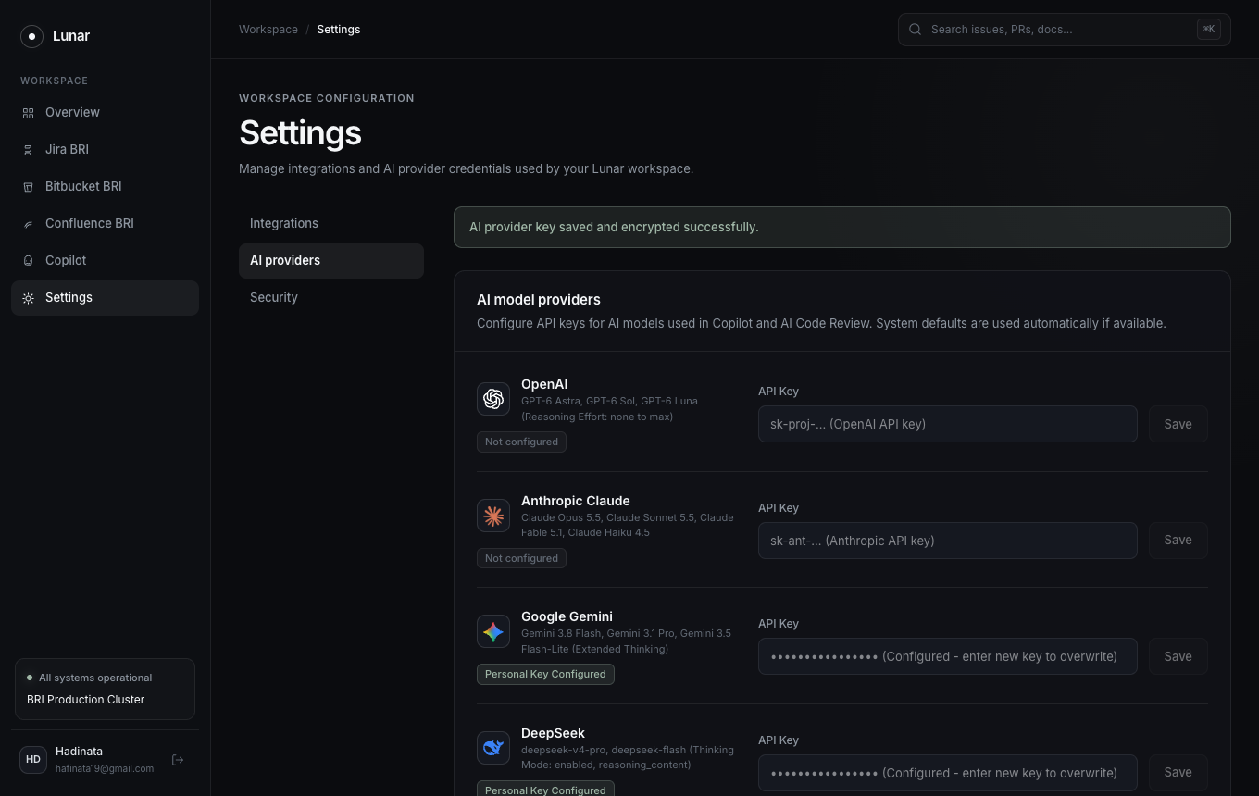
Figure 5: Encrypted API Key Saved Toast
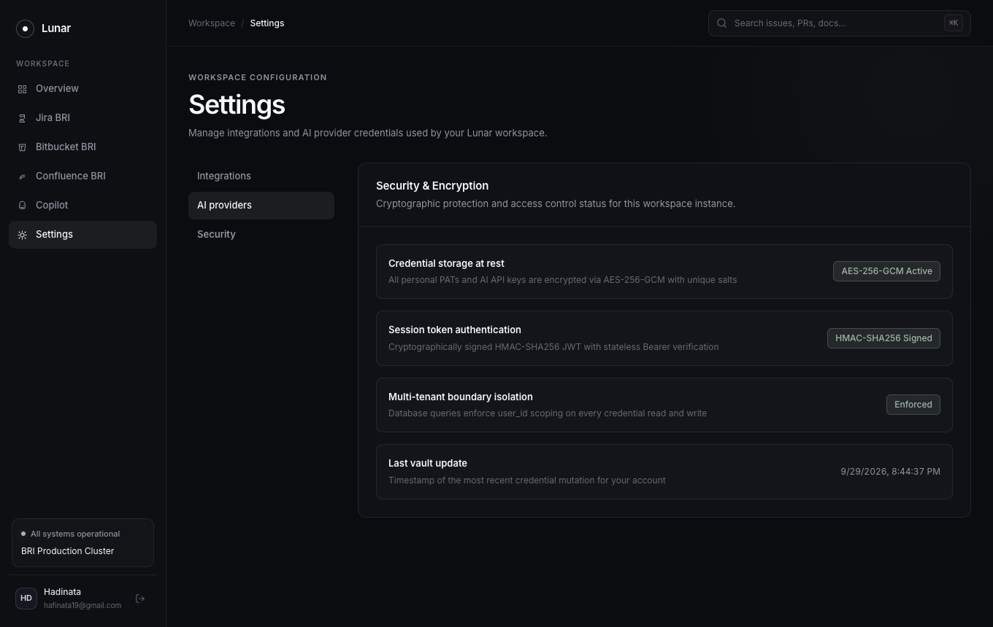
Figure 6: Cryptographic Vault Specifications

