Hospital Readmission Analysis

1.What are the demographic and clinical profiles of the study population?
Variable | Result
Number of patients | 5000
Mean age | 53.29
Median age | 53
Male | 2478
Female | 2518
Mean hospital stay | 7.398519
Mean procedures | 4.462770
Mean comorbidity score | 2.068855
Most common diagnosis | Kidney Disease
Readmission rate | 18.81%
The dataset consists of 5,000 patients with diverse demographic and clinical characteristics. The average age of the patients was 53.29 years, with 49.56% males and 50.44% females. The average length of hospital stay was 7.40 days, while the mean comorbidity score was 2.07. The most common primary diagnosis was Kidney Disease. Overall, 18.81% of patients were readmitted to the hospital.
2.What is the overall hospital readmission rate?
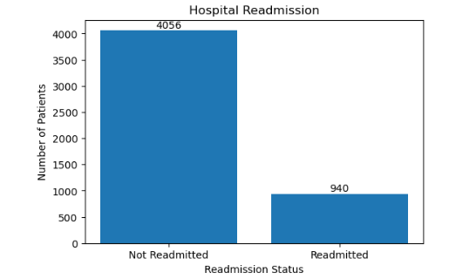
Out of 5,000 patients, 18.81% were readmitted to the hospital, while 81.19% were not. This indicates that nearly one-fifth of the patients experienced hospital readmission.

3.What is the distribution of patients' ages?
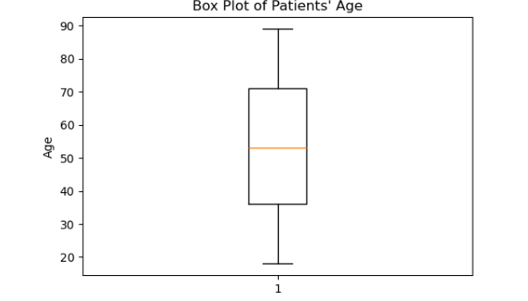
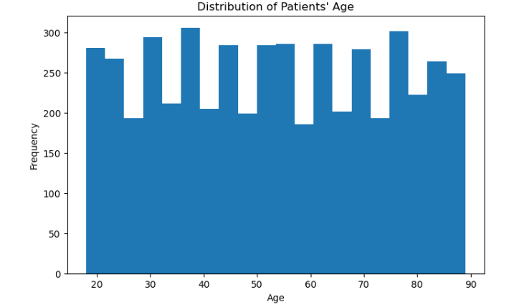
Based on the Histogram and Box Plot, the distribution of patients' ages is approximately symmetric and closely follows a normal distribution. This is confirmed by the skewness value of 0.0095, which is extremely close to zero. The ages span from a minimum of 18 to a maximum of 89 years, with a median in the mid-54s. Additionally, the box plot confirms that the data is completely free of any outliers.

4.Which primary diagnoses are most common among patients, and how are they distributed?
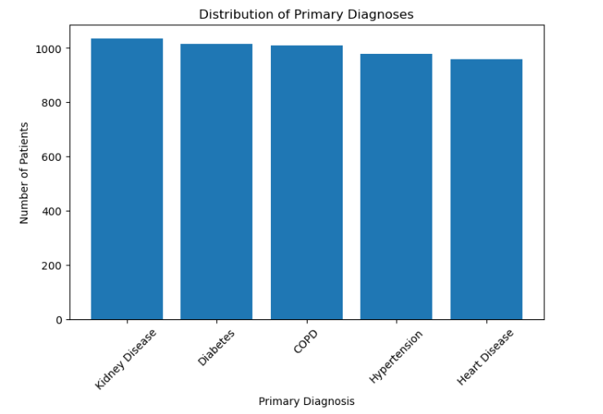
Kidney Disease was the most common primary diagnosis among patients, followed by Diabetes and COPD. In contrast, Heart Disease was the least frequent diagnosis in the dataset.

5.Does age differ between readmitted and non-readmitted patients?
5.1. Box plot:
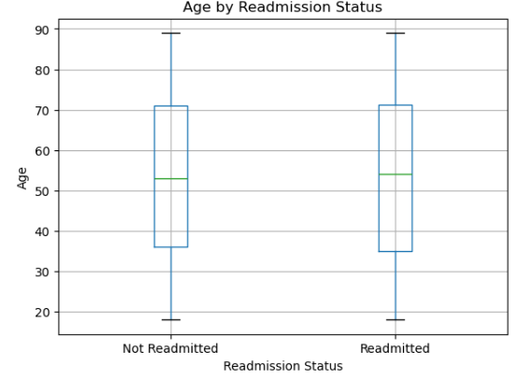
Figure 5.1 Box plot showing the distribution of age by readmission status:
5.2.Shapiro-Wilk Test:
Group | Statistic | p-value | Decision
Not Readmitted | 0.9560612803165769 | 2.531272802033e-33 | Not Normally Distributed
Readmitted | 0.9487634297144052 | 1.509372152922e-17 | Not Normally Distributed
Although the Shapiro–Wilk test indicated a significant deviation from normality (p < 0.05), visual inspection of the box plot and the skewness values suggested that the age distribution was approximately symmetric and free of extreme outliers. Therefore, given the large sample sizes (n > 30), the Independent Samples T-test was considered appropriate based on the Central Limit Theorem.
5.3. Levene's Test:
Test | Statistic | p-value | Decision
Levene's Test | 1.08949475605 | 0.29663370389 | Equal Variances
The assumption of homogeneity of variances was satisfied.
5.4. Independent Samples T-test:
Test | T-statistic | p-value | Decision
Independent Samples T-test | -0.114 | 0.908911 | Not Significant
An Independent Samples T-test was conducted to compare the age of readmitted and non-readmitted patients. The results showed no statistically significant difference in age between the two groups (t = -0.114, p = 0.909). Therefore, age was not significantly associated with hospital readmission in this dataset.
6. Is gender associated with hospital readmission?
6.1.Cross Tabulation:
Gender | Not Readmitted | Readmitted
Female | 2029 | 489
Male | 2027 | 451
The contingency table shows that the numbers of readmitted and non-readmitted patients are similar for both males and females. However, a statistical test is required to determine whether this difference is statistically significant.
6.2. Grouped Bar Chart:
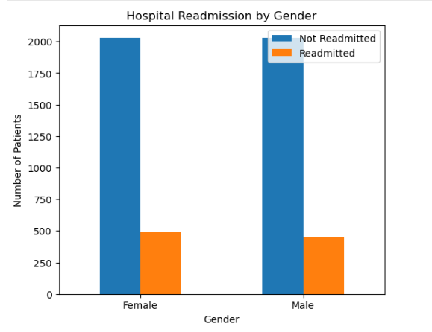
Figure 6.1 Distribution of hospital readmission by gender
6.3. Chi-Square Test:
Test | Chi-square Statistic | p-value | Decision
Chi-Square Test of Independence | 1.138 | 0.286 | Not Significant
A Chi-Square Test of Independence was conducted to examine the association between gender and hospital readmission. The results indicated no statistically significant association between gender and hospital readmission (χ² = 1.138, p = 0.286). Therefore, gender was not a significant factor associated with hospital readmission in this dataset.

7.Do the length of hospital stay, number of procedures, and comorbidity score differ between readmitted and non-readmitted patients?
7.1. Days in Hospital:
7.1.1.box plot:
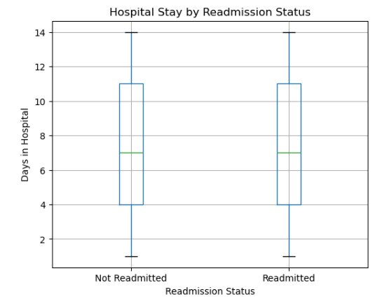
Figure 7.1: Distribution of the length of hospital stay by readmission status.
7.1.2. Shapiro-Wilk Test:
Group | Statistic | p-value | Decision
Not Readmitted | 0.9443854851319141 | 1.278637611510e-36 | Not Normally Distributed
Readmitted | 0.9446383941712276 | 2.882714272810e-18 | Not Normally Distributed
Although the Shapiro–Wilk test indicated a significant deviation from normality (p < 0.05), the box plot and skewness values suggested that the distribution of the length of hospital stay was approximately symmetric and free of extreme outliers. Given the large sample sizes (n > 30), the Independent Samples T-test was considered appropriate based on the Central Limit Theorem.
7.1.3. Levene's Test:
Test | Statistic | p-value | Decision
Levene's Test | 0.1228124272082 | 0.726018759277 | Equal Variances
The assumption of homogeneity of variances was satisfied.
7.1.4. Independent Samples T-test:
Test | T-statistic | p-value | Decision
Independent Samples T-test | 0.70675666124729 | 0.47975068485717 | Not Significant
An Independent Samples T-test was conducted to compare the length of hospital stay between readmitted and non-readmitted patients. The results showed no statistically significant difference between the two groups (t = 0.707, p = 0.480). Therefore, the length of hospital stay was not significantly associated with hospital readmission in this dataset.
7.2.1. number of procedures:

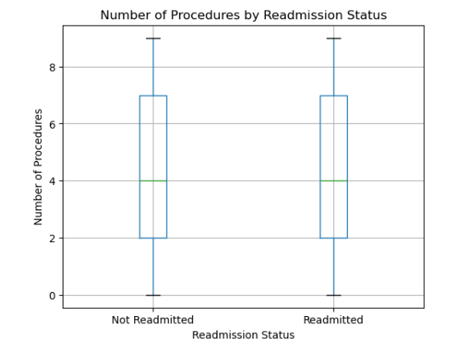
Figure 7.2: Distribution of the number of procedures by readmission status.
7.2.2. Shapiro-Wilk Test:
Group | Statistic | p-value | Decision
Not Readmitted | 0.9325523349301128 | 1.935777648331e-39 | Not Normally Distributed
Readmitted | 0.9397350677238621 | 4.50590751802e-19 | Not Normally Distributed
Although the Shapiro–Wilk test indicated a significant deviation from normality (p < 0.05), the box plot and skewness values suggested that the distribution of the number of procedures was approximately symmetric and free of extreme outliers. Given the large sample sizes (n > 30), the Independent Samples T-test was considered appropriate based on the Central Limit Theorem.
7.2.3. Levene's Test:
Test | Statistic | p-value | Decision
Levene's Test | 2.688608107082 | 0.1011310486342 | Equal Variances
The assumption of homogeneity of variances was satisfied.
7.1.4. Independent Samples T-test:
Test | T-statistic | p-value | Decision
Independent Samples T-test | 0.213228464167713 | 0.831157471226 | Not Significant
An Independent Samples T-test was conducted to compare the number of procedures between readmitted and non-readmitted patients. The results showed no statistically significant difference between the two groups (t = 0.213, p = 0.831). Therefore, the number of procedures was not significantly associated with hospital readmission in this dataset.
7.3.1. comorbidity score:
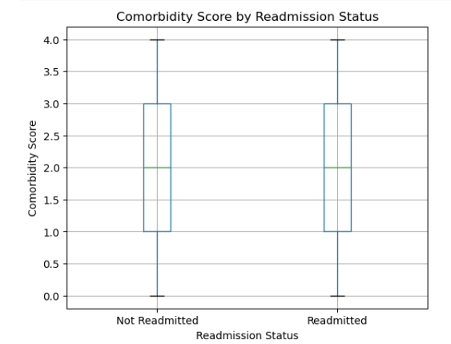
Figure 7.3: Distribution of comorbidity score by readmission status.
7.3.2. Shapiro-Wilk Test:
Group | Statistic | p-value | Decision
Not Readmitted | 0.8856067073604466 | 1.0124047133432e-47 | Not Normally Distributed
Readmitted | 0.8841169786766558 | 6.469393519028e-26 | Not Normally Distributed
Although the Shapiro–Wilk test indicated a significant deviation from normality (p < 0.05), the box plot and skewness values suggested that the distribution of the comorbidity score was approximately symmetric and free of extreme outliers. Given the large sample sizes (n > 30), the Independent Samples T-test was considered appropriate based on the Central Limit Theorem.
7.3.3. Levene's Test:
Test | Statistic | p-value | Decision
Levene's Test | 0.0015365679806 | 0.9687332328832 | Equal Variances
The assumption of homogeneity of variances was satisfied.
7.1.4. Independent Samples T-test:
Test | T-statistic | p-value | Decision
Independent Samples T-test | 0.094756821602599 | 0.924511785433206 | Not Significant
An Independent Samples T-test was conducted to compare the comorbidity score between readmitted and non-readmitted patients. The results showed no statistically significant difference between the two groups (t = 0.095, p = 0.925). Therefore, the comorbidity score was not significantly associated with hospital readmission in this dataset.
8.Is primary diagnosis associated with hospital readmission?
8.1.Cross Tabulation:
primary_diagnosis | Not Readmitted | Readmitted
COPD | 822 | 187
Diabetes | 818 | 198
Heart Disease | 783 | 175
Hypertension | 804 | 174
Kidney Disease | 829 | 206

8.2. Grouped Bar Chart:
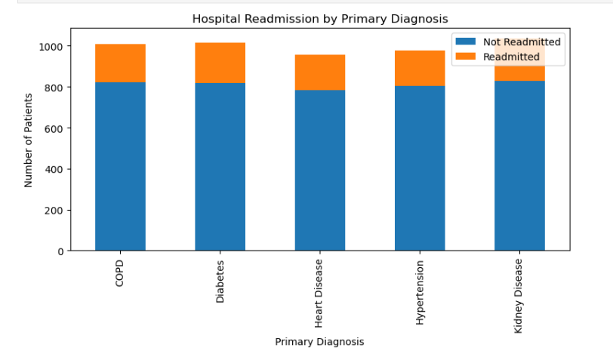
Figure 8.1: Hospital readmission by primary diagnosis.
6.3. Chi-Square Test:
Test | Chi-square Statistic | p-value | Degrees of Freedom | Decision
Chi-Square Test of Independence | 2.0155399024118488 | 0.7329005056851845 | 4 | Not Significant
A Chi-Square Test of Independence was conducted to examine the association between primary diagnosis and hospital readmission. The results indicated no statistically significant association between the two variables (χ² = 2.016, df = 4, p = 0.733). Therefore, hospital readmission was independent of the primary diagnosis in this dataset.

9.Is discharge destination associated with hospital readmission?
9.1.Cross Tabulation:
discharge_to | Not Readmitted | Readmitted
Home | 1052 | 252
Home Health Care | 1045 | 251
Rehabilitation Facility | 987 | 233
Skilled Nursing Facility | 972 | 204

8.2. Grouped Bar Chart:
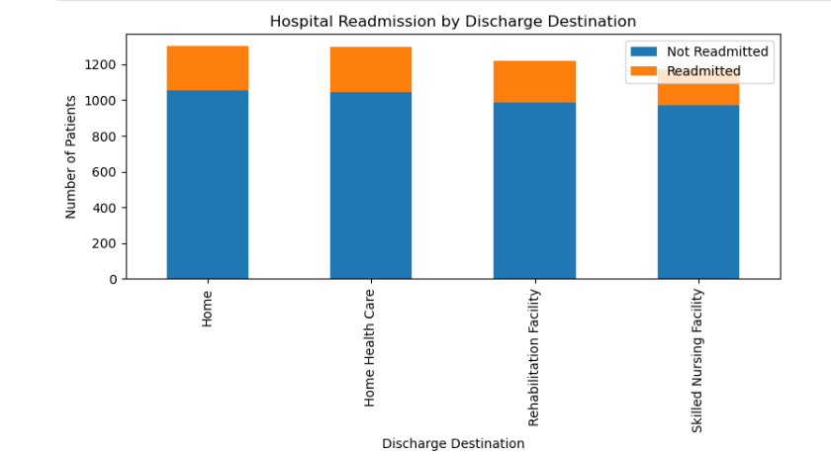
Figure 9.1: Hospital readmission by discharge destination.
9.3. Chi-Square Test:
Test | Chi-square Statistic | p-value | Degrees of Freedom | Decision
Chi-Square Test of Independence | 2.204357928096209 | 0.5310905054487054 | 3 | Not Significant
A Chi-Square Test of Independence was conducted to examine the association between discharge destination and hospital readmission. The results showed no statistically significant association between the two variables (χ² = 2.204, df = 3, p = 0.531). Therefore, hospital readmission was independent of discharge destination in this dataset.

10.What are the relationships among age, length of hospital stay, number of procedures, and comorbidity score?
Variables | Correlation (r) | Interpretation
Age & Days in Hospital | -0.015 | Very Weak Negative
Age & Number of Procedures | 0.017 | Very Weak Positive
Age & Comorbidity Score | -0.017 | Very Weak Negative
Days in Hospital & Number of Procedures | -0.025 | Very Weak Negative
Days in Hospital & Comorbidity Score | -0.001 | No Correlation
Number of Procedures & Comorbidity Score | 0.020 | Very Weak Positive
Pearson correlation analysis was conducted to examine the relationships among age, length of hospital stay, number of procedures, and comorbidity score. The correlation coefficients ranged from -0.025 to 0.020, indicating very weak or negligible linear relationships among all variables. None of the numerical variables showed a meaningful correlation with one another.
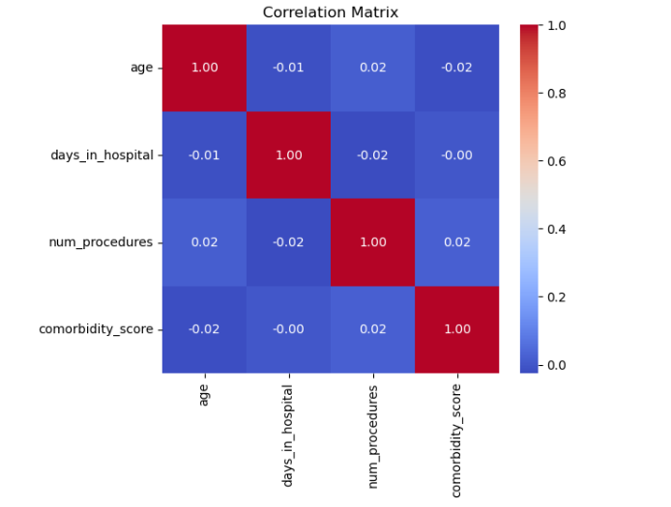
Figure 10.1: Correlation matrix of age, length of hospital stay, number of procedures, and comorbidity score.

11.Which factors are the strongest predictors of hospital readmission?
A multivariate logistic regression model was fitted to identify the factors associated with hospital readmission. Before fitting the model, multicollinearity was assessed using the Variance Inflation Factor (VIF).
11.1.Variance Inflation Factor (VIF):
Variable | VIF
Age | 1.00
Number of Procedures | 1.00
Days in Hospital | 1.00
Comorbidity Score | 1.00
Gender | 1.00
Diabetes | 1.60
Heart Disease | 1.58
Hypertension | 1.59
Kidney Disease | 1.61
Home Health Care | 1.48
Rehabilitation Facility | 1.47
Skilled Nursing Facility | 1.46
All VIF values were below 5, indicating no evidence of multicollinearity among the independent variables.
11.2. Logistic Regression Results:
Variable | β | OR | 95% CI | P-value
Age | 0.0002 | 1.000 | 0.997–1.004 | 0.890
Number of Procedures | -0.003 | 0.997 | 0.972–1.021 | 0.787
Days in Hospital | -0.007 | 0.993 | 0.976–1.011 | 0.447
Comorbidity Score | -0.003 | 0.997 | 0.948–1.048 | 0.906
Gender | -0.081 | 0.922 | 0.800–1.063 | 0.264
Diabetes | 0.063 | 1.065 | 0.853–1.331 | 0.577
Heart Disease | -0.019 | 0.981 | 0.781–1.233 | 0.872
Hypertension | -0.052 | 0.949 | 0.755–1.193 | 0.656
Kidney Disease | 0.089 | 1.093 | 0.877–1.363 | 0.428
Home Health Care | 0.003 | 1.003 | 0.825–1.219 | 0.976
Rehabilitation Facility | -0.014 | 0.987 | 0.809–1.203 | 0.893
Skilled Nursing Facility | -0.136 | 0.873 | 0.711–1.071 | 0.192
The multivariate logistic regression model was not statistically significant (LLR p = 0.9046). Furthermore, none of the independent variables were statistically significant predictors of hospital readmission (all p > 0.05). Odds ratios were close to 1, and all 95% confidence intervals included 1, indicating no meaningful association between the examined variables and hospital readmission.
12. How well does the logistic regression model predict hospital readmission?
The performance of the logistic regression model was evaluated using Accuracy, Precision, Recall, F1-score, ROC-AUC, and the Confusion Matrix.
Table 12.1 Model Performance
Metric | Value
Accuracy | 81.18%
Precision | 0.00
Recall | 0.00
F1-score | 0.00
ROC-AUC | 0.528
The model achieved an accuracy of 81.18%. However, the precision, recall, and F1-score were all equal to 0, indicating that the model failed to correctly identify readmitted patients. The ROC-AUC value of 0.528 suggests that the model performed only slightly better than random guessing.
12.2. Confusion Matrix:
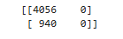
The confusion matrix shows that the model correctly classified 4,056 non-readmitted patients (True Negatives) but failed to correctly identify any readmitted patients (True Positives = 0). All 940 readmitted patients were incorrectly classified as non-readmitted (False Negatives), indicating that the model predicted only the majority class. This explains the high accuracy but zero precision, recall, and F1-score.
12.3. ROC Curve
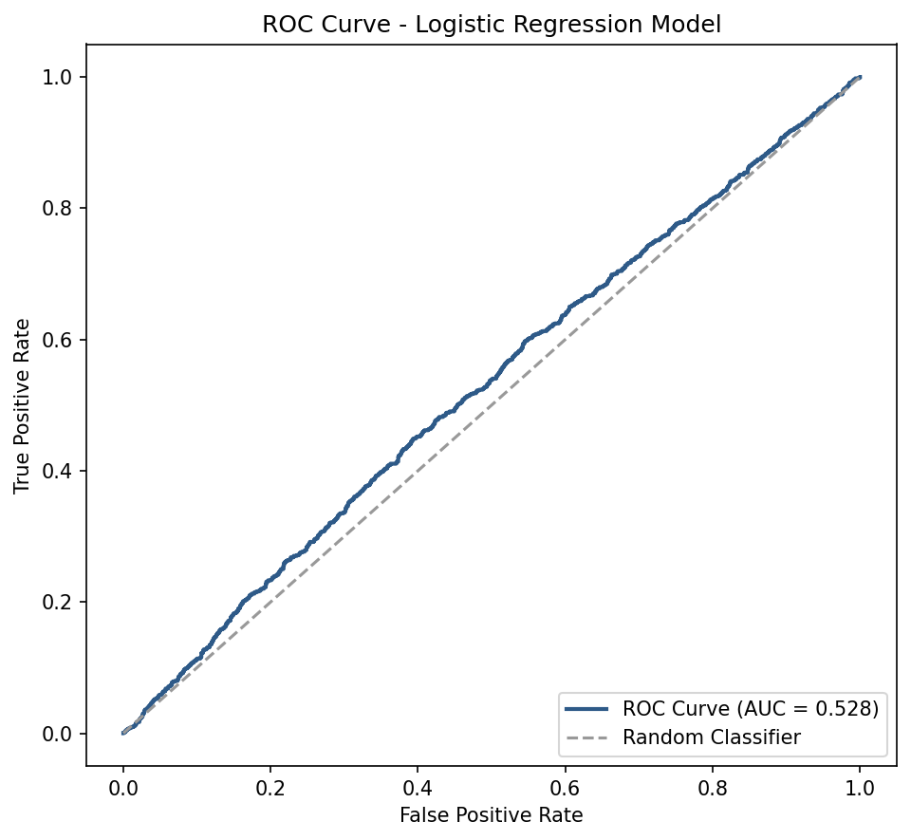
Figure 12.2: Receiver Operating Characteristic (ROC) Curve
Although the model achieved relatively high accuracy (81.18%), it failed to identify readmitted patients, as indicated by zero precision, recall, and F1-score. Furthermore, the ROC-AUC value (0.528) indicates poor discriminative ability. Therefore, the logistic regression model showed limited predictive performance for hospital readmission in this dataset.

13. Do Patients Naturally Cluster Into Distinct Groups?
Statistical Analysis:
Standardization → K-Means Clustering (k = 2–8) → Elbow Method + Silhouette Score → PCA Projection
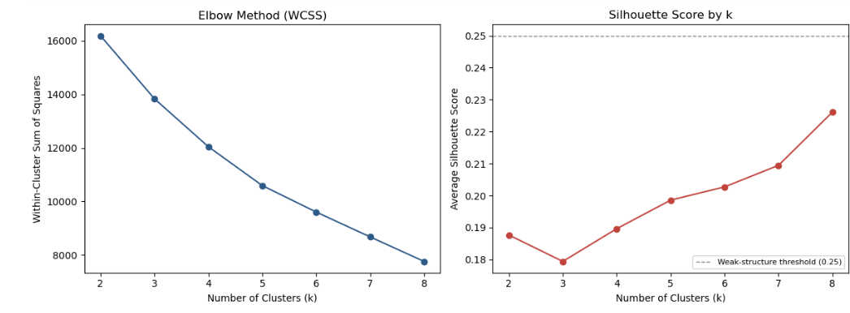
The elbow curve (WCSS) declines smoothly with no distinct 'elbow', and the average silhouette score remains below 0.23 across every tested value of k (2 through 8) — well under the 0.25 threshold conventionally used to indicate weak or absent cluster structure. Both diagnostics point to the same conclusion: there is no natural number of clusters that best fits the data.

PCA Projection of K-Means Clusters (k = 4)
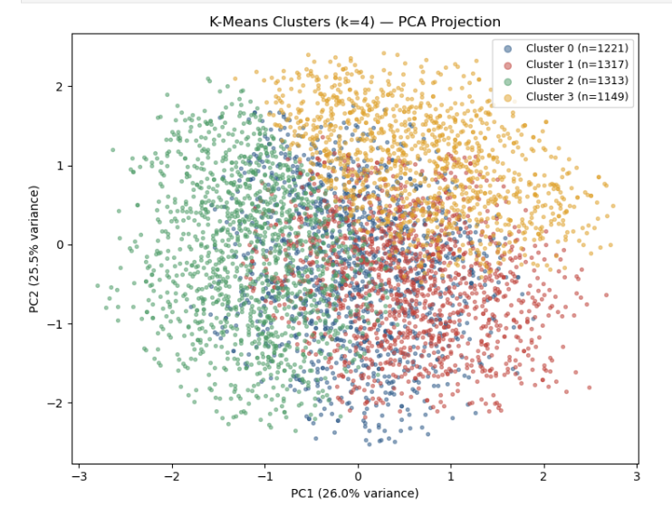
A 4-cluster solution was fitted for illustration (silhouette = 0.1896). The first two principal components explain 26.0% and 25.5% of the variance, respectively. Visually, the four groups form one continuous, overlapping cloud of points with no visible gaps or separation — the K-Means algorithm is partitioning a uniform space rather than detecting genuine subpopulations.
Conclusion: No, patients do not form natural, well-separated clusters. Any partition imposed on this data (e.g., k = 4) is a mathematical convenience for description, not evidence of real patient subgroups.

14. Composition of Each Cluster (MANOVA / ANOVA)
Test | Statistic | df | p-value
Wilks' Lambda | 0.0949 | —
MANOVA (Bartlett's χ² approx.) | χ² = 11762.2 | 12 | < 0.001

Univariate ANOVA per Variable
Variable | F-statistic | p-value
age | 4.99 | 0.0019
num_procedures | 3555.28 | < 0.001
days_in_hospital | 1420.01 | < 0.001
comorbidity_score | 1346.6 | < 0.001

The MANOVA results indicated a statistically significant overall difference among the identified clusters (Wilks' Lambda = 0.0949, Bartlett's χ² = 11762.2, p < 0.001), demonstrating that the clusters differ when all four variables are considered jointly. The subsequent univariate ANOVA tests showed that each variable contributed significantly to these differences. In particular, the largest differences were observed for the number of procedures (F = 3555.28), followed by days in hospital (F = 1420.01) and comorbidity score (F = 1346.60), while age also differed significantly across clusters (F = 4.99, p = 0.0019). These findings indicate that the identified clusters represent patient groups with distinct clinical characteristics across all variables included in the clustering analysis.

15. Readmission Rate by Cluster
Cluster | Readmission Rate
Cluster 0 | 19.9%
Cluster 1 | 18.6%
Cluster 2 | 17.97%
Cluster 3 | 18.8%
Chi-Square Test of Independence: χ²(3) = 1.591, p = 0.661 (Not Significant)
Despite the clusters differing sharply on the variables used to build them (Section 14), their readmission rates are nearly identical — ranging narrowly from 18.0% to 19.9% — and the chi-square test confirms this difference is not statistically significant. In other words, even the most 'distinct' groupings the data can produce carry no information about readmission risk. This closes the loop opened in Sections 5–11: it is not merely that individual variables fail to predict readmission, but that no combination or grouping of them does either.

16. Can a Random Forest Detect Patterns the Logistic Regression Missed?
Statistical Analysis:
Random Forest Classifier (300 Trees, Maximum Depth = 5) → Gini-based Feature Importance
Methodology
A Random Forest classifier was developed to investigate whether a non-linear machine learning model could identify patterns associated with hospital readmission that were not detected by the logistic regression model. The model consisted of 300 decision trees (n_estimators = 300) with a maximum tree depth of 5 (max_depth = 5) to reduce the risk of overfitting. The same predictor variables used in the logistic regression model were included after converting the categorical variables into dummy variables.
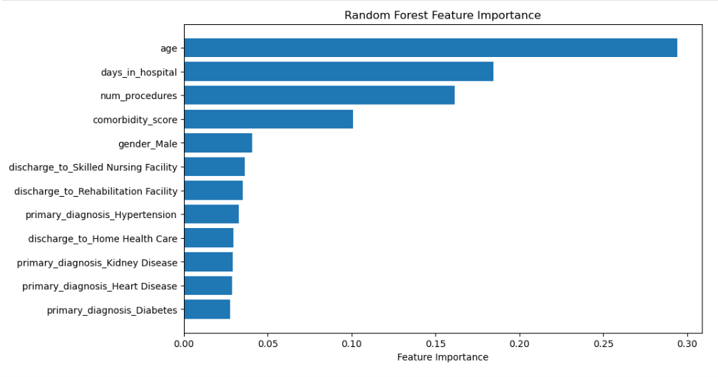
The feature importance plot shows that age is the most influential predictor, followed by days in hospital, number of procedures, and comorbidity score. The remaining variables have relatively lower importance. These values represent the variables' contribution to the Random Forest model and do not necessarily indicate statistically significant predictors.

17. Relative Variable Importance: Random Forest vs. Logistic Regression:
Variable | Logistic Regression | Random Forest
Age | β = 0.0002, P = 0.890 (Not Significant) | 0.2941 (Highest Importance)
Days in Hospital | β = -0.007, P = 0.447 (Not Significant) | 0.1844
Number of Procedures | β = -0.003, P = 0.787 (Not Significant) | 0.1614
Comorbidity Score | β = -0.003, P = 0.906 (Not Significant) | 0.1007
Gender | β = -0.081, P = 0.264 (Not Significant) | 0.0405
Diagnosis Variables | All Not Significant | Low Importance
Discharge Variables | All Not Significant | Low Importance
The comparison indicates that Random Forest ranked age, days in hospital, number of procedures, and comorbidity score as the most important predictors. However, Logistic Regression showed that none of the predictors were statistically significant (all p-values > 0.05). Therefore, although Random Forest provides a ranking of variable importance, it does not indicate statistical significance, and both models suggest limited predictive information in the available variables.

18. Which Model Actually Performs Best? (ROC-AUC + Cross-Validation)

Full-Data Evaluation vs. Cross-Validation
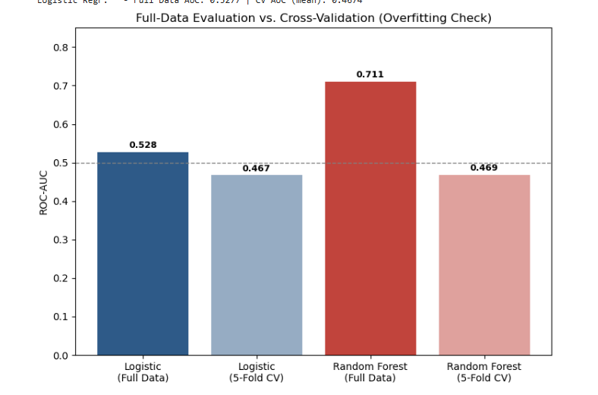
Model | Evaluation | ROC-AUC | Accuracy
Logistic Regression | Full data | 0.528 | 81.2%
Logistic Regression | 5-Fold Cross-Validation | 0.467 (± 0.016) | 81.2%
Random Forest | Full data | 0.711 | 81.2%
Random Forest | 5-Fold Cross-Validation | 0.469 (± 0.018) | 81.2%

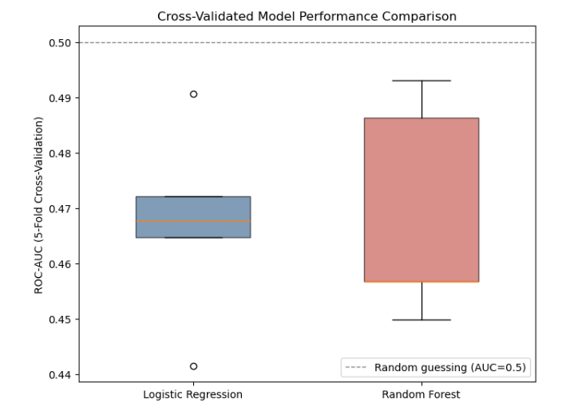

Key finding: the Random Forest's full-data ROC-AUC of 0.711 looked like a strong, usable model — but its cross-validated ROC-AUC drops to 0.469, below the 0.5 line expected from random guessing. This is a textbook case of overfitting: a flexible model with enough trees and depth can memorize idiosyncratic noise in the training sample, producing an illusion of predictive power that disappears completely on held-out folds. The logistic regression, being a much simpler model, shows far less of this gap (0.528 full-data vs. 0.467 cross-validated) precisely because it has less capacity to overfit random noise in the first place.
Both models converge to essentially the same, unremarkable conclusion once evaluated honestly: neither Random Forest nor Logistic Regression can distinguish readmitted from non-readmitted patients better than chance. The 'best' model overall is therefore not the one with the highest full-data score, but the one that is honest about its (lack of) performance — and cross-validation is what reveals that honesty.
CONCLUSION
- None of the tested variables (age, gender, diagnosis, discharge destination, length of stay, procedures, or comorbidity score) show a statistically significant association with readmission
- Multivariate logistic regression, Random Forest, and K-Means clustering all converge on the same conclusion: no combination of these variables meaningfully predicts readmission
- Apparent gains from more complex models (Random Forest's 0.711 full-data ROC-AUC) do not survive honest cross-validation, a reminder to always validate before trusting a training-data score
- Practical implication: reducing readmissions in this population likely depends on factors outside this dataset (e.g., post-discharge follow-up, medication adherence, or social factors) this analysis is as valuable for ruling out what isn't driving it

