

Hadis Maleki

<http://hmaleki.ir>

List of Publication and Presentations in Animation:

* F. Maleki, M. R. Hosnaee (Ph.D), The Camera Movement in Relation to Narration in Animated Films: a Practice-Oriented (In Persian), [Journal of Dramatic Arts and Music](http://dam.journal.art.ac.ir/article_293_55.html), 2016, Oct.
* F. Maleki, M. R. Hosnaee (Ph.D), Adaption and Customization of Software Development Methodology on Animation Production (in Persian), [2nd National Symposium on Animation](http://www.cinematajrobi.ir/vdcj.tehfuqeymsfzu.html?lipi=urn%3Ali%3Apage%3Ad_flagship3_profile_view_base%3BqymKpi0fSi2z1hWzzqh2ww%3D%3D), Kish, Iran, 1-4 Sep. 2015
* F. Maleki, M. R. Hosnaee (Ph.D), ADAPTION AND CUSTOMIZATION OF SOFTWARE DEVELOPING MODELS IN ANIMATION PRODUCTION, [CONFIA 2015](http://www.confia.ipca.pt/files/confia_2015_proceedings.pdf?lipi=urn%3Ali%3Apage%3Ad_flagship3_profile_view_base%3BqymKpi0fSi2z1hWzzqh2ww%3D%3D), Internationl Conference on Illutration and Animation, Portugal
* F. Maleki, M. R. Hosnaee (Ph.D), Camera Movement in Relation to Animation Narration: A study for Deriving the Patterns, [C.A.K.E Conference](https://www.edgehill.ac.uk/cake/files/2014/05/Academic_Schedule_Final.pdf?lipi=urn%3Ali%3Apage%3Ad_flagship3_profile_view_base%3BqymKpi0fSi2z1hWzzqh2ww%3D%3D) publication Accepted in Creative Animation Knowledge Exchange. C.A.K.E ,Edge Hill University 14th – 18th July
* F. Maleki, Zeinab Farhoudi, Making Humanoid Robots More Acceptable Based on the Study of Robot Characters in Animation, Journal of Robotics and Automation ([IJRA](http://www.iaesjournal.com/online/index.php/IJRA/article/view/6639?lipi=urn%3Ali%3Apage%3Ad_flagship3_profile_view_base%3BqymKpi0fSi2z1hWzzqh2ww%3D%3D)) /Institute of Advanced Engineering and Science (IAES), March 2015, Vol 4

Book

* Animation and The Future World, Articles on new approaches of professional Enviroment, Ronagh Pub, DEFC, 2017 link

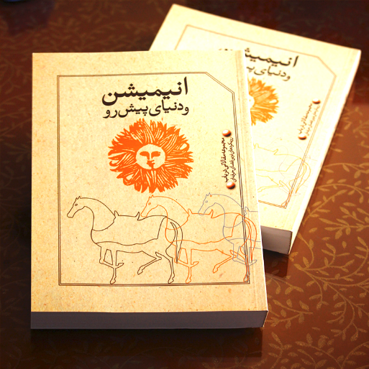

List of Animated short films:

* The World of Night, 2018, Official Selection of 2nd Pasargad Short Film Festival
* E.P., 2016, Jan. Musical Animation، Theme of Environment Protection Technique: Felt cut out
  + Awarded in 1st Pasargad Film Festival, 2015
  + Screened on 2016 8th CMS ICFF ([Tehran Times News](http://www.tehrantimes.com/news/300494/Iranian-films-line-up-for-Indian-festival))
  + In official Selection of The 10th Tehran International Animation Festival (TIAF), 2017

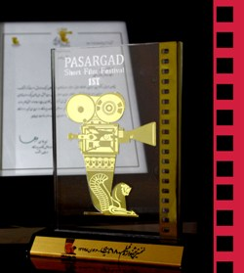

* COMMERCIAL CONTEST, A commercial made for participation in Japan Kitkat

Chosen in Reselections Phase

* SHIFT, 2014,Jan. Story of the red and green characters of pedestrian light, Technique: Digital Cel
  + Official Selection of 4th Carton Animation Festival 2015
  + Presented in Marathon of Athens Animation 2015
  + Official Selection 2015 [Short Short Story](http://www.mergingartsproductions.com/Film/SSS/2015/Films.aspx)
* WORMROSE, 2016, a short animation about smoking and its spiritual side effect.
  + Listed in Official Selection of 10th Festival De Animacion Noche De Monos
* BIOLOGY DEMO, Animations and Coding for Educational Multimedia Software
* Eleph-Ant, 2012,Dec. Adaption of a poem by Parvin Etesami
  + Official Selection of 7th Parvin Etesami Film Festival
* Several Clips such as FISH, 3point-Shot, Green Earth, 2017

Honors:

* Thesis announced as merit student’s thesis by research center of University.
* Thesis was also announced among top list of 9th Tehran International Animation Festival
* Won Prize and Trophy of 1st Pasargad short Film Festival

Other projects and publications:

* Translating articles from English to Persian for National journals of Animation and Cinema, DEFC
  + Mike Jones, Vanishing Point: Spatial Composition and the Virtual Camera, animation: an interdisciplinary journal, Vol 2(3)
  + Franziska Bruckner, Hybrid Image, Hybrid Montage: Film Analytical Parameters for Live Action/Animation Hybrids, animation: an interdisciplinary journal, 2015, Vol. 10(I)
  + Paul Wells, The Beautiful Village and the True Village
  + Paul Ward, Rotoshop in Context: Computer Rotoscoping and Animation Aesthetics, Animation Journal, Volume 12, 2014

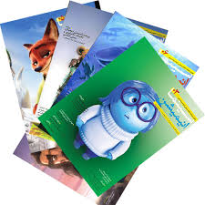



Hadis Maleki

<http://hmaleki.ir>