

Hadis Malekie

<http://hmaleki.ir>

List of degrees in Computer Science and Software Engineering:

* Several MOOC courses
* 2002-2007,Software Engineering, Shahid Beheshti University (SBU), B.Sc.
* Network Security Workshop[, IPM center](ipm.ac.ir)

List of Taught Courses at school

* Python
* C, C++, Pascal for Programming Contests
* VB
* Small Basic
* Scratch
* Algorithms
* Cryptography
* Dreamweaver
* 3Ds Max
* GameMaker
* Animation
* Music Notation
* ICDL
* Content Generation (for teachers)

List of papers in CS:

* Making Humanoid Robots More Acceptable Based on the Study of Robot Characters in Animation, International Journal of Robotics and Automation (IJRA) , March 2015
* A Newer World for Blind, 4th international Technology Conference 2008, Boston
* Steganography's Applications , Article Base
* Moiré in Computer, awarded in SBU First symposium of student research, May 2006
* Moiré in Computer, awarded in SBU First symposium of student research, May 2006

List of projects in Computer:

*Multimedia Software, Lets be friend with Iranian Musical Instruments, Tehran: Sooreh Mehr Publications, May 2012

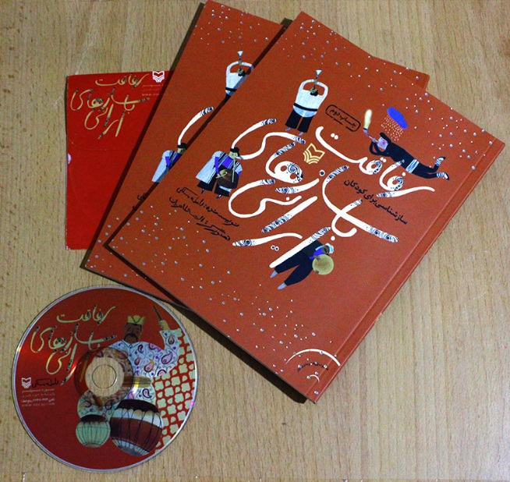

*Simulation of Kazaa - teamwork -OS: Linux ( Redhat ,Fedora ,Suse ) - Language : C

*Simulation of Selective Repeat and Go Back N Algorithms - teamwork- Language: java ( IntelliJ idea 5 )

*Simulation of Link State Routing - teamwork -Language : java ( IntelliJ idea 5 )

* E-learning System- - teamwork- Language and IDE : , SQL server Rational Rose,VB.net , ASP.net

* Credit Cards for Shoping, teamwork - Language and IDE: SmartDraw, Visio, Oracle 9.2, Visual c#.net

* DB for Ministery of Urban and Housing - Language and IDE: SQL server 2000 , Visual c#.NET

* Detecting Spam E-mail - teamwork - Language and IDE : Prolog - Strawberry Prolog

**WebSite Design and Develope:**

* Sotoudeh-products, stationery store, 2017-2018

* Italian Painting, Artist in Residency in Italy, 2018

* Aloobaloo, Animation and Media Studio, 2016

* Guilagraph, Online Woocommerce Shop,2016

* Bonnepomme Magazine, Wordpress, 2016

* Cando Studio, 2015

* Doh-re-mi, Music theory club, 2006



Hadis Maleki

<http://hmaleki.ir>