List of Publication and Exhibition in Photography:

* Official selection at @MontanhaPicoFestival #festivalmontanha in Azores, Portugal. Exhibition from January 7th to April 2018 at @MiratecArts Foto_Galeria (Madalena Fire Dept)
* The Photographic Angle Touring Exhibition in UK, Theme:[Pattern](http://www.thephotographicangle.co.uk/tpa-exhibitions.pdf),17Jan 2018- 30 May2018
* 1st Place winner of the [Patchwork Photography Contest](http://www.thephotographicangle.co.uk/competition/patchwork) of Photographic Angle, July 2016

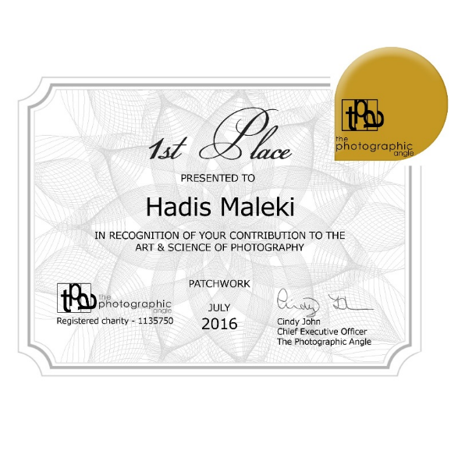

* Photograph published as book cover of “We Were in the Scene”, a poem book by Mahboubeh Ebrahimi ,2017

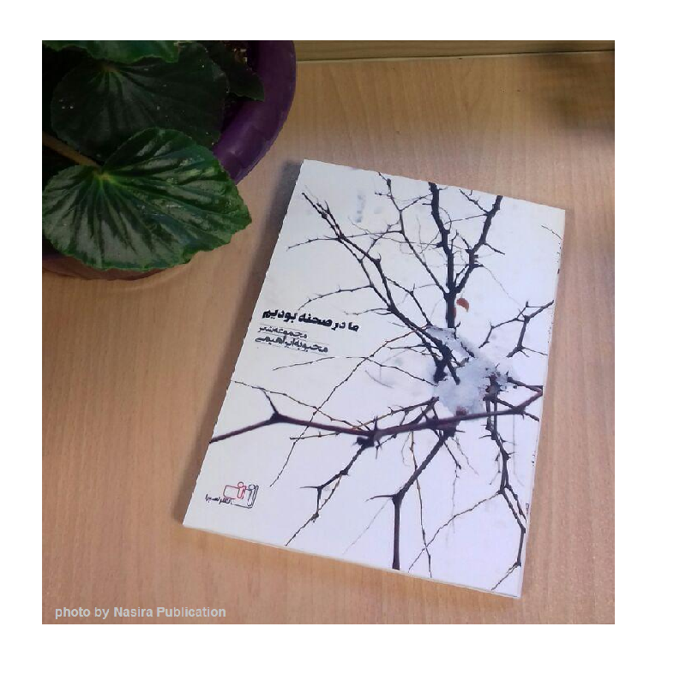

* Exhibition: Searching Quality within City: Second Photography Competition
* Photograph published in book: Searching Quality within City: Second Photography Competition, 2017

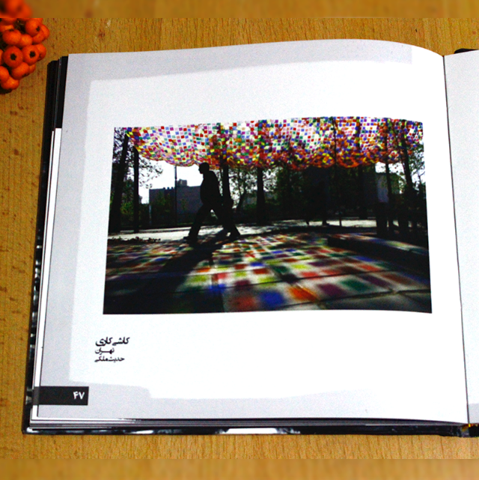

* English to Persian translation of the Book “Ultimate guide to street photography” by James Maher, Digital Photography School, (volunteer work)

List of projects in Photography:

* Conference Photography and musical clip making of Real Portfolio Management Workshop held in Monenco by Rsrastak, 2015
* Conference Photography of Agile management conference in 12th International Management Conference by Rsrastak, 2017
* Volunteer Photography of celebration of 40th anniversary of establishment of Computer department in Shahid Beheshti University,2017
* Photography Sessions of manteau and women costume for Harir Mezon, 2017
* Product Photography for Guilagraph Handcrafts
* Scene photography for Aloobaloo Media Art



Hadis Maleki

<http://hmaleki.ir>