Name : Hadiya Naeem
Roll no: SU92- BSAIM-F25-078
Section: BSAI-3B
Lab task 4
Introduction:
In this lab we study about informed search algorim . Informed search uses extra information called a heuristic to guide the search towards a goal.
Explanation of g(n), h(n), f(n)
A* evaluation function
A* uses three important values:
G(n): the actual cost
H(h): the estimated value
F(n): the totat estimated cost
Formula:
F(n) = g(n) + h(n)
Manual calculation
Selected node | g(n) | h(n) | f(n)
S | 0 | 5 | 5
A | 1 | 4 | 5
C | 3 | 2 | 5

A* implementation:
A* uses priority queue to select the node with the smallest f-value.
The returned path is S A C G
Program:
import heapq

graph = {
"S":[("A",1),("B",4)],
"A": [("C", 2)],
"B":[("G" , 5)],
"c":[("G", 3)],
"G":[]
}

heuristic = {
"S": 5,
"A": 4,
"B": 4,
"C": 2,
"G":0
}

def search(start, goal, h):
pq =[(h[start], 0 , start, [start])]
best = {start:0}
processed = []

while pq:
f, g, node, path = heapq.heappop(pq)

if g != best[node]:
continue
processed.append(node)
print("processed", node, "g", g, "h", h[node], "f", f)

if node == goal:
return path, g, processed

for child, weight in graph[node]:
new_g = g + weight

if new_g < best.get(child, float("inf")):
best[child] = new_g
new_f = new_g + h[child]

heapq.heappush( pq, (new_f, new_g, child, path + [child]))
return None, float ("inf"), processed

print("A* search")
astar_path, astar_cost, astar_order = search("S", "G",heuristic)

print("A* path", astar_path)
print("A* cost", astar_cost)
print("A*processed", astar_order)

print("\n UCS search")
zero_heuristic ={node: 0 for node in graph}

ucs_path, ucs_cost, ucs_order = search("S", "G", zero_heuristic)

print("UCS path",ucs_path)
print("UCS cost", ucs_order)

output:
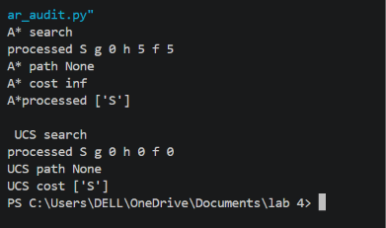

UCS :
Ucs is used as a control experiment by setting all heuristic values to zero. It selects nodes according to the actual path cost.
Edge case:
Observed : A* selects the route through B, with a total cost for C.
Likey cause: the heuristic gives a very high estimed remaining cost fro C
Reflection :
In the lab I learned how A* uses actual path cost and heuristic estimates. I learned how to calculate g(n) h(n) and g(n)

