Final Year Design Project
College Management System
for Govt. Graduate College, Mandi Bahauddin
By
Hadia
085668
Sharfa Kiran
085646
Syeda Laraib Qamar Kazmi
085713
Under the supervision of
Prof. Ubaid Ullah
Bachelor of Science in Information Technology (2022-2026)
DEPARTMENT OF INFORMATION TECHNOLOGY
GOVT. GRADUATE COLLEGE, MANDI BAHAUDDIN

College Management System for Govt. Graduate College, Mandi Bahauddin
A project presented to
Govt. Graduate College, Mandi Bahauddin
In partial fulfilment
of the requirement for the degree of
Bachelor of Science in Information Technology (2022-2026)
By
Hadia
085668
Sharfa Kiran
085646
Syeda Laraib Qamar Kazmi
085713
DEPARTMENT OF INFORMATION TECHNOLOGY
GOVT. GRADUATE COLLEGE, MANDI BAHAUDDIN

DECLARATION
We hereby declare that this software, neither whole nor as a part, has been copied out from any source. It is further declared that we have developed this software and accompanied report entirely on the basis of our personal efforts. If any part of this project is proved to be copied out from any source or found to be reproduction of some other, we will stand by the consequences. No portion of the work presented has been submitted as part of any application for any other degree or qualification of this or any other university or institute of learning.

Signature: ___________________ Signature: ___________________
Hadia [085668] Sharfa Kiran [085646]
Signature: ___________________
Syeda Laraib Qamar Kazmi [085713]

CERTIFICATE OF APPROVAL
It is to certify that the final year design project (FYDP) of BSIT, session (2022-2026), titled “College Management System for Govt. Graduate College, Mandi Bahauddin” was developed by Hadia (085668), Sharfa Kiran (085646), and Syeda Laraib Qamar Kazmi (085713) under the supervision of Prof. Ubaid Ullah; in my opinion, it is fully adequate, in scope and quality, for the degree of Bachelor of Science in Information Technology.
Signature: ___________________________________
FYDP Advisor: Prof. Ubaid Ullah
Signatures (Faculty Advisory Committee – FAC)
 | FAC1 | FAC2
Name | Prof. Muhammad Faiyaz | Prof. Ubaid Ullah
Signature
Signature: ___________________________________
Head of FYDP Coordination Office: Prof. Muhammad Faiyaz
Signature: ___________________________________ Dated: ______________
Head of Department, Information Technology: Prof. Muhammad Faiyaz

Executive Summary
Govt. Graduate College, Mandi Bahauddin runs its academic life on paper. Roughly 3,000 students across Intermediate and BS programmes, and about 50 faculty members, still queue up at the accounts window for a fee challan, wait for a hand-written attendance register to be tallied, and find out their semester result from a notice board rather than a phone. Every one of these steps is a place where a form goes missing, a number gets mistyped, or a student simply doesn't find out in time. That was the starting problem: a college of this size cannot keep running its records by hand without the errors and delays showing up somewhere — a wrong CGPA on a transcript, a fee challan that doesn't match what the accounts office actually has on file, an exam schedule that reaches half the class.
Our answer is a suite of three Android applications — one for admins, one for teachers, one for students — backed by a single shared database and a common design system, so the same piece of data (a student's attendance, a session's fee structure, a published datesheet) is always the same regardless of which app is reading it. The admin app is where the college's actual structure lives: departments, the sessions (intakes) within them, each session's curriculum and timetable, and its fee structure. Teachers mark attendance, enter midterm and sessional marks, submit exam papers, and record semester GPA/CGPA against that same structure. Students see their own slice of it — attendance, marks, fee challan, datesheets, calendar notices — without ever walking into an office.
Midway through the project we made a deliberate architectural change: the backend moved from Firebase (Firestore + Auth) to Supabase (Postgres, with Row-Level Security enforcing who can see and write what, GoTrue for authentication, and Storage for uploaded files like exam papers and documents), and the UI layer moved from XML Activities/Fragments to Jetpack Compose with a proper MVVM/Repository split, wired together with Hilt. The reasoning was straightforward: a relational schema with real foreign keys and row-level policies gives us guarantees a document store couldn't — a mark can't be attributed to a student who was never enrolled in that session, a fee record can't outlive the session it belongs to — and Compose let us build one shared component library (the “Modernist” red/ink design system) that all three apps use identically instead of maintaining three separate sets of XML layouts.
Every major workflow in this report reflects that rebuilt system as it exists in the codebase today, not the original Firebase/Java prototype: department-centric academic structure, per-session fees, a lock-then-request-approval workflow for marks (a teacher enters a score once; changing it after the fact requires the admin's sign-off), semester result recording with GPA/CGPA and supply-subject tracking, fines, a calendar, datesheets, an uploadable-documents library, and a tiered Insights dashboard built directly on Postgres views so that what an admin sees college-wide, a teacher sees scoped to their own classes, purely through the database's own access rules — no extra application logic required. All three apps build and run against the live Supabase project.
Keywords: College Management System, Row-Level Security, Jetpack Compose, Supabase, Android

Acknowledgement
[PLACEHOLDER — write this yourself, in your own words. It's the one section of this report a template can't fill in for you. Typically thanks: Prof. Ubaid Ullah (your FYDP advisor) for supervision and guidance; the FYP Coordination Office / Prof. Muhammad Faiyaz; the Department of Information Technology, Govt. Graduate College, Mandi Bahauddin; and family or anyone else who supported you through the project.]

Signature: ___________________ Signature: ___________________
Hadia [085668] Sharfa Kiran [085646]
Signature: ___________________
Syeda Laraib Qamar Kazmi [085713]

Abbreviations
Abbreviations and acronyms used throughout this report, ordered alphabetically.
Abbreviation | Description
API | Application Programming Interface
BS | Bachelor of Science
BSIT | Bachelor of Science in Information Technology
CGPA | Cumulative Grade Point Average
CMS | College Management System
CRUD | Create, Read, Update, Delete
DI | Dependency Injection (Hilt)
DTO | Data Transfer Object
FAC | Faculty Advisory Committee
FR | Functional Requirement
FYDP | Final Year Design Project
GGC MBD | Govt. Graduate College, Mandi Bahauddin
GPA | Grade Point Average
JWT | JSON Web Token
MVVM | Model-View-ViewModel
NFR | Non-Functional Requirement
RLS | Row-Level Security (Postgres)
RPC | Remote Procedure Call (a Postgres function invoked from the app)
SDK | Software Development Kit
SRS | Software Requirements Specification
UI | User Interface
UUID | Universally Unique Identifier

Table of Contents

List of Figures
Figure 1-1 Project timeline, reconstructed from commit history and session records
Figure 3-1 CMS layered architecture
Figure 3-2 Login sequence
Figure 3-3 Marks entry / edit-request / approval sequence
Figure 3-4 Attendance marking sequence
Figure 3-5 Document publish/download sequence
Figure C-1 Admin login screen
Figure C-2 Admin dashboard — live enrolment/faculty/department counts
Figure C-3 Session detail — semester promotion, enrollment, Manage/Curriculum
Figure C-4 Session fee structure editor
Figure C-5 Admin Insights — college-wide session/at-risk/exam data
Figure C-6 Faculty records — status & permission management
Figure C-7 Teacher home — today's load, quick actions
Figure C-8 Teacher Exams hub
Figure C-9 Marks Entry — locked scores with edit-request pencil
Figure C-10 Request mark change dialog
Figure C-11 Mark Attendance — live at-risk highlighting
Figure C-12 Teacher Insights — scoped to their own class only
Figure C-13 Student login/register screen
Figure C-14 Student home — CGPA gauge, next class, weakest-subject alert
Figure C-15 Student Exams hub
Figure C-16 Student Marks screen
Figure C-17 Student Fee Challan

List of Tables
Table 1-1 Related System Analysis with proposed project solution
Table 1-2 Tools and Technologies for Proposed Project
Table 2-1 User Classes and Characteristics
Table 2-2 Description of FR-1
Table 2-3 Description of FR-2
Table 2-4 Description of FR-3
Table 2-5 Description of FR-4
Table 2-6 Description of FR-5
Table 2-7 Description of FR-6
Table 2-8 Description of FR-7
Table 2-9 Description of FR-8
Table 2-10 Description of FR-9
Table 2-11 Description of FR-10
Table 2-12 Description of FR-11
Table 2-13 Description of FR-12
Table 2-14 Description of FR-13
Table 2-15 Description of FR-14
Table 2-16 Description of FR-15
Table 2-17 Description of FR-16
Table 2-18 Description of FR-17
Table 2-19 Description of FR-18
Table 2-20 Description of FR-19
Table 2-21 Description of FR-20
Table 2-22 Description of FR-21
Table 2-23 Description of FR-22
Table 3-1 Data Dictionary — Identity
Table 3-2 Data Dictionary — Academic Structure
Table 3-3 Data Dictionary — Financial
Table 3-4 Data Dictionary — Notices
Table 3-5 Data Dictionary — Analytics Views
Table 4-1 Details of APIs/SDKs used in the project
Table 4-2 Metrics of the Git Repository
Table 5-1 Testcase UT-1
Table 5-2 Testcase UT-2
Table 5-3 Testcase FT-1
Table 5-4 Testcase FT-2
Table 5-5 Testcase FT-3
Table 5-6 Testcase IT-1
Table 5-7 Testcase IT-2
Table 5-8 Testcase PT-1
Table 5-9 Testcase PT-2
Table 6-1 Deployment Steps
Table 7-1 Evaluation — Objectives vs Status
Table 7-2 Traceability Matrix
Table A-1 Use Case Description — Sign In
Table A-2 Use Case Description — Enter Marks & Request Edit
Table A-3 Use Case Description — Approve/Reject Mark Edit Request
Table A-4 Use Case Description — View Fee Challan
Table A-5 Use Case Description — Build & Publish Datesheet
Table A-6 Use Case Description — Upload & Publish Document

Chapter 1

Introduction

1. Introduction
This chapter lays out why the College Management System (CMS) exists, what it is meant to achieve, and how it is built. It covers the problem the college was actually living with, the three-app solution we built for it, the concrete objectives that solution targets, its scope, the modules that make it up, how it compares to systems like it, and the tools that went into building it.

1.1 Problem Statement
Govt. Graduate College, Mandi Bahauddin has roughly 3,000 students enrolled across its Intermediate and Bachelor's programmes, taught by about 50 faculty members, and every one of its academic and administrative processes is still run on paper. Fee challans are written out by hand at the accounts office, which means a student cannot get one without physically visiting during office hours and waiting in a queue. Attendance is marked in a physical register per class, then manually tallied at the end of the term to decide who meets the minimum-attendance requirement for exams — a process that is slow and open to arithmetic error. Midterm and sessional marks are recorded on paper sheets before being compiled into a semester result and GPA/CGPA by hand, with no independent check on that compilation beyond the teacher's and admin's own diligence. Exam datesheets and college notices are posted on physical noticeboards, so a student who does not visit campus on the right day may simply miss them.
None of this is a single catastrophic failure — it is the ordinary way many colleges of this size and resourcing operate. But it accumulates: a misread number on a marks sheet becomes a wrong CGPA on a transcript; a fee challan written from memory can disagree with what the accounts office has on record; an attendance shortfall discovered only at the end of the semester leaves no time to correct it. And every one of these processes requires the student or teacher to be physically present at the right office at the right time, which is the part that does not scale as enrolment grows. The problem this project addresses is exactly that: how does a college of this size keep its records accurate, timely, and reachable from outside the campus, without expanding its administrative staff to match?

1.2 Problem Solution
The solution is a suite of three role-based Android applications — cmsadmin, cmsteacher, and cmsstudent — that all read and write the same Supabase (Postgres) database, so a fact recorded once (a student's attendance for the day, a session's fee structure, a published exam datesheet) is visible identically to everyone who is allowed to see it, and to no one who isn't. Which app you sign into decides what you can do, not which data exists.
The admin app owns the college's structure: departments, the sessions (intakes) inside each department, each session's curriculum and weekly timetable, its fee structure, and its roster of students. From there, admin also runs the approval queues (student account linking, teacher-submitted mark-edit requests), the teacher lifecycle (disable/ban/reactivate, permission flags), and the notices side of the system — calendar events, datesheets, and an uploadable documents library — plus a tiered Insights dashboard for exam performance and at-risk students.
The teacher app is where the day-to-day academic work happens: marking attendance, entering midterm/sessional marks (locked after first entry, with a request-based path to correct a mistake), submitting exam papers, and recording semester GPA/CGPA including supply subjects. The student app is a read-mostly window onto all of it — attendance history, marks, semester results, fee challan, datesheets, calendar, and documents — plus the one write path a student has: submitting a link request to claim their own roll number.
Underneath all three, a shared library module (cmscommon) owns the domain models, the Supabase-backed repositories, an offline Room cache with a background SyncEngine for data that's read often (rosters, timetables, attendance), and the “Modernist” Compose design system so the three apps look and behave as one product rather than three separately-built ones. Postgres Row-Level Security — not application code — is what actually enforces who can read or write which row, which is what lets the same Insights queries return a college-wide view for admin and an automatically-scoped view for a teacher without any role-branching in the app.

1.3 Objectives of the Proposed System
The system is built around the following measurable objectives:
- Let a student generate and view their own fee challan from their phone, with zero in-person visits to the accounts office required for a routine, unmodified challan.
- Let a teacher mark a full class's daily attendance in under one minute per class, replacing the paper register with a digital one that is immediately visible to admin and the affected students.
- Enforce that a midterm or sessional score, once entered, cannot be silently changed — any correction must go through an explicit admin-approved request, closing the main source of unaudited mark changes.
- Give every student visibility into their own semester GPA/CGPA progression, including supply subjects, without waiting for a printed transcript.
- Publish exam datesheets and college notices (holidays, deadlines, events) to every affected student and teacher the moment they're published, replacing the noticeboard.
- Scope every piece of data — attendance, marks, fees, analytics — to the correct role automatically via database-level access rules (Postgres Row-Level Security), rather than relying on the application to remember to check permissions.
- Keep the system usable when connectivity drops, by caching the data a user reads most often (roster, timetable, attendance) locally and reconciling once the connection returns.

1.4 Scope
In scope: three native Android applications (admin, teacher, student) covering the full academic-and-administrative cycle for one college — departments, sessions, curriculum, timetable, attendance, marks, semester results, per-session fees, fines, calendar, datesheets, an uploadable-documents library, student account linking, teacher lifecycle management, and role-scoped analytics. The initial deployment target is Govt. Graduate College, Mandi Bahauddin; the department-centric data model (a department owns many sessions/intakes, each session owns its own curriculum, timetable, and fee structure) is generic enough to extend to other PU-affiliated colleges without a schema change, though that rollout is not part of this project.
Out of scope: web or iOS clients (Android only), online/electronic fee payment (the system generates and displays a challan; payment still happens at the accounts office), automated exam-paper grading, and a public-facing website. Stakeholders are the college administration (department heads, the accounts office, the FYP-equivalent college management), teaching faculty, and enrolled students — all three are directly represented by one of the three apps.
Priorities, in the order features were actually built: (1) identity and the department-centric academic structure — without departments/sessions/curriculum nothing else has anywhere to attach; (2) the day-to-day teacher workflows — attendance and marks, since these are the highest-frequency actions in the system; (3) the financial and notices layer — fees, fines, calendar, datesheets, documents; (4) governance and oversight — link-request approval, teacher lifecycle, and tiered analytics, since these depend on the first three layers already existing.

1.5 System Components
The system is organised as three client apps sharing one backend and one common library module. Each app's modules are listed below, grouped app by app.

1.5.1 Client Admin App (cmsadmin)
- Departments — create/list departments; each owns many sessions.
- Sessions — create/delete a session (intake) under a department; promote its current semester.
- Curriculum — per-session, per-semester subject list.
- Master Timetable & Session Timetable — weekly slot grid (subject/teacher/room) with double-booking prevention.
- Session Fee Structure — per-session fee heads, cadence, due date, payment note.
- Teachers — roster, account creation, permission flags, status lifecycle (disable/ban/reactivate).
- Link Requests — approve/reject a student's claim to a roll number.
- Attendance Records — dept → session → semester report + PDF/CSV export.
- Calendar — create/delete college-wide events (holidays, exams, deadlines) with audience targeting.
- Datesheets — build an exam grid (slots) and publish it.
- Documents — upload a PDF/DOCX or type body text (prospectus/rules/report/other) and publish it.
- Mark Edit Requests — review queue to approve/reject a teacher's request to change an already-locked score.
- Insights — college-wide session overview, at-risk students, exam-score statistics.
- Notifications — send/manage notices to teachers and/or students.

1.5.2 Client Teacher App (cmsteacher)
- Home — at-a-glance dashboard for the signed-in teacher.
- Mark Attendance + History — daily attendance entry per class, with a history view.
- Exams hub — Marks Entry (midterm/sessional, live negative/overflow validation, locks after first save), Submit Exam Paper, Semester Results (GPA/CGPA/supply), Datesheets (view published).
- Schedule — the teacher's own weekly timetable.
- Menu hub — My Students, Calendar, Documents, Insights (scoped to the teacher's own sessions/courses via RLS), Link Requests (for permitted teachers), Notifications, Profile.

1.5.3 Client Student App (cmsstudent)
- Home — attendance/CGPA snapshot and quick links.
- Attendance — the student's own attendance history.
- Exams hub — Marks (subject scores), Results (GPA/CGPA progression with supply), Datesheets (published only).
- Timetable — the student's own weekly schedule.
- More hub — Calendar, Documents, Fee Challan, Notifications, Profile.
- Link Request — a not-yet-linked account claims its roll number, name, CNIC/B-Form, and DOB for admin review.

1.5.4 Shared Library Module (cmscommon)
- Domain models, DTOs, and Repository interfaces/implementations — the single source of truth for every table each app touches.
- Supabase client wiring — Postgrest (database), Auth/GoTrue (sign-in), Storage (uploaded files: exam papers, documents), Edge Functions (admin-privileged actions like creating a teacher account or changing its status).
- Room offline cache + SyncEngine — background sync for high-read-volume data (roster, timetable, attendance); low-volume features (fees, fines, calendar, datesheets, documents, insights) read directly from Postgrest instead.
- The “Modernist” Compose design system — shared theme, typography, and components (LedgerCard, HubNavCard, SegmentToggle, StatusBadge, etc.) used identically by all three apps.

1.6 Related System Analysis / Literature Review
A handful of existing systems cover pieces of the same ground. None of them fit a Pakistani public-sector college's actual structure (departments → sessions/intakes → semesters, per-session fees, an accounts-office-based fee-collection process) out of the box.
Table 1-1 Related System Analysis with proposed project solution
Application Name | Weakness | Proposed Project Solution
Google Classroom | Built around individual courses, not a college's administrative structure — no fee/challan concept, no institution-wide attendance percentage tracking, no per-session curriculum/timetable model. | Models the college itself (departments, sessions, curriculum, fees) as first-class data, not just course content.
Generic ERP-style college portals (common in Pakistani colleges) | Usually web-only, built for desktop use at an admin's desk; require a developer to touch the database directly for anything not in the original scope; marks corrections have no audit trail. | Native mobile apps for all three roles; every mark change after first entry goes through an explicit, logged approval request instead of a silent database edit.
Paper-based systems (the status quo at GGC MBD) | No real-time visibility for students/teachers, no cross-checking of manually compiled GPA/CGPA, notices depend on physically visiting a noticeboard. | Every role sees the same live data instantly; RLS enforces who can see/write what without a physical visit.

1.7 Vision Statement
For the administration, faculty, and students of Govt. Graduate College, Mandi Bahauddin,
Who need accurate, timely, and remotely-reachable academic and administrative records instead of paper-based ones,
The College Management System (CMS)
Is a suite of three role-based Android applications backed by a single shared database,
That lets a student check attendance, marks, results, and fees from their phone, a teacher mark attendance and enter results digitally with a built-in correction workflow, and an admin manage the college's entire academic structure and oversee it through a role-scoped analytics dashboard,
Unlike the current paper-based process, which requires an in-person visit for almost every interaction and has no audit trail for a changed mark,
Our product makes every one of those interactions instant, auditable, and reachable from outside the campus, while still working offline for the data a user reads most.

1.8 System Limitations and Constraints
Limitations (external, beyond our control):
- Requires an internet connection for any write and for data not already cached locally; the offline cache only covers high-read-volume data (roster, timetable, attendance).
- Android only — no iOS or web client exists.
- Depends on Supabase's free-tier limits (storage quota, function invocations) at the current scale of deployment.
Constraints (self-imposed, within our control):
- Fee collection stays a two-step process by design — the app generates and displays the challan, but payment is still made at the college accounts office, not through an in-app payment gateway.
- A score is locked after its first entry; any change afterward must go through the mark-edit-request workflow rather than a direct edit, even for the teacher who entered it.
- The initial deployment targets a single college (GGC MBD); multi-college support is architecturally possible (departments are already scoped) but not exercised or tested.

1.9 Tools and Technologies
Versions below are pinned in the project's Gradle version catalog (gradle/libs.versions.toml), so they reflect what the codebase actually builds against, not an aspirational list.
Table 1-2 Tools and Technologies for Proposed Project
Tool / Technology | Version | Rationale
Kotlin | 2.1.0 | Primary language for all three apps and the shared module.
Jetpack Compose (BOM) | 2024.12.01 | Declarative UI toolkit; lets all three apps share one component library instead of duplicating XML layouts.
Hilt | 2.52 | Dependency injection across ViewModels/Repositories.
Room | 2.6.1 | Local offline cache for high-read-volume data (roster, timetable, attendance) with a background SyncEngine.
Supabase Kotlin SDK (BOM) | 3.1.4 | Postgrest (database), Auth/GoTrue, Storage, Functions, Realtime — the entire backend client.
Ktor | 3.1.1 | HTTP engine the Supabase SDK runs on.
kotlinx.serialization | 1.8.0 | JSON (de)serialization for every DTO exchanged with Postgrest.
Backend: Postgres + Row-Level Security | Supabase-managed | Enforces per-role read/write access at the database layer instead of in application code.
Android Studio | current stable | IDE for all development.
Git | — | Version control across the monorepo (3 apps + shared module + Supabase migrations).

1.10 Project Deliverables
- This FYDP report, covering requirements, design, implementation, testing, and deployment.
- Three installable Android applications: cmsadmin, cmsteacher, cmsstudent (debug/release APKs).
- The Supabase backend: schema migrations, RLS policies, Edge Functions, and storage bucket configuration (in supabase/).
- Source code for all three apps and the shared cmscommon module, under version control.
- This report's data dictionary and functional-requirements tables, which double as the closest thing to a standalone SRS for this project.

1.11 Project Planning
[NOTE — reconstructed, not the original academic plan: the timeline below is built from actual git commit history (Jan 14 – Jun 17 2026) for the original Java/Firebase build, plus session records for the Kotlin/Compose/Supabase rebuild (Jul 2026), since that later work was never committed to git as individual dated commits. Please confirm the real FYDP milestone/deadline dates and swap them in if they differ.]
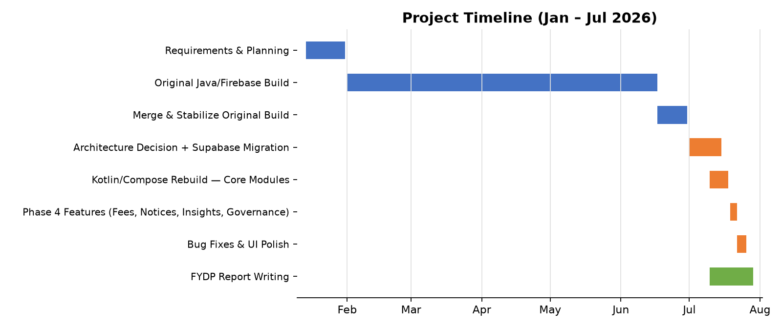
Figure 1-1 Project timeline, reconstructed from commit history and session records

1.12 Summary
This chapter set out the actual problem — a college running entirely on paper records — and the three-app, Supabase-backed solution built to address it, along with the concrete objectives, scope, module breakdown, and technology choices behind that solution. The remaining chapters go into that solution in depth: Chapter 2 specifies its requirements formally, Chapter 3 covers its design and data model, Chapter 4 its implementation, Chapter 5 its testing, Chapter 6 its deployment, and Chapter 7 closes by checking the finished system against the objectives set out here.

Chapter 2

Requirements Analysis

2. Analysis
Chapter 1 described what the system is and why it exists. This chapter pins that down into requirements a reviewer could actually check the finished apps against: who uses the system, how those requirements were gathered, and — in the sections that follow — the specific functional and non-functional requirements themselves.

2.1 User Classes and Characteristics
Three roles use the system, and a fourth distinction — permission flags on the teacher role — matters enough to call out separately.
Table 2-1 User Classes and Characteristics
User Class | Characteristics
Admin | College staff who run the academic structure end to end: departments, sessions, curriculum, timetable, fees, teacher accounts, and the approval queues (student link requests, mark-edit requests). Comfortable with a college's actual bureaucracy — the roles map closely to what an accounts office or registrar already does on paper. Full read/write access, gated by nothing but their own admin flag in Postgres.
Teacher (base) | Faculty who mark attendance, enter marks for the classes they teach, submit exam papers, and record semester results. Their write access is scoped by the college timetable itself — a teacher can only touch a session/course they're actually assigned to teach, enforced at the database level rather than trusted to the app.
Teacher (with permission flags) | Same as above, plus one or more of: approving student link requests, editing the master timetable, sending notifications, or managing datesheets — each a boolean flag an admin sets on that teacher's account, not a separate role.
Student | Enrolled students checking their own attendance, marks, semester results, fee challan, datesheets, and college notices. Read-only everywhere except their own link-request submission — RLS scopes every query to session_id = my_session() so a student physically cannot query another student's row even by guessing an ID.

2.2 Requirement Identifying Technique
Use-case modeling was the main technique. Every one of the three apps is an interactive, session-based tool where a specific actor triggers a specific action and expects a specific result — mark this student present, publish this datesheet, approve this fee change — which is exactly the shape a use case captures well. Storyboarding wasn't a fit here: nothing in the system is graphically driven enough to need it, and the UI itself (the shared "Modernist" Compose component set) was designed after the use cases and requirements, not before them.
In practice, requirements came from watching how the college's existing paper process actually worked — who fills in what, who signs off on it, what happens when someone makes a mistake — and then asking what a digital equivalent of that step would need to do. The mark-lock-then-request-edit requirement is a direct example: it exists because the paper process already had an informal version of it (a teacher didn't get to unilaterally change a mark sheet once it was submitted to the office), so the requirement formalizes an existing norm rather than inventing a new one.

2.3 Functional Requirements
The requirements below are grouped by the module that owns them — academic structure, attendance/marks, financial, notices, and governance/analytics — which follows how the admin app itself is organized rather than an arbitrary alphabetical list. Each one uses the same eight-attribute template so a reviewer can cross-reference it against the traceability matrix in Chapter 7 without guessing at what "source" or "business rule" means from row to row.

2.3.1 FR-1: Manage Departments
Table 2-2 Description of FR-1
Identifier | FR-1
Title | Manage Departments
Requirement | The Admin shall be able to create and list departments. Each department is a top-level container that owns its own sessions (intakes); nothing else in the system can exist without a department to attach to.
Source | College administration — departments are the college's real organisational unit (e.g. Computer Science, Information Technology).
Rationale | Every other piece of academic data (sessions, curriculum, fees, students) is scoped under a department, so this is the first thing that has to exist.
Business Rule | A department's ID cannot contain underscores, since session IDs are built as {deptId}_{startYear}_{shift} and are parsed back apart by splitting on underscore.
Dependencies | None — this is the root of the data model.
Priority | High

2.3.2 FR-2: Manage Sessions
Table 2-3 Description of FR-2
Identifier | FR-2
Title | Manage Sessions
Requirement | The Admin shall be able to create a session (an intake, e.g. "2021 Morning") under a department, delete it, and promote its current semester as the class progresses. Deleting a session shall cascade to its students, timetable, and curriculum.
Source | College administration — a session is a specific batch of students admitted in a given year and shift.
Rationale | Attendance, marks, fees, and timetable all key off a session, not just a department, because two intakes of the same program can be at different semesters simultaneously.
Business Rule | Session ID is built as {deptId}_{startYear}_{shift}; shift is MORNING or EVENING.
Dependencies | FR-1 (a session cannot exist without its department).
Priority | High

2.3.3 FR-3: Manage Curriculum
Table 2-4 Description of FR-3
Identifier | FR-3
Title | Manage Curriculum
Requirement | The Admin shall be able to set the subject list for a given session and semester (course code, name, credit hours), and replace that list wholesale when it needs correcting.
Source | College administration, following the program's official scheme of studies.
Rationale | Curriculum is stored per-session rather than per-department because two intakes of the same program can legitimately differ — a dropped elective, a renumbered course — and the timetable/marks/attendance screens all need to know which subjects apply to which session's current semester.
Business Rule | Saving a semester's subject list deletes the old rows for that session+semester and inserts the new ones, rather than diffing and patching — simpler to reason about, and curriculum changes are infrequent enough that this isn't a performance concern.
Dependencies | FR-2 (a session must exist first).
Priority | High

2.3.4 FR-4: Manage Session Timetable
Table 2-5 Description of FR-4
Identifier | FR-4
Title | Manage Session Timetable
Requirement | The Admin shall be able to assign a subject, teacher, and room to a weekly time slot for a session, and the system shall refuse to save a slot that would double-book a teacher or a room at the same day and time.
Source | College administration and the master timetable process.
Rationale | A teacher physically cannot be in two rooms at once; catching that at save-time is cheaper than discovering it on the first day of class.
Business Rule | Double-booking is checked with a database trigger, not app-side logic, since the admin app and any future client writing to the same table would otherwise need to duplicate the check.
Dependencies | FR-2, FR-3 (a slot references a session's existing subjects).
Priority | Medium

2.3.5 FR-5: Mark Attendance
Table 2-6 Description of FR-5
Identifier | FR-5
Title | Mark Attendance
Requirement | A Teacher shall be able to mark a class's attendance for the current day in a single screen, and view the attendance history for a session/course they teach.
Source | Daily classroom practice — replaces the paper register.
Rationale | This is the single most frequent write in the whole system (once per class, per day, per teacher), so it needs to be fast — the whole class in one screen, not one row at a time.
Business Rule | A teacher can only mark attendance for a session/course they're actually assigned to on the timetable; enforced by RLS (teaches(session_id)), not just hidden in the UI.
Dependencies | FR-4 (a teacher's assignment comes from the timetable).
Priority | High

2.3.6 FR-6: Enter Marks (Locks on First Entry)
Table 2-7 Description of FR-6
Identifier | FR-6
Title | Enter Marks
Requirement | A Teacher shall be able to enter midterm (out of 25) or sessional (out of 15) scores for every student in a class they teach. The field shall reject a negative value or a value above the exam's maximum as the teacher types, before they even try to save. Once a score is saved for a student, it becomes read-only in this screen — a further change has to go through FR-7.
Source | Direct requirement — see 1.3 objectives, and the current problem of unaudited mark changes.
Rationale | Catching an out-of-range score live (rather than after Save, or worse, not at all) prevents a mistyped '250' from ever reaching the database in the first place.
Business Rule | The Save action only writes rows for students who don't already have a saved score — it never re-submits an existing row, since the database itself would reject that update (see FR-7's business rule).
Dependencies | FR-4 (a teacher's class assignment), FR-3 (which exam types/max-marks apply).
Priority | High

2.3.7 FR-7: Request Mark Edit
Table 2-8 Description of FR-7
Identifier | FR-7
Title | Request Mark Edit
Requirement | For a student whose score is already saved (locked), a Teacher shall be able to submit a request with the proposed new score and an optional reason, instead of editing the score directly.
Source | Direct requirement from the college — a mark, once submitted, shouldn't be silently changeable by the same person who entered it.
Rationale | This is the audit trail the paper process never had: every correction after the fact is now a named, timestamped record instead of an invisible edit.
Business Rule | The database enforces this, not just the UI — the session_marks UPDATE policy is admin-only, so even a teacher who bypassed the app couldn't directly overwrite a saved score.
Dependencies | FR-6 (there has to be a saved score to request a change to).
Priority | Medium

2.3.8 FR-8: Approve/Reject Mark Edit Request
Table 2-9 Description of FR-8
Identifier | FR-8
Title | Approve/Reject Mark Edit Request
Requirement | The Admin shall see every pending mark-edit request in one queue, with the current score, the requested score, and the teacher's reason, and shall be able to approve or reject each one. Approving writes the new score onto the student's record and closes the request; rejecting just closes it.
Source | Direct requirement — the other half of FR-7.
Rationale | Centralising this in one queue means an admin doesn't have to go hunting through individual classes to find what's pending.
Business Rule | Approval is two sequential writes (update the score, then mark the request approved), not a single atomic transaction — acceptable here because both writes are admin-gated and idempotent if one had to be retried.
Dependencies | FR-7.
Priority | Medium

2.3.9 FR-9: Record Semester Result
Table 2-10 Description of FR-9
Identifier | FR-9
Title | Record Semester Result
Requirement | A Teacher shall be able to record a student's GPA, CGPA, result status (promoted/repeated/probation/pending), class position, remarks, and any supply (retake) subjects for a completed semester.
Source | End-of-semester result compilation, currently done by hand.
Rationale | This is where the paper process's biggest error risk lived — a hand-compiled CGPA with no independent check. Recording it through one RPC call means the CGPA snapshot on the student's record updates atomically with the semester row.
Business Rule | The snapshot only updates when the semester being recorded is the highest one seen so far for that student — so if an 8th-semester student's result gets entered before catching up an earlier gap, the snapshot doesn't jump ahead incorrectly.
Dependencies | FR-2, FR-6 (marks feed into the GPA calculation, though the calculation itself happens outside the app).
Priority | High

2.3.10 FR-10: Manage Session Fee Structure
Table 2-11 Description of FR-10
Identifier | FR-10
Title | Manage Session Fee Structure
Requirement | The Admin shall be able to set a session's fee cadence (semester or annual), its fee heads (label + amount, e.g. Tuition, Lab), due date, late-fine note, and payment note.
Source | College accounts office fee schedule.
Rationale | Fees were originally modelled per-department; a project-mid-course correction moved them to per-session, since two intakes of the same department can have different fee schedules (a new intake's tuition can rise year over year).
Business Rule | Saving fee heads deletes-then-inserts the whole set for that session, same pattern as curriculum (FR-3) — a small, infrequent write where correctness matters more than avoiding a full rewrite.
Dependencies | FR-2.
Priority | High

2.3.11 FR-11: View Fee Challan
Table 2-12 Description of FR-11
Identifier | FR-11
Title | View Fee Challan
Requirement | A Student shall be able to view their own session's fee structure — cadence, fee heads, total, due date, and payment note — without visiting the accounts office.
Source | Direct requirement — this is the objective from Chapter 1 about generating a fee challan without an office visit.
Rationale | This is informational only; it doesn't process a payment. That was a deliberate scope call (see 1.4/1.8) — the accounts office still collects the money, this screen just removes the reason to visit in person beforehand.
Business Rule | None beyond RLS scoping the query to the student's own session.
Dependencies | FR-10.
Priority | High

2.3.12 FR-12: Issue Fine
Table 2-13 Description of FR-12
Identifier | FR-12
Title | Issue Fine
Requirement | The Admin shall be able to issue a fine against a student's record with a category (library, attendance, exam, disciplinary, other), amount, and reason.
Source | College disciplinary/library process.
Rationale | Fines needed to attach to the student's existing profile screen rather than live as a separate module, since an admin issuing one is usually already looking at that student's record for another reason.
Business Rule | None beyond admin-only write access.
Dependencies | FR-2 (a student has to exist in a session first).
Priority | Low

2.3.13 FR-13: View Fines
Table 2-14 Description of FR-13
Identifier | FR-13
Title | View Fines
Requirement | A Student shall be able to see a read-only list of fines issued against them, with a running total.
Source | Direct requirement — pairs with FR-12.
Rationale | A student finding out about a fine through the app instead of at graduation clearance is the whole point of digitising this.
Business Rule | None.
Dependencies | FR-12.
Priority | Low

2.3.14 FR-14: Manage Calendar Events
Table 2-15 Description of FR-14
Identifier | FR-14
Title | Manage Calendar Events
Requirement | The Admin (or a permitted Teacher) shall be able to create and delete college-wide calendar events — holidays, exam dates, deadlines — and target them to students, teachers, or everyone.
Source | Replaces the physical noticeboard for date-based announcements.
Rationale | Audience targeting exists because a deadline for teachers (grade submission) and a deadline for students (fee due date) shouldn't both show up cluttering everyone's calendar.
Business Rule | Write access requires either is_admin() or a teacher with can_manage_datesheets-equivalent permission; read access is open to all authenticated roles.
Dependencies | None.
Priority | Medium

2.3.15 FR-15: Build & Publish Datesheet
Table 2-16 Description of FR-15
Identifier | FR-15
Title | Build & Publish Datesheet
Requirement | The Admin shall be able to create a datesheet (title, exam type, instructions), add exam slots to it (date, time, course, room, invigilator), and toggle it between draft and published.
Source | Exam scheduling process — replaces the printed datesheet pinned to the noticeboard.
Rationale | A draft/published split matters because a datesheet is rarely finished in one sitting — an admin needs to build it over several sessions before it's ready for students to see.
Business Rule | Students and non-managing teachers can only read published datesheets (see FR-16); drafts are only visible to admin and teachers with datesheet-management permission.
Dependencies | FR-2, FR-3.
Priority | Medium

2.3.16 FR-16: View Datesheet
Table 2-17 Description of FR-16
Identifier | FR-16
Title | View Datesheet
Requirement | A Teacher or Student shall be able to browse published datesheets and expand one to see its exam slots.
Source | Direct requirement — the read side of FR-15.
Rationale | None beyond the obvious — a student needs to know when their own exams are.
Business Rule | Enforced by RLS: only rows with published = true are visible to a non-managing role.
Dependencies | FR-15.
Priority | Medium

2.3.17 FR-17: Upload & Publish Document
Table 2-18 Description of FR-17
Identifier | FR-17
Title | Upload & Publish Document
Requirement | The Admin shall be able to either upload a PDF/DOCX file or type body text directly, tag it with a kind (prospectus, rules, report, other) and an audience, and publish it.
Source | College documents that currently only exist as physical printouts (prospectus, rulebook).
Rationale | Giving the admin a choice between uploading a file and just typing text covers both cases — a rulebook that's genuinely a formatted PDF, and a one-off short notice that doesn't deserve a whole file.
Business Rule | Uploaded files live in a private Supabase Storage bucket; a document under the archives/ path is intentionally excluded from the public-read policy, reserved for internal-only material.
Dependencies | None.
Priority | Low

2.3.18 FR-18: View/Download Document
Table 2-19 Description of FR-18
Identifier | FR-18
Title | View/Download Document
Requirement | A Teacher or Student shall be able to browse published documents, read inline body text, and download an attached file to open it locally.
Source | Direct requirement — the read side of FR-17.
Rationale | None beyond the obvious.
Business Rule | Downloaded files are opened through the device's own file-provider/viewer rather than an in-app viewer, since supporting every document format in-house wasn't worth building.
Dependencies | FR-17.
Priority | Low

2.3.19 FR-19: Submit Student Link Request
Table 2-20 Description of FR-19
Identifier | FR-19
Title | Submit Student Link Request
Requirement | A newly-registered account with no linked student record shall be able to submit a claim — session, roll number, name, CNIC/B-Form, date of birth — asking to be linked to that roll number.
Source | Onboarding — a student's Supabase auth account and their session_students roster row don't exist as the same thing until this link happens.
Rationale | An unlinked account can't read the roster to check whether its claimed roll number is even real, so the claim itself has to be a blind submission that admin verifies server-side.
Business Rule | The (session, roll) pair is verified against the actual roster only at approval time (FR-20), not at submission time, since RLS prevents an unlinked account from querying the roster directly.
Dependencies | FR-2 (the session and roll have to already exist in the roster for the claim to succeed).
Priority | Medium

2.3.20 FR-20: Approve/Reject Link Request
Table 2-21 Description of FR-20
Identifier | FR-20
Title | Approve/Reject Link Request
Requirement | The Admin (or a permitted Teacher) shall see every pending link request, verify the claimed roll number actually exists in that session's roster, and approve or reject it. Approving revokes any account previously linked to that same roll number.
Source | Direct requirement — the other half of FR-19.
Rationale | Revoking a prior link on approval closes an obvious abuse case: without it, a roll number could end up claimed by two different accounts simultaneously.
Business Rule | The match check (does this session+roll exist?) happens server-side at approval time, using the reviewer's own admin/teacher privileges — the requester's account never gets roster read-access itself.
Dependencies | FR-19.
Priority | Medium

2.3.21 FR-21: Manage Teacher Status & Permissions
Table 2-22 Description of FR-21
Identifier | FR-21
Title | Manage Teacher Status & Permissions
Requirement | The Admin shall be able to disable, ban, or reactivate a teacher's account, and toggle their permission flags (approve link requests, edit timetable, send notifications, manage datesheets).
Source | College HR/administrative process for faculty account lifecycle.
Rationale | Disabling or banning immediately revokes that teacher's ability to sign in — it bans the underlying auth account, not just a flag the app checks — so access actually stops the moment it's toggled, not the next time some check happens to run.
Business Rule | A disabled or banned teacher still appears in the roster (so admin can reactivate them later); only an outright delete removes the row.
Dependencies | None.
Priority | Medium

2.3.22 FR-22: View Tiered Insights
Table 2-23 Description of FR-22
Identifier | FR-22
Title | View Tiered Insights
Requirement | The Admin shall see college-wide session overviews, at-risk students (low attendance or CGPA), and exam-score statistics. A Teacher shall see the same three views scoped automatically to only the sessions and courses they teach.
Source | Direct requirement — analytics for oversight, one of the last features built.
Rationale | "Tiered" doesn't mean two separate screens with two separate query paths — it's the same three Postgres views (session_overview, at_risk_students, exam_stats) queried by both roles. Row-Level Security on the underlying tables does the scoping, so there's no role-branching logic in the app at all.
Business Rule | session_overview joins from a world-readable table (academic_sessions), so a teacher's query technically returns a row for every session college-wide — just with student counts and averages blank for sessions they don't teach, since RLS blocks the joined rows, not the session row itself. No student-level data ever leaks through this.
Dependencies | FR-5, FR-6, FR-9 (the underlying views read attendance, marks, and GPA data).
Priority | Low

2.4 Non-Functional Requirements

2.4.1 Reliability
High-read-volume data — roster, timetable, attendance — is cached locally in Room and kept current by a background SyncEngine, so a teacher marking attendance mid-class doesn't lose the roster if the connection drops for a few seconds. Lower-volume features (fees, fines, calendar, datesheets, documents, insights) read directly from Postgrest instead of maintaining a local copy, since they're checked far less often and a brief loading spinner on a weak connection is an acceptable cost for not maintaining a second cache layer.
Failure mode when a write genuinely can't reach the server: the screen shows the error instead of silently discarding the action — there's no queued-retry mechanism for writes yet, which is a real gap the Future Work section (7.4) calls out rather than papers over.

2.4.2 Usability
All three apps share one Compose component library, so a Ledger card, a section header, or a segmented toggle looks and behaves identically whether it's in the admin, teacher, or student app — someone who's learned one app already knows the visual language of the other two. Marks entry validates as the teacher types rather than only on submit, and every destructive action (deleting a session, banning a teacher) goes through a confirmation dialog that states what else gets affected, not just a bare "Are you sure?".
One real usability bug did slip through and got caught late: a shared segmented-toggle component had an unconstrained divider that, under certain screen heights, expanded to swallow the rest of the screen below the marks-entry exam-type selector. It was found from a user screenshot, not a design review, which says something about the limits of not having done any structured usability testing yet — noted honestly in Chapter 6's Challenges section rather than left out.

2.4.3 Performance
Screens backed by the Room cache (roster, timetable, attendance) render from local data immediately and sync in the background, so there's no network round-trip on the critical path for the highest-frequency actions. Screens that read directly from Postgrest (fees, insights, documents) accept a network round-trip per load since they're checked far less often — the tradeoff is simplicity over shaving a few hundred milliseconds off an infrequent screen.
No load testing has been run against the Supabase project at anything beyond the current single-college scale; the free-tier connection and storage limits are the practical ceiling right now, and that's an open item rather than a validated number.

2.4.4 Security
Every table is protected by Postgres Row-Level Security, so access control lives in the database, not in application code that a bug could accidentally skip. A student's queries are scoped to session_id = my_session() and roll_number = my_roll(); a teacher's are scoped through a teaches(session_id) function keyed off the timetable; admin bypasses both via an is_admin() check. Authentication itself is Supabase's GoTrue (JWT-based), so the app never handles or stores a raw password.
The clearest proof this actually holds is the Insights feature (FR-22): the exact same SQL query, run by an admin, a teacher, or a student, returns a different result set for each — not because the app checked their role and branched, but because RLS decided what rows existed for that JWT before the app ever saw them.

2.5 External Interface Requirements

2.5.1 User Interfaces Requirements
All three apps follow one shared design system internally called "Modernist" — a flat red/ink Archivo-based look with square (non-rounded) cards, a consistent eyebrow/title/rule header pattern, and one shared set of components (LedgerCard, HubNavCard, SegmentToggle, StatusBadge, and similar). Bottom navigation follows Android's standard 5-tab pattern; destructive actions always show a confirmation dialog naming what else is affected, not a bare confirm/cancel. There's no separate accessibility pass yet — standard Material3 contrast and touch-target defaults apply, nothing beyond that has been verified.

2.5.2 Software Interfaces
Supabase (self-hosted-compatible, currently cloud-hosted) provides four services the app talks to directly: Postgrest for the database, GoTrue for authentication, Storage for uploaded files, and Edge Functions for the handful of actions that need service-role privileges (creating a teacher account, changing a teacher's status) rather than what the signed-in user's own RLS permissions allow. Locally, Room provides the offline cache described in 2.4.1. All three apps and the shared cmscommon module talk to Supabase through the official supabase-kt SDK over Ktor.

2.5.3 Hardware Interfaces
No special hardware — a standard Android phone or tablet is all any of the three apps need. Nothing uses the camera, biometric sensors, or any other device peripheral; a document upload picks an existing file from the device's storage rather than scanning one.

2.5.4 Communications Interfaces
All network traffic is HTTPS/REST against the Supabase project, via Ktor. Account verification and password-reset flows go through GoTrue's built-in email delivery, which means the college's SMTP configuration on the Supabase dashboard is a real dependency for those two flows working at all — noted as a standing deployment item in Chapter 6.

2.6 Summary
This chapter turned Chapter 1's goals into something checkable: three user classes, use-case-driven requirement gathering rooted in the college's actual paper process, twenty-two functional requirements spanning academic structure through governance and analytics, and the non-functional and interface requirements that constrain how all of it has to behave. Chapter 3 now covers how these requirements were turned into an actual system design — the data model, the architecture, and the decisions made along the way.

Chapter 3

Design and Architecture

3. System Design
Chapter 2 fixed what the system has to do. This chapter is about how it actually does it: the structural decisions, the data model, and the trade-offs that came with each one — including the ones that didn't work on the first attempt.

3.1 Design Considerations
Assumptions and Dependencies
The whole design assumes Supabase's security_invoker views behave correctly — a view marked security_invoker re-runs the underlying tables' RLS policies for whoever queries it, rather than running with the view owner's privileges. Tiered access (FR-22) depends entirely on that one Postgres feature working as documented; if it didn't, the Insights feature would need per-role query branching instead of one shared view.
Limitations
Room's schema is versioned but not migrated — every version bump so far has used fallbackToDestructiveMigration, which wipes the local cache rather than writing a real migration path. That's a deliberate pre-launch shortcut: with no users yet, there's nothing to lose by wiping the cache, and it's saved real time across nine schema bumps. It stops being acceptable the moment the app is actually deployed with live user data on a device, since a schema change would then delete a real user's offline cache.
Risks
The biggest risk found during the build wasn't a design flaw so much as an interaction between two correct-looking pieces: kotlinx.serialization drops any DTO field that equals its Kotlin default (encodeDefaults=false), and Postgrest's bulk upsert fills in NULL for any column missing from a row in a multi-row insert. Combine the two and a bulk write where most rows share a field's default value can silently NULL that column out for every row — not just the ones where the value was genuinely absent. It surfaced three separate times before the pattern was recognised (see 3.7), and the fix is now a standing rule: any DTO field whose column is NOT NULL with no database default gets a sentinel default that can never occur for real (empty string, not the semantically-meaningful default).

3.2 Design Models
Three kinds of diagram cover this system, not all of the object-oriented standard set. An architectural component diagram (3.3) shows how the layers fit together. A data dictionary (3.4) stands in for a class diagram — the domain here is genuinely closer to a relational schema than an object graph, since almost every domain "object" is a thin Kotlin data class mapped straight onto a Postgres row, with the real behaviour living in Repository functions and RLS policies rather than in methods on the objects themselves. Sequence diagrams (3.6) cover the four flows worth walking through step by step: login, the marks lock/edit-request/approval loop, attendance marking, and document publish/download.
A state-transition diagram was left out on purpose. The one place a state machine would apply — a teacher account's ACTIVE/DISABLED/BANNED lifecycle, or a mark-edit-request's PENDING/APPROVED/REJECTED status — is a two- or three-state enum with no intermediate transitions or side-effect-heavy states worth drawing out. A one-line description in the relevant FR (2.3.21, 2.3.8) covers it better than a diagram would.

3.3 Architectural Design
The system is four layers, and every one of the three apps goes through all four the same way — there's no shortcut where cmsadmin talks to Postgres directly while cmsteacher goes through a different path. Compose screens hold a ViewModel each; the ViewModel calls into cmscommon's Repository layer, which is the only code that knows about DTOs, Supabase table names, or SQL-shaped queries. Below that, a Repository either reads/writes Room (for the handful of high-frequency, cached features) or talks straight to the Supabase Kotlin SDK, which is what actually reaches Postgrest, GoTrue, Storage, or an Edge Function over the network.
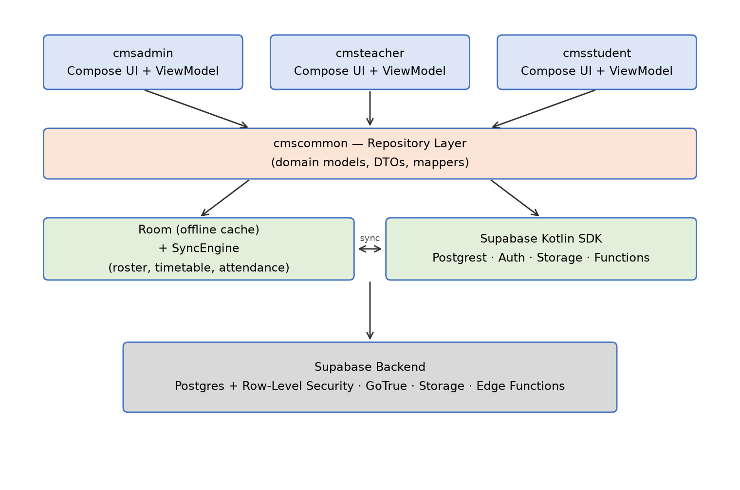
Figure 3-1 CMS layered architecture
This is closest to a layered/client-server hybrid rather than a textbook MVC or MVVM-only pattern — MVVM describes the top two layers (Compose View + ViewModel), but the Repository/Room/Supabase split underneath is really about where data lives and how fresh it needs to be, which MVVM alone doesn't prescribe. The actual enforcement of who can do what isn't in this diagram at all: it lives in Postgres RLS policies at the very bottom, which is why the same architecture serves three different roles without three different code paths.

3.4 Data Design
The domain here maps almost one-to-one onto Postgres tables — a department, a session, a student, a mark, a fee head are each one row somewhere, and the interesting structure is in the foreign keys and RLS policies between them, not in an object hierarchy. The data dictionary below is grouped by the same five domains used everywhere else in this report (identity, academic structure, financial, notices, analytics), pulled directly from the live schema rather than reconstructed from memory, so it reflects exactly what's deployed.
A few conventions run through the whole schema. Every foreign-key-style reference uses the natural key, not a surrogate integer — a session's ID is literally {deptId}_{startYear}_{shift} (e.g. it_2021_MORNING), and a student's ID within a session is {sessionId}_{rollNumber} — because those keys are genuinely stable and human-readable, and it means an admin looking directly at the database can identify a row without a join. Timestamps are timestamptz throughout, defaulting to now() at the database level rather than being set from the client, so a clock skew on someone's phone can't misdate a record.

3.4.1 Data Dictionary

Identity
Who a signed-in account is, and which role/roster row it resolves to. session_students carries a rich profile (30+ columns covering contact details, guardians, emergency contacts, and enrollment status) beyond what's listed here — only the fields that other tables actually reference are shown.
Table 3-1 Data Dictionary — Identity
Entity.Field | Type | Description
profiles.id | uuid (PK) | Matches the GoTrue auth user ID — the JWT subject.
profiles.email | text | Normalized identity key used across the schema.
profiles.role | enum | ADMIN / TEACHER / STUDENT.
profiles.linked_session_id / linked_roll | text | Set once a student account is approved (FR-20); together they point at one session_students row.
profiles.status | enum | Mirrors the account's lifecycle status (see teachers.status).
teachers.email | text (PK) | Normalized identity key; also the FK target from timetable_periods.teacher_email.
teachers.status | enum | ACTIVE / DISABLED / BANNED (FR-21).
teachers.can_approve_link_requests / can_edit_timetable / can_send_notifications / can_manage_datesheets | boolean | Per-teacher permission flags, admin-set (FR-21).
session_students.session_id + roll_number | text (composite PK) | Natural key — no surrogate ID.
session_students.linked_email | text | Set by FR-20's approval; empty string until linked.
session_students.gpa / cgpa | numeric | Snapshot updated by the record_semester_result RPC (FR-9), not written directly.
session_students.enrollment_status | enum | ACTIVE / WITHDRAWN / etc.

Academic Structure
The core of the schema — departments own sessions, sessions own everything else (subjects, timetable, attendance, marks, results).
Table 3-2 Data Dictionary — Academic Structure
Entity.Field | Type | Description
departments.dept_id | text (PK) | No underscores allowed — session IDs split on '_' to recover this.
academic_sessions.session_id | text (PK) | {deptId}_{startYear}_{shift}, e.g. it_2021_MORNING.
academic_sessions.current_semester | int | The one field FR-2's "promote" action changes; drives which curriculum/timetable rows apply.
session_subjects (session_id, semester, course_code) | composite PK | Curriculum — replaced wholesale on save (FR-3), never diffed.
timetable_periods.id | uuid (PK) | day + start_time + end_time + primary_session_id are checked by a trigger to prevent double-booking a teacher/room (FR-4).
session_attendance (session_id, semester, course_code, date, roll_number) | composite PK | One row per student per class per day; is_late defaults false but is explicitly always-encoded (see 3.7) since it hit the DTO-default bug.
session_marks (session_id, semester, course_code, exam_type, roll_number) | composite PK | score is nullable until entered; UPDATE is admin-only (FR-6/FR-7).
mark_edit_requests.id | uuid (PK) | status: PENDING / APPROVED / REJECTED (FR-7/FR-8).
student_semester_gpa (session_id, roll_number, semester) | composite PK | supply_courses is a text[]; written only via the record_semester_result RPC, never a direct insert (FR-9).

Financial
Fees moved from per-department to per-session partway through the project (3.7 explains why); fines were always per-student.
Table 3-3 Data Dictionary — Financial
Entity.Field | Type | Description
session_fees.session_id | text (PK) | One row per session — cadence is ANNUAL or SEMESTER, not per-fee-head.
session_fees.due_date / late_fine_note / payment_note | date / text / text | payment_note defaults to a fixed reminder that fees are payable at the accounts office, not through the app.
session_fee_heads (session_id, label) | composite PK | The actual line items (Tuition, Lab, Library, …); replaced wholesale on save, same delete-then-insert pattern as curriculum.
fines.id | uuid (PK) | category is an enum (LIBRARY / ATTENDANCE / EXAM / DISCIPLINARY / OTHER); amount and reason are required.

Notices
The broadcast/publication side of the system — calendar, exam datesheets, documents, exam papers, and admin notifications. Most rows here have a published/draft flag or an audience/target column, since visibility control is the whole point of this group.
Table 3-4 Data Dictionary — Notices
Entity.Field | Type | Description
calendar_events.audience | enum | ADMIN / TEACHER / STUDENT / ALL (FR-14).
datesheets.published | boolean | Non-managing roles only see published=true rows (FR-15/FR-16).
datesheet_slots.datesheet_id | uuid (FK) | One datesheet has many slots — exam_date, times, room, invigilator.
documents.storage_path / body | text / text | Either or both may be set — an uploaded file, typed text, or both (FR-17).
documents.kind | enum | PROSPECTUS / RULES / REPORT / OTHER.
documents.search | tsvector | Full-text search column, generated — not written directly by the app.
exam_paper_submissions.storage_path | text | Points into the exam-papers Storage bucket; purged along with its row when a session's semester completes, to stay within the free-tier quota.
notifications.target_role / target_dept_id / target_session_id | enum / text / text | All nullable — a notification can be broadcast (all null) or scoped to any combination.

Analytics Views
None of these are tables — all five are Postgres views marked security_invoker, which is the one property that makes FR-22's tiered access work: querying a security_invoker view re-checks the caller's own RLS against the underlying tables, rather than running with whatever privileges created the view.
Table 3-5 Data Dictionary — Analytics Views
View.Field | Type | Description
session_overview | view | session_id, dept_id, shift, current_semester, students, avg_cgpa, avg_attendance — one row per session, joined from academic_sessions/session_students/session_attendance_summary.
at_risk_students | view | session_id, roll_number, name, cgpa, attendance — flags cgpa < 2.00 or attendance < 75%.
exam_stats | view | session_id, semester, course_code, exam_type, entered, avg_score, min_score, max_score, stddev, out_of, pass_rate — aggregated straight from session_marks.
student_gpa_progression | view | session_id, roll_number, semester, gpa, cgpa, term_label, result_status, class_position, gpa_delta (gpa_delta computed vs. the prior semester).
session_attendance_summary | view | session_id, semester, course_code, roll_number, present, absent, leave, total_marked, percentage — the aggregate every other attendance-percentage figure in the app is built from.

3.5 User Interface Design
From the user's side, every screen in all three apps follows the same shape: a header (eyebrow label, title, a short accent rule), then either a form, a list of LedgerCards, or a HubNavCard grid, and — where relevant — a floating action button for the one "create new" action that screen supports. A destructive action (deleting a session, banning a teacher, rejecting a request) always routes through a confirmation dialog that names what else is affected, never a bare "Are you sure?".

3.5.1 Screen Images
[Screenshots skipped for this draft — no Android emulator/device was available in the environment this report was generated in. Before submission, capture and insert screenshots of: Admin (Departments, Session Detail, Mark Edit Requests queue), Teacher (Marks Entry showing a locked score + edit-pencil, Semester Results), and Student (Home, Results, Fee Challan) — roughly 6-8 screens covering one from each major module.]

3.5.2 Screen Objects and Actions
Marks Entry (teacher): each roster row shows ROLL · STUDENT NAME · SCORE. For a not-yet-saved student, SCORE is an editable numeric field with live validation (a red caption appears the instant the value is negative or exceeds the exam's maximum). Once saved, SCORE becomes a static label plus an edit-pencil icon button; tapping it opens the Request Mark Edit dialog (current score, a new-score field with the same live validation, an optional reason, Send Request). A "Pending review" caption replaces the pencil while a request is outstanding, and the pencil is disabled so a second request can't be filed on top of the first.
Mark Edit Requests (admin): each queue card shows the course/exam/roll, current score → requested score, the teacher's reason, and two actions — Approve and Reject — with no intermediate confirmation step, since the action itself is already the confirmation (the request disappears from the queue once acted on).

3.6 Behavioural Model
Four flows are walked through as sequence diagrams below — chosen because each one crosses at least three of the four architectural layers (3.3) and each one has a non-obvious step that a class diagram alone wouldn't surface: login resolves a role before the app can show anything; the marks flow is the whole point of the mark-lock design (2.3.6-2.3.8); attendance marking is the highest-frequency write in the system; and document publish/download is the one flow that touches Storage rather than just Postgrest.

3.6.1 Login Flow
The non-obvious step here is RoleResolver: a JWT alone doesn't tell the app whether it's talking to an admin, teacher, or student — that still has to be looked up from the profiles/teachers rows, and the resolver checks the local Room cache before it checks the network so a previously-signed-in user doesn't stall on a slow connection just to find out their own role again.
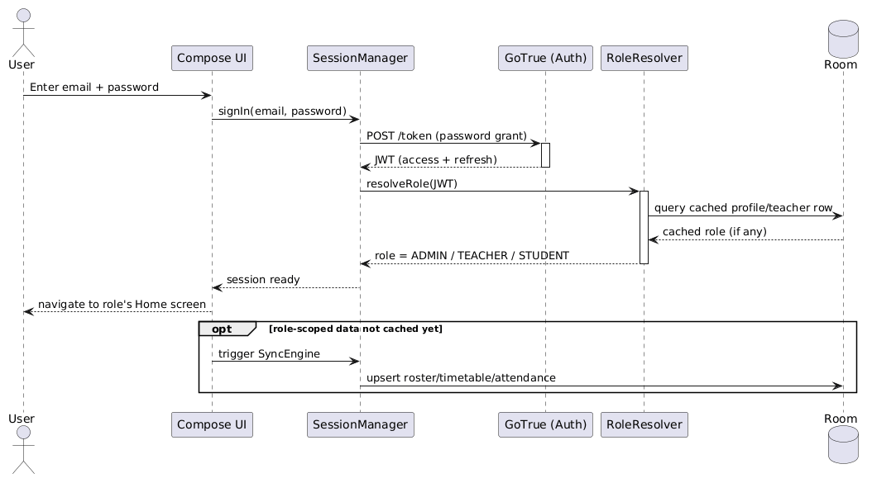
Figure 3-2 Login sequence

3.6.2 Marks Entry, Edit Request, and Approval
This is the one flow in the whole system built entirely around a single business rule (2.3.6-2.3.8): once session_marks.score exists for a student, only an admin-gated UPDATE can change it, so a teacher's own correction has to become a request row instead of a second write to the same table. The three-part split below — first entry, later correction, admin review — mirrors the three FRs it implements one for one.
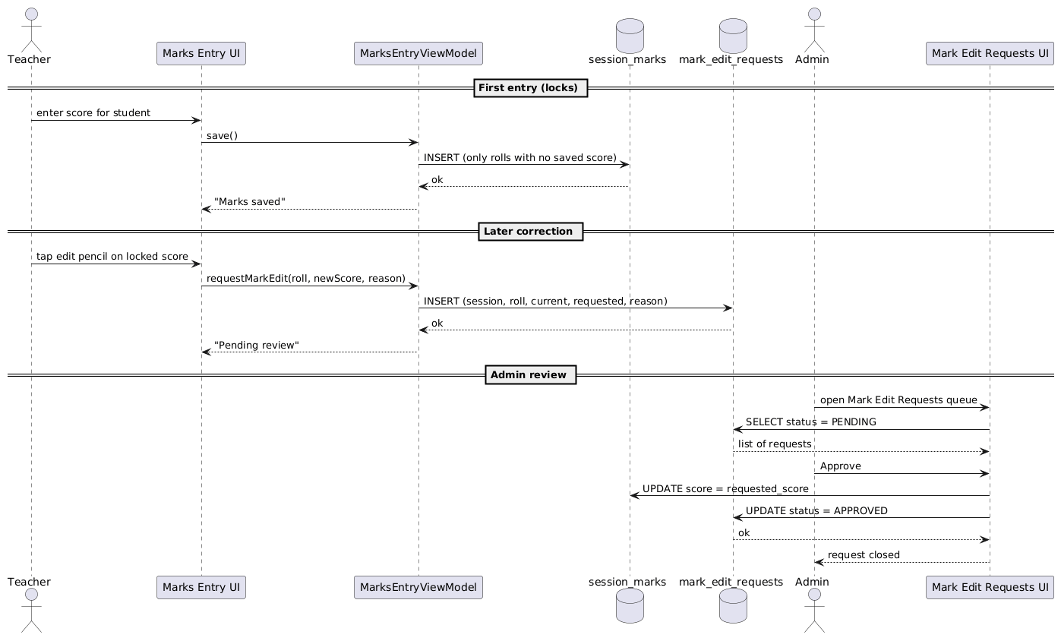
Figure 3-3 Marks entry / edit-request / approval sequence

3.6.3 Attendance Marking
The roster load reads from Room, not the network — this is the highest-frequency screen in the system (2.4.1), so it has to open instantly even on a weak connection. The save is the opposite: it goes straight to Postgrest as one bulk insert, and only updates the local cache afterward, so the source of truth for a write is always the server, never the offline copy.
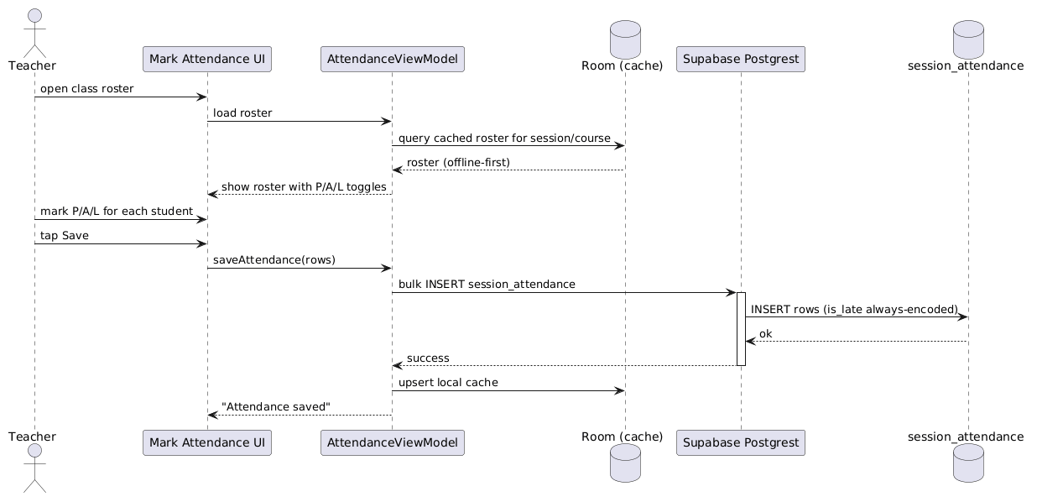
Figure 3-4 Attendance marking sequence

3.6.4 Document Publish and Download
This is the only one of the four flows that touches Supabase Storage rather than just Postgrest. The upload and the metadata insert are two separate calls, not one transaction — if the metadata insert failed after a successful upload, the blob would be orphaned in Storage with no documents row pointing at it, which is a real (if minor) gap noted again in 3.7.
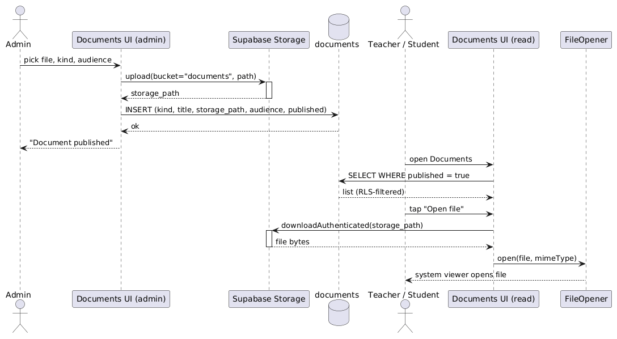
Figure 3-5 Document publish/download sequence

3.7 Design Decisions
- RLS over app-side checks. Every access rule (a teacher only sees their own sessions, a student only their own row) is a Postgres policy, not an if-statement in a Repository. The Insights feature is the proof this pays off: the same query serves three roles with zero role-branching in Kotlin. The cost is that RLS bugs are invisible in the Kotlin code — you have to go look at the policy — which is a real debugging cost the team accepted.
- Fees moved from per-department to per-session mid-project. The original design put a fee structure on each department, shared by every session under it. That broke the first time two intakes of the same department needed different tuition — a genuine requirements miss, not a technical one — so the schema, repository, and both the admin editor and student challan screen were rebuilt around session_fees/session_fee_heads instead.
- Delete-then-insert for small, infrequent collections. Curriculum, session fee heads, and timetable-adjacent lists are all replaced wholesale on save rather than diffed and patched. For a handful of rows edited a few times a semester, the simplicity of "delete the old set, insert the new one" beat writing and maintaining a diffing algorithm nobody would notice the absence of.
- Direct Postgrest over Room caching, for low-traffic features. Fees, fines, calendar, datesheets, documents, and insights all skip the offline cache entirely and read straight from the database. Only roster, timetable, and attendance — the screens opened dozens of times a day — got the Room + SyncEngine treatment. Caching everything would have meant maintaining nine more Room tables for data that's read a handful of times a week.
- The DTO-default-collision rule. kotlinx.serialization's encodeDefaults=false drops any field equal to its Kotlin default; combined with Postgrest's bulk-upsert behaviour (missing columns get filled with NULL, not the database's own default), this silently NULLed out a NOT NULL column three separate times before the pattern was understood. The fix that stuck: any DTO field backing a NOT NULL column with no database-level default gets a sentinel Kotlin default that can never be a real value (empty string, not the semantically normal default) — audited into every new DTO written after the bug was found, not just the three that broke.
- Marks lock after first entry, no exceptions for the entering teacher. This was a deliberate, not incidental, restriction — the alternative (let a teacher edit freely, log the change) was considered and rejected because a log nobody has to look at doesn't function as an audit trail. Requiring admin sign-off, even for the teacher's own typo, was the actual point.

3.8 Summary
This chapter covered how the requirements from Chapter 2 became an actual system: a four-layer architecture with Postgres RLS doing the access-control work rather than the app, a data model documented in full in the data dictionary, four sequence diagrams walking through the flows with the most moving parts, and a candid account of the design decisions that changed mid-project — the fee-structure rework and the DTO-default bug chief among them. Chapter 4 moves from design to the actual implementation: the algorithms, the third-party SDKs, and the state of the code repository itself.

Chapter 4

Implementation

4. Implementation
This chapter is about what's actually running, not the code itself — pseudocode for the pieces worth walking through, the third-party SDKs the apps depend on, and the state of the Git repository the three apps and the shared module live in.

4.1 Algorithm
Two pieces of logic are worth showing as pseudocode rather than just describing in prose: recording a semester result (the one place GPA/CGPA actually gets written), and the live score-validation check that runs on every keystroke in Marks Entry (2.3.6).
Algorithm 1 record_semester_result (Postgres RPC, SECURITY DEFINER)
record_semester_result(session, roll, semester, gpa, cgpa, term_label, result, class_position, remarks, supply[])
Input: session id, roll number, semester number, gpa, cgpa, optional term label/result/
position/remarks, optional supply-subject list
Output: none (writes two tables)

1: if NOT (caller is_admin() OR caller teaches(session)) then
2: raise exception 'not allowed'
3: upsert student_semester_gpa row keyed on (session, roll, semester)
4: on conflict: overwrite gpa/cgpa/term_label/result/position/remarks/supply
5: update session_students.gpa, .cgpa for (session, roll)
6: WHERE no row exists in student_semester_gpa for this student with a HIGHER
7: semester number than the one just recorded
8: -- guarantees the snapshot always reflects the LATEST completed semester,
9: -- even if an earlier semester is (re-)recorded out of order
Algorithm 2 scoreError(raw, maxMarks) — live validation in Marks Entry
scoreError(raw: String, maxMarks: Int): String?
Input: raw text currently in the score field, the exam type's max marks
Output: an error message to show, or null if the field is valid so far

1: if raw is blank then return null -- empty is not yet an error
2: n <- raw.trim().toIntOrNull()
3: if n is null then return "Numbers only"
4: if n < 0 then return "Can't be negative"
5: if n > maxMarks then return "Max is {maxMarks}"
6: return null

4.2 External APIs/SDKs
Everything below is a real dependency the apps build against today, not an aspirational list — versions match 1.9's Tools and Technologies table.
Table 4-1 Details of APIs/SDKs used in the project
API / SDK | Purpose | Used in
Supabase Postgrest-kt | Typed REST client over the Postgres schema — every Repository's read/write path. | cmscommon/data/repository/*.kt
Supabase Auth-kt (GoTrue) | Sign-in, session/token refresh, password reset. | SessionManager, RoleResolver
Supabase Storage-kt | Upload/download for exam papers and documents. | ExamPaperSubmissionRepositoryImpl, DocumentRepositoryImpl
Supabase Functions-kt | Invokes Edge Functions for service-role-only actions (create teacher account, change teacher status). | AdminUserProvisioner
Ktor (OkHttp engine) | The HTTP client every Supabase-kt module runs on. | Configured once in SupabaseModule (Hilt)
kotlinx.serialization | JSON (de)serialization for every DTO. | All *Dto.kt classes
Room + Room-ktx | Local offline cache + DAOs for roster/timetable/attendance. | cmscommon/data/local/*
Hilt | Dependency injection across all three apps and the shared module. | *Module.kt, @HiltViewModel classes
Jetpack Compose + Material3 | All UI in all three apps. | Every feature/*/*.kt screen

4.3 Code Repository
Git is the version-control tool for the whole project — all three apps, the shared cmscommon module, and the Supabase migrations/Edge Functions live in one repository.
Git Repository Link: https://github.com/hadiyasaleem/CMS

4.3.1 Metrics of the Git Repository
These reflect the state of the repository at the time of writing (git log/git shortlog on the default branch), and will keep changing as work continues.
Table 4-2 Metrics of the Git Repository
Metric | Value
Commits | 107
Branches (local + remote) | 9
Contributors | Hadia, Sharfa Kiran, Syeda Laraib Qamar Kazmi (some appear under more than one git identity/machine)
Latest merged PR | #20 — Attendance fragment and activity
Note on the contributor list: several team members show up under two Git identities (e.g. "sharfakiran" and "Sharfa Kiran", "hadiyasaleem" and "Hadiya Saleem") because Git config wasn't consistent across every machine used during development — the commit counts above are real, but attributing them cleanly per person would need a .mailmap rather than a straight git shortlog.

4.4 Summary
This chapter grounded the design in what's actually implemented: the two algorithms worth walking through in pseudocode, the real external SDKs each app depends on, and the state of the Git repository itself. Chapter 5 turns to testing — what's been verified, what's only been compiled, and what's still pending an actual device run.

Chapter 5

Testing and Evaluation

5. Introduction
The honest state of testing on this project: every feature described in this report compiles and builds green across all three apps, and has been manually exercised during development. What hasn't happened yet is a structured device/emulator test pass recording actual pass/fail results — the test cases below are fully specified (steps, inputs, expected results) but their Actual Result and Remarks columns say "Pending execution" rather than a real outcome, because that's what's true right now. Running these on a real device and filling in real results is the one thing standing between this chapter and a finished testing record.
Test cases are grouped the same way most of this report is: by the layer of the system they exercise (unit, functional, integration, performance), following the template below for each one.

5.1 Unit Testing (UT)
Unit tests target pure logic with no database or UI involved — the best candidate in this codebase is the live score-validation function (scoreError, 4.1 Algorithm 2), since it's a pure function with clean input/output boundaries.
Table 5-1 Testcase UT-1
Testcase ID | UT-1
Requirement ID | FR-6
Title | scoreError rejects a negative score
Description | Unit test of the live-validation function used in Marks Entry.
Objective | Confirm a negative input produces the "Can't be negative" message and no other case does.
Driver/precondition | None — scoreError is a pure Kotlin function.
Test steps | 1. Call scoreError("-5", 25). 2. Call scoreError("5", 25) as a control case.
Input | raw = "-5", maxMarks = 25 (and raw = "5" for the control case).
Expected Results | First call returns "Can't be negative"; control case returns null.
Actual Result | Pending execution — not yet run on a device/emulator
Remarks | Pending

Table 5-2 Testcase UT-2
Testcase ID | UT-2
Requirement ID | FR-6
Title | scoreError rejects a score above the exam maximum
Description | Unit test of the live-validation function used in Marks Entry.
Objective | Confirm a value above maxMarks produces "Max is {maxMarks}", and a value exactly at the maximum is accepted.
Driver/precondition | None.
Test steps | 1. Call scoreError("30", 25). 2. Call scoreError("25", 25) as a boundary case.
Input | raw = "30", maxMarks = 25 (and raw = "25" for the boundary case).
Expected Results | First call returns "Max is 25"; boundary case (exactly at max) returns null.
Actual Result | Pending execution — not yet run on a device/emulator
Remarks | Pending

5.2 Functional Testing (FT)
Functional tests exercise a whole feature end to end through the actual UI, checking the system meets the requirement it was built for rather than just that one function returns the right value.
Table 5-3 Testcase FT-1
Testcase ID | FT-1
Requirement ID | FR-6
Title | Teacher enters a new midterm score
Description | A teacher opens Marks Entry, picks a class, and enters a score for a student who has none yet.
Objective | Confirm a valid new entry saves and immediately locks (becomes read-only with an edit-request pencil).
Driver/precondition | Signed in as a teacher assigned to at least one session/course; that student has no midterm score yet.
Test steps | 1. Open Marks Entry. 2. Select a class and MIDTERM. 3. Type 20 into a student's score field. 4. Tap Save.
Input | Score = 20 for a student with no prior midterm score.
Expected Results | Save succeeds; the field becomes a read-only "20" with an edit-pencil icon next to it.
Actual Result | Pending execution — not yet run on a device/emulator
Remarks | Pending

Table 5-4 Testcase FT-2
Testcase ID | FT-2
Requirement ID | FR-7, FR-8
Title | Teacher requests a mark change and admin approves it
Description | End-to-end run of the lock → request → approve workflow across the teacher and admin apps.
Objective | Confirm the requested score only lands on the student's record after admin approval, not before.
Driver/precondition | A student already has a locked midterm score of 20.
Test steps | 1. In the teacher app, tap the edit-pencil next to the locked score. 2. Enter 22 as the new score with a reason. 3. Submit. 4. In the admin app, open Mark Edit Requests. 5. Approve the request.
Input | Requested score = 22, reason = "transcription error".
Expected Results | After step 3, the teacher app shows "Pending review" for that student and the score is still 20. After step 5, the student's score is 22 and the request disappears from the admin queue.
Actual Result | Pending execution — not yet run on a device/emulator
Remarks | Pending

Table 5-5 Testcase FT-3
Testcase ID | FT-3
Requirement ID | FR-15, FR-16
Title | Admin publishes a datesheet and a student sees it
Description | Admin builds a datesheet with one exam slot and publishes it; a student in that session opens Datesheets.
Objective | Confirm a draft datesheet is invisible to students, and becomes visible only once published.
Driver/precondition | A datesheet exists in draft state with at least one slot.
Test steps | 1. As the student, open Datesheets — confirm the draft is not listed. 2. As admin, toggle the datesheet to Published. 3. As the student, refresh Datesheets.
Input | One datesheet, one slot (course, date, time, room).
Expected Results | Step 1 shows no datesheet. Step 3 shows the datesheet with its slot visible after expanding it.
Actual Result | Pending execution — not yet run on a device/emulator
Remarks | Pending

5.3 Integration Testing (IT)
Integration tests check that pieces which pass unit and functional tests on their own still behave correctly once wired together — specifically here, that the RLS policies on one table interact correctly with a write that touches two tables in sequence.
Table 5-6 Testcase IT-1
Testcase ID | IT-1
Requirement ID | FR-6, FR-7
Title | Bulk marks save skips already-locked students without erroring
Description | A class has some students with scores already saved and some without; the teacher enters new scores only for the unsaved ones and hits Save.
Objective | Confirm the bulk-save call only ever contains new rows, so it never triggers the admin-only UPDATE policy on session_marks for an already-existing row (which would abort the batch — see 3.7).
Driver/precondition | A class of at least 3 students, 1 of whom already has a saved score.
Test steps | 1. Open Marks Entry for that class. 2. Enter scores only for the 2 unsaved students. 3. Tap Save.
Input | Two new scores; the third student's field is left as its existing locked value.
Expected Results | Save succeeds and only the 2 new rows are written; the already-locked student's score is untouched and the call does not error.
Actual Result | Pending execution — not yet run on a device/emulator
Remarks | Pending

Table 5-7 Testcase IT-2
Testcase ID | IT-2
Requirement ID | FR-19, FR-20
Title | Approving a link request updates both profiles and session_students
Description | A student submits a link request; admin approves it.
Objective | Confirm approval's multi-step write (profiles.linked_session_id/linked_roll AND session_students.linked_email) lands consistently, and any previously-linked account on that roll number is revoked.
Driver/precondition | A pending link request for a roll number not yet linked to any account.
Test steps | 1. Submit a link request as an unlinked student account. 2. As admin, open Link Requests and approve it. 3. Sign back in as the student.
Input | Session ID and roll number matching an existing roster row.
Expected Results | After approval, the student's home screen shows their real roster data (name, attendance, etc.) instead of the unlinked placeholder state.
Actual Result | Pending execution — not yet run on a device/emulator
Remarks | Pending

5.4 Performance Testing (PT)
No performance testing has been run yet — there's no load on the Supabase project beyond development traffic, so a real number here would be meaningless. The two test cases below are specified so they're ready to run once the app is on real devices with a realistic dataset; the intended tool is Android Studio's built-in Profiler for on-device timing, since nothing beyond that is needed at this scale.
Table 5-8 Testcase PT-1
Testcase ID | PT-1
Requirement ID | FR-5
Title | Attendance screen load time for a full class
Description | Time from opening Mark Attendance to the full roster being interactive.
Objective | Confirm the single most frequent screen in the app (used once per class, per day) loads fast enough not to eat into class time.
Driver/precondition | A session with a full roster (up to the 50-student cap) already cached in Room.
Test steps | 1. Cold-start the teacher app. 2. Navigate to Mark Attendance. 3. Select a class. 4. Measure time to the roster rendering as interactive.
Input | A 50-student roster, cold app start.
Expected Results | Target: under 1 second from selecting the class to the roster being tappable, since it's read from the local Room cache, not the network.
Actual Result | Pending execution — not yet run on a device/emulator
Remarks | Pending

Table 5-9 Testcase PT-2
Testcase ID | PT-2
Requirement ID | FR-22
Title | Insights screen load time (direct Postgrest reads)
Description | Time from opening Insights to all three tabs (Sessions, At-Risk, Exams) finishing their loads.
Objective | Confirm the analytics views, which read directly from Postgrest with no local cache, still return in an acceptable time on a typical mobile connection.
Driver/precondition | A college-scale dataset (multiple departments, sessions, and a semester's worth of marks/attendance).
Test steps | 1. Open the admin Insights screen. 2. Measure time until all three tabs' data has loaded.
Input | College-scale dataset, typical mobile data connection.
Expected Results | Target: under 3 seconds per tab; if it's meaningfully slower, that's a real signal the free-tier Supabase plan's connection limits are becoming a bottleneck (see 2.4.3).
Actual Result | Pending execution — not yet run on a device/emulator
Remarks | Pending

5.5 Summary
Nine test cases are specified across unit, functional, integration, and performance levels, covering the workflows this report leans on most heavily — the marks lock/edit-request/approval loop, link-request approval, and datesheet publishing. None of them have been executed on a real device yet, which is stated plainly rather than papered over with invented results. Chapter 6 covers what deploying this system to GGC MBD actually looks like, including the real challenges already hit during development.

Chapter 6

System Conversion

6. Introduction
There's no legacy digital system at GGC MBD to migrate away from — the "old system" this project replaces is paper: registers, hand-filled fee challans, printed datesheets. That changes what "conversion" means here: there's no data export from a previous system, no cutover window where two databases need to agree, just a rollout of something genuinely new.

6.1 Conversion Method
Phased conversion is the right fit, not direct or parallel. The four modules that matter most for day-one usefulness — attendance, marks entry, fee challan viewing, and datesheets — can go live as soon as the admin has entered a department's sessions and rosters; deeper features (Insights, teacher lifecycle management, fines) can follow once the college's admin staff are comfortable with the basics. Direct conversion doesn't apply since there's no old system to abruptly switch off, and parallel conversion doesn't make sense either — there's nothing to run in parallel with.
Rollout is naturally per-department too, not all-at-once college-wide: onboarding one department's admin, teachers, and students first surfaces onboarding friction (unfamiliar roll-number formats, missing CNIC data, teachers unsure which session they're assigned to) on a small population before every department hits the same issues simultaneously.

6.2 Deployment
There's no production server to provision — Supabase's hosted platform is the backend, and the three Android apps are distributed as APKs rather than through the Play Store for this initial rollout. Deployment is really two checklists: one on the Supabase dashboard, one for getting the apps onto devices.
Table 6-1 Deployment Steps
Step | Action
1 | On the Supabase dashboard, create the bootstrap admin account and set its role to ADMIN in the profiles table — every other admin action depends on at least one such account existing.
2 | Configure Auth → SMTP so account-verification and password-reset emails actually send; without this, FR-19 (link request) and password reset silently fail to deliver mail.
3 | Add cms://login-callback to Auth → Redirect URLs, required for the deep-link back into the app after email verification.
4 | Build a signed release APK for each of the three apps (:app:cmsadmin:assembleRelease, etc.).
5 | Install each APK on the intended device population — clean install (uninstall any prior debug build first) to avoid a stale Room schema colliding with a fresh one.
6 | Have the bootstrap admin create the first department, session, and a small pilot roster, then confirm a teacher and student account can each sign in and see their own scoped data.

6.2.1 Data Conversion
Minimal, because there's no source database to extract from — the college's existing records are paper registers and hand-written rosters, not a system with an export format. The one real data-entry task is the admin manually keying in each session's roster (roll number, name, and the optional richer profile fields) through the Session Students screen the first time a department comes onto the system; there's no bulk-import tool for this yet, which is listed as a gap in Future Work (7.4) rather than something already solved.
Backup, in the absence of anything to convert, means the normal Supabase database backup/restore that comes with the hosted project — nothing project-specific was built on top of it.

6.2.2 Training
Two of the system's most frequently used flows are walked through below as a short user manual. Screenshots aren't included in this draft — see the placeholder note — but the steps themselves are accurate to the current UI and can be followed on the actual app.
[Screenshots for each numbered step below were not captured for this draft (no device/emulator session was available while writing it). Insert a screenshot of the named screen at each step before final submission.]

Marking Attendance (Teacher)
1. Open the Faculty Ledger app and sign in.
2. Tap Attend in the bottom navigation.
3. Pick the class (session + course) you're about to teach.
4. Mark each student Present, Absent, or Leave using the P/A/L control next to their name.
5. Tap Save. The class's attendance for today is now recorded — tap History from the same screen to review any previous day.

Viewing Fee Challan (Student)
1. Open the Student Ledger app and sign in.
2. Tap More in the bottom navigation, then Fee Challan.
3. The screen shows your session's fee cadence (semester or annual), each fee head with its amount, the total, and the due date.
4. This screen is informational only — pay the amount shown at the college's accounts office, not through the app.

6.3 Post Deployment Testing
Once the six deployment steps in 6.2 are done for a pilot department, the following smoke checks confirm the rollout actually worked before opening it up to more departments — and correspond directly to the FT/IT test cases specified in Chapter 5, run for real this time rather than only specified:
- The bootstrap admin can sign in and see the pilot department, session, and roster they created.
- A teacher account tied to that session can mark attendance and enter marks for their assigned class only — and cannot see or touch a different department's data (confirms RLS scoping, not just UI hiding).
- A student's link request submitted against the pilot roster is visible in the admin's Link Requests queue and, once approved, that student sees their real attendance/marks/fee data.
- Password-reset and account-verification emails actually arrive (confirms the SMTP configuration from 6.2 step 2 took effect).
If any of these fail, the fix belongs in the corresponding chapter — an RLS gap is a Chapter 3 design bug, a missing email is a Chapter 6 configuration gap, not a new category of its own.

6.4 Challenges
Three real problems surfaced during development that are worth recording honestly, since each one changed how a piece of the system is built — not hypothetical risks, things that actually broke.

The DTO default-collision bug (hit three times before the pattern was recognised)
kotlinx.serialization is configured with encodeDefaults=false, so any DTO field left at its Kotlin default gets dropped from the JSON payload entirely. That's normally harmless — until a bulk insert has several rows where most share a field's default value, and Postgrest fills the missing column with NULL for every row in that batch, not just the ones genuinely missing a value. It first surfaced as attendance rows silently failing to save is_late correctly, then again with exam-type fields, before the actual cause was pinned down. The fix became a standing rule rather than a one-off patch: any DTO field backing a NOT NULL column with no database default gets a sentinel default value that can never occur for real (an empty string instead of a real status name, for instance), so the field is never silently omitted.

Tightening marks RLS broke the bulk-save path
When the mark-lock/edit-request feature (2.3.6–2.3.8) restricted session_marks UPDATE to admin-only, the existing "Save all scores in this class" button started failing outright — it always bulk-upserted the whole roster, and Postgrest's upsert is an INSERT with an ON CONFLICT DO UPDATE clause, which needs UPDATE privilege the moment any row in the batch already exists. One already-locked student in a batch of thirty was enough to abort the entire save. The fix was in the ViewModel, not the database: the save action now filters out any student who already has a saved score before it ever calls the bulk-write, so the call is a pure INSERT and never touches the tightened UPDATE policy.

A UI bug that only showed up in a user's screenshot
A shared segmented-toggle component (used for exam-type selection, fee-cadence selection, and elsewhere) had a VerticalDivider with no height constraint. Under Material3's defaults that divider tries to fill all available vertical space, and since the surrounding layout had no bounded height either, the whole toggle expanded to swallow the rest of the screen on the Marks Entry page specifically. No design review caught it — it was found because a user sent a screenshot of what looked like a broken, mostly-blank screen. The fix (constrain the row to its content's intrinsic height) was small once found, but finding it relied on an actual user hitting it rather than any structured testing process, which is the real lesson: this project doesn't yet have a UI review step that would have caught this before it shipped.

6.5 Summary
Deployment here is a phased, per-department rollout rather than a cutover from an existing system, since the thing being replaced is paper rather than software. The real value of this chapter is the Challenges section — three concrete bugs that changed the design (a serialization/RLS interaction, a bulk-write assumption that broke under tightened security, and a layout bug only a real user surfaced) — recorded as they actually happened rather than smoothed into a success story. Chapter 7 closes the report: whether the objectives from Chapter 1 were actually met, and what's left to build.

Chapter 7

Conclusion

7. Introduction
This chapter checks the objectives from Chapter 1 against what actually got built, traces requirements through to code and tests, and closes with what's genuinely left to do — not a polished wrap-up, but an honest accounting.

7.1 Evaluation
Table 7-1 Evaluation — Objectives vs Status
Objective (from 1.3) | Status
Student generates/views their own fee challan with zero in-person visits for a routine challan | Met — FR-11, informational view only, no payment processing (deliberately out of scope, see 1.4/1.8)
Teacher marks a full class's attendance in under a minute, visible to admin/students immediately | Met — FR-5; timing itself untested on-device (5.4/PT-1 pending)
A mark, once entered, can't be silently changed — correction requires admin approval | Met — FR-6/FR-7/FR-8, enforced at the RLS layer, not just the UI
Student sees semester GPA/CGPA progression, including supply subjects, without a printed transcript | Met — FR-9, ResultsScreen
Datesheets and notices reach affected students/teachers the moment they're published | Met — FR-14/FR-15/FR-16; "the moment" is on next screen open, not a push notification (see 7.4)
Data is scoped to the correct role via database-level rules, not application-remembered checks | Met — every table/view is RLS-protected; FR-22's tiered Insights is the clearest demonstration of this
System stays usable when connectivity drops (cached roster/timetable/attendance) | Partially met — Room caches the high-frequency reads; there is no queued-retry for writes made while offline (2.4.1)

7.2 Traceability Matrix
Every requirement from 2.3 traced through to the component that implements it and, where one exists, the test case that exercises it. Several rows say "Not yet tested" rather than inventing a Test ID — Chapter 5 only specifies nine test cases, not twenty-two, and that gap is real (see 5.5, 7.4).
Table 7-2 Traceability Matrix
Req. | Design Specification | Code | Test ID
FR-1 | DepartmentRepository | DepartmentRepositoryImpl.kt | Not yet tested
FR-2 | AcademicSessionRepository | AcademicSessionRepositoryImpl.kt | Not yet tested
FR-3 | CurriculumRepository | AcademicStructureRepositoryImpls.kt | Not yet tested
FR-4 | SessionTimetableRepository + DB trigger | SessionTimetableRepositoryImpl.kt | Not yet tested
FR-5 | SessionAttendanceRepository | SessionAttendanceRepositoryImpl.kt | Not yet tested
FR-6 | SessionMarksRepository + MarksEntryViewModel | MarksEntryViewModel.kt, MarksEntryScreen.kt | UT-1, UT-2, FT-1
FR-7 | MarkEditRequestRepository | MarkEditRequestRepositoryImpl.kt, MarksEntryScreen.kt | FT-2, IT-1
FR-8 | MarkEditRequestRepository.approveRequest | MarkEditRequestsScreen.kt | FT-2
FR-9 | record_semester_result RPC | SemesterResultsScreen.kt | Not yet tested
FR-10 | SessionFeeRepository | SessionFeesScreen.kt | Not yet tested
FR-11 | SessionFeeRepository | FeeChallanScreen.kt | Not yet tested
FR-12 | FineRepository | StudentProfileScreen.kt | Not yet tested
FR-13 | FineRepository | ProfileScreen.kt (student) | Not yet tested
FR-14 | CalendarRepository | CalendarScreen.kt | Not yet tested
FR-15 | DatesheetRepository | DatesheetsScreen.kt (admin) | FT-3
FR-16 | DatesheetRepository | DatesheetsScreen.kt (student/teacher) | FT-3
FR-17 | DocumentRepository | DocumentsScreen.kt (admin) | Not yet tested
FR-18 | DocumentRepository | DocumentsScreen.kt (student/teacher) | Not yet tested
FR-19 | StudentLinkRequestRepository | LinkRequestScreen.kt (student) | IT-2
FR-20 | StudentLinkRequestRepository.approveRequest | LinkRequestsScreen.kt (admin) | IT-2
FR-21 | TeacherRepository.setStatus | TeachersScreen.kt (admin) | Not yet tested
FR-22 | InsightsRepository + security_invoker views | InsightsScreen.kt (admin/teacher) | PT-2

7.3 Conclusion
Six of the seven objectives from Chapter 1 are met outright, and the seventh — staying usable offline — is met for reads but not yet for writes made while disconnected, which is a real, specific gap rather than a rounding error. What this project actually demonstrates is narrower and more interesting than "we built three apps": that a single set of Postgres Row-Level Security policies can serve three different roles' worth of access control without the applications themselves ever encoding who's allowed to see what. FR-22's Insights feature is the cleanest proof of that — the exact same query, run by an admin, a teacher, and a student, returns three different result sets because the database decided that, not the app.
The path here wasn't smooth in a straight line — the backend was rebuilt mid-project from Firebase to Supabase, the data model moved from offering-centric to department-centric, and three concrete bugs (documented honestly in 6.4) each forced a real design change rather than a quick patch. That the finished system still builds green across all three apps and matches the requirements in Chapter 2 is the actual claim being made here, not that the process was clean.

7.4 Future Work
Listed roughly in the order they'd matter most to an actual deployment, not alphabetically:
- Offline write queue — right now a write attempted with no connection just fails with an error; queuing it for retry once connectivity returns would close the one real gap in 7.1's offline objective.
- Bulk roster import — the admin currently keys in every student one at a time (6.2.1); a CSV/Excel import would remove the single biggest data-entry cost of onboarding a new department.
- Push notifications — calendar events, datesheet publishing, and fee-due reminders currently rely on the user opening the app; a push channel would make "published" actually mean "notified."
- Executed device testing — Chapter 5's nine test cases need to actually run on a device with real Actual Result data, and the set itself should grow well past nine once that process exists.
- A structured UI/usability review — the segmented-toggle bug in 6.4 was found by luck, not process; even a lightweight design-review pass before each feature ships would likely have caught it earlier.
- Teacher lifecycle audit log — disabling/banning a teacher (FR-21) changes their access immediately but doesn't currently record a history of who changed what and when.
- Load testing against the free-tier Supabase plan's real limits, to know in advance rather than find out live where the connection/storage ceiling actually is at multi-department scale.

References
Supabase. "Row Level Security." Internet: https://supabase.com/docs/guides/database/postgres/row-level-security, [accessed 2026].
Supabase. "Postgrest, Auth, Storage, and Edge Functions." Internet: https://supabase.com/docs, [accessed 2026].
Supabase. "supabase-kt — Kotlin client for Supabase." Internet: https://github.com/supabase-community/supabase-kt, [accessed 2026].
Android Developers. "Jetpack Compose." Internet: https://developer.android.com/develop/ui/compose, [accessed 2026].
Android Developers. "Room persistence library." Internet: https://developer.android.com/training/data-storage/room, [accessed 2026].
Android Developers. "Guide to app architecture (MVVM, ViewModel, Repository)." Internet: https://developer.android.com/topic/architecture, [accessed 2026].
Google. "Material Design 3." Internet: https://m3.material.io, [accessed 2026].
Google. "Hilt dependency injection." Internet: https://developer.android.com/training/dependency-injection/hilt-android, [accessed 2026].
Kotlin. "kotlinx.serialization." Internet: https://github.com/Kotlin/kotlinx.serialization, [accessed 2026].
PostgreSQL Global Development Group. "Row Security Policies" and "CREATE VIEW (security_invoker)." Internet: https://www.postgresql.org/docs/current/ddl-rowsecurity.html, [accessed 2026].

Appendix A

Use Case Description (Fully Dressed Format)

Appendix-A Use Case Description (Fully Dressed Format)
Six use cases are detailed below, covering the workflows most central to this report — sign-in (shared by all three apps), the full marks lock/edit-request/approval loop, viewing a fee challan, and the two publish-workflows (datesheets, documents).

UC-1 Sign In
Table A-1 Use Case Description — Sign In
Use Case ID | UC-1
Use Case Name | Sign In
Actors | Admin, Teacher, Student (any of the three apps)
Description | An account holder authenticates to reach their role-scoped home screen.
Trigger | User opens the app (or returns to it after a sign-out) and enters credentials.
Preconditions | The account already exists in GoTrue and, for a Teacher or Student, its profile row has a resolved role.
Postconditions | A valid session/JWT is held by the app; the user lands on their role's home screen with their own data loading.
Normal Flow | 1. User opens the app. 2. User enters email and password. 3. App calls GoTrue sign-in. 4. On success, RoleResolver reads the account's role from profiles. 5. App navigates to the Admin/Teacher/Student home screen and begins syncing that role's reference data.
Alternative Flows | 3a. Invalid credentials: GoTrue returns an error; the app shows it inline and stays on the sign-in screen. 4a. Account has no resolved role yet (a student who hasn't linked to a roster row): app shows the "not yet linked" state and offers the link-request flow (UC not detailed separately — see FR-19).
Business Rules | A DISABLED or BANNED teacher account (FR-21) is blocked at the GoTrue level, not just app-side — the ban is on the underlying auth user.
Assumptions | The device has network connectivity for the initial sign-in call; subsequent app opens can restore a cached session without one.

UC-2 Enter Marks & Request Edit
Table A-2 Use Case Description — Enter Marks & Request Edit
Use Case ID | UC-2
Use Case Name | Enter Marks & Request Edit
Actors | Teacher
Description | A teacher enters midterm/sessional scores for a class, and later requests a correction to a score already locked.
Trigger | Teacher opens Marks Entry for one of their assigned classes.
Preconditions | The teacher is assigned to the session/course on the timetable; the exam type (midterm/sessional) is selected.
Postconditions | New scores are saved and immediately locked; a correction to an existing score exists as a PENDING request, not yet applied.
Normal Flow | 1. Teacher selects a class and exam type. 2. For each student without a saved score, teacher types a value; the field validates live (rejects negative/over-max). 3. Teacher taps Save — only the new, valid entries are written. 4. Saved fields become read-only with an edit-pencil icon.
Alternative Flows | 2a. Typed value is invalid: an inline error shows and that student's entry is excluded from the save. 4a. Teacher taps the edit-pencil on an already-locked score: a dialog opens for a new score + optional reason; submitting creates a mark_edit_requests row instead of writing the score directly, and the field shows "Pending review" until an admin acts (UC-3).
Business Rules | The database's session_marks UPDATE policy is admin-only, so a locked score literally cannot be overwritten by a direct write — this is enforced independently of the UI.
Assumptions | The class roster and any already-saved scores are already synced to the device (Room cache) before the screen opens.

UC-3 Approve/Reject Mark Edit Request
Table A-3 Use Case Description — Approve/Reject Mark Edit Request
Use Case ID | UC-3
Use Case Name | Approve/Reject Mark Edit Request
Actors | Admin
Description | Admin reviews a teacher's pending request to change an already-locked score and approves or rejects it.
Trigger | Admin opens the Mark Edit Requests queue (People hub).
Preconditions | At least one PENDING request exists (created via UC-2's alternative flow).
Postconditions | Approve: the requested score is written onto session_marks and the request is marked APPROVED. Reject: the request is marked REJECTED and the score is unchanged.
Normal Flow | 1. Admin opens Mark Edit Requests. 2. For a listed request, admin reviews the course, roll number, current score, requested score, and reason. 3. Admin taps Approve. 4. The system writes the new score, then marks the request APPROVED, then removes it from the pending queue.
Alternative Flows | 3a. Admin taps Reject instead: the request is marked REJECTED and step 4's score write never happens.
Business Rules | Approval is two sequential writes (score update, then request status update), not one atomic transaction — both are admin-gated and idempotent if a retry were needed, which is an accepted trade-off for simplicity over strict atomicity (3.7).
Assumptions | Only one admin is reviewing the queue at a time; concurrent approval of the same request by two admins is not specifically guarded against.

UC-4 View Fee Challan
Table A-4 Use Case Description — View Fee Challan
Use Case ID | UC-4
Use Case Name | View Fee Challan
Actors | Student
Description | A student checks their session's fee structure and due date without visiting the accounts office.
Trigger | Student opens More → Fee Challan.
Preconditions | An admin has already set up a fee structure for the student's session (FR-10); if not, the screen has nothing to show.
Postconditions | The student has seen the current cadence, fee heads, total, due date, and payment note.
Normal Flow | 1. Student opens Fee Challan. 2. The app reads the session's fee structure directly from Postgrest (no local cache, since this is a low-frequency read). 3. The screen renders the cadence, each fee head with its amount, the running total, due date, and payment note.
Alternative Flows | 2a. No fee structure has been set for this session yet: the screen shows an empty-state message instead of a blank table.
Business Rules | This screen is read-only and never processes a payment — a deliberate scope decision (1.4, 1.8); the payment note always directs the student to the accounts office.
Assumptions | The student's account is already linked to a session_students row (FR-20) — an unlinked account has no session to look up a fee structure for.

UC-5 Build & Publish Datesheet
Table A-5 Use Case Description — Build & Publish Datesheet
Use Case ID | UC-5
Use Case Name | Build & Publish Datesheet
Actors | Admin (or a Teacher with datesheet-management permission)
Description | Admin assembles an exam datesheet (title, slots) and publishes it so students/teachers can see it.
Trigger | Admin opens Records → Datesheets and creates a new datesheet.
Preconditions | The session(s) the datesheet covers already exist.
Postconditions | The datesheet exists with its slots; once published, it's visible to students and non-managing teachers.
Normal Flow | 1. Admin creates a datesheet (title, exam type, instructions) — starts as draft. 2. Admin adds one or more slots (exam date, time, course, room, invigilator). 3. Admin reviews the assembled datesheet. 4. Admin toggles it to Published.
Alternative Flows | 4a. Admin leaves it as draft to keep building later: it stays invisible to students/non-managing teachers until explicitly published. 2a. Admin deletes a slot entered by mistake before publishing.
Business Rules | Only published=true datesheets are visible to students and teachers without datesheet-management permission — enforced by RLS on the datesheets/datesheet_slots tables, not by hiding drafts in the UI alone.
Assumptions | One admin builds a given datesheet without simultaneous editing by a second admin.

UC-6 Upload & Publish Document
Table A-6 Use Case Description — Upload & Publish Document
Use Case ID | UC-6
Use Case Name | Upload & Publish Document
Actors | Admin
Description | Admin makes a college document (prospectus, rules, report) available to students/teachers, either as an uploaded file or typed text.
Trigger | Admin opens Records → Documents and adds a new document.
Preconditions | None beyond being signed in as admin.
Postconditions | The document exists, tagged with a kind and audience; once published, the intended audience can view/download it.
Normal Flow | 1. Admin chooses to either upload a PDF/DOCX file or type body text directly. 2. Admin sets the document's kind (prospectus/rules/report/other) and audience. 3. Admin publishes it. 4. An uploaded file is stored in the private documents Storage bucket; typed text is stored inline.
Alternative Flows | 1a. Admin provides both a file and typed text (e.g. a summary plus the full attached document). 3a. Admin leaves it unpublished as a draft to finish later.
Business Rules | A document filed under the archives/ storage path is excluded from the general public-read policy, reserved for internal-only material — everything else published is readable by its target audience.
Assumptions | The uploaded file is a reasonable size for the free-tier Storage quota; no client-side file-size limit is currently enforced beyond what Storage itself rejects.

Appendix B

Coding Standards

Appendix-B General Coding Standards & Guidelines
These are the conventions actually followed across cmsadmin, cmsteacher, cmsstudent, and the shared cmscommon module — not a generic checklist, but what the codebase does in practice.
1. Naming: camelCase for variables, properties, and function names (rollNumber, syncSession()); PascalCase for classes, interfaces, and Composable functions (SessionMarksRepository, MarksEntryScreen); SCREAMING_SNAKE_CASE only for true compile-time constants (CMS_DATABASE_VERSION).
2. Suffix conventions carry meaning and are used consistently: *Repository (interface) / *RepositoryImpl (implementation), *Dto (a Postgrest row shape), *Entity (a Room table row), *ViewModel, *Screen. A reader can tell a type's role from its name alone without opening the file.
3. One class/interface per file, filename matching the type name (SessionFeeRepository in SessionFeeRepository.kt) — the one common exception is small, tightly-related DTOs or sealed-class variants grouped in one *Dtos.kt or *Enums.kt file when splitting them out would add navigation overhead for no real benefit.
4. Dependency injection is Hilt throughout: @HiltViewModel + @Inject constructor for ViewModels, @Binds in a *Module.kt for interface-to-implementation wiring, @Provides for anything needing manual construction (Room database instances, Supabase client). No manual service-locator pattern anywhere in the codebase.
5. Repositories are the only layer allowed to know about DTOs, table names, or Postgrest/Room APIs — a ViewModel calls a Repository method and gets back a domain model, never a raw row shape. This is enforced by convention/code review, not a compiler check.
6. Comments explain the non-obvious, not the obvious: a comment exists to record a hidden constraint, a subtle invariant, or the reason behind a workaround (see the DTO-default-collision note in AttendanceRowDto, 3.7) — not to restate what a well-named function already says. No boilerplate KDoc blocks on self-explanatory getters.
7. Kotlin's own formatting conventions (4-space indent, trailing commas in multi-line argument lists, expression-body functions where they fit on one line) are followed via the default Android Studio/Kotlin formatter — no custom style config beyond that.
8. Package structure mirrors architecture, not feature-of-the-week: domain/model, domain/repository, data/remote/dto, data/repository, data/local (entity/dao) sit in cmscommon; each app's own feature/<name>/ folder holds that feature's Screen + ViewModel together.
9. Errors surface to the user rather than being silently swallowed — Repository calls that can fail are wrapped in runCatching at the ViewModel boundary and turned into an Outcome.Error the UI actually displays, not a logged-and-ignored exception.
10. Follow DRY where it's genuinely the same logic twice, not where it merely looks similar: shared UI (LedgerCard, HubNavCard, SegmentToggle) and shared data-access patterns (delete-then-insert for wholesale replacement, described in 3.7) are factored into cmscommon once; three near-identical but independently-evolving screens (like each app's own Datesheets screen) are left separate rather than forced into one over-parameterized component.
11. Row-Level Security is the actual access-control boundary (2.4.4) — application code is written as if a malicious or buggy client could bypass every UI check, because RLS, not the app, is what actually enforces who can read or write a row.

Appendix C

Prototype

Appendix-C Application Prototype
The screenshots below were captured from all three apps' real debug builds running on a physical Android device (Samsung Galaxy A07, USB debugging), signed into real accounts against the live Supabase project — not mockups. They're grouped by app, and each one is chosen to show a feature this report discusses by name rather than a generic tour.

Admin App
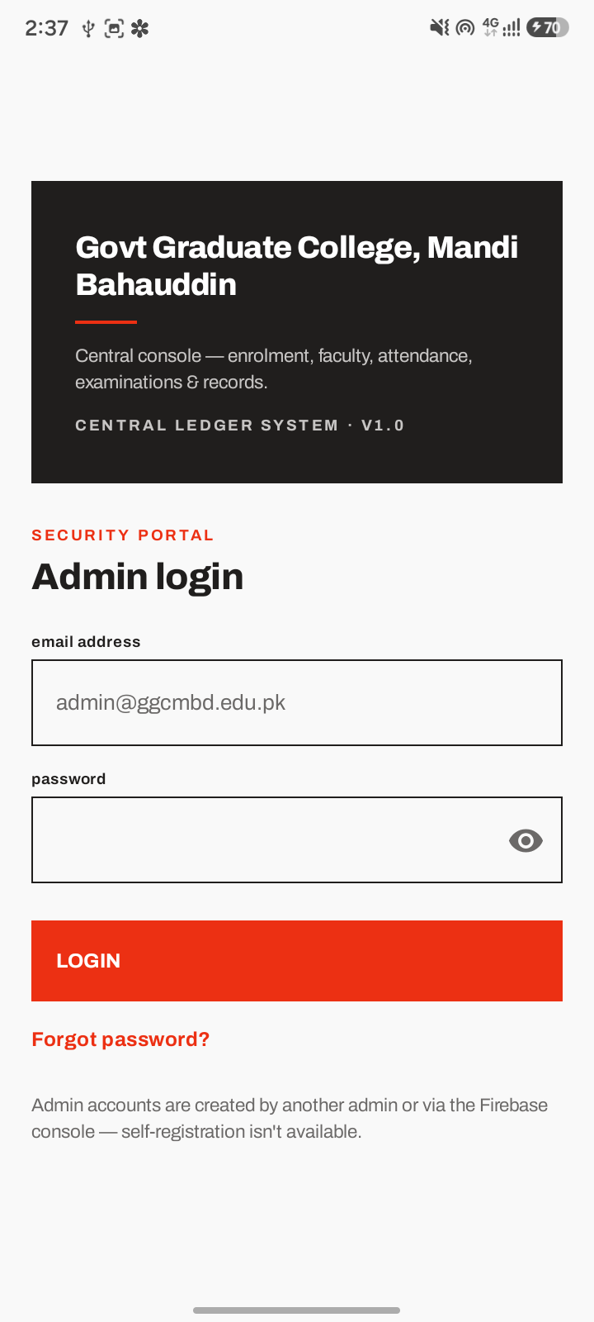
Figure C-1 Admin login screen
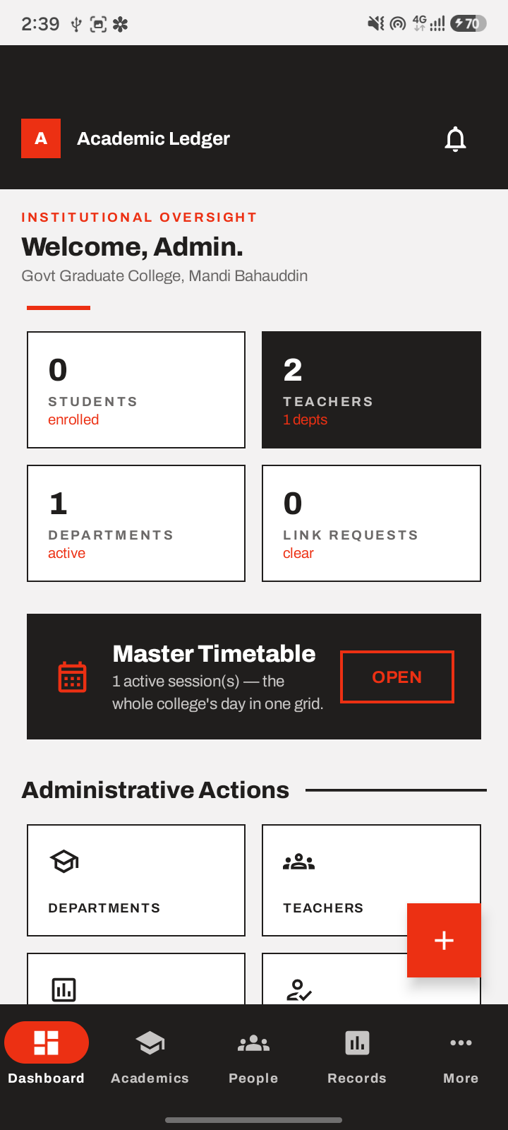
Figure C-2 Admin dashboard — live enrolment/faculty/department counts
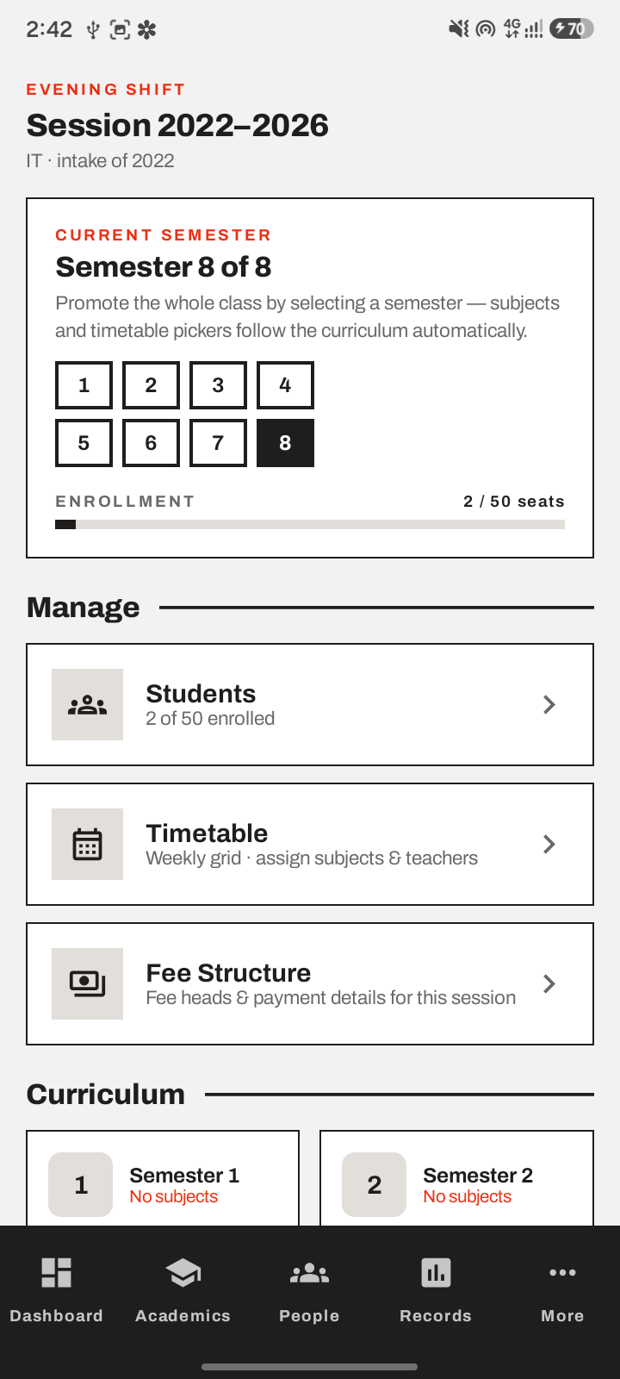
Figure C-3 Session detail — semester promotion, enrollment, Manage/Curriculum (FR-2)
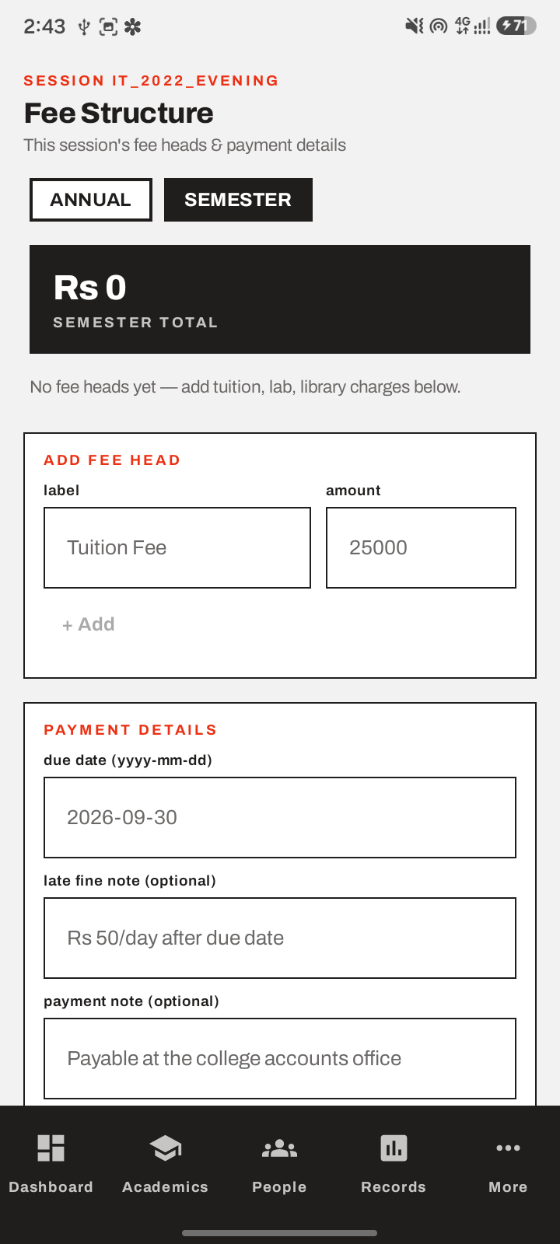
Figure C-4 Session fee structure editor (FR-10)
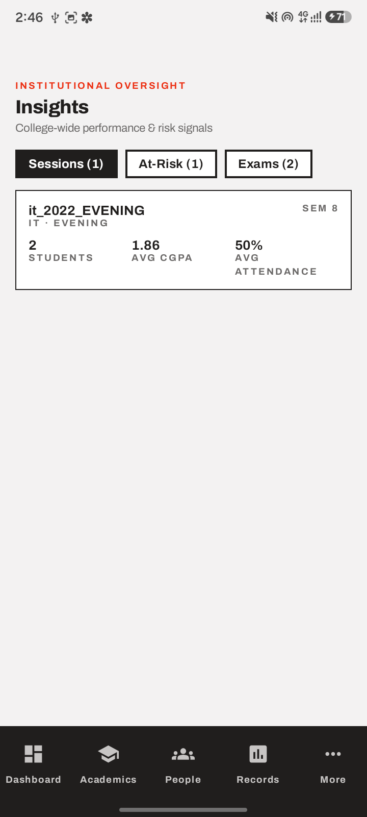
Figure C-5 Admin Insights — college-wide session/at-risk/exam data (FR-22)
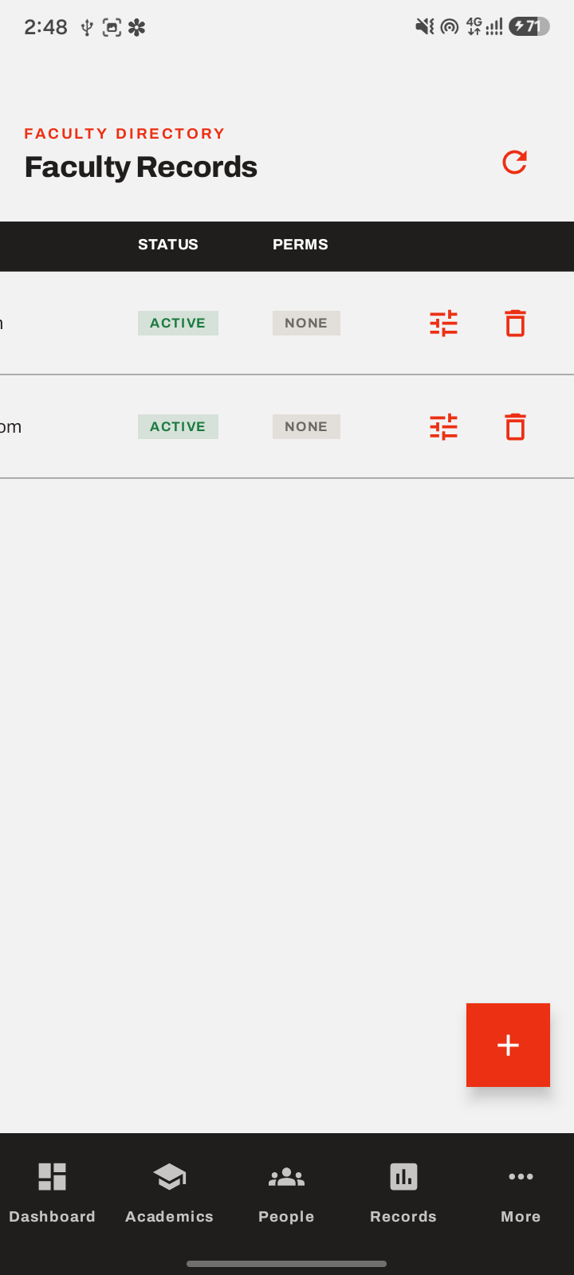
Figure C-6 Faculty records — status & permission management (FR-21)

Teacher App
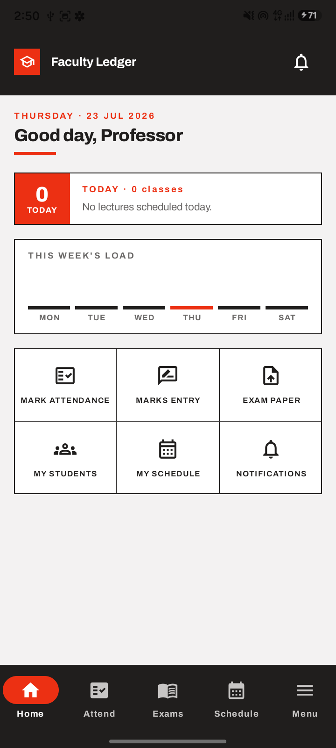
Figure C-7 Teacher home — today's load, quick actions
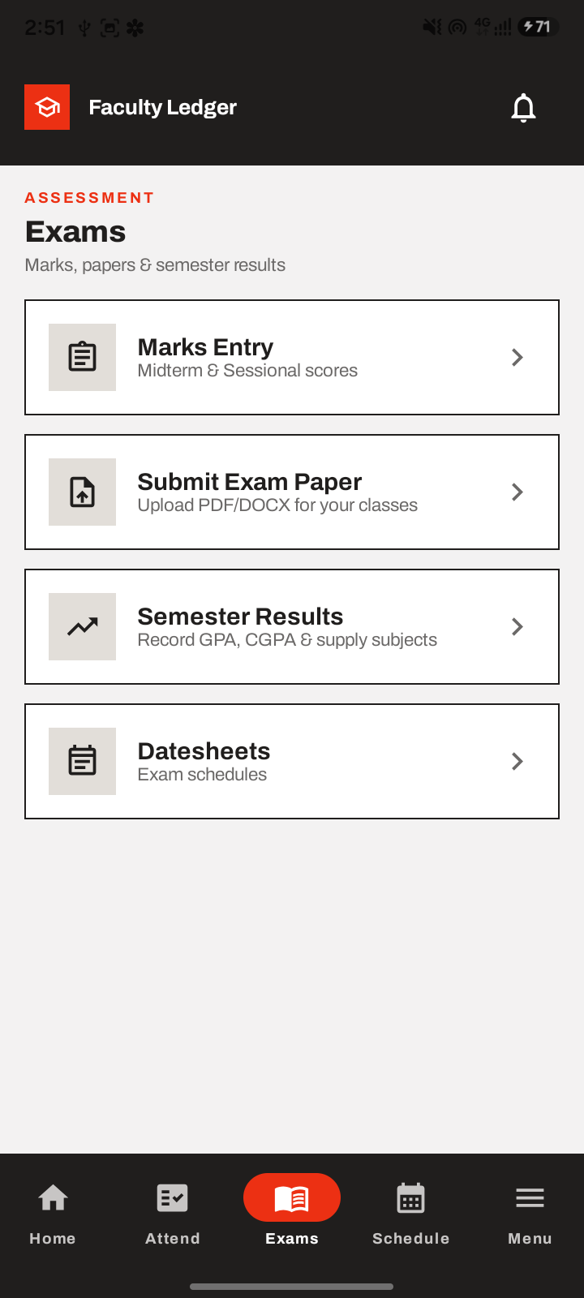
Figure C-8 Teacher Exams hub (Marks Entry, Exam Paper, Semester Results, Datesheets)
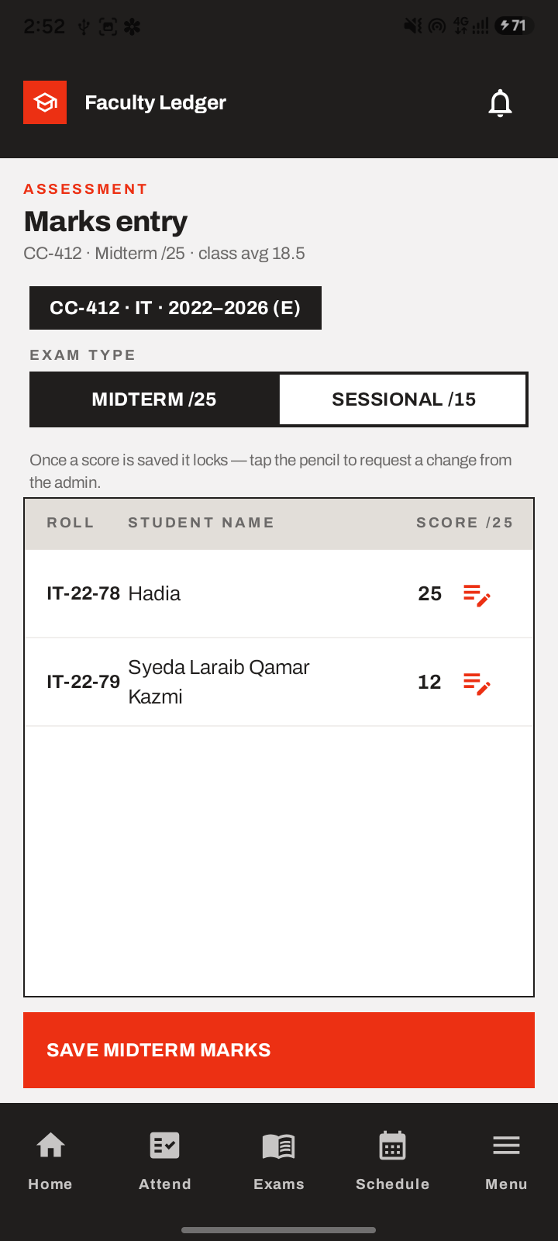
Figure C-9 Marks Entry — locked scores with edit-request pencil (FR-6)
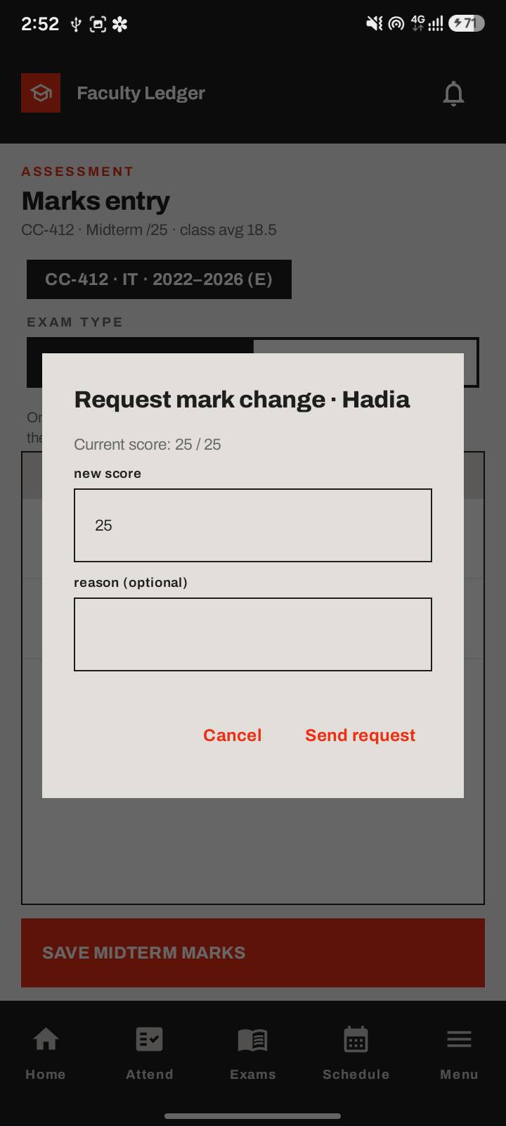
Figure C-10 Request mark change dialog (FR-7)
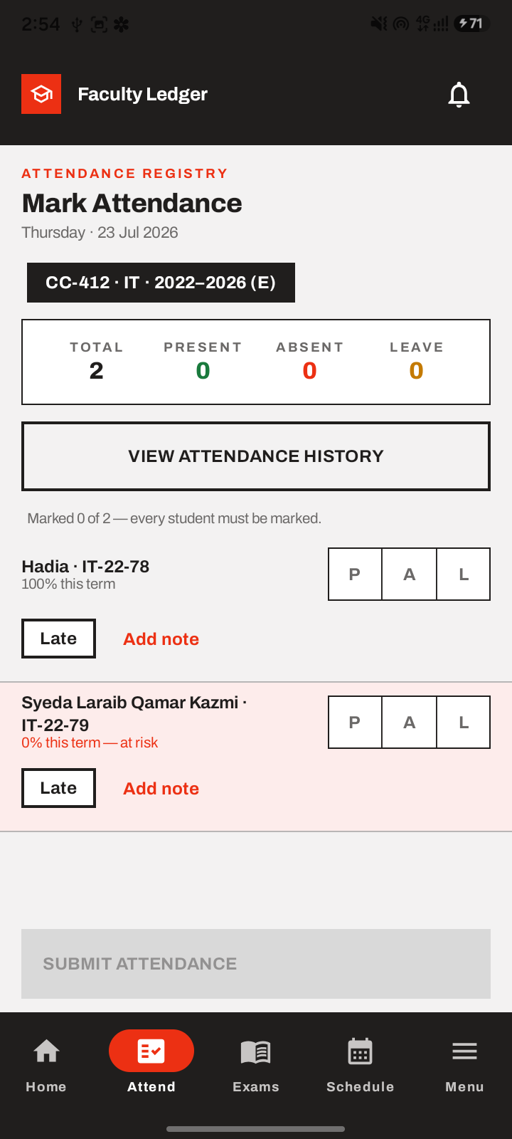
Figure C-11 Mark Attendance — live at-risk highlighting
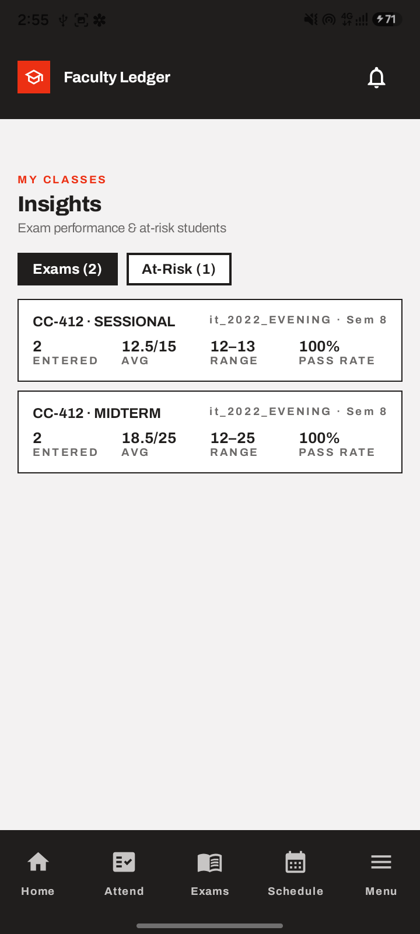
Figure C-12 Teacher Insights — automatically scoped to their own class only (FR-22)

Student App
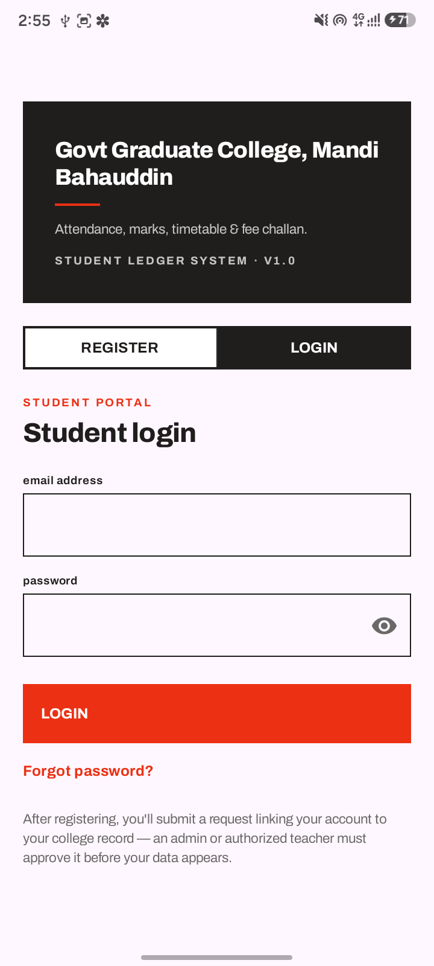
Figure C-13 Student login/register screen
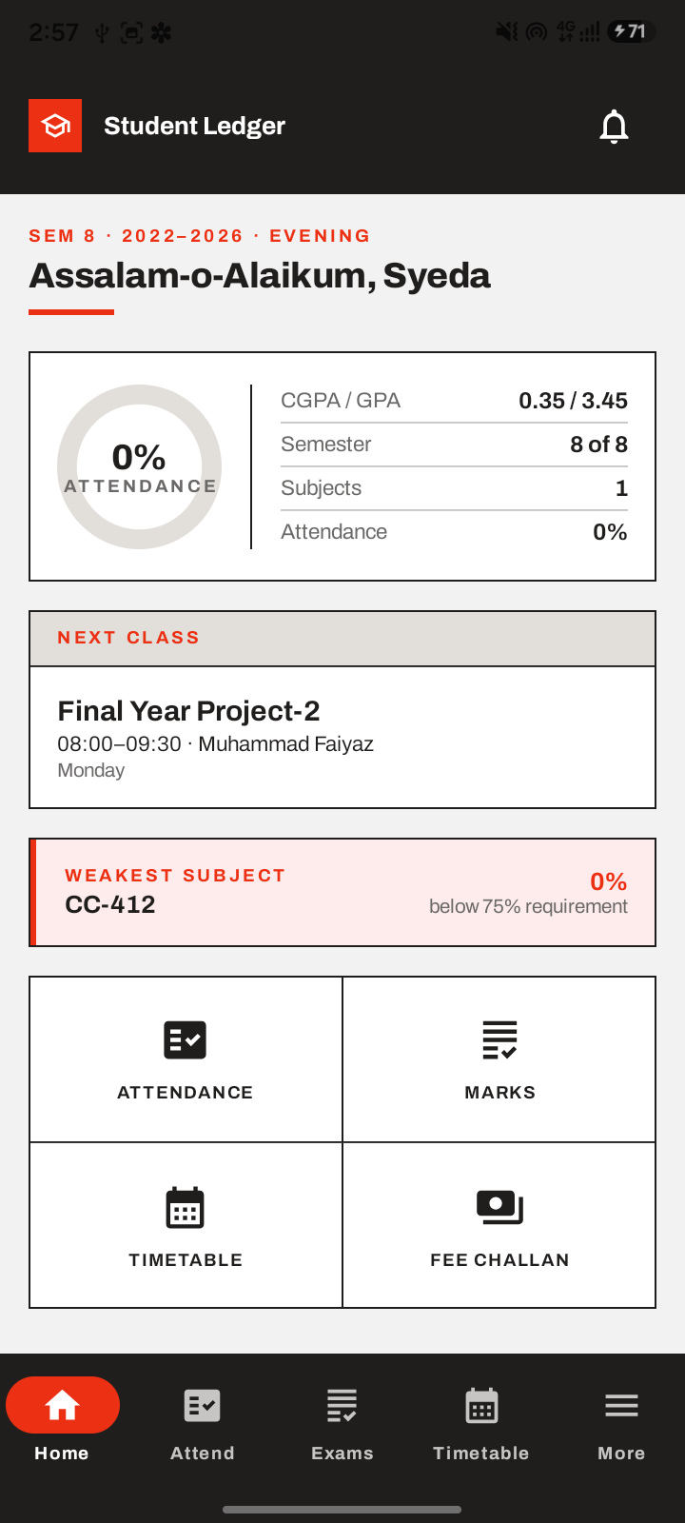
Figure C-14 Student home — CGPA gauge, next class, weakest-subject alert
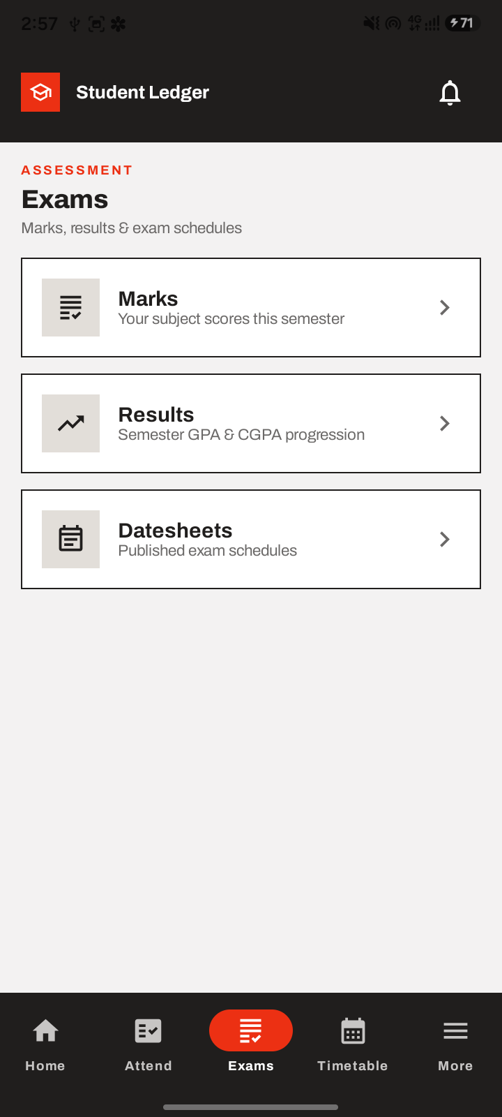
Figure C-15 Student Exams hub (Marks, Results, Datesheets)
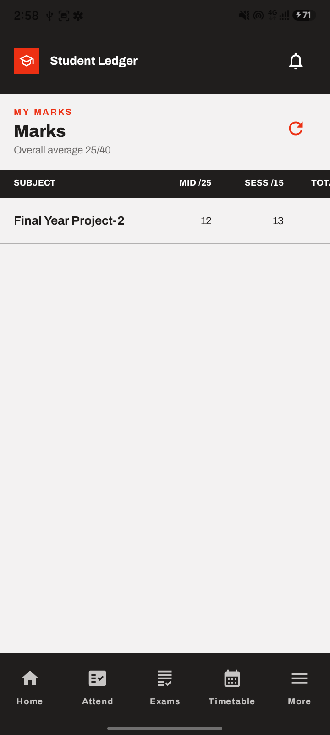
Figure C-16 Student Marks screen
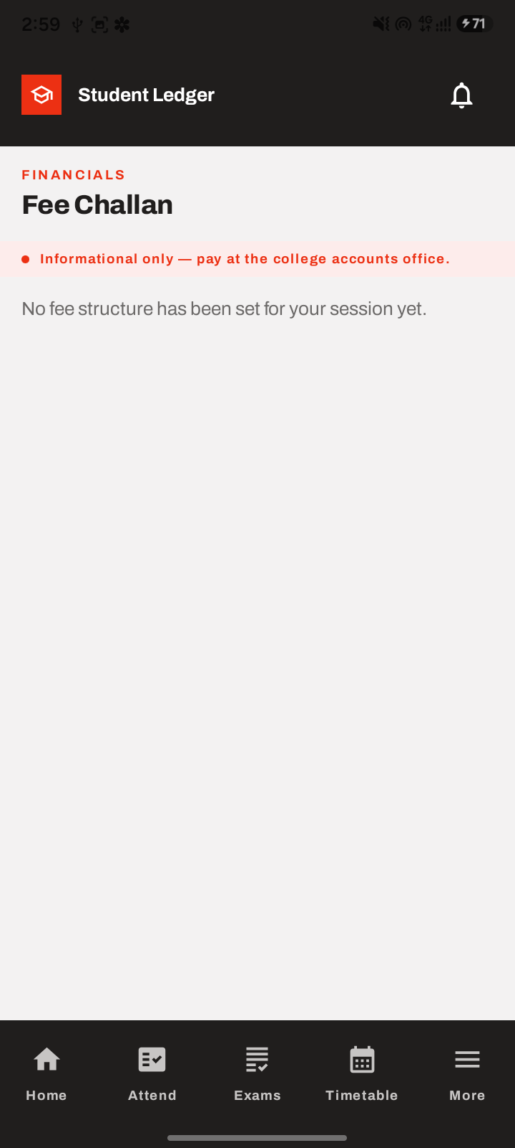
Figure C-17 Student Fee Challan (FR-11)

