Laptop Interconnect Application

The WiiRemoteConnection object in the PDA_GUI application was implemented in two stages. Brian Peek’s managed C# Wii Remote Library was used. Essentially, we split up the library into two parts: the actual Wii Remote connection piece, and the processing of the Wii Remote raw data. The processing of the Wii Remote data is done by the “wiiwm” Visual Studio Project. Essentially it is a gutted version of the original library, keeping all of the core functionality in terms of processing reports from raw Wii Remote data. In this library, instead of opening up a handle to the Wii Remote itself, we open up a FileStream to a device driver that we created “wiiwm_driver”. This device driver talks over Bluetooth COM ports to an intermediary laptop through the laptop interconnect application. This application uses the actual Wii Remote connection piece of Brain Peek’s library and actually talks with the Wii Remote.

The purpose of the laptop interconnect application (Visual Studio project named “Wiimote_PDA_COM”) is to provide an avenue for the PDA to retrieve a data stream from the Wii Remote. It is not directly possible (without device driver development) to connect the PDA to the Wii Remote via Bluetooth and retrieve data. This application’s sole purpose is to read all data from the PDA (writes to the Wii Remote) through a Bluetooth serial COM port and forward it to the Wii Remote. The application then will read data from the Wii Remote via a Bluetooth HID connection and forward it back to the PDA. This happens in a continuous loop so that the PDA can retrieve all of the Wii Remote’s accelerometer readings.

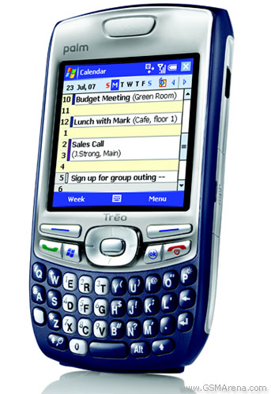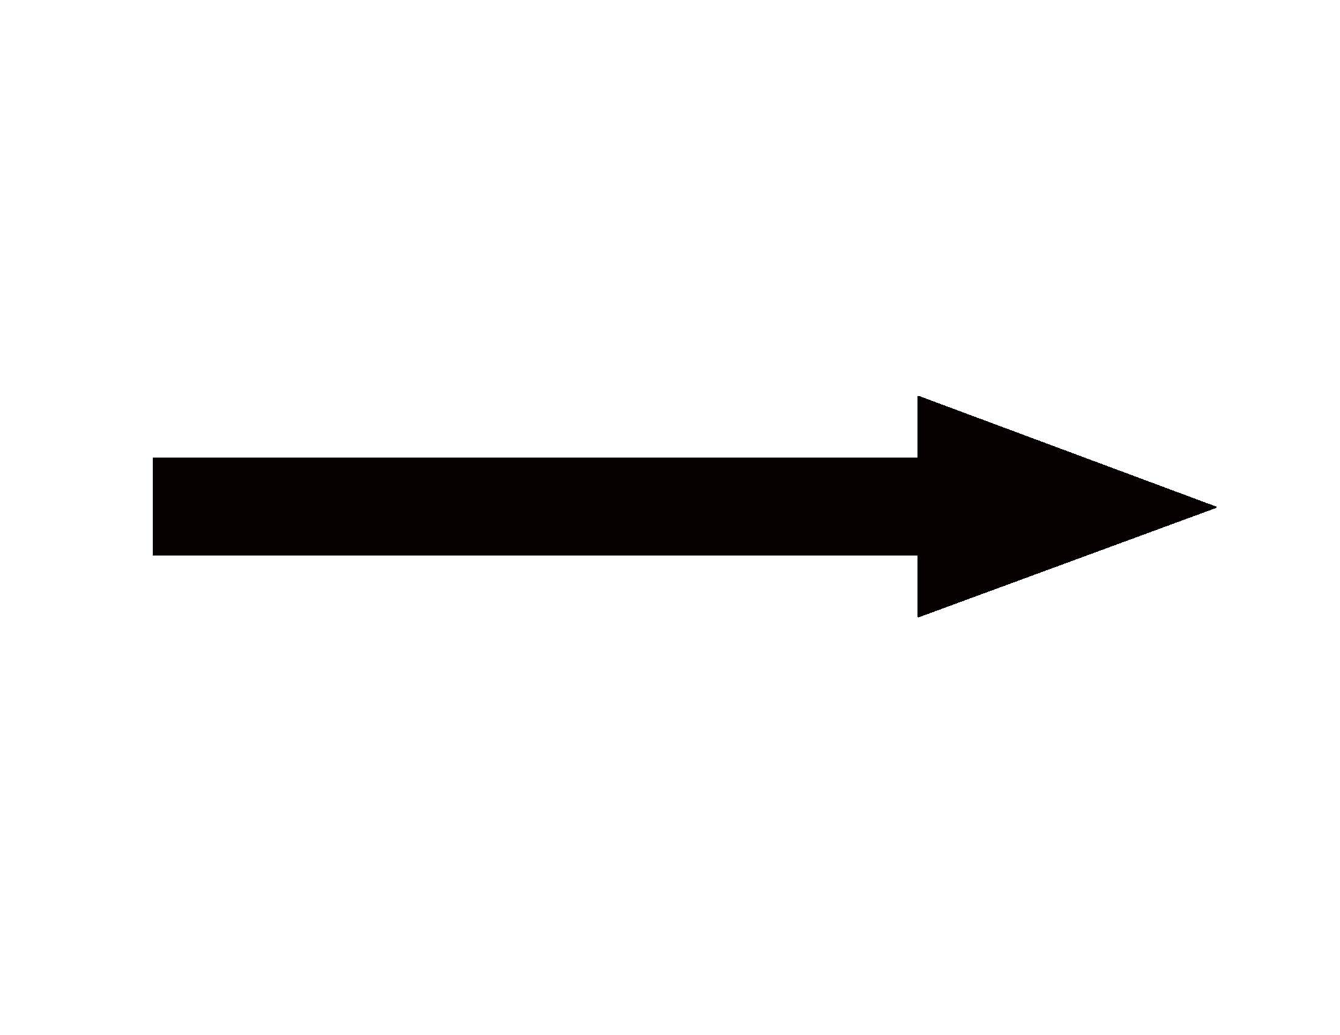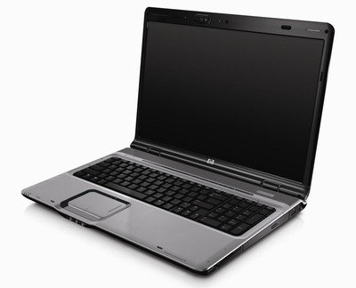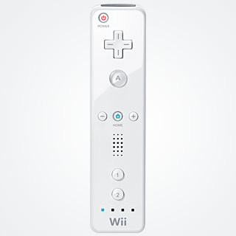

This application was developed in such a way that it allows for an easy transition for updated technology (i.e. A new device driver that allows the PDA to directly retrieve data from the Wii Remote). The PDA still writes and reads from the laptop COM port just like it would read and write to the Wii Remote since all the laptop application does is forward the bytes from one port to another. The only thing that would change would be that the PDA would have to open up a FileStream to the new device driver, instead of the laptop/COM port driver that is currently being used. Another benefit of setting up the system architecture this way is that it allowed us as a development team to do our work on the PDA, not the Laptop.

Laptop Interconnect Code

Here is a segment of the main workhorse methods implemented by the Laptop Interconnect Application:

///<summary>
/// Loop used to relay PDA reports to and from the wii Remote
///</summary>
public void PDA_ReadWriteLoop()
{
int i;
int read;
BeginWiiRead();
while (true)
{
if (pdaStream != null && wiiStream != null && pdaStream.CanRead && wiiStream.CanRead)
{
pdaReadBuff = new byte[REPORT_LENGTH];
read = pdaStream.Read(pdaReadBuff, 0, REPORT_LENGTH);
if (read != 0)
{

for (i = 0; i < 22; i++)
{
if (pdaReadBuff[i] != 255)
{
break;
}
}

if (i == 22)
{
pdaStream.Close();
Disconnect();
Environment.Exit(1);

}
else
{
wiiStream.Write(pdaReadBuff, 0, REPORT_LENGTH);
}
}
}

}
}

public void BeginWiiRead()
{
pdaWriteBuff = new byte[REPORT_LENGTH];
if(wiiStream.CanRead)
wiiStream.BeginRead(pdaWriteBuff, 0, REPORT_LENGTH, new AsyncCallback(OnWiiRead), pdaWriteBuff);
}

public void OnWiiRead(IAsyncResult ir)
{

pdaStream.Write(pdaWriteBuff, 0, REPORT_LENGTH);

//Start reading some more
BeginWiiRead();
}

As soon as a connection is established between the laptop and the Wii Remote, it immediately enters the PDA_ReadWriteLoop. This function will then immediately call BeginWiiRead(), which essentially just continues to read data from the Wii Remote and writes it back to the PDA COM port. The bulk of information exchanged here is the Wii Remote accelerometer data. A protocol has also been set up between the PDA and the Laptop Interconnect Application that causes the Laptop to stop reading data from the Wii Remote. Built into the device driver, there is code that writes to the Laptop COM port 22 bytes of “FFFFFFFFFFFFFFFFFFFFFFFFFFFFFFFFFFFFFFFFFFFF”. This disconnect message is read by the Laptop Interconnect Application, at which point the application disconnects from the Wii Remote and exits. This should occur when Activity Monitor application is quit on the PDA.

WWM_Activator

The last application that is worth mentioning is the WWM_Activator VS Project. This project can activate/deactivate the device driver and also flush the COM ports. We had issues where the Laptop Interconnect Application would leave some bits in the COM port after exit. This function simply flushes out the COM port by reading from it until the stream is null. It is useful in debugging.

Device Driver Implementation

For more information on how to develop, deploy, and run a Windows Mobile Device Driver, refer to the supplementary documentation “How To Develop a Windows Mobile Device Driver”. This walks through the process we went through of developing and deploying our own device driver in Windows Mobile to talk over COM ports.

Use:

To use the Laptop Interconnect Application, simply run the “Wiimote_PDA_COM” VS Project. This will open up a FileStream to the PDA specified COM Port, and the Wii Remote. From here, the PDA_GUI application can be run and data will be exchanged between the Wii Remote and the PDA.

