Activity Monitor User Manual
12/7/09

Mike Hadley, Andrew Atutis, James Licata, John Ellis, Steve Deyo, Jacor Finlayson, Brett Peplowski, Joe Belmont, Jon Eggleston, Ryan Edgar

How to Use The PDA or Laptop Application
By John Ellis and James Licata

Start the application
Warning messages may appear if:
*Connection to server is not established
*Wiimote is not connected to PDA/Laptop
*A config file does not yet exist

Clinician Set Up

Click on the Bear icon in the bottom left corner of the screen.
Fill in the fields for:
*Patient Name
*Username
*Password
*Hostname (not currently implemented)
Click the save button
*Optional: Click the test button to see if PDA/Laptop can connect
to the server, alert message will show status
Click close button, quit application for changes to be completed

User

Statistics start recording when application starts.

Tasks Button
*When clicked displays user's current task
*Past stats displayed at the bottom

Progress Button
*Displays stats in real time
-Steps
-Steps/Min
-Time
-Distance
*User can select from combobox past stats for the week

Quit Button
*Quits application
*Warning messages may be displayed about saving statistics to
the PDA/Laptop or sending stats to the server.

Laptop Interconnect Application
By Mike Hadley

The WiiRemoteConnection object in the PDA_GUI application was implemented in two stages. Brian Peek’s managed C# Wii Remote Library was used. Essentially, we split up the library into two parts: the actual Wii Remote connection piece, and the processing of the Wii Remote raw data. The processing of the Wii Remote data is done by the “wiiwm” Visual Studio Project. Essentially it is a gutted version of the original library, keeping all of the core functionality in terms of processing reports from raw Wii Remote data. In this library, instead of opening up a handle to the Wii Remote itself, we open up a FileStream to a device driver that we created “wiiwm_driver”. This device driver talks over Bluetooth COM ports to an intermediary laptop through the laptop interconnect application. This application uses the actual Wii Remote connection piece of Brain Peek’s library and actually talks with the Wii Remote.

The purpose of the laptop interconnect application (Visual Studio project named “Wiimote_PDA_COM”) is to provide an avenue for the PDA to retrieve a data stream from the Wii Remote. It is not directly possible (without device driver development) to connect the PDA to the Wii Remote via Bluetooth and retrieve data. This application’s sole purpose is to read all data from the PDA (writes to the Wii Remote) through a Bluetooth serial COM port and forward it to the Wii Remote. The application then will read data from the Wii Remote via a Bluetooth HID connection and forward it back to the PDA. This happens in a continuous loop so that the PDA can retrieve all of the Wii Remote’s accelerometer readings.

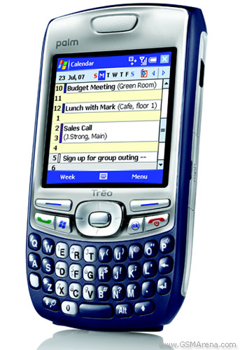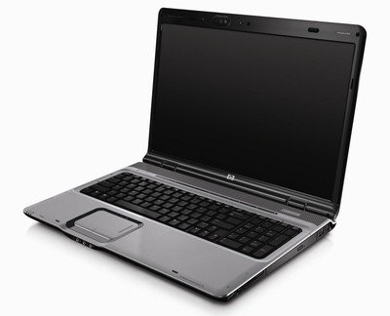

This application was developed in such a way that it allows for an easy transition for updated technology (i.e. A new device driver that allows the PDA to directly retrieve data from the Wii Remote). The PDA still writes and reads from the laptop COM port just like it would read and write to the Wii Remote since all the laptop application does is forward the bytes from one port to another. The only thing that would change would be that the PDA would have to open up a FileStream to the new device driver, instead of the laptop/COM port driver that is currently being used. Another benefit of setting up the system architecture this way is that it allowed us as a development team to do our work on the PDA, not the Laptop.

Laptop Interconnect Code
By Mike Hadley

Here is a segment of the main workhorse methods implemented by the Laptop Interconnect Application:

///<summary>
/// Loop used to relay PDA reports to and from the wii Remote
///</summary>
public void PDA_ReadWriteLoop()
{
int i;
int read;
BeginWiiRead();
while (true)
{
if (pdaStream != null && wiiStream != null && pdaStream.CanRead && wiiStream.CanRead)
{
pdaReadBuff = new byte[REPORT_LENGTH];
read = pdaStream.Read(pdaReadBuff, 0, REPORT_LENGTH);
if (read != 0)
{

for (i = 0; i < 22; i++)
{
if (pdaReadBuff[i] != 255)
{
break;
}
}

if (i == 22)
{
pdaStream.Close();
Disconnect();
Environment.Exit(1);

}
else
{
wiiStream.Write(pdaReadBuff, 0, REPORT_LENGTH);
}
}
}

}
}

public void BeginWiiRead()
{
pdaWriteBuff = new byte[REPORT_LENGTH];
if(wiiStream.CanRead)
wiiStream.BeginRead(pdaWriteBuff, 0, REPORT_LENGTH, new AsyncCallback(OnWiiRead), pdaWriteBuff);
}

public void OnWiiRead(IAsyncResult ir)
{

pdaStream.Write(pdaWriteBuff, 0, REPORT_LENGTH);

//Start reading some more
BeginWiiRead();
}

As soon as a connection is established between the laptop and the Wii Remote, it immediately enters the PDA_ReadWriteLoop. This function will then immediately call BeginWiiRead(), which essentially just continues to read data from the Wii Remote and writes it back to the PDA COM port. The bulk of information exchanged here is the Wii Remote accelerometer data. A protocol has also been set up between the PDA and the Laptop Interconnect Application that causes the Laptop to stop reading data from the Wii Remote. Built into the device driver, there is code that writes to the Laptop COM port 22 bytes of “FFFFFFFFFFFFFFFFFFFFFFFFFFFFFFFFFFFFFFFFFFFF”. This disconnect message is read by the Laptop Interconnect Application, at which point the application disconnects from the Wii Remote and exits. This should occur when Activity Monitor application is quit on the PDA.

WWM_Activator
By Ryan Edgar

The last application that is worth mentioning is the WWM_Activator VS Project. This project can activate/deactivate the device driver and also flush the COM ports. We had issues where the Laptop Interconnect Application would leave some bits in the COM port after exit. This function simply flushes out the COM port by reading from it until the stream is null. It is useful in debugging.

Device Driver Implementation
By Ryan Edgar and Mike Hadley

For more information on how to develop, deploy, and run a Windows Mobile Device Driver, refer to the supplementary documentation “How To Develop a Windows Mobile Device Driver”. This walks through the process we went through of developing and deploying our own device driver in Windows Mobile to talk over COM ports.

Use:

To use the Laptop Interconnect Application, simply run the “Wiimote_PDA_COM” VS Project. This will open up a FileStream to the PDA specified COM Port, and the Wii Remote. From here, the PDA_GUI application can be run and data will be exchanged between the Wii Remote and the PDA.

Database Installation

By Ryan Edgar and Brett Peplowski
The following steps will setup the Activity_Monitor database and insert some sample records. For this procedure, two files are required: ee418_db.sql and ee418_data.sql.
- Install the latest version of MySQL. (You may want to add the bin directory to your path.)
- Login to the MySQL server and execute the ee418_db.sql script. ("\. c:/ee418_db.sql") This will create the Activity_Monitor database with the appropriate tables.
- Execute the ee418_data.sql script. ("\. c:/ee418_data.sql") This will insert the sample data into the Activity_Monitor database.
- Download the client and Server certificates from SVN source/database/newcerts. Copy them to the directory "C:/newcerts". The DAOs currently require the certs to be in this directory.
- Change the configuration file of the MySQL server: my.ini, to point to the correct certs. SSL and MySQL section below.
- Insert a user that requires SSL. ("GRANT ALL PRIVILEGES ON Activity_Monitor.* TO 'ee418_ssl'@'128.153.%' IDENTIFIED BY 'Ee418_My5ql' REQUIRE SSL;") This user is used by the DAOs of both the WebUI and the WebServices Server.
The database should now be accessible from the DAOs in both the Server and WebUI installations.
Current Username and Password
Username: root
Password: bnbdbpw
SSL: Not Required.

Setup and Design of Server and Database Components

Activity Monitor Service
The activity monitor service is a Web Service provided to the pda to facilitate retrieving a patient's daily task and uploading statistics. To install the service, place the ActivityMonitor.asmx file in a directory and set the directory to be exposed through IIS. Now connect to the ActivityMonitor.asmx file from the web and reference it from the PDA or Laptop_GUI applications. The Activity Monitor Service must reference the Web Service DAOs library in order to access the database. The class diagram for this component is below.
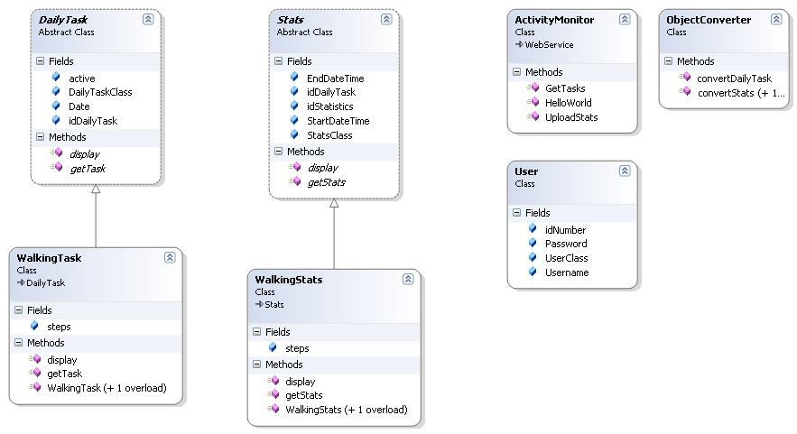

Web Service DAOs
The DAOs for the Activity Monitor Service are written in C# and packaged as a library, DLL. The configuration for the connection string is performed in the DAO.cs file. In order to connect to the MySQL database, the MySQL ODBC 5.1 Driver must be downloaded and installed on the computer running the Web Service DAOs library. See the database installation document for the correct configuration settings and authentication details. The class diagram for this component is below.
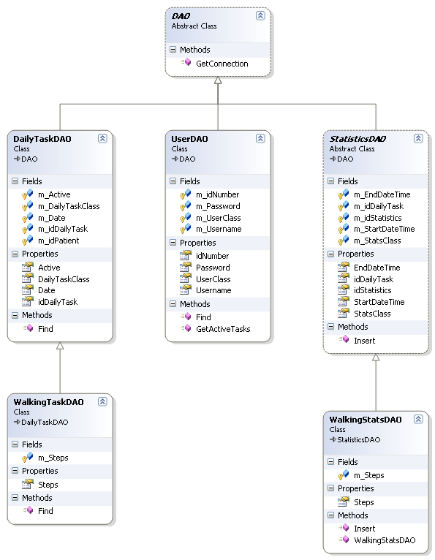

Web User Interface DAOs
The DAOs for the WebUI are written in PHP. They are constructed using Objects in PHP, and thus php5 is required. The configuration of the DAOs is done in the db_config.php file. The queries are kept in the db_queries.php file. And a global include for all DAOs is provided by the db_include.php file. To utilize the DAOs in the WebUI add: require_once("daos/db_include.php"); to the top of the php script. In order for the database access to work, the MySQL ODBC 5.1 Driver must be installed on the computer running the web server.
The %Driver substring of the DB_CONN_STRING constant will be substituted out during runtime for the DB_DRIVER constant value. A similar technique is used to generate the SQL queries to run against the database at runtime. The database key DB_KEY is the key string used to encrypt the content in the database columns which must be protected. The key acts as the password to the MySQL AES_ENCRYPT function. The three SSL constants must point to the appropriate files. They can point to the same files used by the ActivityMonitorService DAOs. If the connection between the web server and the database does not need to use SSL set DB_USE_SSL to 0.

