Activity Monitor System

High Level Design
Strawman – Version 1

Introduction

This document states the high level design for the Mobile Pedometer system. This document should be used by the designers and developers as a basis for the implementation of the system, as it also contains system level use cases, and state diagrams. The goal of this high level design document is to make the reader knowledgeable on the structural design of the system, as well as more knowledgeable about what the system does/is capable of doing.

The Activity Monitor system will provide a better way to monitor patient rehabilitation using a Wii Remote and a PDA (Palm Treo 750). The system will be targeted towards nursing homes and rehab hospitals which require monitoring of elderly people, recovering athletes, and people with balance issues. The system will further provide independent mobility while monitoring a patient’s progress with prescribed Daily Tasks.

To perform this, we have developed a Web UI, complete with a database application, which is easy to use and can safely and securely store a patient’s data.

Use Cases

The diagram below shows all of the interactions each user will be able to do with the system once they log in or power on. Patients will interact with the PDA, while Researchers and Clinicians interact with the Web UI.
All patients have the ability to start the PDA application, begin their daily task, upload data to the server, and complete their daily task.
Researchers and Clinicians share many uses of the system, including Viewing Patient Health Charts, Logging into the Web UI, and Viewing Patient Completion Charts. The Clinician has some accesses to the system that a Researcher does not however. The Clinician may Add Patients to the Web UI as well as assign Daily Tasks.
Researchers may view Group Patient Health Charts to compile trends.

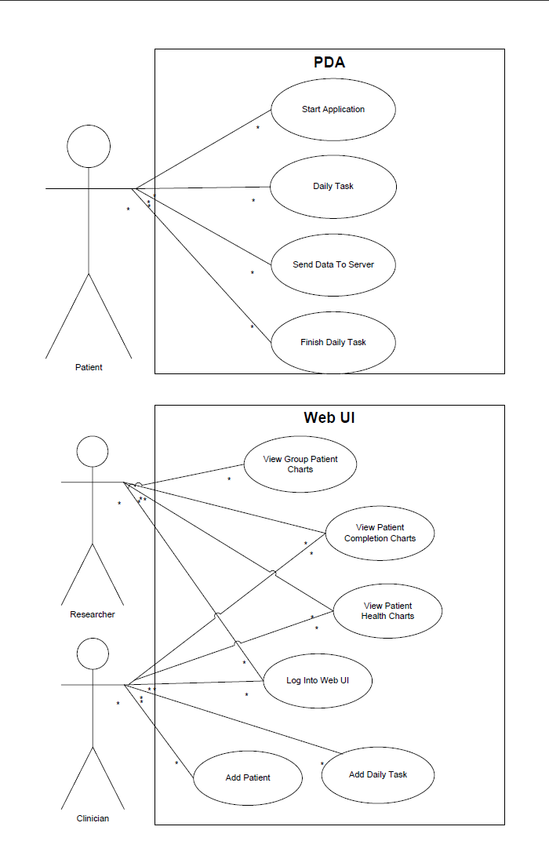

Scenarios

The following describe common paths that a user may take through the system.

Patient goes through their Daily Task.
- The Patient starts the Activity Monitor application on the PDA.
- The PDA begins to monitor walking activity.
- The Patient completes the Daily Task and is presented with an alert on the PDA.
- The PDA begins to download the computed PDA Statistics to the server. The PDA also updates the Daily Task for the next day.
- The Patient exits the Activity Monitor application.

Clinician adds a new patient
- A Clinician logs onto the web interface.
- The Clinician navigates to the “Add Patient” page.
- The Clinician enters the relevant Patient Profile information.
- The Clinician submits the form and the Patient is added to the database.
- The Clinician logs off the Web UI.
- The Clinician configures the PDA so that it will log in the patient with their unique Username and Password.

A Clinician adds a new task for
- A Clinician logs onto the Web UI
- The Clinician navigates to the “List Patients” page.
- The Clinician then clicks on the appropriate Patient and the Patient’s profile information is displayed.
- The Clinician clicks on the “New Daily Task” button.
- The Clinician enters the appropriate data.
- The Clinician logs off the Web UI.

A Clinician reviews Patient Completion Charts/Patient Health Charts
- A Clinician logs onto the Web UI
- The Clinician navigates to the “List Patients” page.
- The Clinician clicks on the appropriate Patient.
- The Clinician clicks on the Patient Health Chart or the Patient Completion Chart
- The correct chart is displayed with the correct statistical data.
- The Clinician analyzes the data and discusses with the Patient.
- The Clinician logs off the Web UI.

A Researcher reviews Patient Completion Charts/Patient Health Charts/Group Patient Charts
- A Researcher logs onto the Web UI
- The Researcher navigates to the Patient Completion Chart/Patient Health Chart/Group Patient Chart.
- The Researcher analyzes the data and reports back to the appropriate Clinicians.
- The Researcher logs off the Web UI.

System Flow
The following diagram shows how the overall system will function.
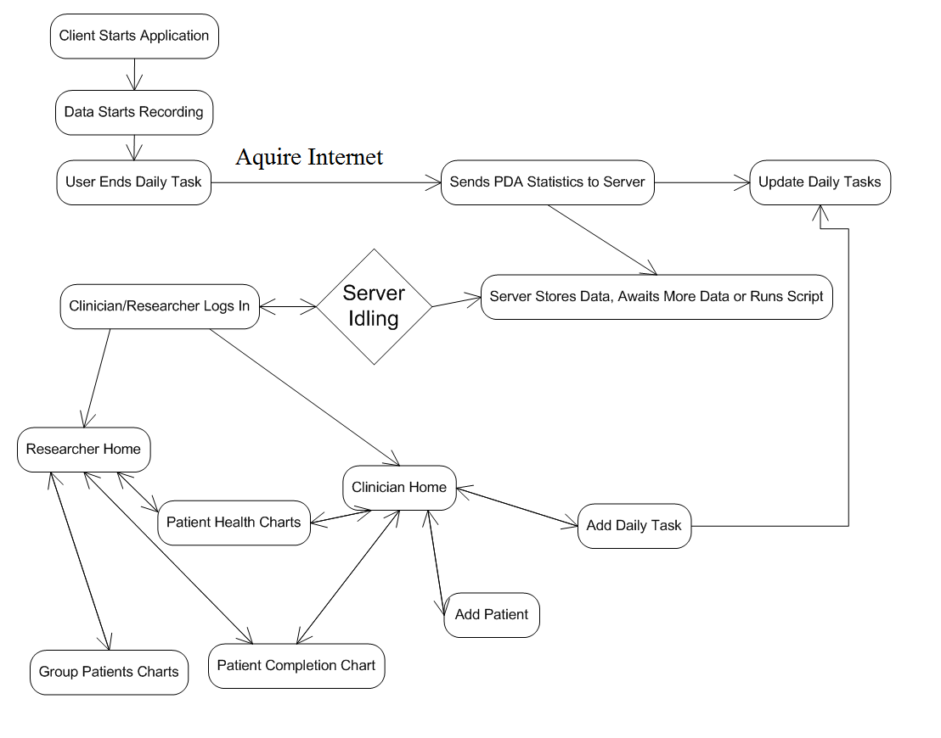
User Flow Diagram
The following diagram shows the paths for the user interface.

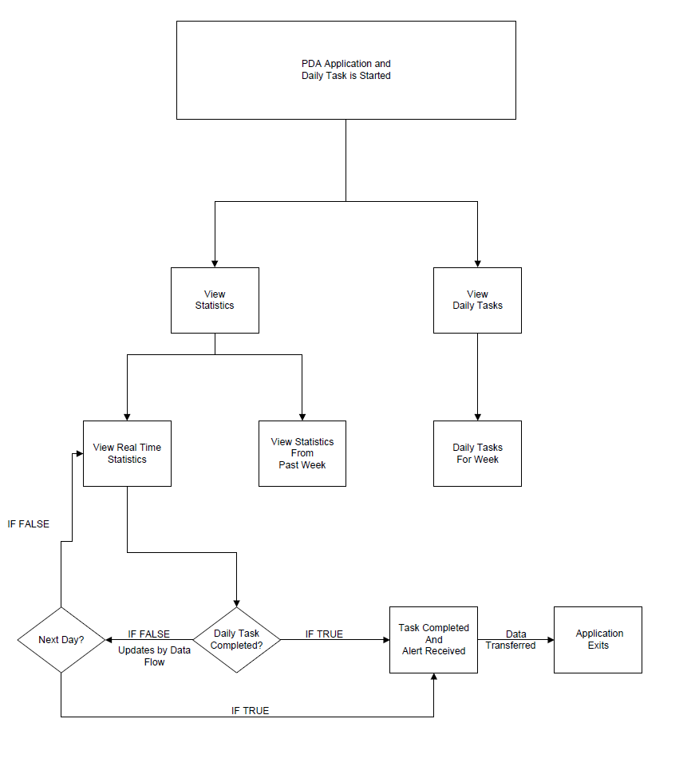
Data Flow Diagram
The following shows the data flow through the application and server.

