Strawman SSD

1 Introduction

1.1 Purpose
This document states the design for the Mobile Pedometer system. This document should be used by the designers and developers as a basis for the implementation of the application.

1.2 Scope
This design document provides a high level overview of the software modules required to produce a functional Mobile Pedometer, using a Wii Remote and a Palm Treo 750.

1.3 Definitions & Acronyms
● Clinician - Person directing and monitoring Patients, their progress, and their daily tasks.
● Researcher - Person interested in analyzing data collected by the system to find trends to help clinicians in diagnosis and therapy.
● PDA - Personal Digital Assistant, device the patient carries that records and interfaces with Wii Remote.
● Wii Remote - Item worn by patient to help record information during a Daily Task, a controller component familiar to the Nintendo Wii system.
● Bluetooth - Open wireless protocol for exchanging data over short distances from fixed and mobile devices, used between Wii Remote and PDA.
● Web UI (to be named later) - Interface used by Clinician's and Researcher's to access and edit Patient information.
● Patient Profile - Area accessed and maintained by Clinicians via the Web UI, where Patient data and progress are represented.
● Clinician Profile - Area accessed by Clinicians after logging into the Web UI, where Patient list and Clinician information are represented.
● Researcher Profile - Area accessed by Researchers after logging into the Web UI, where data from Patients can be represented collectively for analysis.
● Server - Windows Server box running in remote location, where the PDA sends its data to be stored in the database. Also accessed by the Web UI to obtain database information for the Web UI.
● Client GUI - Interface used by the patients on the PDA. Allows user to view tasks, current progress, and statistics about their current daily task.
● Daily Task - Exercise and instructions ordered to a Patient by a Clinician. This is generally the number of steps that must be walked in a day.
● Data Dump

2 References

3 Decomposition
3.1 System Architecture Overview
The Smart Pedometer uses a three tier application. The client on the PDA gathers data during activities done by the patient. The client can send its data gathered from the Wii-Remote to the server via web services and it can also retrieve new activities from the server. The server will store the data and will also some analysis of the data. The server will also host the Web UI which Clinicians and Researchers look at the analyzed data and add new patients.

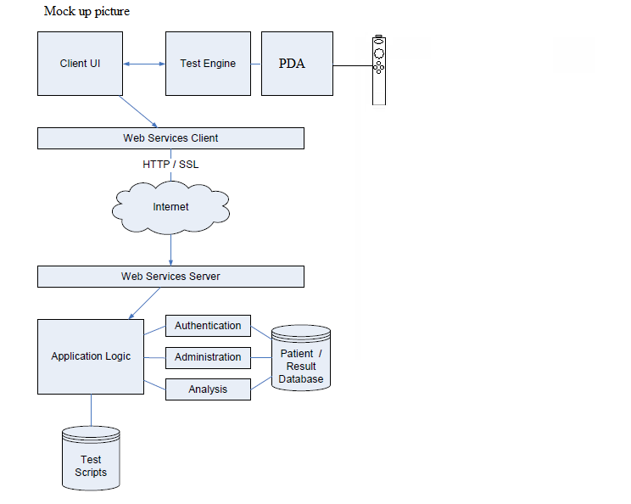
The application tiers can be broken down into sub-modules. The client side is composed of a Client UI, which the user interacts with a Test Engine, which interfaces with the Wii-Remote through blue-tooth in order to record data. The server side is broken down into an Application Logic module that can access and change the data and can also analyze it. Communication between the client and server passes through the Internet using web services.
3.2 Module Decomposition
3.2.1 Client User Interface
The Client User Interface serves as the primary medium for patient interaction with the system. This is a user interface that is displayed on the PDA for use by the patient with prescribed exercise.
3.2.2 Web User Interface
The Web User Interface (Web UI) serves as the primary medium for clinician interaction with the system. This is a user interface that is displayed on a workstation for use by the clinician to monitor prescribed exercise. This interface is also accessed by researchers, who use patient data to analyze trends and predict improvements.
3.2.3 Server Logic
The purpose of server side application logic is to integrate the flow of information between the client interface, Web UI and the database. This module is the interface between every other module in the architecture.
3.2.4 Database
The database module consists of four separate components: the Data Class Interface module, the Command Module, the Connection Management module, and the Database Adapter module.
(This section to be modified once we decide on DAOs)

