

**Secure Software Design**

Lab Mid-Term

Haider Zaman Satti

SP21-BCT-006

Class: BCT-7

**Part 1**

The following are the two tables/schemas chosen from the design based on assignment # 2 that was based on “IOT Smart Home System”:

**1. Devices**

* id: int (primary key)
* name: str
* location: str
* status: bool (on/off)
* type: str (e.g., light, fan, thermostat)

**2. Users**

* id: int (primary key)
* name: str
* email: str
* role: str (admin/user)

**Part 2**

Then we implemented the both the backend and the frontend, using fastapi and streamlit and we implemented all the crud operations for them, the following are the screenshots showing proof of work:

Backend using fastapi

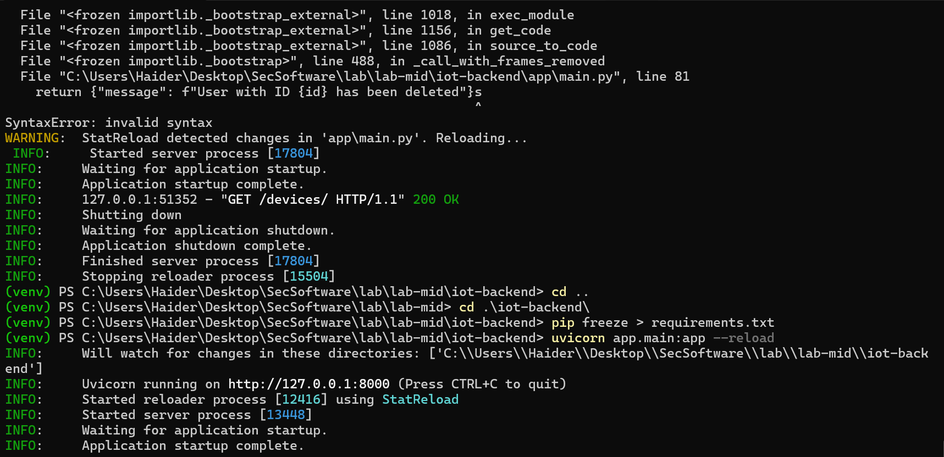

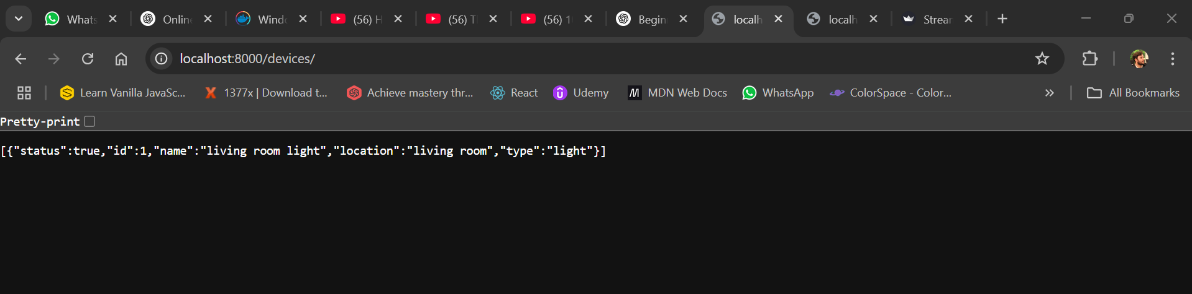

Frontend using streamlit

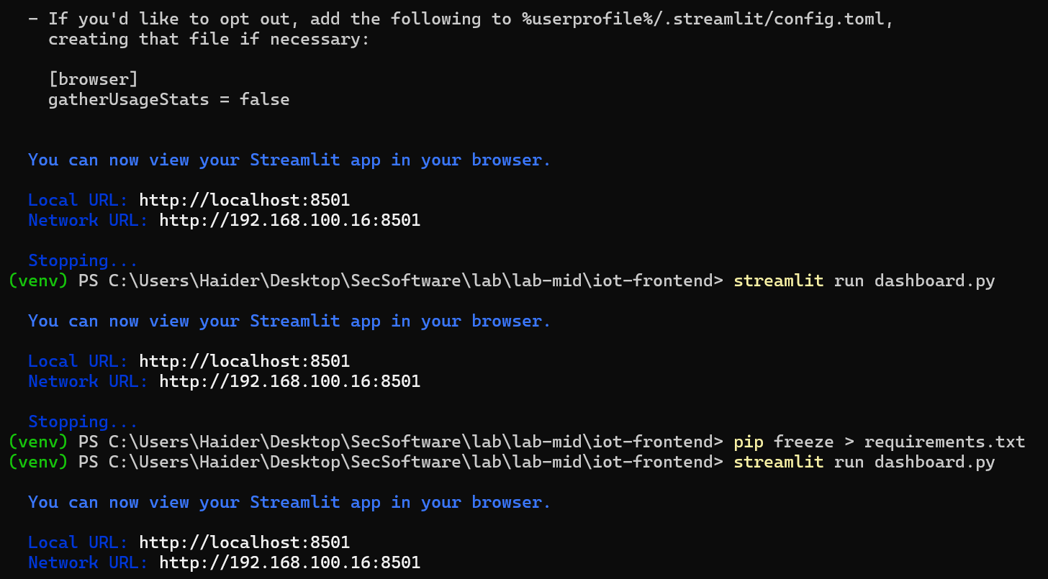

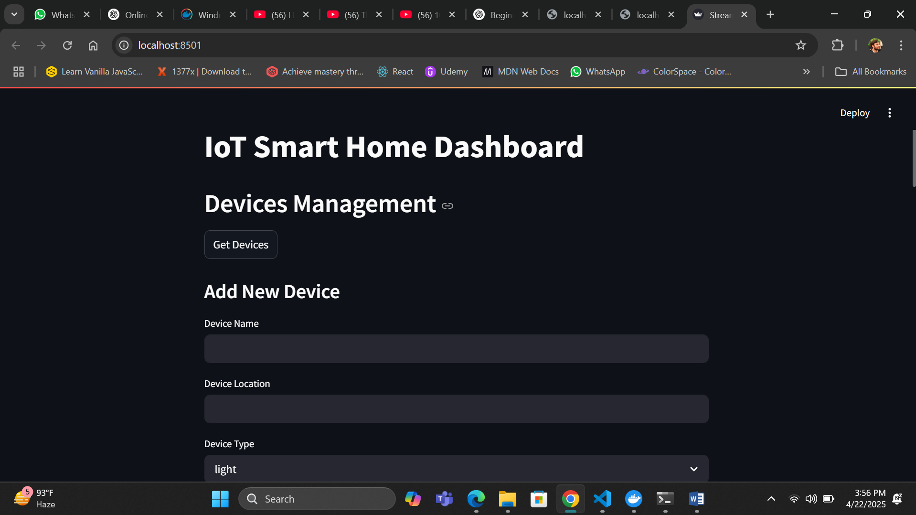

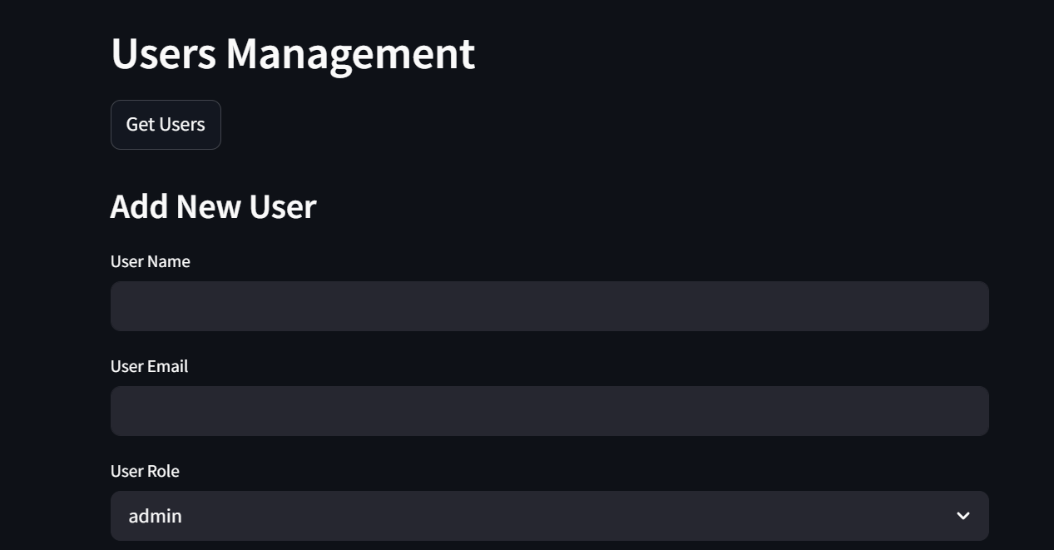

**Part 3**

Dockerizing both the frontend and backend:



Building the container

