Names: *Xinyu Hadrian Hu, and Duanwei Zhan*

Student Number: 500194233, and 500824903

TA: Jasminder Singh

Date: June 25, 2020

COE 608: Computer Architecture and Design

COE 608: Lab 1 Report

Objective

The purpose of this lab is to re-acquaint ourselves with the VHDL language, and to re-familiarize ourselves with the Quartus 13.1 IDE. The goal is to generate an XOR gate.

Design and Implementation

The design and implementation of the XOR gate was utilized using the following Truth Table:

See Figure 1: XOR Gate Truth Table below.



Figure 1: XOR Gate Truth Table

This logic-gate diagram from All About Circuits website is an excellent graphical display of the xor gate. See Figure 2: XOR Gate Logic Diagram on the next page.

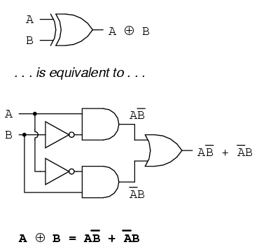

Figure 2: XOR Gate Logic Diagram

The function of the XOR gate is therefore: $F = (A and (not B)) or ((not A) and B)$.

Observations and Results

The following figures: Figure 3: Functional Waveform for 2to1 multiplexer and Figure 4: Timing Waveform for 2to1 multiplexer are the waveforms generated from Quartus II.

Waveforms: Functional and Timing

Below are the waveforms, both functional and timing:

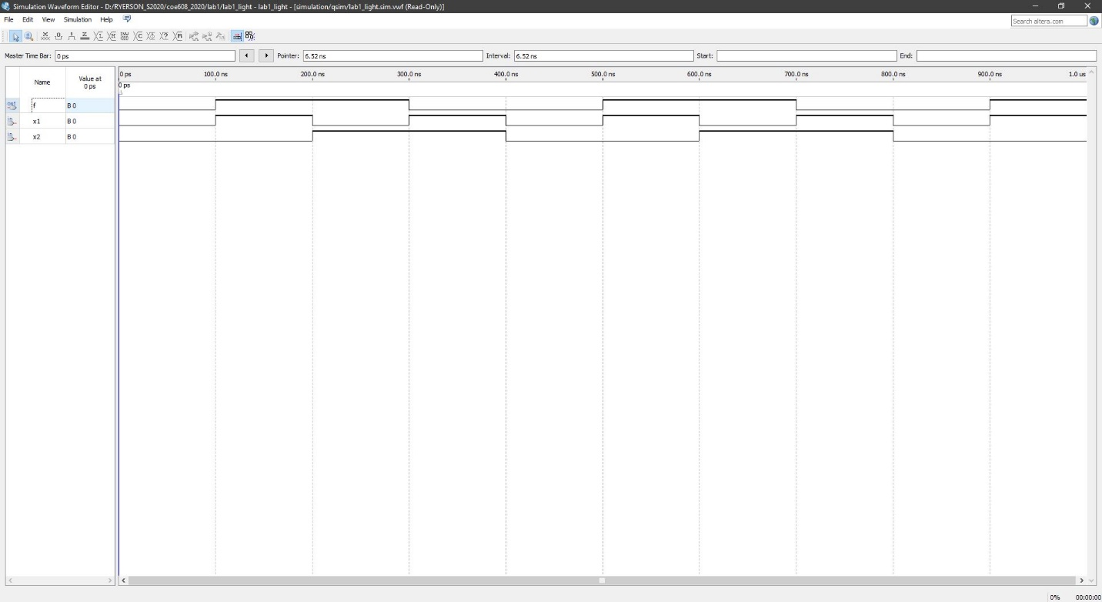

Figure 3: Functional Waveform for 2to1 multiplexer

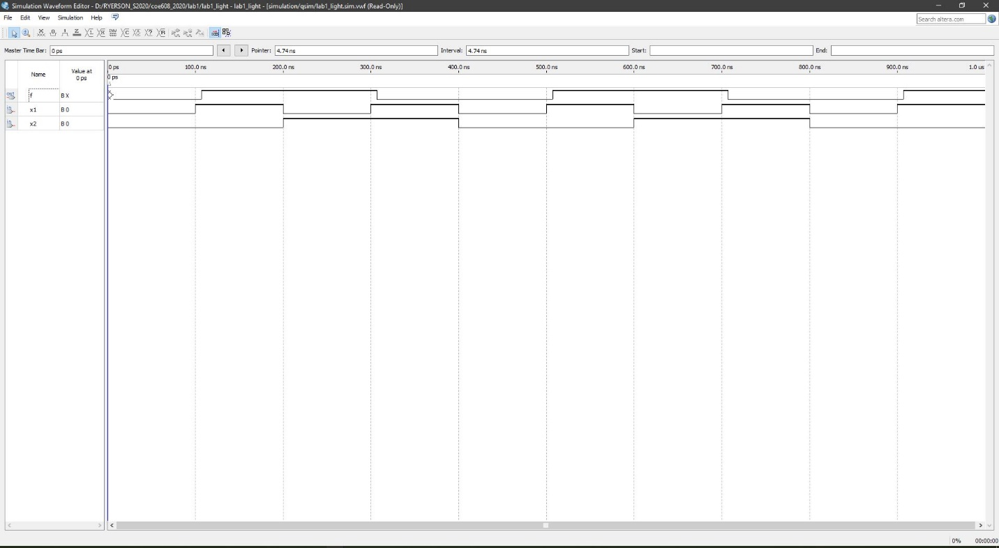

Figure 4: Timing Waveform for 2to1 multiplexer

Discussions and Conclusion

As can be observed, there is only a slight delay of less than 1 ns with the implementation of the code for the 2-to-1 multiplexer.

This XOR function works as intended. For example, when there is either a one or a zero, then there would be one. If the inputs have both zeroes and ones, then the output is zero.

Appendix: VHDL Codes

I have included the VHDL codes and the screenshots of the waveforms for better viewing.