Name: Xinyu Hadrian Hu, and Duan Wei Zhang

Student Number: 500194233, and 500824903

TA: Jasminder Singh

Date: July 30, 2020

COE 608: Computer Architecture and Design

COE 608: Lab 5 Report

Objective

The purpose of this lab was to create the Control Unit for the CPU.

Design and Implementation

The implementation of the CPU Control Unit is based on the idea of finite state machines. Finite state machines are the basis for the control unit since the change of state means that the instructions can change. Finite state machines have an initial starting state, followed by several other states. Each state has an input and an output. As the input changes, the output either remains in the original state, our present state, or it may change to the next state. Finite state machines can be either implemented using Mealy or Moore methods. The Mealy method depends on the present state and present input. The Moore finite state machine only depends on the present state. The efficiency of each finite state machine varies from situation to situation, and the needs of the designer and end-user requirements.

An operational decoder is also used to help determine the operation needed for each opcode of the MIPS ISA.

The finite state machine model from the VHDL code of the program is provided below:

See Figure 1: Finite State Machine of the CPU Control Unit.

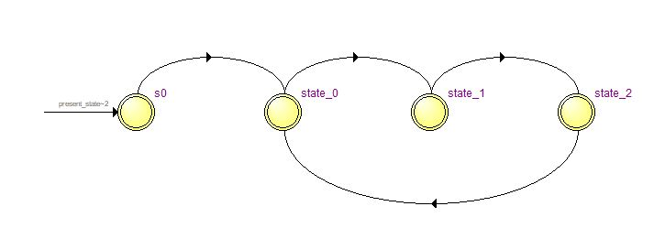

Figure 1: Finite State Machine of the CPU Control Unit

CPU Control Unit: Functional and Timing

The next two figures are the waveforms, both functional and timing of the final CPU control unit:

See Figure 2: CPU Control Unit Functional Waveform and Figure 3: CPU Control Unit Timing Waveform below.

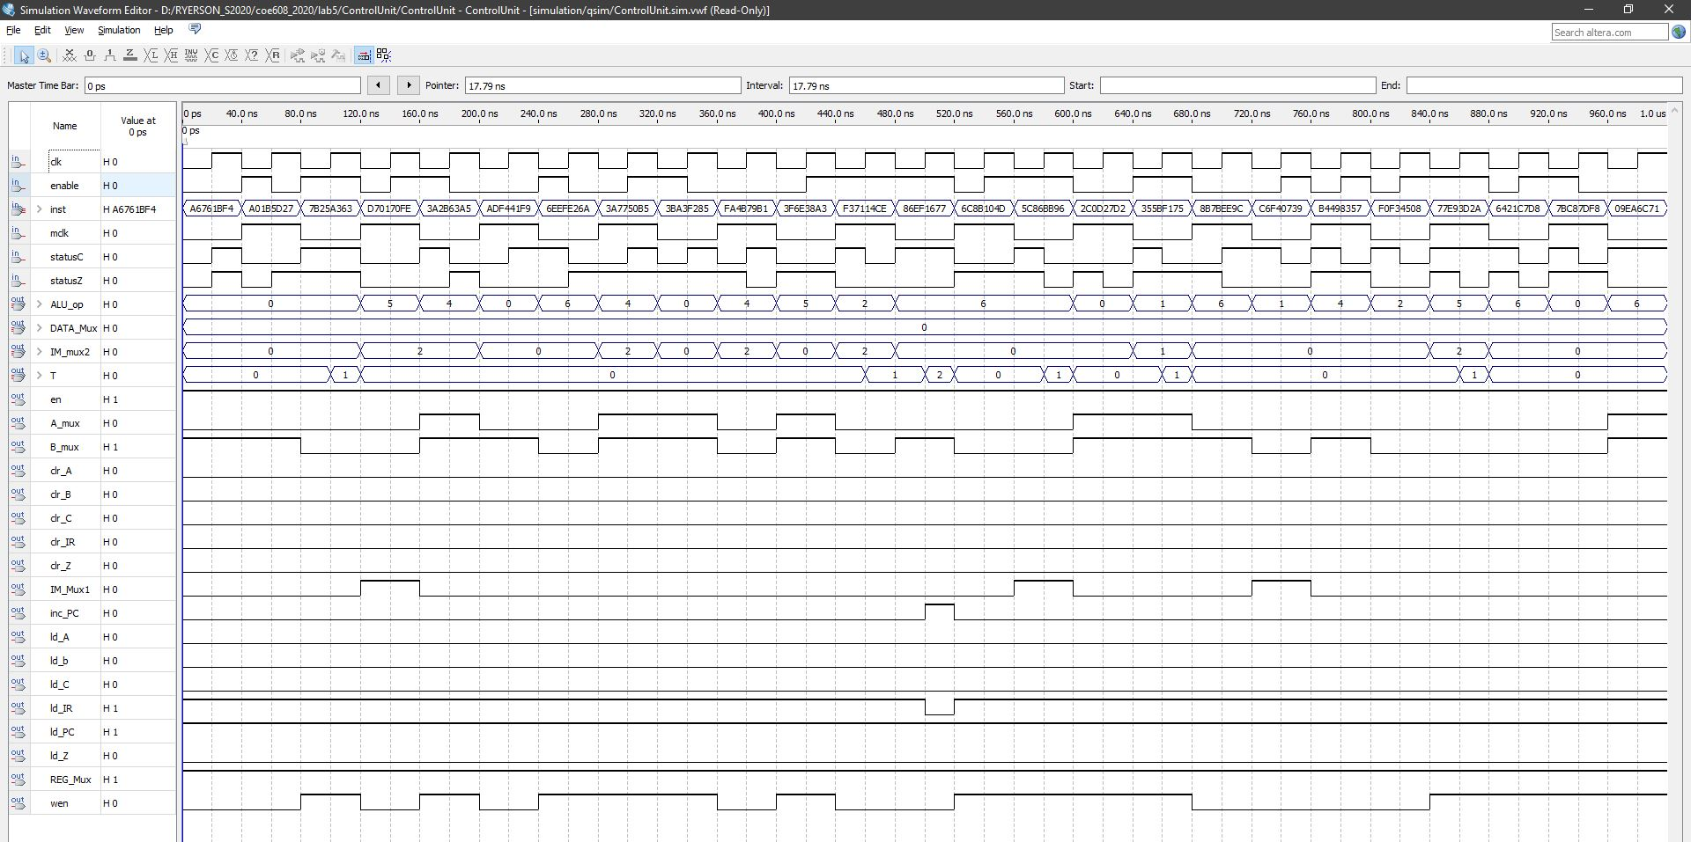

Figure 2: CPU Control Unit Functional Waveform

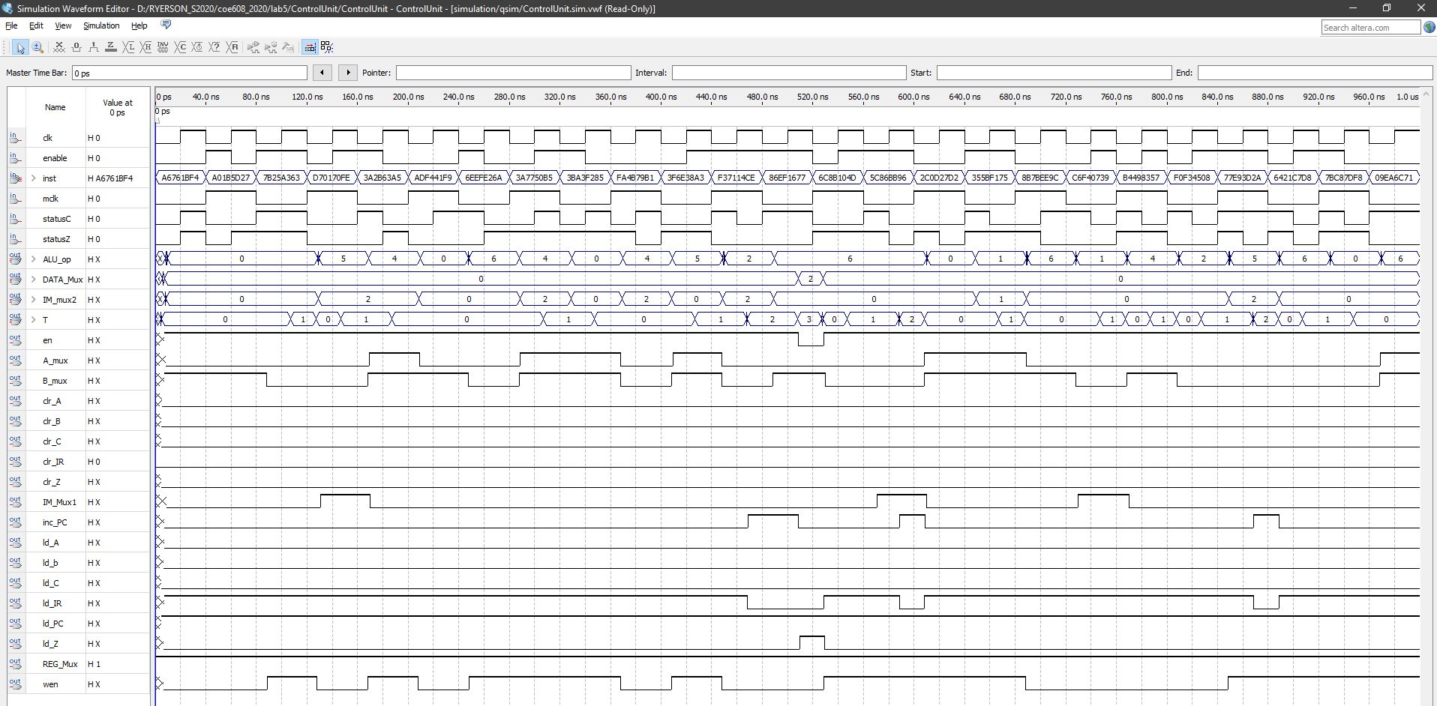

Figure 3: CPU Control Unit Timing Waveform

Appendix: VHDL Codes

The following appendix includes the VHDL code for the CPU control unit and the magnified screenshots of the waveforms for easier reading.

I also include the VHDL code by both of us—both Hadrian and Duan Wei Zhang. I have included the waveforms for the individual operations in a “table of contents” which is a screenshot of the order of the waveforms by order.