**LAB #9**

**Purpose:**

This lab is concerned with structures and linked lists. A few of you might not have seen the latest linked lists topics in class already but look at the slides and try your best.

**Before the lab:**

1. Read you notes concerning structures and linked lists.

**During the lab:**

PART I - Do the following exercises:  
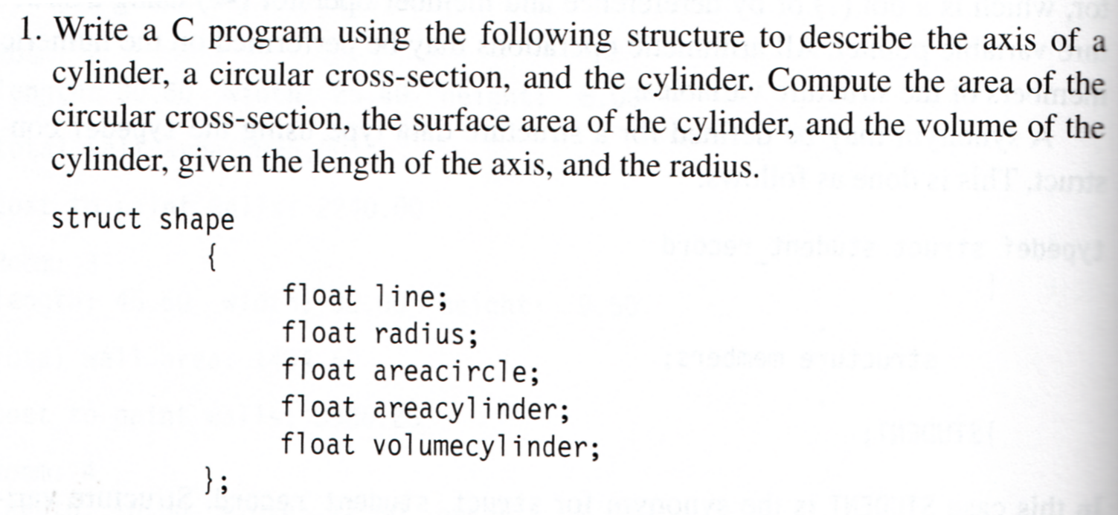  
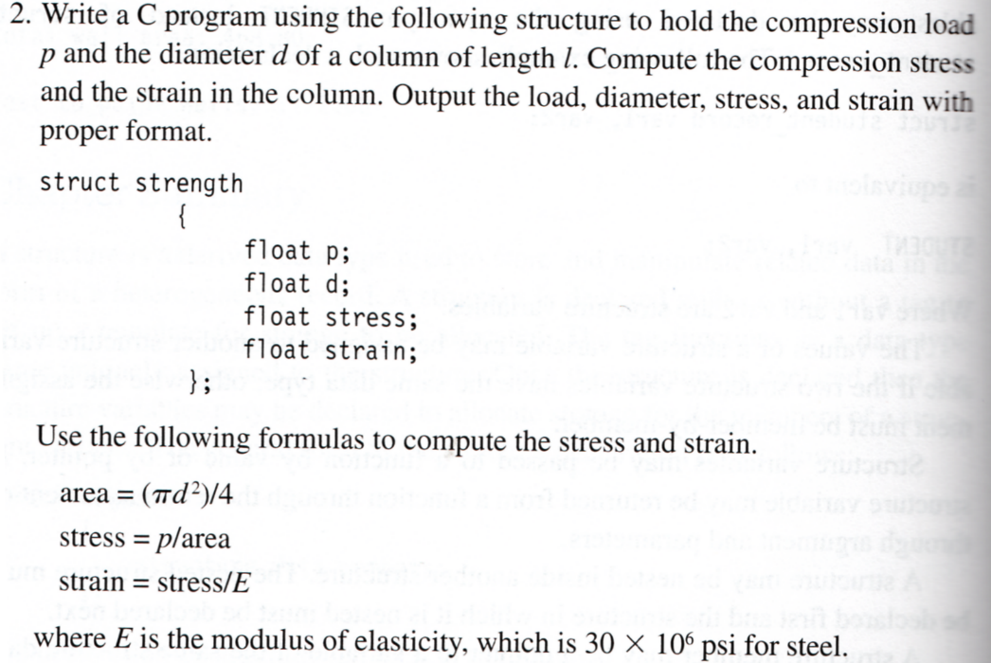

3. Look at this [example program](http://www.ihypress.net/programming/c/prog.php?chap=10&pgm=05). Write a similar program that will create such a dynamic linked list using a structure that stores cars (make, model, color, year). Write then a function that will print the list of all the yellow cars newer than 2010.

PART III - Tracing exercise:  
What would be the output of the following program (do this by hand - do not use the computer):  
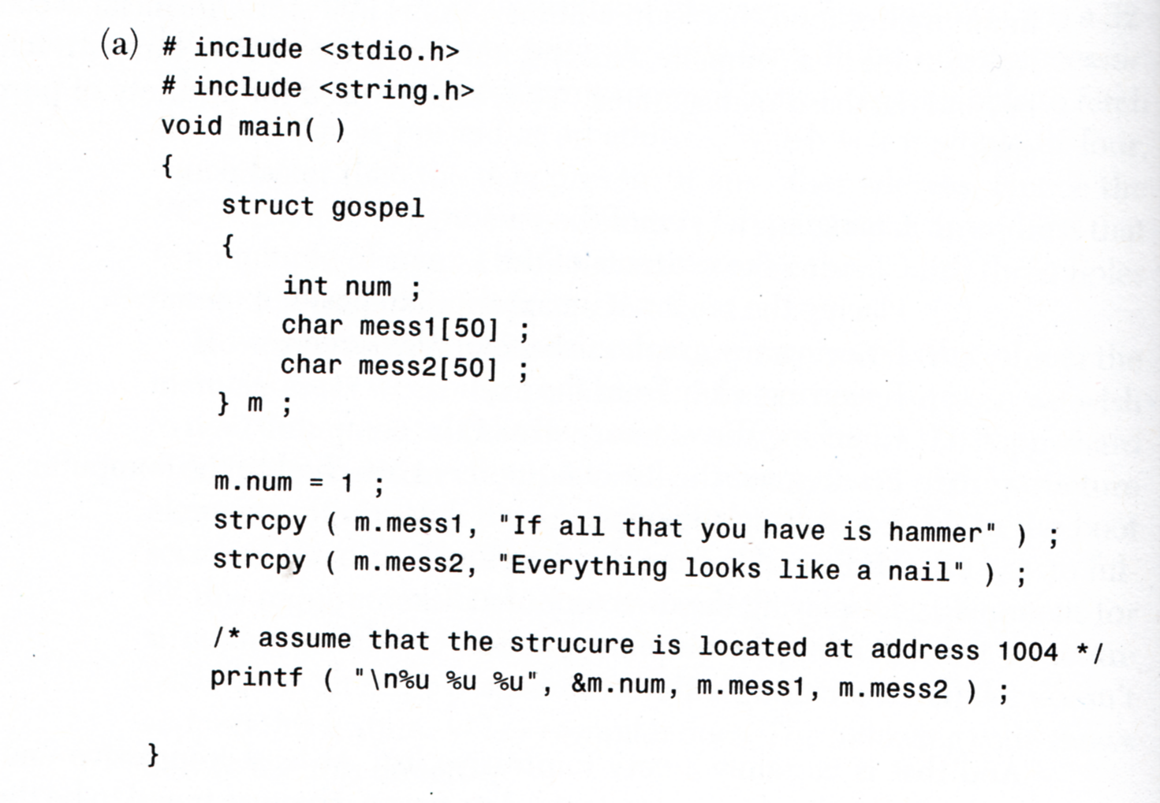  
  
PART II - More exercises (if you have the time)  
Write the following four C programs:  
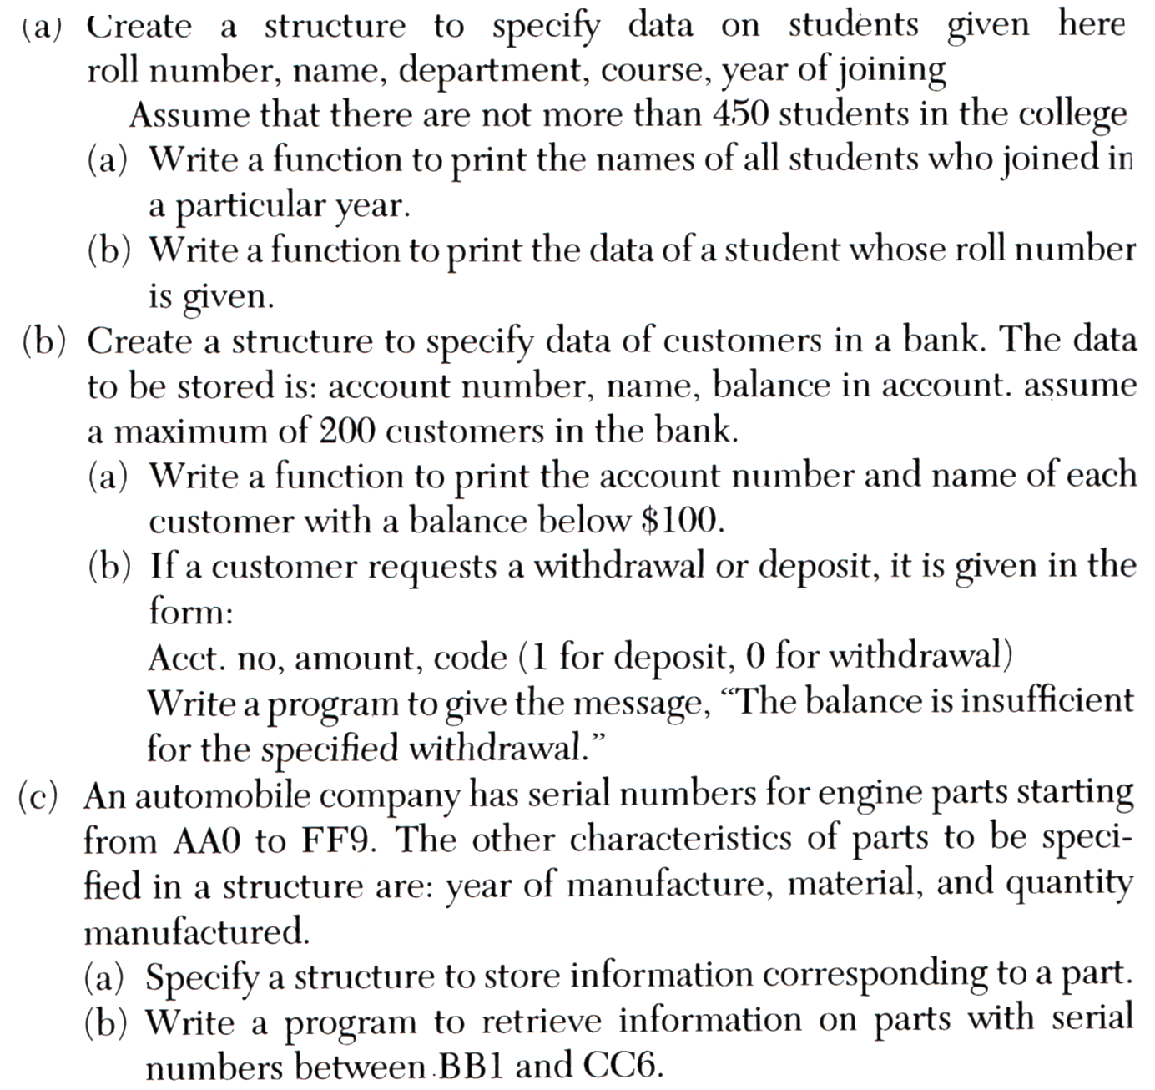

**After the lab:**

1. Review the steps you took to perform the various operations in the lab.

**Homework:**

* On paper (no computer needed), do the homework question presented below (write the code by hand as you would on a test or an exam).
* ry your solution with the computer to see if you got the correct solution.

