About me :
Electrical Engineer specialized in Hardware Design, with experience in multi-layer PCB design, simulation, and hardware validation. Skilled in Altium Designer, LTspice, and HyperLynx for schematic design, PCB layout, and SI/PI analysis. Strong knowledge of PCBA processes, PCB assembly, design for manufacturability (DFM), and PCB industrialization. Passionate about developing reliable hardware solutions for embedded and electronic systems.

Expérience Professionnelle

Freelance Hardware Design Engineer | OTTO ES Novembre 2025 – Mars 2026
Provided freelance hardware design support for the development of a custom 8-layer System-on-Module (SoM) based on the NXP i.MX6UL MPU. Responsible for schematic capture, component selection, PCB layout, and design optimization for high-speed interfaces including DDR3L memory and Ethernet. Applied industry best practices in signal integrity, power integrity, and manufacturable PCB design, gaining hands-on experience with complex embedded hardware architectures.

InternshipS:

Internship — Final Year Project (PFE) | Junior Hardware Design Engineer OTTO ES · February – August 2025
- Designed a 6-layer multi-connectivity IoT Gateway PCB built around an STM32MP1 System-on-Module (SOM), integrating Wi-Fi/Bluetooth, LTE, LoRa, and GPS modules alongside power management, communication, debugging, and storage blocks. Applied controlled impedance routing, differential pair constraints, and a structured stackup to ensure RF and high-speed signal integrity, while optimising EMI performance through ground plane strategy and component placement. Fabrication files (Gerbers, BOM, assembly drawings) were fully prepared and delivered for manufacturing.
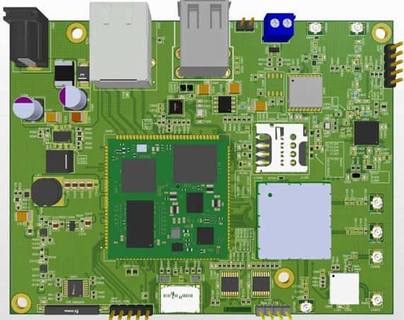

- Each power rail was validated before fabrication through a two-stage simulation approach. Power integrity was analysed using HyperLynx, covering current density distribution, voltage drop mapping, and hotspot detection across the board. Voltage regulators were individually validated using LTspice and PSpice for TI, simulating startup transients, output ripple, and load regulation behaviour to confirm stable power delivery under all operating conditions.

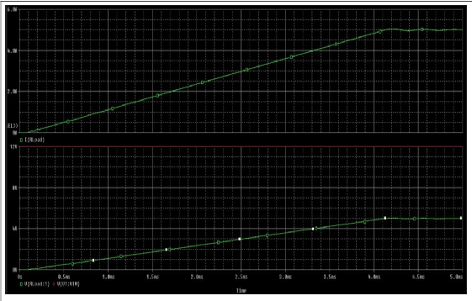
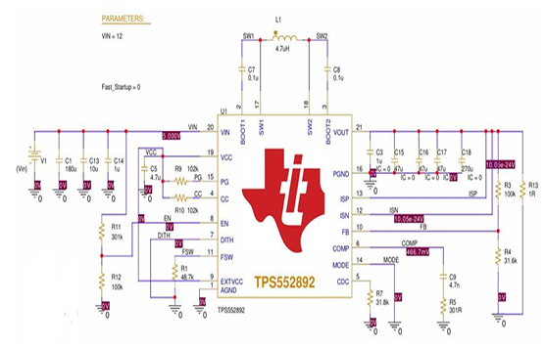

Internship La Pratique Electronique (LPE) · July 2024
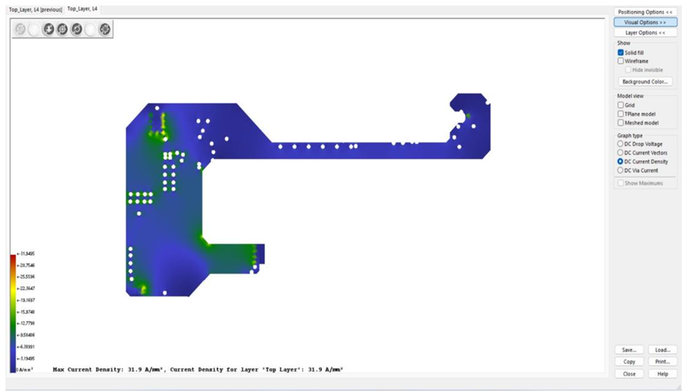
Contributed to the complete PCBA manufacturing process, covering both SMT and THT assembly — from solder paste printing, pick-and-place, and reflow soldering through to conventional soldering and Automatic Optical Inspection (AOI). Optimised the SMT reflow process by adjusting conveyor speed and temperature profile, validated using Datapack measurements to ensure board reliability.

Tunisie Telecom · July 2023
Acquired knowledge of transmission media, high-speed access technologies, and multiple access techniques (TDMA, FDMA, CDMA) through the analysis of existing telecom infrastructure and network architecture.

Academic PROJECTS:

BLDC Motor Controller
Designed a 2-layer 3-phase BLDC motor controller PCB for electric vehicle applications, featuring three independent half-bridge stages with dedicated gate drivers, MOSFETs, and per-phase current sensing. Developed during an IEEE SSCS ENIS chapter workshop in collaboration with ACTIA ES.

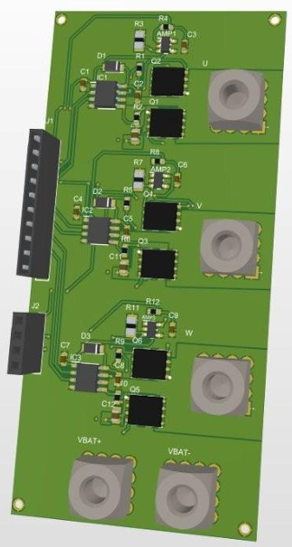

Gaz-Detect Board
Designed and implemented an embedded system for real-time gas leak detection. Full circuit designed under Altium Designer with a 2-layer PCB, tested and validated on a perforated board. Features a 3-level alert system with TFT display, buzzer alarm, and automatic fan activation.

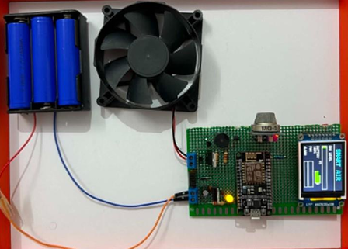
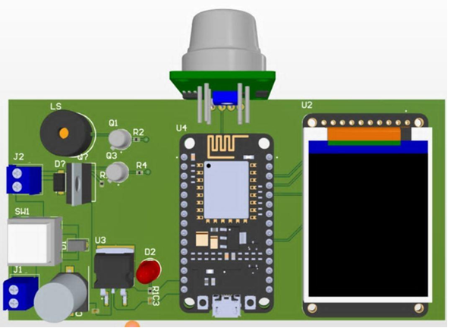
DC Motor Speed Regulator
Designed a 2-layer PWM-based DC motor speed regulator, covering schematic capture, PCB layout, and functional validation using closed-loop PWM control.

Weather Monitoring Station
Designed a 2-layer multi-sensor weather station PCB based on an STM32 microcontroller, integrating temperature, humidity, and pressure sensors. Developed embedded firmware in C.

Certificate:

Certificate — Altium Designer Pro: From Design to Manufacturing (pdf)

QHSE Training (pdf)

Tools & Competences:
- EDA / PCB Design :Altium Designer - Proteus - Saturn PCB Toolkit
- Simulation :LTspice · PSpice for TI · HyperLynx (SI/PI)
- Embedded Protocols: UART · SPI · I2C · CAN · SDMMC · USB · Ethernet
- Programming :C · C++ · Python · VHDL · MATLAB · LabVIEW

Volunteer & Community
Invited as a speaker at SSCAS Fawazir 2.0, delivering a PCB design session to students and junior engineers within the IEEE SSCS ENIS community.

