**HTML5 Assignments**

Q. 1) Create a Web Page to display an article with main heading and sub headings (minimum three headings). Use different fonts for different headings (example – Arial, Times New Roman, helvetica).

Q.2) Create a Web page to display the name of six cities with different headings. Write minimum five sentences for each city. Style the words with color, bold, italic, size, subscript, superscript etc.

Q.3) Display five different images. Skip two lines between each image. Each image should have a title.

Q.4) Create a navigation bar and add links to five different pages of five different websites that should open in a new window.

Q.5) Create an ordered list of five different categories (Ice creams, chocolates, Jeans, Television and Mobile Phones) and list down (un-ordered list) five companies names under each category who sell them in market.

Q.6) Print h1 level heading followed by a horizontal line whose width is 100%. Write a paragraph on your favorite festival below the horizontal line. Insert another horizontal line and display a definition list of 10 words used in the paragraph.

Q.7) Split your browser display are into two colums say nav-links and content-frame. Write five articles that should have at least an image text. Attach these article with nav-links and display them in content-frame when clicked.

Q.8) Web page with a list of youtube videos and brief description about the video

Q. 9) A web page to display test paper (computer code, questions and answers)

Q. 10) A web page to display trailer of a movie and playlist to play audio songs

Q.11) Display student marks sheet with school logo.

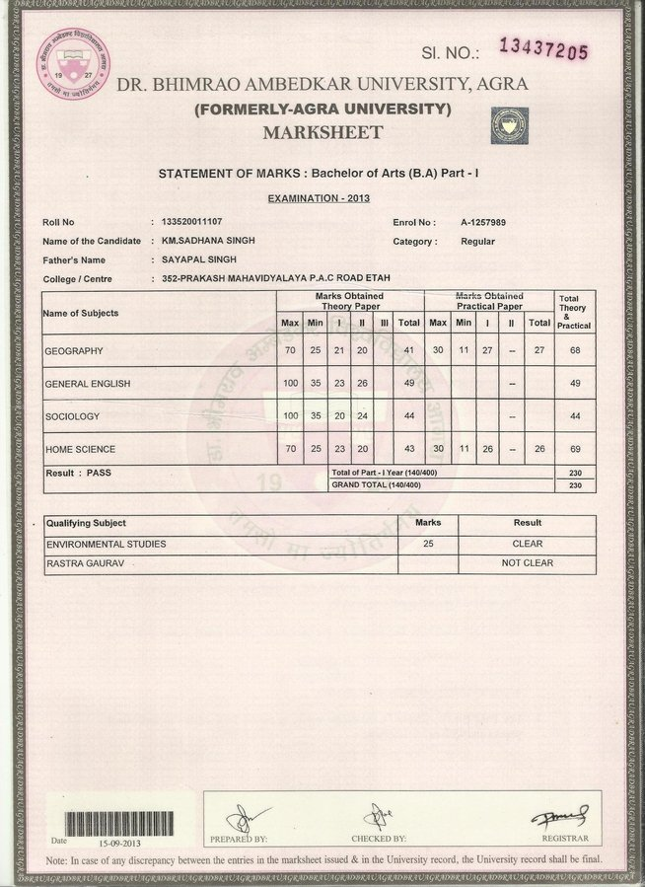

Q. 12) Develop a web page to display magazine article. The shall contain article heading, picture related to article and content. The content shall be displayed in three columns.

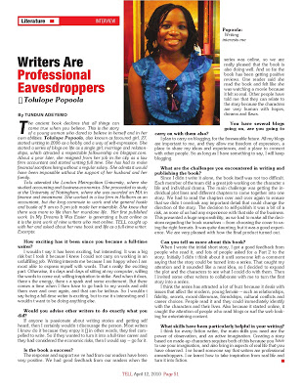

Q.13) Create the given example using (a) Table layout (b) Using clear and float properties.

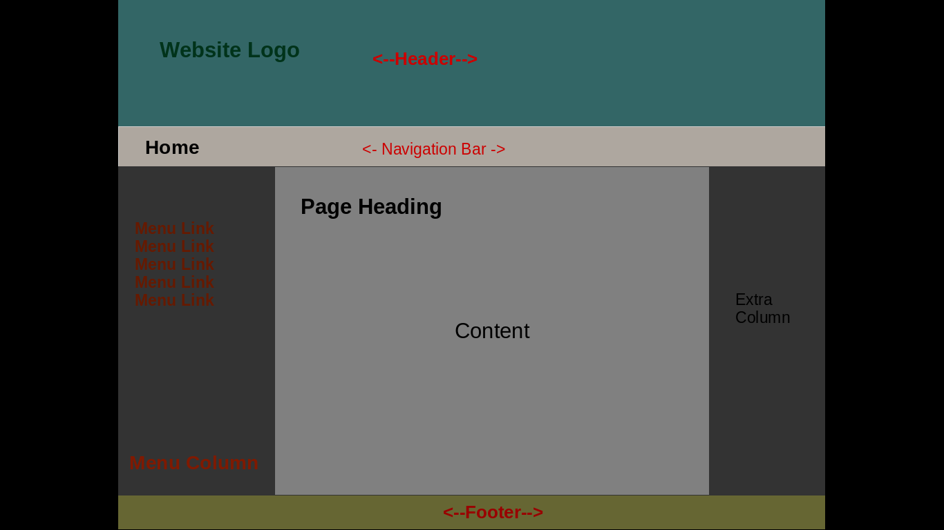

# Q.14) Design following web page using (a) Table layout (b) Clear and float properties.

# 

# Q.15) Design the web page as following using float and clear properties:

# 

# 

# Q.16) Design following web page:

# 

Q. 17) Web page with <picture> tags to select different images

Q.18) Create Your personnel website with these features

* Homepage – navigation bar, Brief about yourself along with picture
* Contact Page
* Photo gallery – display images with caption in matrix form
* Resume Page (education details in a table)
* Hobby page with Links to pages of interest to you etc.

# Q.19) Create an Email Registration form with Name, Permanent address, mailing address, phone number, date of birth, email id, “username display name” and password.

# Add appropriate validation using auto-complete, placeholder, Email attribute.

# Q.20) Create Photographer portfolio. The web page should show on desktop as described below. It should have fixed header and no footer.

|  |  |
| --- | --- |
| Fixed header | |
| Image | image |
| Image | image |
| Image | image |

# ~~~ End of document ~~~