City Bus Management Android Application

Project Title : City Bus Management

Abstract:

This is an android application used to find out the bus number from one place to another place.
User need to give the details of source and destination.
Accordingly it will display the details of the bus number which is going in that route.
It is a time saving application to user.
User can easily get the information of the bus number of a particular route.
In this way a user will be free of confusion about the buses.
It will also be very helpful for those people who are new to the city.

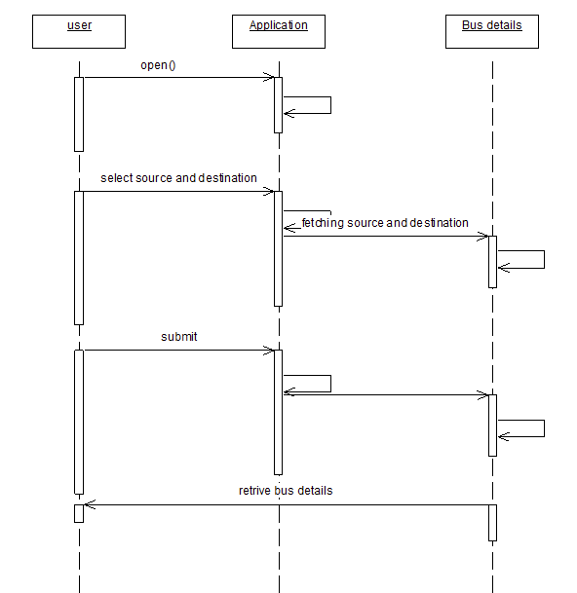

KEY FUNTIONALITY:

In the cities, especially in India buses are major form of transportation. So by this app we can get the information required for reaching to the desired destination. We select the source and destination and after pressing the submit button we get the bus number of the bus we have to travel . Thus this application has its importance in the city travelling.

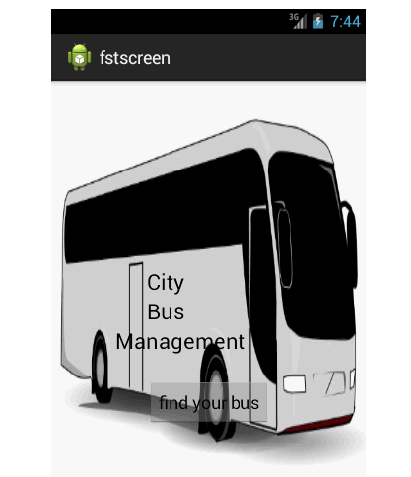

Introduction

Existing system:

There are some bus route finders and bus number finding systems in the internet these days But these require internet connectivity for the working of the application. This is somewhat money consuming. Also if the net is slow the process is also slow. And if the net connectivityis weak then the process of finding the busses will also be difficult. To overcome the above problems we have developed our particular project which will work without internet.

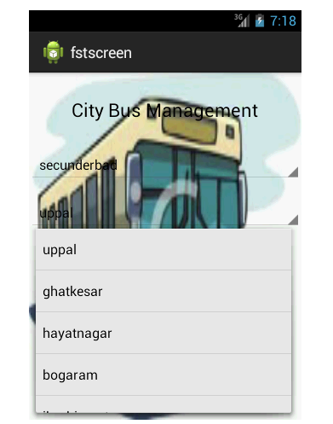

Proposed System:

CityBusManagement applicationthat wehave developedwill workwithout internet connectivity. This is the major advantage thisparticular applicationwe have developed our project t has a database of its own which makes it independent of internet,and it displays the bus numbers on its own. This makes finding of the bus numbers easy, fast and efficient .

