Android Template Questions
Introduction & Basic GUI
- Creating the simple “Hello World” android application by passing value in the value string and display hello by clicking on the button.
- Create an android application to print current date and time.
- Create an android application to display hello on Toast.
- Create android program to implement android layouts.
- Create a Buttion and on the click of button print current date and time.
- Create a button and on the click of button print the toast and on the toast print current date and time.
- Create a customised toast to print hello and a image onn the click of button.
- Cretae a toast to print the status of toggle button click.
- Create a student registration page in android:
Name:
Address:
Mobile:
Mobile:
Course: Java[] C [] Linux[] Embedded C[]
Gender: Male() Female()
Submit
On the click of submit toast should show the entire data.
- In the above application, add a field which can take country. Select the coutry name from spinner and the selected country should be shown the toast.
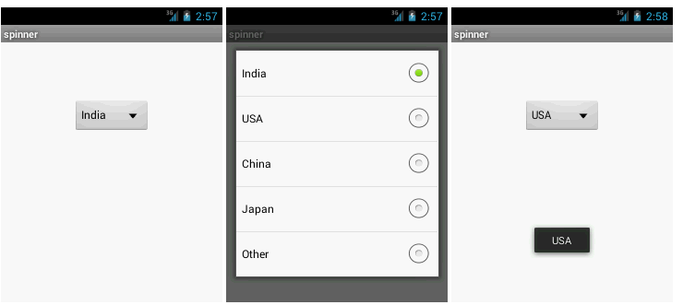
11. Just a minor change in the above program, instead of using spinner to select the country name, use auto complete view to automatically detect the country name.
12. Create a rating form:
Movie Name: Should be selected from auto comlete view
Rate the moview: by using Android rating bar widgets
SUBMIT
13. Create your weekly activity planner tool(It may be sprint planning tool):
Name: Vikas
Hours: 20
Strory ID: IT_APP_008(select by auto complete view)
To Do :
1. Creating assigment question
2. Review the old assigment questions
In Progress: Preparing the assignment questions
Done: Assigment question preparation of android is done
Date: 17/10/2014(get the date from date picker)
Time:(Select the time from time picker)
SUBMIT
Once you submit all the data, the stakeholder should be able to view the entire form in website.
14.Create a downloader app in android and show the progress of download by using android progress bar.
15. Write a program to implment the activity life cycle.
16. Create an android application to implement context menu.

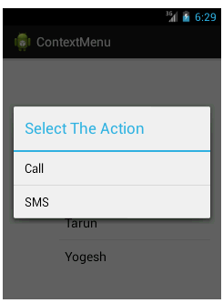

17. Write a program to create pop up menu
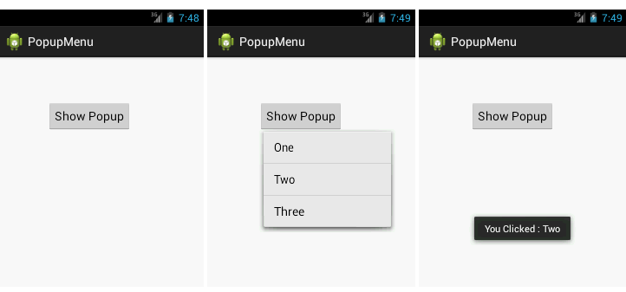
18. Write a program to store and retrive the from the phone using internal storage memnory.
19.Write a program to store the data on the external storage device.
20.Write an application to store the following data in the SQLite:
Name:
Address:
Mob:
Email Id:
Company Name:

SUBMIT(after submission of data the manager should be ablr to see the data in web site)
View
- Create an android application to display the list of fruit stored in an Array?
- Create the custom list view to build the above application (q.no. 3) with the image of the fruit in the left side.

- Write a program to Implement Android session management with shared preferences
- Write an android program to play a video file.
- Write a program to open camera and save the picture in sd card.
- Write a login example in android with the help of SQLite Database.
- Create a splash screen in android.
- Write a program to Download images .
- Write a program to show phone contacts in auto complete suggestion.
- Write a program to implement tab layout.
- Write an android program to create notification alert.

Telephony Manager API

- Create an Android application that prints information of the telephony services.
- Create an Android application to check whether phone is ringing or phone is in a call or phone is neither ringing nor in a call.
- Creating an Android application to develop a basic android app that speaks the incoming number while phone is in ringing mode.
- Create and Android application that can make a phone call in android phone via intent.
- Create an Android application to send sms in android phone via intent.
- Create an Android app to send email in android phone via intent.

