Program#1:Write a Java program to print message “Welcome to Emertxe” in console.?(low)

Program#2:Create a Constrictor with passing parameter and set the value of that parameter by using this keyword?(low)

Program#3:Write a method inside a class by passing value and call the method inside the class?
(Medium)

Program#4:By using recursion calculate factorial of given number? (High)
Ex: Factorial of 5=120

Program#5:Declare int, float, double and string datatype variables and get the value from console and assign it and display? (Medium)

Program#6:Write a program by using final keyword in class, method and variable? (High)

Program#7:Create a own package name as Animal and write java program in that package. Use that class in some other package?(Medium)

Program#8:Create a java program and use private variable. Try to access that variable in some other class?(Medium)

Program#9:Convert the given input of two number into bytecode and add the bytecode by using bitwise operator and display the output?(High)
Ex:
1 = 0001
2 = 0010
________

3 = 0011

Program#10: Swap the two values without using temporary variable?(Medium)

Program#11: Write a program to count the same character in the String?(High)
Ex:EMERTXE
E=3
M=1
R=1
T=1
X=1

Program#12: Write a program to display following output as below.(High)

Player 1, enter your name: Alice
Player 2, enter your name: Bob

A: 3 B: 4 C: 5

Alice, choose a pile: A
How many to remove from pile A: 2

A: 1 B: 4 C: 5

Bob, choose a pile: C
How many to remove from pile C: 3

A: 1 B: 4 C: 2

Alice, choose a pile: B
How many to remove from pile B: 1

A: 1 B: 3 C: 2

Bob, choose a pile: B
How many to remove from pile B: 1

A: 1 B: 2 C: 2

Alice, choose a pile: A
How many to remove from pile A: 1

A: 0 B: 2 C: 2

Bob, choose a pile: B
How many to remove from pile B: 1

A: 0 B: 1 C: 2

Alice, choose a pile: C
How many to remove from pile C: 2

A: 0 B: 1 C: 0

Bob, choose a pile: B
How many to remove from pile B: 1

A: 0 B: 0 C: 0

Alice, there are no counters left, so you WIN!
Bonus points for checking the counter value, wrong choose and good display.

Program#13: Write a program to display the “welcome to Emertxe” inside the frame when only Mouse enter into the frame. Set background color as blue for frame? (Medium)

Program#14: Create a Menubar in java program as like as below?(High)

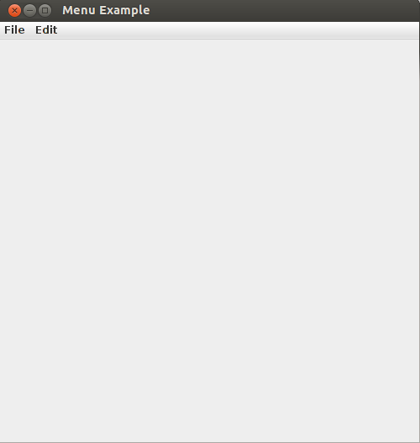

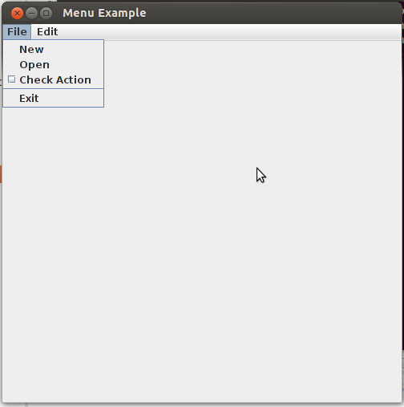

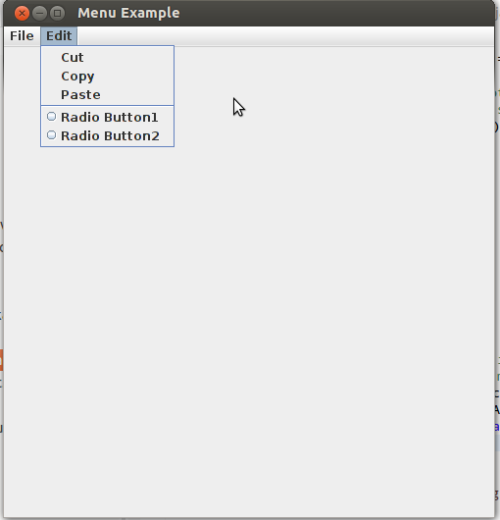
Program#15: Write a program to create a two label(user name,password) and two text box and one button in frame. When button clicked, check the user name and password is matched or not. Based on that out put will display in frame?(High)

UserName:

Password:

Click

Display all Employee Detail.

Program#16: Write a Java program to convert given primitive data type into Wrapper class?(Low)
Ex:
int of 5 into Integer of 5.

Program#17: Write a java program to add only unique value of object as key in the collection?(High)
Ex:
HashMap hp = new HashMap();
hp.put(obj1,val1);
hp.put(obj1,val2);//Error

Program#18: Write a java program to display in the sorting order employee details based on empId?(Medium)

Output Like:
EmpId EmpName EmpDept EmpSalary
101 Raj Admin 5000
102 Arun Development 4000

Program#19: Write some data into newly created file in java? (Medium)

File Name:welcome.txt.
File Content: Hi! Welcome to Emertxe.

Program#20: Create Vechical Interface with 5 method declarations and implement them in Car and Auto class.(Medium)

