Course Booklet for
Java Programming Language



know how of Java Programming Language
By Emertxe
version1.0 (Jan 16, 2013 )

All rights reserved. Copyright @ 2013
Emertxe Information Technologies Pvt Ltd
(http://www.emertxe.com

Table of Contents
Preface 13
Chapter 1:Getting Started 14
1.1:Objectives 14
1.2:What Is the Java Technology? 15
1.2.1:Primary Goals of the Java Technology 15
1.3:The Java Virtual Machine 16
1.4:Garbage Collection 16
1.5:The Java Runtime Environment 17
1.5.1: JVM Tasks 18
1.5.2:The Class Loader 18
1.5.3:The Bytecode Verifier 18
1.6:A Simple Java Application 19
1.6.1:Compiling and Running the SampleHello Program 19
Chapter 2:Object-Oriented Programming 20
2.1:Objectives 20
2.2:Software Engineering 21
2.3:Abstraction 22
2.4:Classes as Blueprints for Objects 22
2.4.1:Declaring Java Technology Classes 22
2.4.2:Declaring Attributes 23
2.4.3:Declaring Methods 23
2.4.4:Accessing Object Members 23
2.5:Encapsulation 24
2.6:Source File Layout 24
2.7:Software Packages 25
2.7.1:The package Statement 25
2.7.2:The import Statement 26
2.7.3:Compiling Using the -d Option 26
2.7.4:Deployment 27
2.8:Using the Java Technology API Documentation 27
Chapter 3:Identifiers, Keywords, and Types 29
3.1:Objectives 29
3.2:Semicolons, Blocks, and White Space 30
3.3:Identifiers 30
3.4:Java Programming Language Keywords 31
3.5:Basic Java Programming Language Types 31
3.5.1:Primitive Types 31
3.5.2:Java Reference Types 32
3.6:Constructing and Initializing Objects 32
3.6.1:Memory Allocation and Layout 32
3.6.2:Explicit Attribute Initialization 33
3.6.3:Executing the Constructor 33
3.6.4:Assigning a Variable 34
3.6.5:Assigning References 34
3.7:The this Reference 34
3.8:Java Programming Language Coding Conventions 35
Chapter 4:Class Design 37
4.1:Objectives 37
4.2:Subclassing 38
4.2.1:Single Inheritance 39
4.3:Access Control 39
4.4:Overriding Methods 39
4.4.1:Overridden Methods Cannot Be Less Accessible 39
4.4.2:Invoking Overridden Methods 40
4.5:Polymorphism 41
4.6:The instanceof Operator 41
4.6.1:Casting Objects 41
4.7:Overloading Methods 42
4.7.1:Methods Using Variable Arguments 42
4.8:Overloading Constructors 43
4.8.1:Constructors Are Not Inherited 43
4.8.2:Invoking Parent Class Constructors 43
4.9:Constructing and Initializing Objects: A Slight Reprise 43
4.10:The Object Class 44
4.10.1:The equals Method 44
4.10.2:The toString Method 44
4.11:Wrapper Classes 46
4.11.1:Autoboxing of Primitive Types 46
Chapter 5:Advanced Class Features 47
5.1:Objectives 47
5.2:The static Keyword 48
5.2.1:Class Attributes 48
5.2.2:Class Methods 48
5.2.3:Static Initializers 49
5.3:The final Keyword 49
5.3.1:Final Classes 49
5.3.2:Final Methods 49
5.3.3:Final Variables 50
5.3.3.1:Blank Final Variables 50
5.4:Enumerated Types 50
5.4.1:Old-Style Enumerated Type Idiom 51
5.4.2:The New Enumerated Type 51
5.4.3:Advanced Enumerated Types 51
5.5:Static Imports 52
5.6:Abstract Classes 53
5.7:Interfaces 54
5.7.1:Uses of Interfaces 54
Chapter 6:Exceptions and Assertions 55
6.1:Objectives 55
6.2:Exceptions 56
6.2.1:Exception Example 56
6.3:The try-catch Statement 57
6.3.1:Using Multiple catch Clauses 57
6.4:Call Stack Mechanism 58
6.5:The finally Clause 58
6.6:Exception Categories 59
6.7:Common Exceptions 60
6.8:The Handle or Declare Rule 61
6.9:Method Overriding and Exceptions 61
6.10:Creating Your Own Exceptions 63
6.11:Assertions 64
6.11.1:Recommended Uses of Assertions 64
6.11.1.1:Internal Invariants 64
6.11.1.2:Control Flow Invariants 65
6.11.1.3:Postconditions and Class Invariants 65
6.11.2:Controlling Runtime Evaluation of Assertions 65
Chapter 7:Collections and Generics Framework 66
7.1:Objectives 66
7.2:The Collections API 67
7.3:Collection Implementations 68
7.3.1:List 68
7.3.2:Set 69
7.4:The Map Interface 70
7.5:Legacy Collection Classes 71
7.6:Ordering Collections 72
7.6.1:The Comparable Interface 72
7.6.2:The Comparator Interface 72
7.7:Generics 73
7.7.1:Generics: Examining Type Parameters 74
7.7.2:Generics: Refactoring Existing Non-Generic Code 75
7.8:Iterators 76
7.9:The Enhanced for Loop 77
Chapter 8:I/O Fundamentals 78
8.1:Objectives 78
8.2:System Properties 79
8.2.1:The Properties Class 79
8.3:I/O Stream Fundamentals 79
8.3.1:Data Within Streams 80
8.4:Byte Streams 80
8.4.1:The InputStream Methods 80
8.4.2:The OutputStream Methods 80
8.5:Character Streams 81
8.5.1:The Reader Methods 81
8.5.2:The Writer Methods 81
8.6:Node Streams 82
8.7:I/O Stream Chaining 83
8.8:Processing Streams 83
8.9:Basic Byte Stream Classes 84
8.10:Serialization 85
8.11:Basic Character Stream Classes 86
Chapter 9:Console I/ O and File I/O 87
9.1:Objectives 87
9.2:Console I/O 88
9.2.1:Writing to Standard Output 88
9.2.2:Reading From Standard Input 88
9.2.3:Simple Formatted Output 89
9.2.4:Simple Formatted Input 89
9.3:Files and File I/O 90
9.3.1:Creating a New File Object 90
9.3.2:The File Tests and Utilities 90
9.4:File Stream I/O 91
Chapter 10:Building Java GUIs Using the Swing API 92
10.1:Objectives 92
10.2:What Are the Java Foundation Classes (JFC)? 93
10.3:What Is Swing? 93
10.3.1:Pluggable Look-and-Feel 93
10.4:Swing Architecture 94
10.5:Swing Packages 95
10.6:Swing Containers 97
10.6.1:Top-level Containers 97
10.7:Swing Components 98
10.8:Properties of Swing Components 99
10.9:Layout Managers 100
10.10:GUI Construction 101
Chapter 11:Handling GUI-Generated Events 102
11.1:Objectives 102
11.2:What Is an Event? 103
11.3:Java SE Event Model 103
11.3.1:Delegation Model 103
11.4:GUI Behavior 104
11.4.1:Event Categories 104
11.4.2:A Listener Example 105
11.5:Concurrency in Swing 106
Chapter 12:GUI-Based Applications 107
12.1:Objectives 107
12.2:How to Create a Menu 108
12.2.1:Creating a JMenuBar 108
12.2.2:Creating a JMenu 108
12.2.3:Creating a JMenuItem 109
12.3:Controlling Visual Aspects 109
12.3.1:Colors 109
Chapter 13:Threads 110
13.1:Objectives 110
13.2:Threads 111
13.3:Creating the Thread 111
13.3.1:Starting the Thread 111
13.4:Thread Scheduling 112
13.5:Basic Control of Threads 113
13.5.1:Testing Threads 113
13.5.2:Accessing Thread Priority 113
13.5.3:Putting Threads on Hold 113
13.6:Using the synchronized Keyword 114
13.6.1:The Object Lock Flag 114
13.6.2:Releasing the Lock Flag 115
13.6.3:Using synchronized – Putting It Together 116
13.7:Thread Interaction – wait and notify 117
13.7.1:The Pool Story 117
13.8:Putting It Together 118
Chapter 14:Networking 119
14.1:Objectives 119
14.2:Networking 120
14.2.1:Sockets 120
14.2.2:Setting Up the Connection 120
14.3:Networking With Java Technology 121
14.4:Addressing the Connection 121
14.4.1:Port Numbers 121
14.5:Java Networking Model 122
14.6:Minimal TCP/IP Server 123
14.7:Minimal TCP/IP Client 124
14.8:A Network Application using UDP 125
Chapter 15:Exploring the Model View Controller (MVC) Design Pattern 128
15.1:Objectives 128
15.2:Design Patterns 129
15.2.1:Definition of Design Pattern 129
15.2.2:The MVC Design Pattern 130
15.3:InfoTool Application Overview 131
15.4:Demonstrating MVC in the InfoTool Application 132
15.4.1:InfoTool Model 133
15.4.2:InfoTool Controller 134
15.5:InfoTool MVC Participant Sequence Diagram 135
15.6:InfoTool MVC Participant Interaction Diagram 135
Chapter 16:Implementing Unit Testing 137
16.1:Objectives 137
16.2:Unit Testing 138
16.2.1:The Need for Unit Testing 138
16.2.2:Understanding Test Cases and Their Uses 138
16.2.3:The Need for a Test Framework 138
16.3:Features of JUnit for Unit Testing 139
16.3.1:JUnit Features 139
16.4:The JUnit Framework 140
16.4.1:Design of JUnit 140
16.5:Apply JUnit for Unit Testing 141
16.5.1:Creating Test Cases 141
16.6:Netbeans Support for JUnit 142
16.6.1:Special Features 142
Chapter 17:Implementing the JavaTM Database Connectivity (JDBC) API 143
17.1:Objectives 143
17.2:Introducing the JDBC Interface 144
17.2.1:The Two Components of the JDBC API 144
17.2.2: The JDBC API 147
17.2.3:Using Java DB: A Real-World JDBC Driver 148
17.3:Connecting Through the JDBC Interface 148
17.4:Connecting Through the JDBC Interface Detailed Review 150
17.4.1:Registering a JDBC Driver 150
17.4.2:Establishing a DBMS Session 150
17.4.3:Creating an SQL Query Wrapper Object 150
17.4.4:Submitting a Query and Receiving the Results 151
17.4.5:Extracting the Data From the Result Wrapper Object 151
17.5:Mapping Between SQL Data Types and Java Data Types 152
17.6:Production Code Strategies for JDBC API Usage 153
17.6.1:Loading Properties From a File 154
17.7:Introducing the DAO Pattern 155
Chapter 18:Handling GUI Events 156
18.1:Objectives 156
18.2:MVC Client Software Components 157
18.3:Delegation Event Model 157
18.3.1:Propagating Notification of Events 159
18.3.2:Event Listener Implementation Issues 159
Chapter 19:Logging Messages in GUI 160
19.1:Objectives 160
19.2:Using the Logging API 161
19.2.1:Creating a Logger Object 161
19.2.2:Configuring the Logger Object 161
19.3:Using the Logging Configuration File 164
19.4:Simple Logging Example 165
19.5:Writing Custom Handlers 166
Chapter 20:Implementing Multiple-Tier Design 167
20.1:Objectives 167
20.2:Comparing Two-Tier and Three-Tier Designs 168
20.3:Networking With Java Technology 170
20.4:Command Design Pattern 170
20.4.1:Applying the Command Design Pattern 171
Chapter 21:Implementing Advanced Multiple-Tier Design 172
21.1:Objectives 172
21.2:Multithreaded Server 173
21.3:The java.util.concurrent.locks Package 174
21.3.1:The Lock Interface 174
21.3.2:The Condition Interface 174
21.3.3:The ReentrantLock Class 175
21.3.4:The IoThread Class 175
21.3.5:The IoThreadPoolManager Class 176
21.4:Network Server Design Issues 177
21.4.1:Multithreaded Server Issues 177
Chapter 22:Communicating with Remote Objects Using Java RMI 178
22.1:Objectives 178
22.2:The Java RMI 179
22.3:Creating a Java RMI Application 181
22.4:Deploying a Java RMI Application 183
Chapter 23:Introduction to Java Servlets 186
23.1:Objectives 186
23.2:Web Application Technologies 187
23.2.1:HTTP Client-Server Architecture 187
23.2.2:Web Site Structure 187
23.2.2.1:Uniform Resource Locator 188
23.3:Web Sites and Web Applications 188
23.4:Execution of CGI Programs 188
23.4.1:Advantages and Disadvantages of CGI Programs 190
23.5:Using Java in the Web 190
23.5.1:Execution of Java Servlets 190
23.5.2:Advantages and Disadvantages of Java Servlets 191
23.6:Java Servlets 191
23.7:A First Java Servlet 192
23.8:HTTP Methods 193
Chapter 24:Introduction to Java Server Pages 194
24.1:Objectives 194
24.2:A Weakness in Servlets 195
24.2.1:Addressing the Problem With JSPs 195
24.3:Key Elements of JSPs 196
24.4:How a JSP Is Processed 196
24.5:Reading Input Parameters From the Browser 197
24.5.1:Sending Parameters in an HTTP GET Request 197
24.6:Remaining Problems With the JSP Approach 198
24.7:Model, View, and Controller 198
Chapter 25:Implementing an MVC Design 199
25.1:Objectives 199
25.2:Developing the MVC Solution 200
25.2.1:Responsibilities of the Controller 200
25.2.2:Connecting the Components 200
25.2.3:Forwarding From a Servlet to a JSP 200
25.2.4:Passing Data From the Servlet to the JSP 201
25.2.5:Using Data in the JSP 201
25.3:A Complete MVC Example 202
Chapter 26:The Servlet’s Environment 203
26.1:Objectives 203
26.2:HTTP Revisited 204
26.2.1:Hypertext Transfer Protocol 204
26.2.2:HTTP Methods 204
26.2.3:HTTP Request 205
26.2.4:HTTP Response 207
26.3:Collecting Data From the User 207
26.3.1:HTML Form Mechanism and Tag 207
26.4:Input Types for Use With Forms 208
26.4.1:Text Input Component 208
26.4.2:Drop-Down List Component 208
26.4.3:Submit Button 208
26.5:Web Container Architecture 209
26.5.1:Request and Response Process 209
26.5.2:Sequence Diagram of an HTTP GET Request 210
26.6:The HttpServlet API 211
26.6.1.1:The HttpServletRequest API 212
26.6.1.2:The HttpServletResponse API 212
26.6.2:Handling Errors in Servlet Processing 212
26.7:The HTTP Protocol and Client Sessions 213
26.8:The HttpSession API 213
26.8.1:Storing Session Attributes 215
26.8.2:Retrieving Session Attributes 215
26.8.3:Closing the Session 215
26.8.4:Additional Session Methods 215
26.9:Using Cookies for Client-Specific Storage 216
26.9.1:Cookie API 216
26.10:Using Cookies Example 218
26.11:Using URL-Rewriting for Session Management 219
Chapter 27:Container Facilities for Servlets and JSPs 220
27.1:Objectives 220
27.2:Packaging Web Applications 221
27.2.1:The Default Context Root 221
27.2.2:Essential Structure of a WAR file 222
27.3:Deployment Descriptors 223
27.3.1:The web-fragment.xml Files 223
27.3.2:Controlling Configuration 223
27.3.3:Dynamic Configuration of Web Applications 224
27.4:Servlet Mapping 225
27.4.1:Multiple and Wildcard URL Patterns 225
27.4.2:Mapping Using Annotations 226
27.4.3:Invoking a Servlet by Name 226
27.5:Servlet Context Information 226
27.5.1:Context Parameters 226
27.5.2:Supplying Context Parameters 228
27.6:Servlet Initialization Parameters 228
27.6.1:Using Annotations 229
27.6.2:Reading Servlet Initialization Parameters 229
27.7:Other Configuration Elements 229
Chapter 28:More View Facilities 231
28.1:Objectives 231
28.2:Scopes 232
28.3:More Details About the Expression Language (EL) 234
28.3.1:EL and Scopes 234
28.3.2:EL Implicit Objects 234
28.3.3:The Dot Operator In EL 235
28.3.4:Array Access Syntax With EL 235
28.3.5:EL and Errors 235
28.3.6:EL Arithmetic Operators 237
28.3.7:Comparisons and Logical Operators 237
28.4:Configuring the JSP Environment 239
28.5:Presentation Programming 240
28.5.1:Standard Custom Tags 240
28.5.2:Tag Example 240
28.6:Key View Programming Tags 241
28.6.1:JSTL if Tag 241
28.6.2:JSTL forEach Tag 241
Chapter 29:Developing JSP Pages 244
29.1:Objectives 244
29.2:JavaServer Pages Technology 245
29.2.1:How a JSP Page Is Processed 245
29.3:Writing JSP Scripting Elements 247
29.3.1:Comments 247
29.3.2:Directive Tag 248
29.3.3:Declaration Tag 248
29.3.4:Scriptlet Tag 248
29.3.5:Expression Tag 249
29.3.6:Implicit Variables 249
29.4:Using the page Directive 250
29.5:Including JSP Page Segments 252
29.5.1:Using the include Directive 252
29.6:Using Standard Tags 253
29.6.1:The useBean Tag 254
29.6.2:The setProperty Tag 254
29.6.3:The getProperty Tag 254
29.7:Other Standard Tags 255
Chapter 30:Developing JSP Pages Using Custom Tags 256
30.1:Objectives 256
30.2:The JSTL 257
30.2.1:The Java EE Job Roles Involved in Web Application Development 257
30.3:Designing JSP Pages With Custom Tag Libraries 257
30.3.1:Custom Tag Library Overview 258
30.3.2:Custom Tag Syntax Rules 259
30.3.3:JSTL Sample Tags 259
30.4:Using a Custom Tag Library in JSP Pages 261
30.5:JSTL Tags 261
30.5.1:Core Actions 262
30.5.2:XML Processing 262
30.5.3:Formatting Actions 263
30.5.4:Relational Database Access 263
30.5.5:Functions 264
Chapter 31:More Controller Facilities 265
31.1:Objectives 265
31.2:Servlet Life Cycle Overview 266
31.2.1:The ServletConfig API 267
31.3:Servlet Lifecycle and Annotations 268
31.3.1:Lifecycle Method Annotations 268
31.4:Servlets and Threading 269
31.4.1:Handling Concurrency 269
31.4.2:Data Shared Between Invocations by a Single Client 269
31.4.3:Sharing Data Between Multiple Clients 269
31.5:Web Container Request Cycle 270
31.5.1:Web Container Request Processing 270
31.5.2:Applying Filters to an Incoming Request 271
31.6:Filter API 273
31.7:Developing a Filter Class 275
31.7.1:The init Method 275
31.7.2:The doFilter Method 275
31.7.3:The destroy Method 275
31.8:Configuring the Filter 277
31.8.1:Configuring a Filter Using Annotations 277
31.8.2:Declaring a Filter in the web.xml File 277
31.8.3:Declaring a Filter Mapping in the web.xml File 279
31.9:Handling Multipart Forms 280
Chapter 32:More Options for the Model 281
32.1:Objectives 281
32.2:The Model as a Macro-Pattern 282
32.3:Database and Resource Access 283
32.3.1:Data Access Object (DAO) Pattern 283
32.3.2:JDBC API 284
32.4:Developing a Web Application Using a Database 284
32.4.1:Traditional Approaches to Database Connections 284
32.4.2:Using a DataSource and the Java Naming and Directory Interface API 285
32.4.3:Configuring a DataSource and the JNDI API 286
32.5:Object Relational Mapping Software 287
32.6:Java Persistence API Structure 288
32.7:Entity Class Requirements 289
32.7.1:Declaring the Entity Class 289
32.8:Life Cycle and Operational Characteristics of Entity Components 290
32.8.1:Persistence Units 290
32.8.2:The persistence.xml file 290
32.8.3:The EntityManager 292
32.8.4:Entity Instance Management 292
32.8.5:User Transactions 293
32.9:Java Persistence API Example 293
Chapter 33:Asynchronous Servlets and Clients 294
33.1:Objectives 294
33.2:Asynchronous Servlets 295
33.2.1:Separating Request Receipt from Response Generation 295
33.2.2:Asynchronous Servlet Example 295
33.3:Asynchronous Listeners 296
33.4:Asynchronous JavaScript Clients 296
33.5:Combining Asynchronous Servlets With Asynchronous JavaScript 297
Chapter 34:Implementing Security 298
34.1:Objectives 298
34.2:Security Considerations 299
34.3:Confusion of Code and Data 299
34.3.1:Preventing Code as Data Attacks 299
34.4:Authentication and Authorization 300
34.5:Authenticating the Caller 301
34.6:Examining the Java EE Authorization Strategies 302
34.7:Using Declarative Authorization 303
34.7.1:Creating a Credentials Database 303
34.7.2:Declaring Security Roles 303
34.7.3:Mapping Users to Roles 304
34.7.4:Declaring Permission Requirements 304
34.8:Using Programmatic Authorization 304
34.8.1:Using the isUserInRole Method 306
34.9:Enforcing Encrypted Transport 306
34.9.1:Using an Annotation to Mandate Encrypted Transport 306

Preface
This book is intended for attendees of Java course at Emertxe Information Technologies (P) Ltd. This book consists of three sections – Java Programming language, Developing applications with the Java SE Platform and Web Component Development with Servlets & JSPs.

A brief description about each course is given below:

- Java Programming Language
This course is a combination of two Java courses (Fundamentals of Java Programming language and Java Programming language using Java SE)
The Fundamentals of the Java Programming Language course was designed to enable students with little or no programming experience to begin to learn programming using the Java programming language. The course teaches the significance of object-oriented programming, the keywords and constructs of the Java programming language, and the steps required to create simple Java technology programs. Students taking this course can receive a solid basis in the Java programming language upon which to base continued work and training.

- Developing Applications with the Java SE Platform
The Developing Applications With the Java SE Platform course provides students with practical experience in designing a vertical solution for a distributed, multi-tier application. The course takes students through the process of designing a multi-tier application in a case study approach – requirements gathering, analysis and design, and development of the key components of the application. Students will design the application with a Model-View-Controller (MVC) pattern, implement testing with JUnit, create a Graphical User Interface (GUI) that supports logging, implement database connections with JDBC, create both client and server components, implement threading to enabling scaling of your application and use Remote Method Invocation (RMI) to communicate between objects on your client and server components.

- Web Component Development with Servlets & JSPs
JavaServer Pages (JSP page) technology and servlets are the key web-tier technologies defined in the Java Platform, Enterprise Edition (Java EE platform). The Web Component Development With Servlet and JSP Technologies course provides experienced developers of Java technology applications the knowledge and skills to quickly build web applications from JSP page and servlet technologies using the Sun Java System Application Server, and the Apache Struts framework. Students are exposed to the current methods for analyzing, designing, developing, and deploying web applications with Java technologies. Lab exercises provide students with experience in constructing and deploying the small-to-medium scale web applications found in Intranet and low-volume commercial sites.

Getting Started

Objectives
Upon completion of this module, you should be able to:
● Describe the key features of Java technology
● Write, compile, and run a simple Java technology application
● Describe the function of the Java Virtual Machine (JVM)
● Define garbage collection
● List the three tasks performed by the Java platform that handle code security

What Is the Java Technology?

The Java technology is:

● A programming language
● A development environment
● An application environment
● A deployment environment

Primary Goals of the Java Technology

Java technology provides the following:
● A language that is easy to program because it:
● Eliminates many pitfalls of other languages, such as pointer arithmetic and memory management that affect the robustness of the code
● Is object-oriented to help you visualize the program in real-life terms
● Enables you to streamline the code
● An interpreted environment resulting in the following benefits:
● Speed of development – Reduces the compile-link-load-test cycle
● Code portability – Enables you to write code that can be run on multiple operating systems on any certified JVM
● A way for programs to run more than one thread of activity
● A means to change programs dynamically during their runtime life by enabling them to download code modules
● A means of ensuring security by checking loaded code modules

The Java technology architecture uses the following features to fulfill the previously listed goals:
● The JVM
● Garbage collection
● The JRE
● JVM tool interface

The Java Virtual Machine

The Java Virtual Machine Specification defines the JVM as:
An imaginary machine that is implemented by emulating it in software on a real machine. Code for the JVM is stored in .class files, each of which contains code for at most one public class.
This specification enables the Java software to be platform-independent because the compilation is done for a generic machine, known as the JVM. You can emulate this generic machine in software to run on various existing computer systems or implement it in hardware.
The compiler takes the Java application source code and generates bytecodes. Bytecodes are machine code instructions for the JVM. Every Java technology interpreter, regardless of whether it is a Java technology development tool or a web browser that can run applets, has an implementation of the JVM.

The JVM design enables the creation of implementations for multiple operating environments. For example, Sun Microsystems provides implementations of the JVM for the Solaris OS and the Linux and Microsoft Windows operating environments.

Garbage Collection

Garbage collection happens automatically during the lifetime of a Java technology program, eliminating the need to deallocate memory and avoiding memory leaks. However, garbage collection schemes can vary dramatically across JVM implementations.

The Java Runtime Environment

Java software source files are compiled in the sense that they are converted into a set of bytecodes from the text format in which you write them. The bytecodes are stored in .class files.

At runtime, the bytecodes that make up a Java software program are loaded, checked, and run in an interpreter. In the case of applets, you can download the bytecodes, and then they are interpreted by the JVM built into the browser. The interpreter has two functions: it executes bytecodes
and it makes the appropriate calls to the underlying hardware.

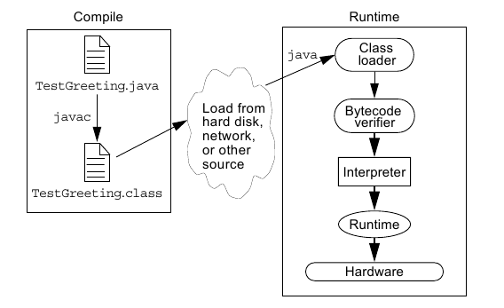

JVM Tasks
The following section provides a more comprehensive discussion of the
three main tasks performed by the JVM:
● Loads code – Performed by the class loader
● Verifies code – Performed by the bytecode verifier
● Executes code – Performed by the runtime interpreter

The Class Loader

The class loader loads all classes needed for the execution of a program.

The Bytecode Verifier

Java software code passes several tests before running on your machine. The JVM puts the code through a bytecode verifier that tests the format of code fragments and checks code fragments for illegal code, which is code that forges pointers, violates access rights on objects, or attempts to
change object type.

A Simple Java Application

Like any other programming language, you use the Java programming language to create applications. A simple Java application that prints a greeting to the world.

SampleHello.Java

public class SampleHello
{
public static void main(String[] args)
{
System.out.println(“Hello world...!”);
}
}

Compiling and Running the SampleHello Program

After you have created the SampleHello.java source file, compile it with the following line:
javac SampleHello.java

If the compiler does not return any messages, the new file SampleHello.class is stored in the same directory as the source file, unless specified otherwise. To run your SampleHello application, use the Java technology interpreter. The executables for the Java technology tools (javac, java,
javadoc, and so on) are located in the bin directory.

java SampleHello

Object-Oriented Programming

Objectives
Upon completion of this module, you should be able to:
● Define modeling concepts: abstraction, encapsulation, and packages
● Discuss why you can reuse Java technology application code
● Define class, member, attribute, method, constructor, and package
● Use the access modifiers private and public as appropriate for the guidelines of encapsulation
● Invoke a method on a particular object
● Use the Java technology API online documentation

Software Engineering

Software engineering is a difficult and often unruly discipline. For the past half-century, computer scientists, software engineers, and system architects have sought to make creating software systems easier by providing reusable code.

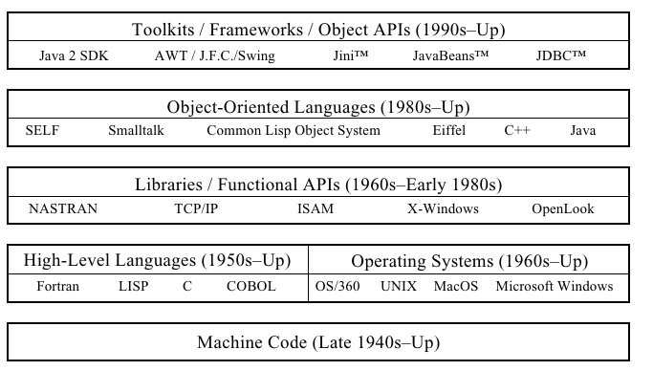

Abstraction
Software design has moved from low-level constructs, such as writing in machine code, toward much higher levels. There are two interrelated forces that guided this process: simplification and abstraction. Simplification was at work when early language designers built high-level language constructs, such as the IF statements and FOR loops, out of raw machine codes. Abstraction is the force that hides private implementation details behind public interfaces.
The concept of abstraction led to the use of subroutines (functions) in high-level languages and to the pairing of functions and data into objects. At higher levels, abstraction led to the development of frameworks and APIs.

Classes as Blueprints for Objects

A class is a software blueprint that you can use to instantiate (that is, create) many individual objects. A class defines the set of data elements (attributes) that define the objects, as well as the set of behaviors or functions (called methods) that manipulate the object or perform interactions between related objects. Together, attributes and methods are called members.

Declaring Java Technology Classes

The Java technology class declaration takes the following form:

<modifier>* class <class_name>
{
<attribute_declaration>*
<constructor_declaration>*
<method_declaration>*
}

Declaring Attributes

The declaration of an object attribute takes the following form:

<modifier>* <type> <name> [ = <initial_value>];

Declaring Methods

To define methods, the Java programming language uses an approach that is similar to other languages, particularly C and C++. The declaration takes the following basic form:

<modifier>* <return_type> <name> ( <argument>* )
{
<statement>*
}

Accessing Object Members

Encapsulation

Encapsulation is the methodology of hiding certain elements of the implementation of a class but providing a public interface for the client software. This is an extension of information hiding because the information in the data attributes is a significant element of a class’s implementation.

Source File Layout

A Java technology source file takes the following form:

[<package_declaration>]
<import_declaration>*
<class_declaration>+

The order of these items is important. That is, any import statements must precede all class declarations and, if you use a package declaration, it must precede both the classes and imports.

Software Packages

Most software systems are large. It is common to group classes into packages to ease the management of the system. UML includes the concept of packages in its modeling language. Packages can contain classes as well as other packages that form a hierarchy of packages.

The package Statement
The Java technology programming language provides the package statement as a way to group related classes. The package statement takes the following form:
package <top_pkg_name>[.<sub_pkg_name>]*;

The import Statement

The import statement takes the following form:

import <pkg_name>[.<sub_pkg_name>].<class_name>;
OR
import <pkg_name>[.<sub_pkg_name>].*;

Compiling Using the -d Option

Normally, the Java compiler places the class files in the same directory as the source files. You can reroute the class files to another directory using the -d option of the javac command. The simplest way to compile files within packages is to be working in the directory one level above the
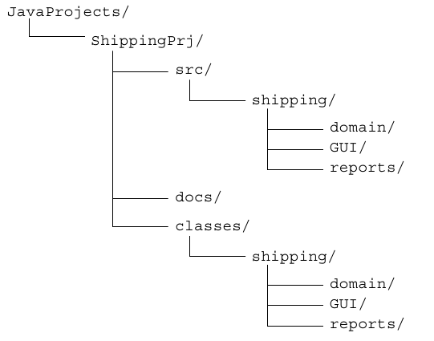
beginning of the package.

for ex:
cd JavaProjects/ShippingPrj/src
javac -d ../classes shipping/domain/*.java

Deployment

You can deploy an application on a client machine without manipulating the user’s CLASSPATH environment variable. Usually, this is best done by creating an executable Java archive (JAR) file. To create an executable JAR file, you must create a temporary file that indicates the class name that
contains your main method, like this:

Main-Class: mypackage.MyClass

Next, build the JAR file as normal except that you add an additional option so that the contents of this temporary file are copied into the META-INF/MANIFEST.MF file. Do this using the “m” option, like this:
jar cmf tempfile MyProgram.jar

Finally, the program can be run simply by executing a command like this:
java -jar /path/to/file/MyProgram.jar

Using the Java Technology API Documentation

A set of HTML files document the supplied API. The layout of this documentation is hierarchical, so that the home page lists all the packages as hyperlinks. When you select a particular package hotlink, the classes that are members of that package are listed. Selecting a class hotlink from a package page presents a page of information about that class.

The main sections of a class document include the following:
● The class hierarchy
● A description of the class and its general purpose
● A list of attributes
● A list of constructors
● A list of methods
● A detailed list of attributes with descriptions
● A detailed list of constructors with descriptions and formal parameter lists
● A detailed list of methods with descriptions and formal parameter lists

Identifiers, Keywords, and Types

Objectives
Upon completion of this module, you should be able to:
● Use comments in a source program
● Distinguish between valid and invalid identifiers
● Recognize Java technology keywords
● List the eight primitive types
● Define literal values for numeric and textual types
● Define the terms primitive variable and reference variable
● Declare variables of class type
● Construct an object using new
● Describe default initialization
● Describe the significance of a reference variable
● State the consequence of assigning variables of class type

Semicolons, Blocks, and White Space
In the Java programming language, a statement is one or more lines of code terminated with a semicolon (;).

A block, sometimes called a compound statement, is a group of statements bound by opening and closing braces ({ }).

Identifiers

In the Java programming language, an identifier is a name given to a variable, class, or method. Identifiers start with a letter, underscore (_), or dollar sign ($). Subsequent characters can be digits. Identifiers are case-sensitive and have no maximum length.

Java Programming Language Keywords
Keywords have special meaning to the Java technology compiler. They identify a data type name or program construct name.

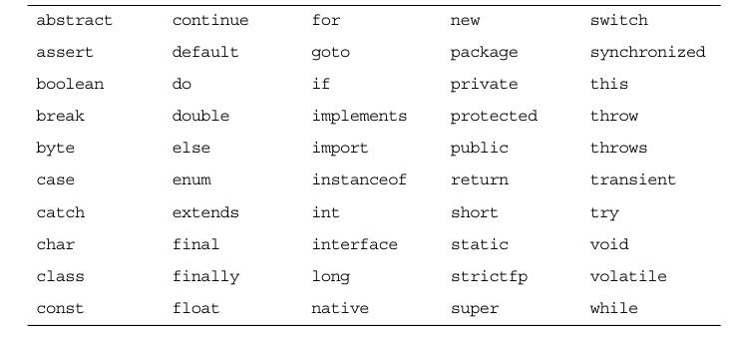

Basic Java Programming Language Types
The Java programming language has many built in data types. These fall into two broad categories: class types and primitive types. Primitive types are simple values, are not objects. Class types are used for more complex types, including all of the types that you declare yourself. Class types are
used to create objects.

Primitive Types
The Java programming language defines eight primitive data types, which can be considered in four categories:
● Logical – boolean
● Textual – char
● Integral – byte, short, int, and long
● Floating point – double and float

Java Reference Types
As you have seen, there are eight primitive Java types: boolean, char, byte, short, int, long, float, and double. All other types refer to objects rather than primitives. Variables that refer to objects are reference variables.

Constructing and Initializing Objects

Memory Allocation and Layout
In a method body, the following declaration allocates storage only for the reference

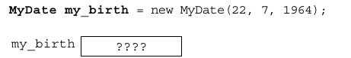

The keyword new in the following example implies allocation and initialization of storage
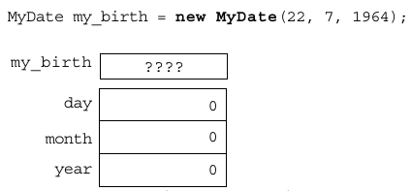

Explicit Attribute Initialization
If you place simple assignment expressions in your member declarations, you can initialize members explicitly during construction of your object.
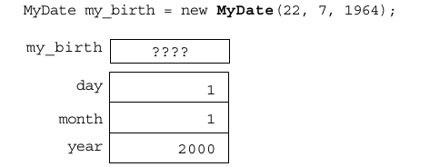

Executing the Constructor
The final stage of initializing a new object is to call the constructor. The constructor enables you to override the default initialization. You can perform computations. You can also pass arguments into the construction process so that the code that requests the construction of the new object
can control the object it creates.
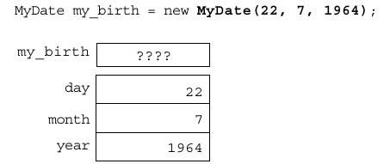

Assigning a Variable

Assigning References

The this Reference
Two uses of the this keyword are:
● To resolve ambiguity between instance variables and parameters
● To pass the current object as a parameter to another method

Java Programming Language Coding Conventions

The following are the coding conventions of the Java programming language:
● Packages –

● Classes –

● Interfaces –

● Methods –

● Variables –

● Constants –

● Spacing –

● Comments –

Class Design

Objectives
Upon completion of this module, you should be able to:
● Define inheritance, polymorphism, overloading, overriding, and virtual method invocation
● Use the access modifiers protected and the default (package- friendly)
● Describe the concepts of constructor and method overloading
● Describe the complete object construction and initialization operation

Subclassing
In programming, you often create a model of something (for example, an employee), and then need a more specialized version of that original model. For example, you might want a model for a manager. A manager is an employee, but an employee with additional features.

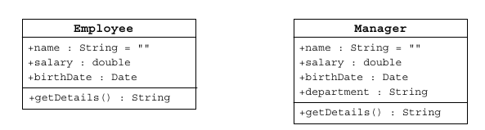

In object-oriented languages, special mechanisms are provided that enable you to define a class in terms of a previously defined class.

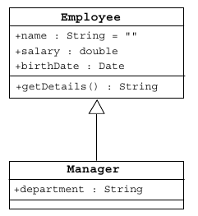

Class Diagrams for Employee and Manager Using Inheritance

Single Inheritance

The Java programming language permits a class to extend one other class only. This restriction is called single inheritance. The relative merits of single and multiple inheritance are the subject of extensive discussions among object-oriented programmers.

Access Control

Variables and methods can be at one of four access levels: public, protected, default, or private. Classes can be at the public or default

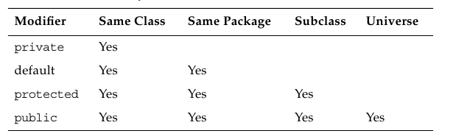

Overriding Methods
If a method is defined in a subclass so that the name, return type, and argument list match exactly those of a method in the parent class, then the new method is said to override the old one.

Overridden Methods Cannot Be Less Accessible

Invoking Overridden Methods

Polymorphism

An object has only one form (the one that is given to it when constructed). However, a variable is polymorphic because it can refer to objects of different forms. The Java programming language, like most object-oriented languages, actually permits you to refer to an object with a variable that is one of the parent class types. So you can say:
Employee e = new Manager(); //legal

The instanceof Operator

Given that you can pass objects around using references to their parent classes, sometimes you might want to know what actual objects you have. This is the purpose of the instanceof operator.

Casting Objects

In circumstances where you have received a reference to a parent class, and you have determined that the object is, in fact, a particular subclass by using the instanceof operator, you can access the full functionality of the object by casting the reference.

Overloading Methods

In some circumstances, you might want to write several methods in the same class that do the same basic job with different arguments. Consider a simple method that is intended to output a textual representation of its argument. This method could be called println().

By reusing the method name, you end up with the following methods:
public void println(int i)
public void println(float f)
public void println(String s)

Methods Using Variable Arguments

Overloading Constructors

When an object is instantiated, the program might be able to supply multiple constructors based on the data for the object being created.

Constructors Are Not Inherited

Invoking Parent Class Constructors

Constructing and Initializing Objects: A Slight Reprise

First, the memory for the complete object is allocated and the default values for the instance variables are assigned. Second, the top-level constructor is called and follows these steps recursively down the inheritance tree:
1. Bind constructor parameters.
2. If explicit this(), call recursively, and then skip to Step 5.
3. Call recursively the implicit or explicit super(...), except for Object because Object has no parent class.
4. Execute the explicit instance variable initializers.
- Execute the body of the current constructor.

The Object Class
The Object class is the root of all classes in the Java technology programming language. If a class is declared with no extends clause, then the compiler adds implicitly the code extends Object to the declaration;

The equals Method

The toString Method

Wrapper Classes

The Java programming language provides wrapper classes to manipulate primitive data elements as objects. Such data elements are wrapped in an object created around them. Each Java primitive data type has a corresponding wrapper class in the java.lang package. Each wrapper class object encapsulates a single primitive value.

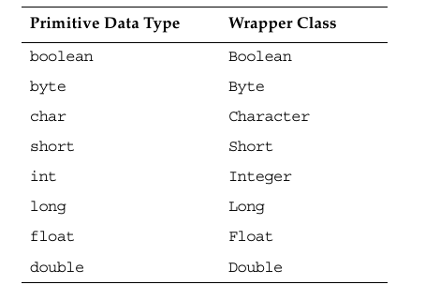

Autoboxing of Primitive Types
If you have to change the primitive data types to their object equivalents (called boxing), then you need to use the wrapper classes. Also to get the primitive data type from the object reference (called unboxing), you need to use the wrapper class methods.

Advanced Class Features

Objectives
Upon completion of this module, you should be able to:
● Create static variables, methods, and initializers
● Create final classes, methods, and variables
● Create and use enumerated types
● Use the static import statement
● Create abstract classes and methods
● Create and use an interface

The static Keyword

The static keyword declares members (attributes, methods, and nested classes) that are associated with the class rather than the instances of the class.

Class Attributes

You achieve a shared effect by marking the variable with the keyword static. Such a variable is sometimes called a class variable to distinguish it from a member or instance variable, which is not shared.

Class Methods

Sometimes you need to access program code when you do not have an instance of a particular object available. A method that is marked using the keyword static can be used in this way and is sometimes called a class method.

Static Initializers

A class can contain code in static blocks that are not part of normal methods. Static block code executes once when the class is loaded. If a class contains more than one static block, they are executed in the order of their appearance in the class.

The final Keyword

Final Classes

The Java programming language permits you to apply the keyword final to classes. If you do this, the class cannot be subclassed.

Final Methods

You can also mark individual methods as final. Methods marked final cannot be overridden. For security reasons, you should make a method final if the method has an implementation that should not be changed and is critical to the consistent state of the object.

Final Variables

If a variable is marked as final, the effect is to make it a constant. Any attempt to change the value of a final variable causes a compiler error.

Blank Final Variables

A blank final variable is a final variable that is not initialized in its declaration. The initialization is delayed. A blank final instance variable must be assigned in a constructor, but it can be set once only. A blank final variable that is a local variable can be set at any time in the body of the method, but it can be set once only.

Enumerated Types

A common idiom in programming is to have finite set of symbolic names that represent the values of an attribute.
For example, to represent the suits of playing cards you might create a set of symbols: SPADES,
HEARTS, CLUBS, and DIAMONDS. This is often called an enumerated type.

Old-Style Enumerated Type Idiom

The New Enumerated Type

Advanced Enumerated Types

Static Imports

J2SE version 5.0 provides the static import feature that enables unqualified access to static members without having to qualify them with the class name.

Abstract Classes

The Java programming language enables a class designer to specify that a superclass declares a method that does not supply an implementation. This is called an abstract method. The implementation of this method is supplied by the subclasses. Any class with one or more abstract methods is called an abstract class .

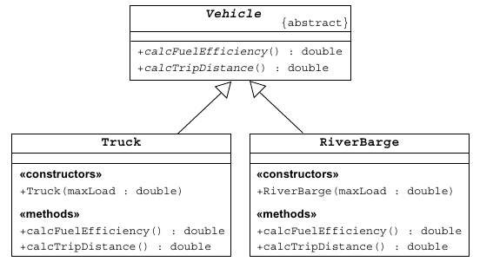

Interfaces

The public interface of a class is a contract between the client code and the class that provides the service. Concrete classes implement each method. However, an abstract class can defer the implementation by declaring the method to be abstract, and a Java interface declares only the contract and no implementation.

A concrete class implements an interface by defining all methods declared by the interface. Many classes can implement the same interface. These classes do not need to share the same class hierarchy. Also, a class can implement more than one interface

Uses of Interfaces

You use interfaces to:
● Declare methods that one or more classes are expected to implement
● Reveal an object’s programming interface without revealing the actual body of the class (this can be useful when shipping a package of classes to other developers)
● Capture similarities between unrelated classes without forcing a class relationship
● Simulate multiple inheritance by declaring a class that implemensts several interfaces

Exceptions and Assertions

Objectives
Upon completion of this module, you should be able to:
● Define exceptions
● Use try, catch, and finally statements
● Describe exception categories
● Identify common exceptions
● Develop programs to handle your own exceptions
● Use assertions
● Distinguish appropriate and inappropriate uses of assertions
● Enable assertions at runtime

Exceptions

Exceptions are a mechanism used by many programming languages to describe what to do when something unexpected happens. Typically, something unexpected is an error of some sort, for example when a method is invoked with unacceptable arguments, or a network connection fails, or the user asks to open a non-existent file.

The Java programming language provides two broad categories of exceptions, known as checked and unchecked exceptions.

Checked exceptions are those that the programmer is expected to handle in the program, and that arise from external conditions that can readily occur in a working program. Examples would be a requested file not being found or a network failure.

Unchecked exceptions might arise from conditions that represent bugs, or situations that are considered generally too difficult for a program to handle reasonably. They are called unchecked because you are not required to check for them or do anything about them if they occur. Exceptions that arise from a category of situations that probably represent bugs are called runtime exceptions. An example of a runtime exception is attempting to access beyond the end of an array.

Exception Example

The try-catch Statement

The Java programming language provides a mechanism for figuring out which exception was thrown and how to recover from it.

Using Multiple catch Clauses

There can be multiple catch blocks after a try block, each handling a different exception type.

Call Stack Mechanism

If a statement throws an exception, and that exception is not handled in the immediately enclosing method, then that exception is thrown to the calling method. If the exception is not handled in the calling method, it is thrown to the caller of that method. This process continues. If the exception is still not handled by the time it gets back to the main() method and main() does not handle it, the exception terminates the program abnormally.

The finally Clause

The finally clause defines a block of code that always executes, regardless of whether an exception was caught.

Exception Categories

The class java.lang.Throwable acts as the parent class for all objects that can be thrown and caught using the exception-handling mechanisms. Methods defined in the Throwable class retrieve the error message associated with the exception and print the stack trace showing where the exception occurred. There are three key subclasses of Throwable: Error, RuntimeException, and Exception .

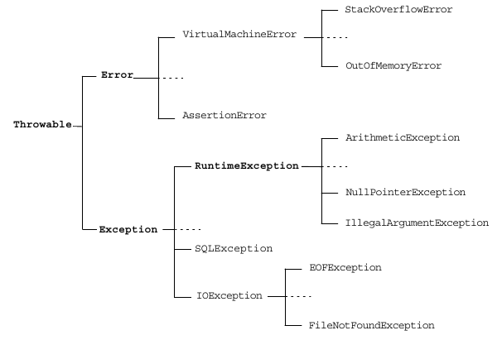

Common Exceptions

The Java programming language provides several predefined exceptions. Some of the more common exceptions are:

● NullPointerException

● FileNotFoundException

● NumberFormatException

● ArithmeticException

● SecurityException

The Handle or Declare Rule

A method can declare that an exception might be thrown in the body of the method with a throws clause as follows:

void trouble() throws IOException {...}

Following the keyword throws is a list of all the exceptions that the method can throw back to its caller. Although only one exception is shown here, you can use a comma-separated list if this method throws multiple possible exceptions, like this:

void trouble() throws IOException, OtherException {...}

Method Overriding and Exceptions

When overriding a method that throws exceptions, the overriding method can declare only exceptions that are either the same class or a subclass of the exceptions.

Creating Your Own Exceptions

User-defined exceptions are created by extending the Exception class. Exception classes contain anything that a regular class contains.

To throw an exception that you have created, use the following syntax:

throw new ServerTimedOutException("Could not connect", 80);

Always instantiate the exception on the same line on which you throw it, because the exception can carry line number information that will be added when the exception is created.

Assertions

Two syntactic forms are permitted for assertion statements, these are:

assert <boolean_expression> ;
assert <boolean_expression> : <detail_expression> ;

In either case, if the Boolean expression evaluates to false, then an AssertionError is thrown. This error should not be caught, and the program should be terminated abnormally.

If the second form is used, then the second expression, which can be of any type, is converted to a String and used to supplement the message that prints when the assertion is reported.

Recommended Uses of Assertions

Assertions should be used generally to verify the internal logic of a single method or a small group of tightly coupled methods. Generally, assertions should not be used to verify that code is being used correctly, but rather that its own internal expectations are being met.

Internal Invariants

Control Flow Invariants

Postconditions and Class Invariants

Controlling Runtime Evaluation of Assertions

One of the major advantages of assertions over using exceptions is that assertion checking can be disabled at runtime. If this is done, then there is no overhead involved in checking the assertions, and the code runs as fast as if the assertion test had never been present. This is better than using conditional compilation for two reasons. First, it does not require a different compile phase for production. Second, if required, the assertions can be re-enabled in the field to determine if the assertions have become invalid due to some unforeseen environmental effect.

By default, assertions are disabled. To turn assertions on, use either of these forms:

java -enableassertions MyProgram
java -ea MyProgram

Collections and Generics Framework

Objectives

Upon completion of this module, you should be able to:
● Describe the implementations of the core interfaces in the Collections framework
● Examine the Map interface
● Examine the legacy collection classes
● Create custom ordering by implementing the Comparable and Comparator interfaces
● Use generic collections
● Use type parameters in generic classes
● Refactor existing non-generic code
● Write a program to iterate over a collection
● Examine the enhanced for loop

The Collections API

A collection is a single object managing a group of objects. The objects in the collection are called elements. Typically, collections deal with many types of objects, all of which are of a particular kind (that is, they all descend from a common parent type).

The Collections API contains interfaces that group objects as one of the following:

● Collection – A group of objects known as elements;
implementations determine whether there is specific ordering and whether duplicates are permitted
● Set – An unordered collection; no duplicates are permitted
● List – An ordered collection; duplicates are permitted

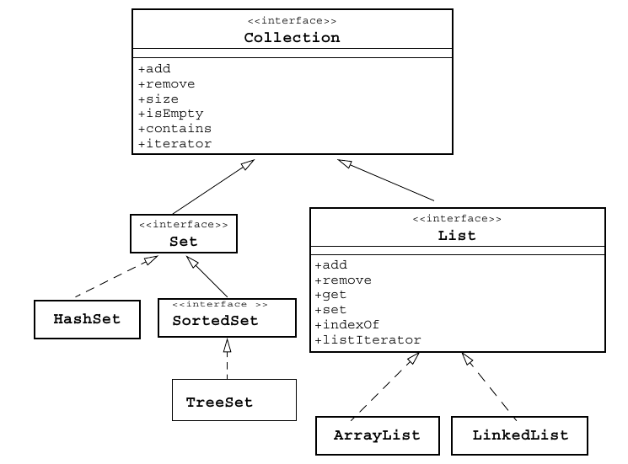

Collection Implementations
There are several general purpose implementations of the core interfaces (Set, List, Map and Deque) in the Collections framework.

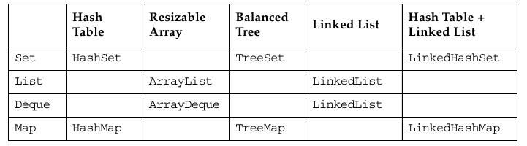

List

Set

The Map Interface
Maps are sometimes called associative arrays. A Map object describes mappings from keys to values. By definition, a Map object does not allow duplicate keys and a key can map to one value at most.

The Map interface provides three methods that allow map contents to be viewed as collections are:
● entrySet – Returns a Set that contains all the key value pairs.
● keySet – Returns a Set of all the keys in the map.
● values – Returns a Collection containing all the values contained in the map.
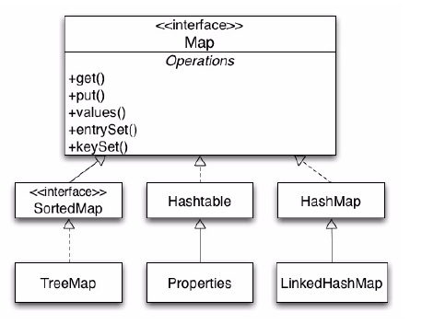

Legacy Collection Classes

● The Vector class implements the List interface.
● The Stack class is an extension of Vector that adds typical stack operations: push, pop, and peek.
● The Hashtable is an implementation of Map.
● The Properties class is an extension of Hashtable that only uses Strings for keys and values.
● Each of these collections has an elements method that returns an Enumeration object. The Enumeration is an interface similar to, but incompatible with, the Iterator interface. For example, hasNext is replaced by hasMoreElements in the Enumeration interface.

Ordering Collections

The Comparable and Comparator interfaces are useful for ordering collections. The Comparable interface imparts natural ordering to classes that implement it. The Comparator interface is used to specify order relation. It can also be used to override natural ordering. These interfaces are useful for sorting the elements in a collection.

The Comparable Interface

The Comparable interface is a member of the java.lang package. When you declare a class, the JVM implementation has no means of determining the order you intend for objects of that class. You can, by implementing the Comparable interface, provide order to the objects of any class. You can sort collections that contain objects of classes that implement the Comparable interface.

The Comparator Interface

The Comparator interface provides greater flexibility with ordering. For example, if you consider the Student class, the sorting of students was restricted to sorting on GPAs. It was not possible to sort the student based on first name or some other criteria. This section demonstrates how sorting flexibility can be enhanced using the Comparator interface.

Generics

It provides information for the compiler about the type of collection used. Hence, type checking is
resolved automatically at run time. This eliminates the explicit casting of the data types to be used in the collection. With the addition of autoboxing of primitive types, you can use generics to write simpler and more understandable code.

Generics: Examining Type Parameters

This section examines the use of type parameters in (the class, constructor and method declarations of) generic classes. Table compares the non- generic version (pre-Java SE 5.0 platform) and the generic version (since the Java SE 5.0 platform) of the ArrayList class.
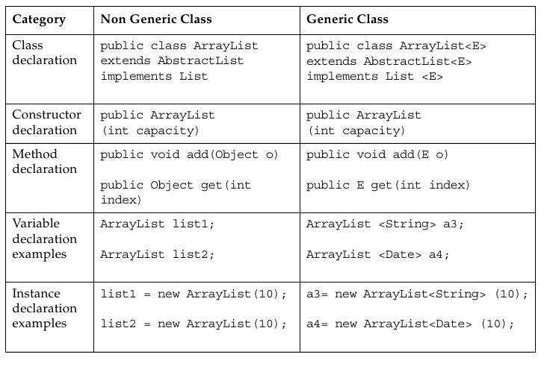

Generics: Refactoring Existing Non-Generic Code

With generic collections, you can specify generic types without type arguments, which are called raw types. This feature is allowed to provide compatibility with the non-generic code. At compile time, all the generic information from the generic code is removed, leaving behind a raw type. This enables interoperability with the legacy code as the class files generated by the generic code and the legacy code would be the same. At runtime, ArrayList<String> and ArrayList<Integer> get translated into ArrayList, which is a raw type.

Iterators

You can scan (iterate over) a collection using an iterator. The basic Iterator interface enables you to scan forward through any collection. In the case of an iteration over a set, the order is non-deterministic. The order of an iteration over a list moves forward through the list elements. A List object also supports a ListIterator, which permits you to scan the list backwards and insert or modify list elements.

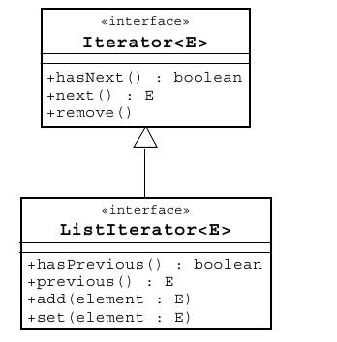

The Enhanced for Loop

The enhanced for loop makes traversing through a collection simple, understandable, and safe. The enhanced for loop eliminates the usage of separate iterator methods and minimizes the number of occurrences of the iterator variable.

I/O Fundamentals

Objectives
Upon completion of this module, you should be able to:
● Write a program that uses command-line arguments and system properties
● Examine the Properties class
● Construct node and processing streams, and use them appropriately
● Serialize and deserialize objects
● Distinguish readers and writers from streams, and select appropriately between them

System Properties

System properties are another mechanism used to parameterize a program at runtime. A property is a mapping between a property name and its value; both are strings. The Properties class represents this kind of mapping. The System.getProperties method returns the system properties object. The System.getProperty(String) method returns the string value of the property named in the String parameter. There is another method, System.getProperty(String, String), that enables you to supply a default string value (the second parameter), which is returned if the named property does not exist.

The Properties Class

An object of the Properties class contains a mapping between property names (String) and values (String). It has two main methods for retrieving a property value: getProperty(String) and getProperty(String, String); the latter method provides the capability of specifying a default value that is returned if the named property does not exist.

I/O Stream Fundamentals

A stream is a flow of data from a source to a sink. Typically, your program is one end of that stream, and some other node (for example, a file) is the other end. Sources and sinks are also called input streams and output streams, respectively. You can read from an input stream, but you cannot write to it. Conversely, you can write to an output stream, but you cannot read from it.

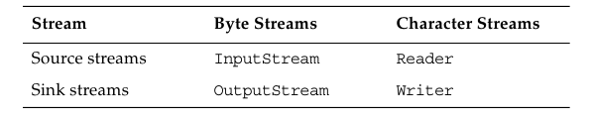

Data Within Streams

Java technology supports two types of data in streams: raw bytes or Unicode characters. Typically, the term stream refers to byte streams and the terms reader and writer refer to character streams.

Byte Streams

The InputStream Methods

The following methods provide access to the data from the input stream:
int read()
int read(byte[] buffer)
int read(byte[] buffer, int offset, int length)
void close()
int available()
long skip(long n)
boolean markSupported()
void mark(int readlimit)
void reset()

The OutputStream Methods

The following methods write to the output stream:
void write(int)
void write(byte[] buffer)
void write(byte[] buffer, int offset, int length)
void close()
void flush()

Character Streams

The Reader Methods

The following methods provide access to the character data from the
reader:
int read()
int read(char[] cbuf)
int read(char[] cbuf, int offset, int length)
void close()
boolean ready()
long skip(long n)
boolean markSupported()
void mark(int readAheadLimit)
void reset()

The Writer Methods

The following methods write to the writer:
void write(int c)
void write(char[] cbuf)
void write(char[] cbuf, int offset, int length)
void write(String string, int offset, int length)

Similar to output streams, writers include the close and flush methods.
void close()
void flush()

Node Streams

In the Java JDK, there are three fundamental types of nodes :
● Files
● Memory (such as arrays or String objects)
● Pipes (a channel from one process or thread [a light-weight process] to another; the output pipe stream of one thread is attached to the input pipe stream of another thread)
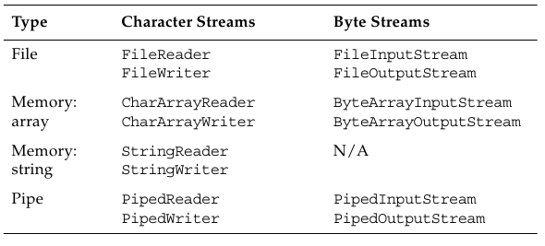

I/O Stream Chaining

A program rarely uses a single stream object. Instead, it chains a series of streams together to process the data. Figure demonstrates an example input stream; in this case, a file stream is buffered for efficiency and then converted into data (Java primitives) items.
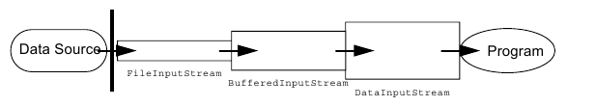

Figure demonstrates an example output stream; in this case, data is written, then buffered, and finally written to a file.
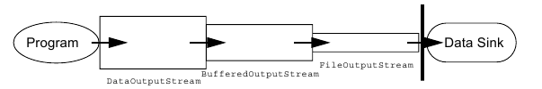

Processing Streams

A processing stream performs some sort of conversion on another stream. Processing streams are also known as filter streams. A filter input stream is created with a connection to an existing input stream. This is done so that when you try to read from the filter input stream object, it supplies you with characters that originally came from the other input stream object. This enables you to convert the raw data into a more usable form for your application.

Basic Byte Stream Classes

The hierarchy of input byte stream classes in the java.io package.

The InputStream Class Hierarchy
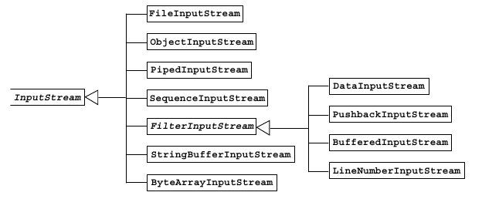

The OutputStream Class Hierarchy

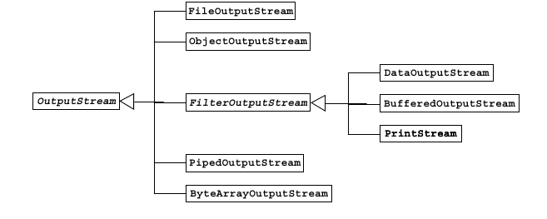

Serialization

Saving an object to some type of permanent storage is called persistence. An object is said to be persistent-capable when you can store that object on a disk or tape or send it to another machine to be stored in memory or on disk. The non-persisted object exists only as long as the Java Virtual Machine is running.

Serialization is a mechanism for saving the objects as a sequence of bytes and later, when needed, rebuilding the byte sequence back into a copy of the object.

Basic Character Stream Classes

The hierarchy of Reader character stream classes in the java.io package.

The Reader Class Hierarchy

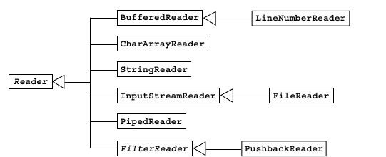

The Writer Class Hierarchy
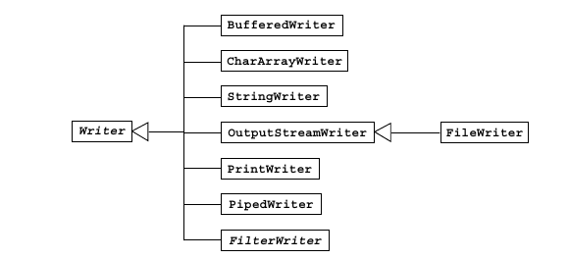

Console I/ O and File I/O

Objectives
Upon completion of this module, you should be able to:
● Read data from the console
● Write data to the console
● Describe files and file I/O

Console I/O

Most applications must interact with the user. Such interaction is sometimes accomplished with text input and output to the console (using the keyboard as the standard input and using the terminal window as the standard output).
Java JDK supports console I/O with three public static variables on the java.lang.System class:
● The variable System.out is a PrintStream object that refers (initially) to the terminal window that launched the Java technology application.
● The variable System.in is an InputStream object that refers (initially) to the user’s keyboard.
● The variable System.err is a PrintStream object that refers (initially) to the terminal window that launched the Java technology application.

Writing to Standard Output

You can write to standard output through the System.out.println(String) method. This PrintStream method prints the string argument to the console and adds a newline character at the end.

Reading From Standard Input

Simple Formatted Output

The Java programming language version 5 provided C language-style printf functionality. It provides standard formatted output from the program. This enables programmers to migrate from legacy code.
You can use the printf as normal C and C++ syntax.

System.out.printf("%s %5d %f%n",name,id,salary);

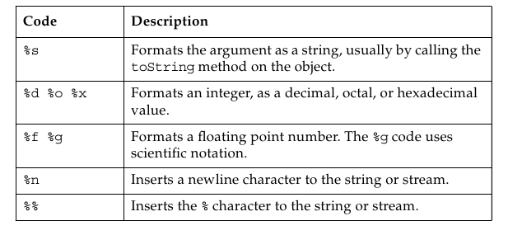

Simple Formatted Input

The Scanner class provides formatted input functionality. It is part of the java.util package. It provides methods for getting primitive values and strings and blocks as it waits for input from the user.

Files and File I/O

● Creating File objects
● Manipulating File objects
● Reading and writing to file streams

Creating a New File Object

In Java technology, a directory is just another file. You can create a File object that represents a directory and then use it to identify other files, as shown in the third bullet .

●File myFile;
myFile = new File("myfile.txt");
● myFile = new File("MyDocs", "myfile.txt");
● File myDir = new File("MyDocs");
myFile = new File(myDir, "myfile.txt");

The File Tests and Utilities

After you create a File object, you can use any methods in the following sections to gather information about the file.

File Names
The following methods return file names:
● String getName()
● String getPath()
● String getAbsolutePath()
● String getParent()
● boolean renameTo(File newName)

Directory Utilities
The following methods provide directory utilities:
● boolean mkdir()
● String[] list()

General File Information and Utilities
The following methods return general file information:
● long lastModified()
● long length()
● boolean delete()

File Tests
The following methods return information about file attributes:
● boolean exists()
● boolean canWrite()
● boolean canRead()
● boolean isFile()
● boolean isDirectory()
● boolean isAbsolute()
● boolean isHidden()

File Stream I/O

The Java SE Development Kit supports file input in two forms:
● Use the FileReader class to read characters
● Use the BufferedReader class to use the readLine method

The Java SE Development Kit supports file output in two forms:
● Use the FileWriter class to write characters
● Use the PrintWriter class to use the print and println methods

Building Java GUIs Using the Swing API

Objectives
Upon completion of this module, you should be able to:
● Describe the JFC Swing technology
● Define Swing
● Identify the Swing packages
● Describe the GUI building blocks: containers, components, and layout managers
● Examine top-level, general-purpose, and special-purpose properties of container
● Examine components
● Examine layout managers
● Describe the Swing single-threaded model
● Build a GUI using Swing components

What Are the Java Foundation Classes (JFC)?

JFC, or Java Foundation Classes, is a set of Graphical User Interface (GUI) support packages that are available as part of the Java SE platform and which became core application program interfaces (APIs) in JDK 1.2.

What Is Swing?

Swing is an enhanced component set that provides replacement components for those in the original AWT and a number of more advanced components. These components enable you to create user interfaces with the type of functionality that has become expected in modern applications. Such components include trees, tables, advanced text editors, and tear-off toolbars.

Pluggable Look-and-Feel
Pluggable look-and-feel enables developers to build applications that execute on any platform as if they were developed for that specific platform. A program executed in the Microsoft Windows environment appears as if it was developed for this environment; and the same program executed on the UNIX platform appears as if it was developed for the UNIX environment.

Swing Architecture
Swing components are designed based on the Model-View-Controller (MVC) architecture. The Swing architecture is not strictly based on the MVC architecture but has its roots in the MVC.

Model-View-Controller Architecture
According to the MVC architecture, a component can be modeled as three separate parts.

● Model – The model stores the data used to define the component.
● View – The view represents the visual display of the component. This display is governed by the data in the model.
● Controller – The controller deals with the behavior of the components when a user interacts with it. This behavior can include any updates to the model or view.
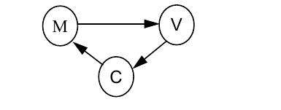

Separable Model Architecture

The Swing components follow a separable model architecture. In this architecture the view and the controller are merged as a single composite object, because of their tight dependency on each other. The model object is treated as a separate object just like in MVC architecture.
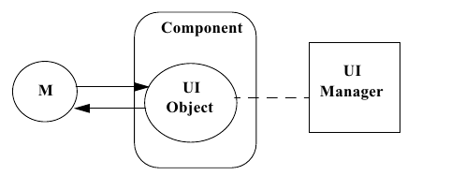

Swing Packages

The Swing API has a rich and convenient set of packages that makes it powerful and flexible.
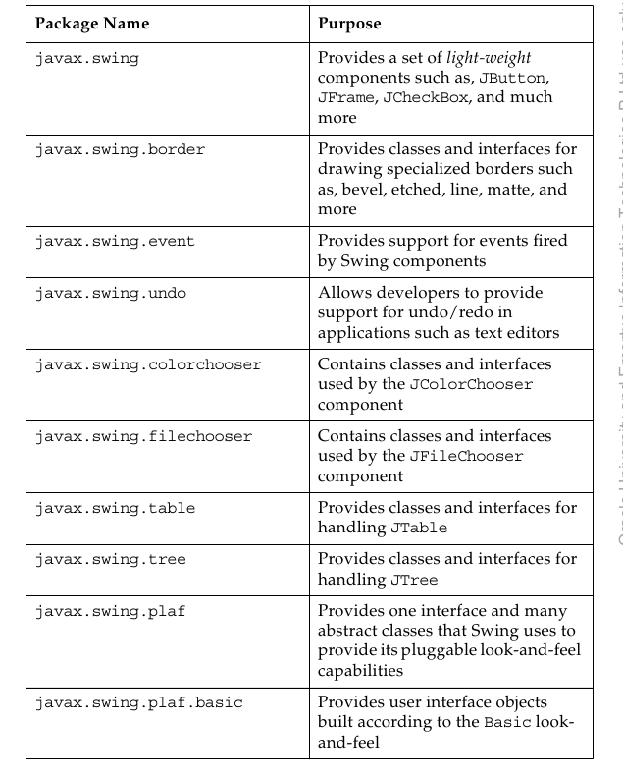

Swing Containers

Swing containers can be classified into three main categories
● Top-level containers
● General-purpose containers
● Special-purpose containers

Top-level Containers

Top-level containers are at the top of the Swing containment hierarchy. There are three top-level Swing containers: JFrame, JWindow, and JDialog. There is also a special class, JApplet, which, while not strictly a top-level container, is worth mentioning here because it should be used as the top-level of any applet that uses Swing components.

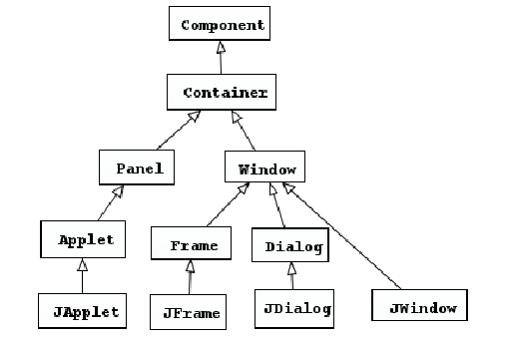

Swing Components

Swing GUIs use two kinds of classes: GUI classes and non-GUI support classes. The GUI classes are visual and descendants of JComponent, and are called J classes. The non-GUI classes provide services and perform vital functions for GUI classes; however, they do not produce any visual output

Swing components can be broadly classified as follows:
● Buttons
● Text components
● Uneditable information display components
● Menus
● Formatted display components
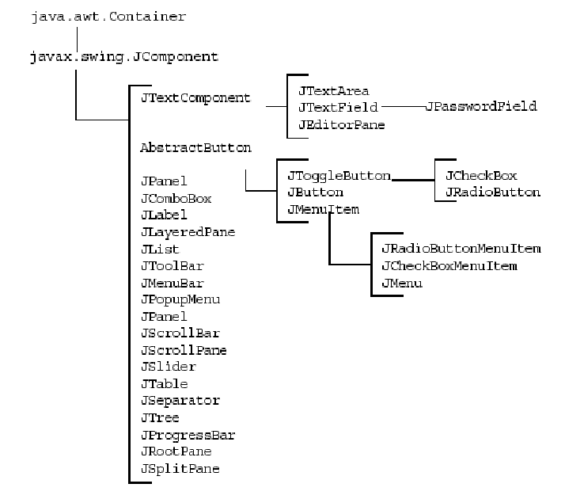
● Other basic controls

Properties of Swing Components

Layout Managers

A layout manager determines the size and position of the components within a container. The alternative to using layout managers is absolute positioning by pixel coordinates. Absolute positioning is achieved through setting a container's layout property to null. Absolute positioning is not platform-portable. Issues such as the sizes of fonts and screens ensure that a layout that is correct based on coordinates can potentially be unusable on other platforms.

Unlike absolute positioning, layout managers have mechanisms to cope with the following situations:
● The resizing of the GUI by the user
● Different fonts and font sizes used by different operating systems or
by user customization
● The text layout requirements of different international locales (left-
right, right-left, vertical)

GUI Construction
A Java technology GUI can be created using either of the following techniques:

● Programmatic construction
This technique uses code to create the GUI. This technique is useful for learning GUI construction. However, it is very laborious for use in production environments.

● Construction using a GUI builder tool
This technique uses a GUI builder tool to create the GUI. The GUI developer uses a visual approach to drag-and-drop containers and components to a work area. The tool permits the positioning and resizing of containers and components using a pointer device such as a computer mouse. With each step, the tool automatically generates the Java technology classes required to reproduce the GUI.

Handling GUI-Generated Events

Objectives
Upon completion of this module, you should be able to:
● Define events and event handling
● Examine the Java SE event model
● Describe GUI behavior
● Determine the user action that originated an event
● Develop event listeners
● Describe concurrency in Swing-based GUIs

What Is an Event?

When the user performs an action at the user interface level (clicks a mouse or presses a key), this causes an event to be issued. Events are objects that describe what has happened. A number of different types of event classes exist to describe different categories of user action.

Event Handlers
An event handler is a method that receives an event object, deciphers it, and processes the user’s interaction.

Java SE Event Model

Delegation Model

The delegation event model came into existence with JDK version 1.1. With this model, events are sent to the component from which the event originated, but it is up to each component to propagate the event to one or more registered classes, called listeners. Listeners contain event handlers that receive and process the event. In this way, the event handler can be in an object separate from the component. Listeners are classes that implement the EventListener interface.
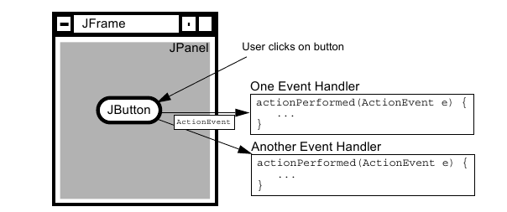

Events are objects that are reported only to registered listeners. Every event has a corresponding listener interface that mandates which methods must be defined in a class suited to receiving that type of event. The class that implements the interface defines those methods, and can be registered as a listener.

GUI Behavior

Event Categories
The general mechanism for receiving events from components has been described in the context of a single type of event. Many of the event classes reside in the java.awt.event package, but others exist elsewhere in the API.
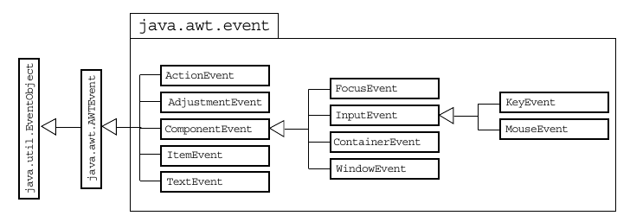

A Listener Example

Concurrency in Swing

Applications that contain a GUI require several threads for handling the GUI efficiently. Threads responsible for executing the application code are called current threads.
● Threads responsible for handling the events generated by various components are called event dispatch threads.
● Threads responsible for executing lengthy tasks are called worker threads. Some examples of these lengthy tasks include waiting for some shared resource, waiting for user input, blocking for network or disk I/O, performing either CPU or memory-intensive calculations. These tasks can be executed in the background without affecting the performance of the GUI. You can use instances of the SwingWorker class to represent these worker threads. The SwingWorker class extends the Object class and implements the RunnableFuture interface.

The SwingWorker class provides the following utility methods:

● For communication and coordination between worker thread tasks and tasks on other threads, the SwingWorker class provides properties such as progress and state to support inter-thread communication.
● To execute simple background tasks, the doInBackground method can be used for running the tasks background.
● To execute tasks that have intermediate results, the results are published in a GUI using the publish and process methods.
● To cancel the background threads, they can be canceled using the cancel method.

GUI-Based Applications

Objectives
Upon completion of this module, you should be able to:
● Describe how to construct a menu bar, menu, and menu items in a Java GUI
● Understand how to change the color and font of a component

How to Create a Menu

A JMenu is different from other components because you cannot add a JMenu component to ordinary containers and have them laid out by the layout manager. You can add menus only to a menu container. The following procedure to create a menu:

1. Create a JMenuBar object, and set it into a menu container, such as a JFrame.
2. Create one or more JMenu objects, and add them to the menu bar object.
3. Create one or more JMenuItem objects, and add them to the menu object.

Creating a JMenuBar

Creating a JMenu

Creating a JMenuItem

Controlling Visual Aspects

You can control the colors used for the foreground and the background of AWT components.

Colors

You use two methods to set the colors of a component:
setForeground()
setBackground()
Both of these methods take an argument that is an instance of the java.awt.Color class. You can use constant colors referred to as Color.red, Color.blue, and so on. The full range of predefined colors is listed in the documentation page for the Color class.

Threads

Objectives
Upon completion of this module, you should be able to:
● Define a thread
● Create separate threads for,controlling the code and data that are used by that thread
● Control the execution of a thread and write platform-independent code with threads
● Describe the difficulties that might arise when multiple threads share data
● Use wait and notify to communicate between threads
● Use synchronized to protect data from corruption

Threads

In this module, a thread, or execution context, is considered to be the encapsulation of a virtual CPU with its own program code and data. The class java.lang.Thread enables you to create and control threads.

A thread, or execution context, is composed of three main parts:
● A virtual CPU
● The code that the CPU executes
● The data on which the code works

Creating the Thread

A Thread constructor takes an argument that is an instance of Runnable. An instance of Runnable is made from a class that implements the Runnable interface (that is, it provides a public void run() method).

Starting the Thread
A newly created thread does not start running automatically. You must call its start method.

syntax:
threadrefname.start();

Thread Scheduling

The model of a pre-emptive scheduler is that many threads might be runnable, but only one thread is running. This thread continues to run until it ceases to be runnable or until another thread of higher priority becomes runnable. In the latter case, the lower priority thread is pre- empted by the thread of higher priority, which gets a chance to run instead.

A Thread object can exist in several different states throughout its lifetime
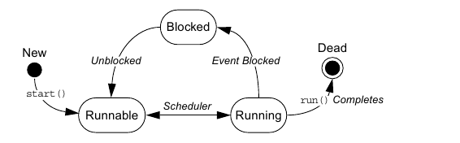

Basic Control of Threads

Testing Threads
A thread can be in an unknown state. Use the method isAlive to determine if a thread is still viable. The term Alive does not imply that the thread is running; it returns true for a thread that has been started but has not completed its task.

Accessing Thread Priority

Use the getPriority method to determine the current priority of the thread. Use the setPriority method to set the priority of the thread. The priority is an integer value. The Thread class includes the following constants:

Thread.MIN_PRIORITY
Thread.NORM_PRIORITY
Thread.MAX_PRIORITY

Putting Threads on Hold

Mechanisms exist that can temporarily block the execution of a thread. You can resume execution as if nothing happened. The thread appears to have executed an instruction very slowly.

The Thread.sleep() Method
The join() Method
The Thread.yield() Method

Using the synchronized Keyword

It provides the Java programming language with a mechanism that enables a programmer to control threads that are sharing data.

Problem:

The Object Lock Flag

In Java technology, every object has a flag associated with it. You can think of this flag as a lock flag. The keyword synchronized enables interaction with this flag, and provides exclusive access to code that affects shared data. The following is the modified code fragment:

Releasing the Lock Flag

The lock flag is given back to its object automatically. When the thread that holds the lock passes the end of the synchronized code block for which the lock was obtained, the lock is released. Java technology ensures that the lock is always returned automatically, even if an encountered exception, a break statement, or a return statement transfers code execution out of a synchronized block.

Using synchronized – Putting It Together

The synchronized mechanism works only if all access to delicate data occurs within the synchronized blocks.

synchronized blocks
synchronized method

Thread Interaction – wait and notify

The java.lang.Object class provides two methods, wait and notify, for thread communication. If a thread issues a wait call on a rendezvous object x, that thread pauses its execution until another thread issues a notify call on the same rendezvous object x. For a thread to call either wait or notify on an object, the thread must have the lock for that particular object. In other words, wait and notify are called only from within a synchronized block on the instance on which they are being called.

The Pool Story

When a thread executes synchronized code that contains a wait call on a particular object, that thread is placed in the wait pool for that object. Additionally, the thread that calls wait releases that object’s lock flag automatically. You can invoke different wait methods.

wait()
wait(long timeout)

When a notify call is executed on a particular object, an arbitrary thread is moved from that object’s wait pool to a lock pool, where threads stay until the object’s lock flag becomes available. The notifyAll method moves all threads waiting on that object out of the wait pool and into the lock pool. Only from the lock pool can a thread obtain that object’s lock flag, which enables the thread to continue running where it left off when it called wait.

Putting It Together

An example of thread interaction that demonstrates the use of wait and notify methods to solve a classic producer-consumer problem.

Networking

Objectives
At the end of this module, you should be able to:
● Develop code to set up the network connection
● Understand the TCP/IP Protocol
● Use ServerSocket and Socket classes for implementation of TCP/IP clients and servers

Networking

Sockets

Socket is the name given, in one particular programming model, to the endpoints of a communication link between processes.

Setting Up the Connection

To set up the connection, one machine must run a program that is waiting for a connection, and a second machine must try to reach the first. This is similar to a telephone system, in which one party must make the call, while the other party is waiting by the telephone when that call is made.

A description of the TCP/IP network connections is presented in this module.
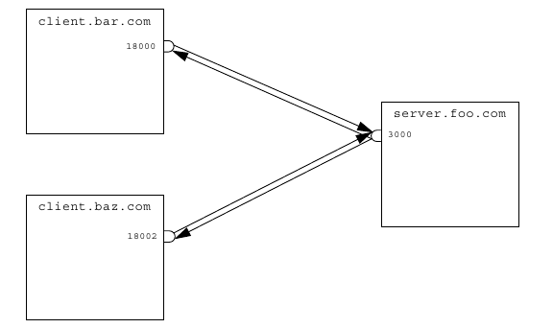

Networking With Java Technology

Addressing the Connection

A network connection requires a port number, which you can think of as a telephone extension number. After you connect to the proper computer, you must identify a particular purpose for the connection.

Port Numbers

Port numbers in TCP/IP systems are 16-bit numbers and the values range from 0–65535. In practice, port numbers below 1024 are reserved for predefined services, and you should not use them unless communicating with one of those services (such as telnet, Simple Mail Transport Protocol [SMTP] mail, ftp, and so on). Client port numbers are allocated by the host OS to something not in use, while server port numbers are specified by the programmer, and are used to identify a particular service.

Both client and server must agree in advance on which port to use. If the port numbers used by the two parts of the system do not agree, communication does not occur.

Java Networking Model
In the Java programming language, TCP/IP socket connections are implemented with classes in the java.net package.
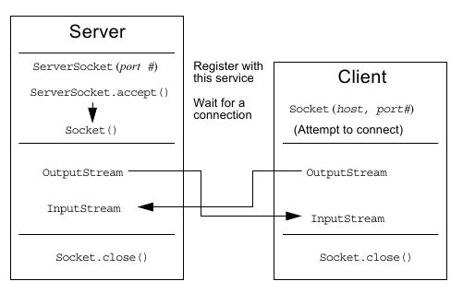

● The server assigns a port number. When the client requests a connection, the server opens the socket connection with the accept() method.
● The client establishes a connection with host on port port#.
● Both the client and server communicate by using an InputStream and an OutputStream.

Minimal TCP/IP Server

TCP/IP server applications rely on the ServerSocket and Socket networking classes provided by the Java programming language. The ServerSocket class takes most of the work out of establishing a server connection.

Minimal TCP/IP Client

The client side of a TCP/IP application relies on the Socket class. Again, much of the work involved in establishing connections is done by the Socket class.

A Network Application using UDP

Course Booklet for
Developing Applications With the
Java SE 6 Platform

Know how of Developing Applications With the Java SE 6 Platform
By Emertxe
version1.0 (Jan 16, 2013 )

All rights reserved. Copyright @ 2013
Emertxe Information Technologies Pvt Ltd
(http://www.emertxe.com

Exploring the Model View Controller (MVC) Design Pattern

Objectives

Upon completion of this module, you should be able to:
● Explain design patterns
● Explain the InfoTool Application
● Demonstrate the MVC pattern in the InfoTool application
● Explain the InfoTool MVC participant sequence diagram
● Explain the InfoTool MVC participant interaction diagram

Design Patterns

Definition of Design Pattern

● A design pattern is a “description of communicating objects and classes that are customized to solve a general design problem in a particular context.” (Gamma, et al.)
● “Each pattern describes a problem, which occurs over and over again in our environment, and then describes the core of the solution to that problem in such a way that you can use this solution a million times over, without ever doing it the same way twice.” (Christopher Alexander)

The second statement is about building architecture, but it can also be applied to object-oriented design. In object-oriented design, patterns appear over and over again.
The discipline of using design patterns formalizes a pattern by identifying three essential elements of the pattern:
● A pattern name, which is a handle used to describe the pattern
● The problem, which states when to apply the pattern
● The solution, which describes the elements that make up the design

The MVC Design Pattern

As the name implies, the three main participants of the MVC design pattern are as follows:
● Model – Represents the application data and the business rules that govern access and modification of this data
● View – Renders the content of the model
● Controller – Defines application behavior by interpreting and mapping the user gestures into actions performed by the model

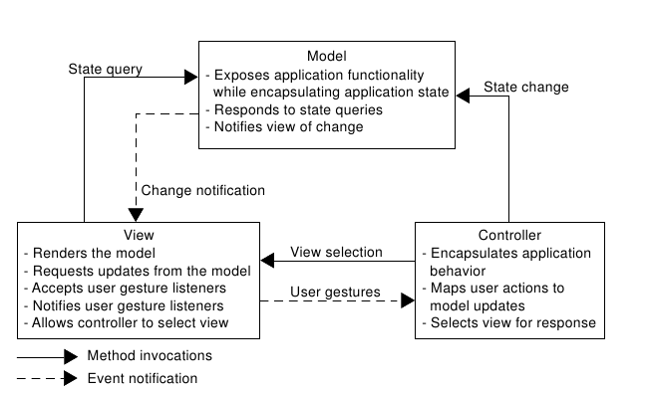

InfoTool Application Overview

The InfoTool application is a simple information display and update application. It consists of a single server with multiple clients attached to it.

Two-Client InfoTool Configuration
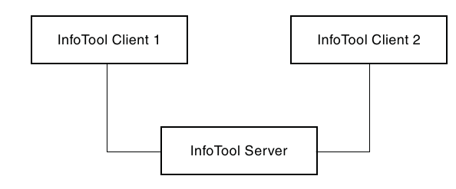
Each client can view and update information presented through multiple display pages. Each display page contains data display fields, data entry fields, data update controls, and page navigation controls.

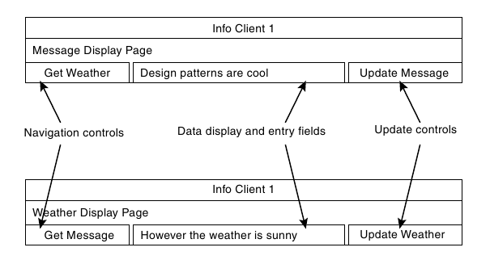

Demonstrating MVC in the InfoTool Application

An object diagram that presents the MVC participants in the InfoTool application.
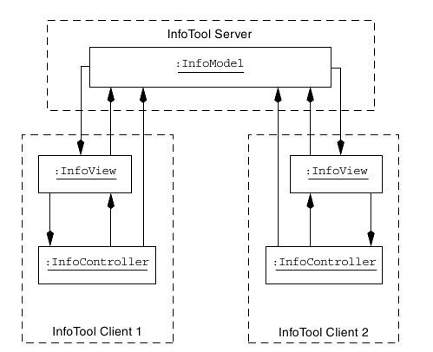

InfoTool Model

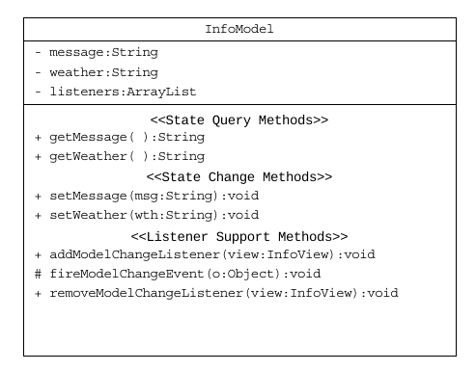
The Unified Modeling Language (UML) class diagram for the InfoModel class. InfoTool View
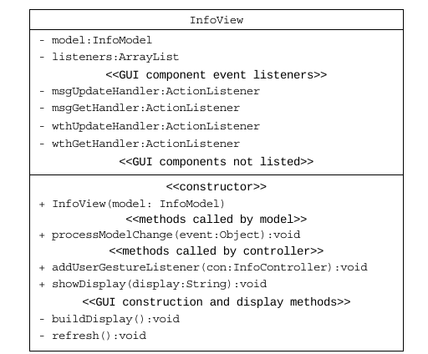

InfoTool Controller

The InfoController UML Class Diagram
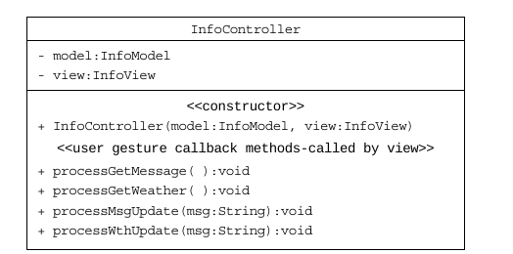
The InfoTool controller is responsible for interpreting the user gestures captured by the view. This is a two-part process, consisting of startup activities and continued monitoring activities.

InfoTool MVC Participant Sequence Diagram

The interactions that take place among the MVC participants at startup.
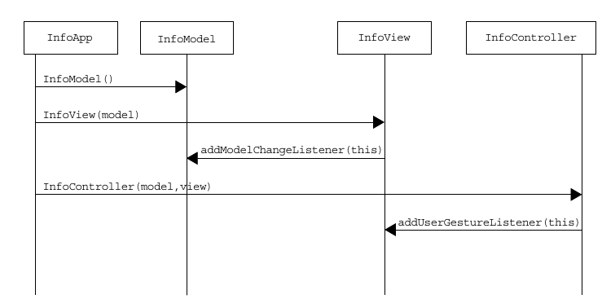

InfoTool MVC Participant Interaction Diagram

The interactions that take place among the MVC participants in response to user gestures.

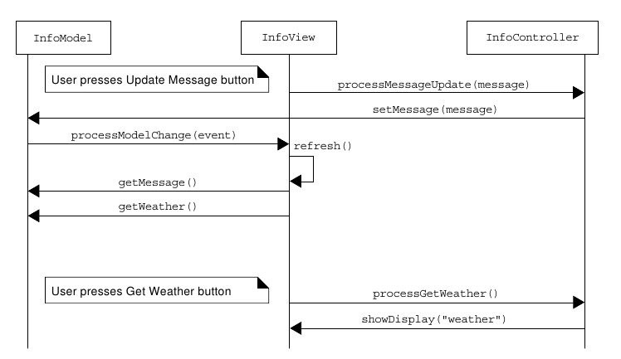

Implementing Unit Testing

Objectives
Upon completion of this module, you should be able to
● Describe unit testing
● Describe the features of JUnit for unit testing
● Describe the JUnit framework
● Apply JUnit for unit testing
● Describe Netbeans support for JUnit

Unit Testing

Unit testing is the process of testing individual components through their interfaces.

The Need for Unit Testing

you cannot create a robust application without validating each of the individual components that contribute to the application development. By performing unit testing, you can ensure that the composition, and debugging is achieved because it enables you to decide if the bug is in a component or between components.

Understanding Test Cases and Their Uses

A test case refers to a set of test data and test scripts and their expected results. You can create test cases as you develop code. A test case validates one or more components’ requirements and validates results in the form of a PASS or a FAIL value. Unit tests are coded with these test cases as reference baselines. Unit tests are typically used to test each functionality independently. However, they can be used for regression testing, as well as for validation testing.

The Need for a Test Framework

You can achieve a systematic approach to testing by means of a test frame work. Test frameworks have been developed and are available to permanently capture test cases. As the project grows, so does the library of test cases, which is helpful as you change the code. These tests identify where you violated assumptions.

Features of JUnit for Unit Testing

JUnit is a tool for developing, compiling, and running unit tests. It is an open source product. NetbeansTM has provided an implementation of the JUnit framework and supports JUnit for unit testing.
JUnit helps you to write code for test cases faster by providing application programming interfaces (APIs) that describe attributes and variables for developing test cases. Because the test cases are based on an existing framework, they have a well-defined structure and is easy to use. JUnit establishes synergy between coding and testing. JUnit can also test the whole application.

JUnit Features

The JUnit API enables you to write complicated test cases easily. The features of JUnit are as follows:
● Assertions for testing expected results
● Test fixtures for sharing common test data
● Test runners for running tests and the Composite pattern

The JUnit Framework

JUnit is a Java framework for performing unit tests. JUnit establishes an accurate process for development and testing. With JUnit, running tests is similar to compiling code. The compiler tests the syntax of the code and the tests validate the integrity of the code.

JUnit tests check their own results and provide immediate feedback. Manual comparison of results is a tedious process. When tests are run, simple and immediate visual feedback is obtained. A PASS or FAIL, status along with the description of the failure is made available to you. You can also make a hierarchy of test suites and create a test suite for the entire application.

Developer’s write and own the JUnit tests. When a development iteration is complete, the tests are promoted as part of the delivered product. Testing software using Java tests forms a bond between the test and the code being tested.

Design of JUnit

JUnit is designed around two key design patterns:
● Command
● Composite

Apply JUnit for Unit Testing

you write the unit tests for the various functionalities of the Infotool project. The project is a basic Java application, built on the MVC design pattern. It has two client screens that display a certain weather type as a String value and a related message, also as a String value in each of the client screens.

Creating Test Cases

In general, to write a test case, complete the following steps:
1. Define a subclass of the TestCase class.
2. Optionally, you can override the setUp method to initialize object(s) under test.
3. Optionally, override the tearDown method to release object(s) under test.
4. Define one or more public testMethod123 methods that exercise the object(s) under test and assert expected results.
Consider the InfoModel class, the functionalities that are represented by various methods of the InfoModel class are to be tested.

Netbeans Support for JUnit

The JUnit module in Netbeans makes creating and running JUnit tests easier. When generating test methods for existing classes, it generates a reasonable and compilable test code skeleton for each testable method. It also makes navigation between source files and corresponding test files easy by providing a navigation action with a shortcut.

Special Features

Test classes are kept in separate source directories. Each generated test class contains test methods for all accessible methods from the tested class. These methods contain either a simple skeleton suitable for comparing return values of tested methods with values expected by the tests (by default), or these methods can be left empty, the body of the test method then has to be filled by the developer to hold some reasonable test code. Generated test classes are compilable and, by default, print the names of tested methods. It provides a results window for a quick overview of the status of executed tests.

Implementing the JavaTM Database Connectivity (JDBC) API

Objectives

Upon completion of this module, you should be able to:
● Describe the JDBC API
● Explain how using the abstraction layer provided by the JDBC API can make a database front end portable across platforms
● Describe the five major tasks involved with the JDBC programmer’s interface
● State the requirements of a JDBC driver and its relationship to the JDBC driver manager
● Describe the data access objects (DAO) pattern and its applicability to a given scenario

Introducing the JDBC Interface

The JDBC API enables you to write database applications in the Java programming language without having to concern yourself with the underlying details of a particular database. The JDBC API requires a driver that passes the appropriate JDBC API and calls the database engine. The JDBC driver insulates you from the specifics of communicating with the database.

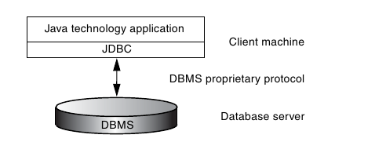

The Two Components of the JDBC API

There are two major components of the JDBC API:
● An implementation interface for database manufacturers
● An interface for application and applet writers

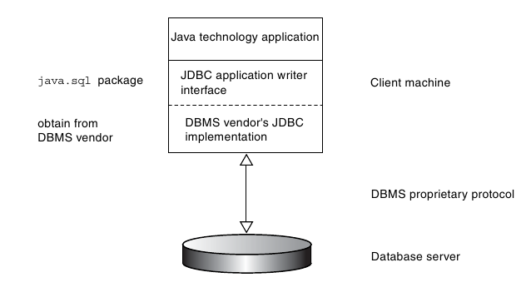

The JDBC API components are contained in the java.sql package, which is a core API of the Java Development Kit (JDK) distribution.

Components of the JDBC API in Detail
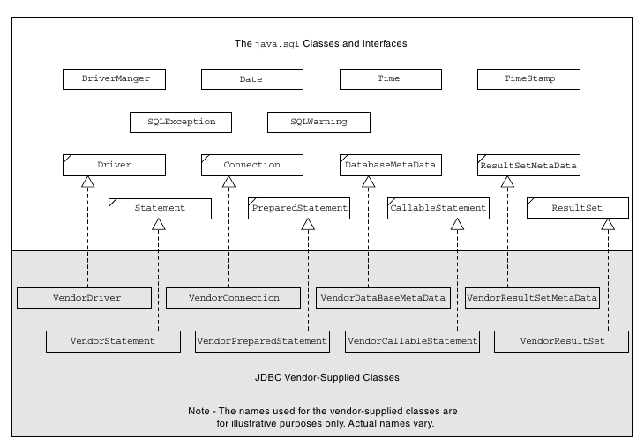

The JDBC API

The classes and interfaces of the JDBC API can be grouped into six functional categories .
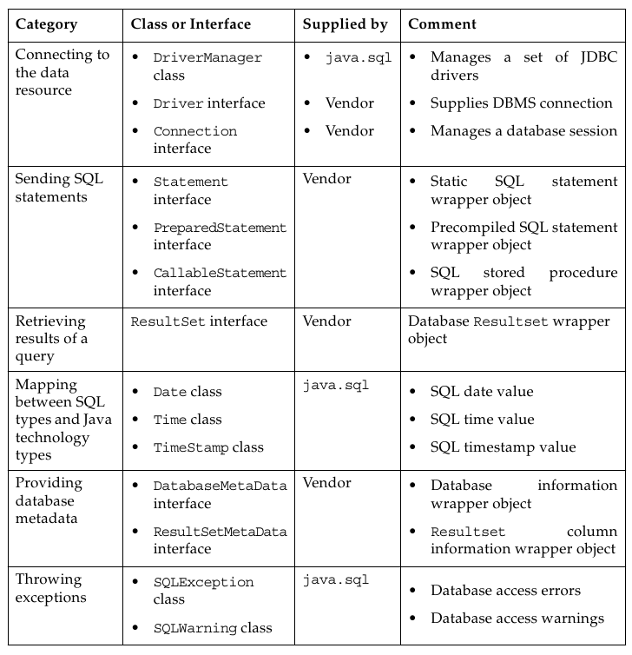

Using Java DB: A Real-World JDBC Driver

Java DB is an multi-user database written entirely in Java technology. It is an open source project being developed as part of the Apache DB project. (See db.apache.org.) .
The Java DB driver file comes packaged in a.jar file called derbyclient.jar. To make this driver file available to your Java Runtime Environment (JRE), copy it to a location that is included in your class path.

Connecting Through the JDBC Interface

The common tasks you perform while connecting through the JDBC interface.

1. Register the vendor-supplied JDBC driver with the DriverManager class.
Most JDBC drivers are designed to register automatically with DriverManager when the JDBC driver class is loaded by the classloader.

2. Establish a DBMS session.
To establish a DBMS session, you create an instance of the vendor-supplied class that implements the java.sql.Connection interface. To create the Connection object, use the static getConnection method of the DriverManager class.

3. Create an SQL query wrapper object.
To create a query wrapper object, you create an instance of the vendor-supplied class that implements the java.sql.Statement interface. To do this, use the createStatement method of the Connection interface.

4. Submit a query and receive the result.
To submit a query, first create a string containing the SQL statement. Next, use this query string as the argument to the executeQuery method of the Statement interface. Finally, receive the query result wrapper object in a variable of type ResultSet.

5. Extract the data from the result wrapper object.
Use the methods of the ResultSet interface to extract the data returned by the query.

6. Close all the acquired objects namely the result set, the statement, and the connection.

Connecting Through the JDBC Interface Detailed Review

Registering a JDBC Driver

When a driver is loaded, it is the responsibility of the driver implementation to register itself with the driver manager.
● It creates an instance of itself in a static code block.
● When the constructor is called either explicitly or implicitly, it
registers itself with the driver manager.

Establishing a DBMS Session

The first step is to specify the database to which you want to connect. To do this in JDBC API, specify a Universal Resource Locator (URL) string that indicates the database type. The proposed URL syntax for a JDBC database is:
jdbc:subprotocol:subname

The DriverManager.getConnection method takes a URL string, a user string, and a password string as arguments. The JDBC driver management layer attempts to locate a driver that can connect to the database represented by the URL. If a driver succeeds in establishing a connection, it returns an appropriate java.sql.Connection object.

Creating an SQL Query Wrapper Object

To create an SQL query wrapper object,get a Statement object from the Connection.createStatement method.
Statement stmt = con.createStatement ();

Submitting a Query and Receiving the Results

Use the Statement.executeUpdate method to submit an INSERT, UPDATE, or DELETE statement to the database. The JDBC API passes the SQL statement to the underlying database connection unaltered. It does not attempt to interpret queries.

Extracting the Data From the Result Wrapper Object

The result of executing a query statement is a set of rows that are accessible using a java.sql.ResultSet object. The rows are received in order.

Mapping Between SQL Data Types and Java Data Types

The mapping between SQL types and Java technology types.
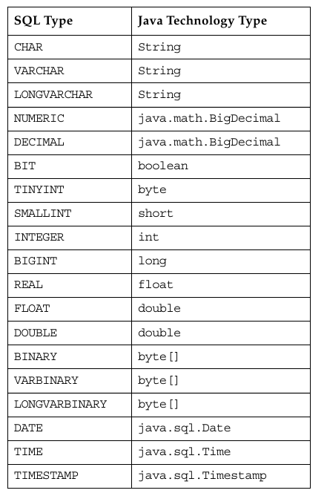

Production Code Strategies for JDBC API Usage

The main issue is the hard-coding of the following information:

● The JDBC driver class name
● URL used for establishing a connection with the JDBC API
● User name
● Password

By hard coding this information, your code lacks flexibility and portability.
To resolve this problem, the first step is to identify and parameterize all deployment-level configuration information. This translates to using variables for each hard-coded piece of data and initializing the variables at application start-up.
The following sections describe strategies you can use to initialize variables on start up.
They are:
● Loading properties from a file
● Loading properties from the command line
● Loading JDBC drivers through jdbc.drivers
● Loading configuration data from a GUI

Loading Properties From a File

You can choose to create a property file with each line containing a property-value pair and use the load method of the java.util.Properties class to load all the properties.
For example, you could create a file named krtkjdbc.txt containing the following property-value pairs.

jdbcDriver = org.apache.derby.jdbc.ClientDriver
jdbcUrl = jdbc:derby://localhost:1527/StockMarket
jdbcUser = public
jdbcPassword = public

The steps to be taken to load properties from a file in the code .
1) The first step is to create an empty java.util.Property object.
// create a properties object
Properties p = new Properties();

2) The next step is to load the properties stored as text in the file krtkjdbc.txt.
p.load(new FileInputStream(“brokerjdbc.txt”));

3) The final step is to initialize the corresponding variables to the property values.

String driver = p.getProperty(“jdbcDriver”;
Class.forName(driver);
System.out.println("LOADED DRIVER ---> " + driver);
.....

Introducing the DAO Pattern

The role of a DAO is to segregate completely the persistence logic from business or presentation logic. This ensures that the user of DAO is unaware of the database, its physical representation, and the relationships between the objects of the database

The DAO design pattern is implemented using the following steps:

1. Define a DAO interface.
The DAO interface contains methods for interacting (reading and writing) with a data source. These methods signatures must be generic. This would enable these methods not to contain any aspects that would bind them to a specific database.

2. Write an implementation of the DAO interface that is specific to the data source used by the application.

3. Code the business logic of the application to access the data source using only the methods of the DAO interface.

Handling GUI Events

Objectives

Upon completion of this module, you should be able to:
● Implement a view class
● Implement a controller class

MVC Client Software Components

Each client requires a dedicated instance of the view class and the controller class. These dedicated instances act as a single entity to serve client requests entered through a user interface associated with the view.

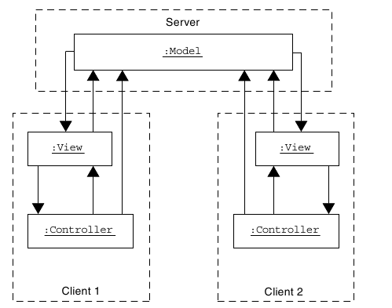

Delegation Event Model

The event Java Development Kit (JDK) model is a delegation model. This model is composed of following three main parts:
● Events – An event is asynchronous data generated by the window server and results from a device activity. The devices usually consist of a mouse and a keyboard.
● Sources – A source of an event is an object that originates or fires the event. A source must define the events it fires, as well as the methods for registering listeners of those events.
● Listeners – A listener is an object that indicates it wants to receive (be notified of) events of a particular type. Listeners register for events using the methods defined by the source of those events.

Propagating Notification of Events

Figure shows how you can propagate the notification of events from the source to the listener using a method call on the listener.
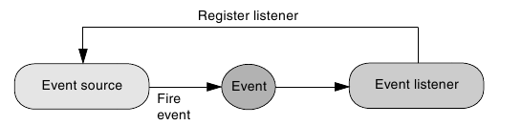

Event Listener Implementation Issues

When implementing event listeners for a GUI-based application, you need to consider a number of design issues.
The following sections present and discuss the following issues:
● Where to place the event listener code
● Using inner classes as event listeners

Where to Place the Event Listener Code

When using the MVC design pattern, you can place the event listeners in the class that implements the view. Recall that an event is caused by a user gesture such as clicking a button or pressing a key. The primary responsibility of the event listener is to notify all interested controllers of the occurrence of the user gesture.

Using Inner Classes as Event Listeners

Consider the code listing for the ButtonPanel class shown in Code 7-1. It shows how you can handle event listening for the four buttons that are created.

Logging Messages in GUI

Objectives

Upon completion of this module, you should be able to:
● Use the logging API
● Examine a logging example
● Write a custom handler
● Set filters to a particular handler

Using the Logging API

The Logging APIs capture information such as security failures, configuration errors, performance bottlenecks, and/or bugs in the application or platform.

This section provides an introduction to using the logging services made available in the java.util.logging API.
The following tasks outline the steps required to use the logging API:
1. Create a logger object.
2. Configure the logger object.
3. Send messages to the logger object.

Creating a Logger Object

You can create a logger object by using the following static method of the java.util.Logger class:

public static Logger getLogger(String name)

Configuring the Logger Object

The purpose of configuring the logging object is to control the publication of the logger. Configuration involves the following actions:
1. Associating a handler with the logger object
2. Setting the log level
3. Optionally associating a filter with the logger object

Associating a Handler With a Logger Object

A logger object is associated with one or more handlers. The handler is responsible for the publication of the log message. This responsibility includes specifying both the format and the output location. Examples of an output location are a console and a file.

The logging API provides the following handlers:

● StreamHandler –

● ConsoleHandler –

● File Handler –

● SocketHandler –

● MemoryHandler –

Setting the Log Level

The logging API includes a Level class that defines seven log levels.
The levels in descending order are as follows:

● ALL
● CONFIG
● FINEST
● FINER
● FINE
● INFO
● WARNING
● SEVERE
Using of Logging Levels

You can use the setLevel method of the logger object to set the minimum level at which the logger should publish log messages. The log level is passed as a parameter in the setLevel method.
For example:
logger.setLevel(Level.INFO);

Using the Logging Configuration File

This logging configuration file is in standard java.util.Properties format.Alternatively, the logging configuration can be initialized by specifying a class that can be used for reading initialization properties. This mechanism allows configuration data to be read from arbitrary sources, such as LDAP. JDBC, etc.

The logging configuration details can be set using the logging.properties file.
To summarise,they are:
1. Setting Handlers
2. Setting Formatters
3. Setting Log Levels
4. Setting Handler limit
5. Setting Handler count

Simple Logging Example

Writing Custom Handlers

The Handler class is an abstract class. It contains the following three methods:

public void publish(LogRecord logRecord);
public void flush();
public void close();

To provide a custom handler, you need to override the three methods of the Handler class to suit your purpose.

Implementing Multiple-Tier Design

Objectives
Upon completion of this module, you should be able to:
● Compare the two-tier design with the three-tier design
● Explain how you can use the Java technology package java.net to implement networking applications
● Demonstrate how to use the Command design pattern

Comparing Two-Tier and Three-Tier Designs

Two-Tier

Advantages of Two-Tier Design
A two-tier design has the following advantages:
● A two-tier design is more extensible than a one-tier design. A two-tier design combines presentation logic, business logic, and data resources into a single address space.
● In contrast to a one-tier design, the client of a two-tier design can be on any host as long as that host is connected by a network to the data resource tier.
● A two-tier design has fewer points of failure than a three-tier design.

Disadvantages of a Two-Tier Design
A two-tier design has the following disadvantages:
● Any changes to the business strategy result in changes to the business logic, which requires redeployment of all clients. This can be very costly and time consuming.
● Each client requires a connection to the data resource.
● This design restricts or complicates the addition of mirroring, caching, proxy services, or secure transactions to the data resource.
● The business logic is in the client tier. Therefore, all the database data that is used by the application is exposed on the network.

Three-Tier

Advantages of Three-Tier Design
A three-tier design has the following advantages:
● It enables efficient use of data resource connections by using connection pooling.
● It is possible to change business logic without redeploying client software.
● It is architecturally better suited for scaling and load balancing than other designs.
● Scaling affects primarily the middle tier only.

Disadvantages of Three-Tier Design
A three-tier design has the following disadvantages:
● This design has increased network traffic.
● This design has multiple points of failure.
● Business objects must be designed to manage transactional integrity.

Networking With Java Technology

The Java technology package java.net provides you with the classes for implementing networking applications. You can use the socket classes in this package to communicate with any server on the Internet or you can implement your own Internet server. When you are designing a network application, you create a network server and a network client.

Command Design Pattern

The Command design pattern provides a generic solution that simplifies the creation of a client-server messaging protocol. In the Command design pattern, each message is considered a command

Command Design Pattern Example :

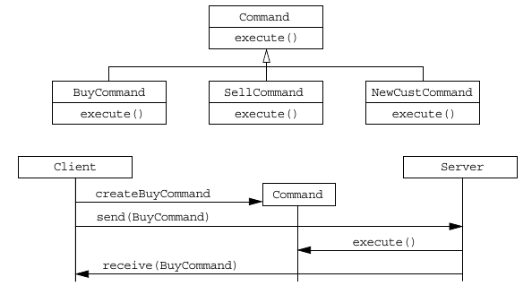

Applying the Command Design Pattern

You perform the following tasks to apply the Command design pattern are:
1. Define the Command class.
2. Identify and define all the Command subclasses.
3. Create a network server class that performs the following activities:
● Accepts network connections from a client
● Receives command objects
● Updates the command objects by invoking the execute method
● Returns the updated command objects
4. Create a network-client interface class that performs the following activities:
● Establishes a network connection with the server
● Sends command objects
● Receives command objects
5. Create a network-aware BrokerModel interface implementation that performs the following activities:
● Creates command objects
● Forwards the command objects to the server through the network-client interface class
● Receives the updated command objects
● Displays data from the command objects on the GUI

Implementing Advanced Multiple-Tier Design

Objectives

Upon completion of this module, you should be able to:
● Use the Java concurrency APIs to create a multithreaded server
● Examine a thread pool
● Identify integrity problems in multithreaded servers

Multithreaded Server

The top half of Figure shows the current single-threaded server design, and the bottom half shows a possible design for a multithreaded server.

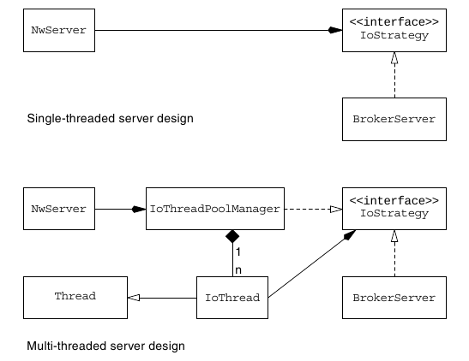

The multithreaded server design of Figure introduces the following new user-defined classes:
● IoThread
● IoThreadPoolManager

The java.util.concurrent.locks Package

The java.util.concurrent.locks package contains interfaces and classes that provide a framework for locking and waiting for conditions that are distinct from built-in synchronization and monitors.

The Lock Interface

The Lock interface provides the skeleton that its implementations should provide to achieve synchronization.The Lock interface provides methods to control access to a shared resource in a multithreaded environment. The Lock interface provides the following three key methods:
● void lock() – This method is used to acquire a lock.
● Condition newCondition() – This method returns a Condition
instance associated with the lock.
● void unlock() – This method releases the lock. Normally, the
thread that acquires the lock should be the one to release the lock as
well.

The Condition Interface

The Condition interface consists of methods that facilitate communication between threads. Conditions provide a means for one thread to suspend execution until notified by another thread that some state condition might now be true. Some of the important methods in the Condition interface are as follows:

● void await() – Makes the current thread wait until it is signalled
or interrupted.
● void signal() – Wakes up a waiting thread. Similar to the
notify() method in the Object class.
● void signalAll() – Wakes up all waiting threads. Similar to the
notifyAll() method in the Object class.

The ReentrantLock Class

The ReentrantLock class is the concrete implementation of the Lock
interface. It provides a mutually exclusive re-entrant lock.

The IoThread Class

The following list contains the requirements for the IoThread class:

● The IoThread class must be associated exclusively with an object that implements the IoStrategy interface.
● The IoThread class must provide a constructor (or preferably a method) to accept a Socket object to forward to the IoStrategy object. The socket originates from the NwServer, which creates the socket when it accepts a connection from a client. It then forwards this socket to the IoThreadPoolManager, which in turn forwards it to the IoThread object.
● The IoThread class must implement the Runnable interface. The run method executes the ioService method of the IoStrategy object with which it is associated.

The IoThreadPoolManager Class

The following notes are provided to explain the design of the IoThreadPoolManager class.
● The IoThreadPoolManager class must contain a pool of IoThread objects.
● At start up, all IoThread objects are marked idle and are available to service a broker client.
● As a broker client connects to the broker server, the IoThreadPoolManager allocates an IoThread object from the IoThread pool to service the broker client. This IoThread object is marked busy.
● When the broker client disconnects, the IoThread object that serviced the client is returned to the pool.
● The IoThreadPoolManager class is required to implement the IoStrategy interface, which contains an ioService method.
● The IoThreadPoolManager class’s implementation of the ioService(Socket socket) method is tasked with the responsibility of locating and allocating an available IoThread object to a connecting broker client.

Network Server Design Issues

In a networked MVC design, the client hosts the view and controller. The server hosts the model. You must check the integrity of your design against the following:

● Lost event registration subscriptions sent from the view (client) to the model (server)
● Lost state query method invocations sent by the view (client) to the model (server)
● Lost business method invocations sent by the controller (client) to the model (server)
● Lost state change notifications sent by the model (server) to the view (client)

Multithreaded Server Issues

If the server supports multiple clients, check your design against the following parameters:
● Data integrity of model in a multithreaded environment.
● Client service threads.
● Empty available-thread pool in a client-thread-reuse design.
● Transaction integrity in a multiclient environment.
● JDBC technology connections, statements, and resultset integrity in a multithreaded environment.

Communicating with Remote Objects Using Java RMI

Objectives

Upon completion of this module, you should be able to:
● Create remote objects
● Use Java RMI to create a multitier application

The Java RMI

The Java RMI enables you to invoke objects in different virtual machines and potentially on different host machines. Objects created in different virtual machines are called remote objects. Tthe Java RMI is designed to enable your programs to invoke the methods of a remote interface on a remote object. Method invocation on the remote object has the same syntax as method invocation on a local object.

The RMI architecture consists of three independent layers between the application program and the Java virtual machine.
They are
1. Stub and Skeleton Layer
2. Remote Reference Layer
3. Transport Layer

A Java RMI solution consists of the following entities:
● Java RMI servers
● Java RMI registry
● Java RMI clients
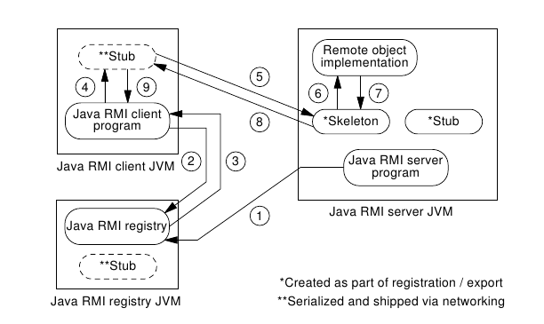

Creating a Java RMI Application

There are six steps involved in creating a Java RMI application:
1. Develop the Java technology remote interface that defines the remote object.
2. Create the implementation class, the servant, for the interface.
3. Create the server that manages the servant instances.
4. Create the client application that uses the remote object. In the end, the client uses the servant.
5. Use the Java technology compiler to create the Java technology class files.
6. Run the Java RMI compiler (rmic) to create the helper classes (stubs and skeletons).

Step 1: Develop the Remote Interface
The Java technology remote interface describes the server object. In contrast with a regular Java technology interface, a Java technology remote interface has to extend java.rmi.Remote, and every method has to throw java.rmi.RemoteException.

Step 2: Create the Implementation Class (Servant)
You must write a servant class for each remote interface. You use instances of the servant class to implement remote objects. Each instance implements a single remote object, and each remote object is implemented by a single servant.
The servant must extend the class java.rmi.server.UnicastRemoteObject.

Step 3: Create the Server
The JRE RMI uses the server to instantiate and publish the servant. In its simplest form, the server preinstantiates all the needed servants and keeps them alive as long as the server lives.

Step 4: Create the Client Application

Step 5: Compile the Java Technology Class Files

Use the javac command to compile the files.

Step 6: Create the Stubs and Skeletons
The utility used to create the stub and skeleton is called the Java RMI compiler, or rmic. Its syntax is similar to the syntax of javac.

Deploying a Java RMI Application

If there are no compilation problems, you can perform the following tasks
to deploy a Java RMI application:
1. Start the Java RMI registry.
2. Start the server.
3. Start the client.

You must ensure you are in the classes directory before starting the Java RMI registry.

rmiregistry

Next you must start the server, which creates the servant and registers it with the Java RMI registry.

java RMIServer Class

The server does produce some output, so it is better to start it in its own console or command prompt.

In the last step, the client is started. You must use a dedicated console or command prompt to start the client.

java RMIClientClass

Course Booklet for
Web Component Development
With Servlet and JSP
Technologies

Know how of Web Component Development With Servlet and JSP Technologies
By Emertxe
version1.0 (Jan 16, 2013 )

All rights reserved. Copyright @ 2013
Emertxe Information Technologies Pvt Ltd
(http://www.emertxe.com

Introduction to Java Servlets

Objectives

Upon completion of this module, you should be able to:
● Outline JavaTM servlet technology

Web Application Technologies

HTTP is used to transfer instructions and data between machines, while HTML is a document display language that lets users create visually pleasing documents and link from one document to another.

The combination of the HTTP protocol and the HTML page description language are the foundation technologies of the World Wide Web.

HTTP Client-Server Architecture

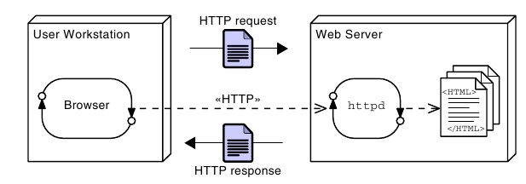

Web Site Structure

A web site is a collection of HTML pages and other media files that contains all the content that is visible to the user on a given web server.
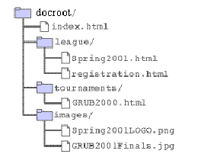

Uniform Resource Locator

A URL locates a specific resource on the Internet. It consists of several parts, and is similar in some ways to a directory and file specification:

protocol://host:port/path/file

Web Sites and Web Applications

A web site is a collection of static files, HTML pages, graphics, and various other files. A web application is an element of a web site that provides dynamic functionality on the server. A web application runs a program or programs on the server.

Execution of CGI Programs

Early in the development of the web, the designers created a mechanism to permit a user to invoke a program on the web server. This mechanism was called the Common Gateway Interface (CGI). When a web site includes CGI processing, this is called a web application.

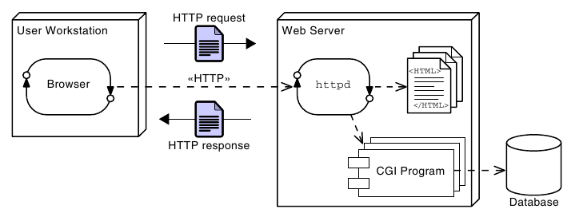

Advantages and Disadvantages of CGI Programs

Using Java in the Web

Java gained the ability to service HTTP requests and take its place in the development of dynamic web sites. The earliest technology developed for this was the servlet. Servlets provide a simple framework that allows Java program code to process an HTTP request and create an HTML page in response.

Execution of Java Servlets

The basic processing steps for Java servlets are quite similar to the steps for CGI. However, the servlet runs as a thread in the web container instead of in a separate OS process. The web container itself is an OS process, but it runs as a service and is available continuously. This is opposed to a CGI script in which a new process is created for each request.

Advantages and Disadvantages of Java Servlets

Java Servlets

Servlets are components that respond to HTTP requests. The web container performs initial processing, and selects the intended servlet to handle the request. The container also controls the life-cycle of the servlet.

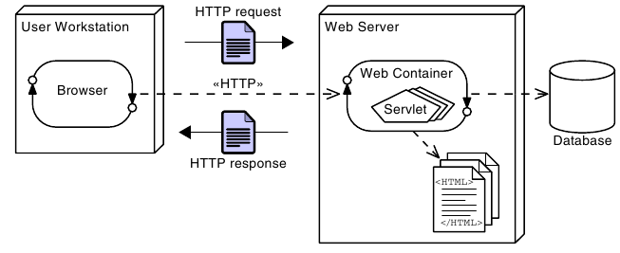

A First Java Servlet

The servlet’s job is two-fold. First, it must perform the required computation; second, it must present the results in a well-formed HTML page.

A simple Servlet code

HTTP Methods

You might be aware that HTTP provides several ways to send requests, and the GET method is just one of these. Another very common HTTP request is the POST method. As you might guess, the servlet provides a doPost method to handle such a request. The arguments of the doPost method are identical to those of doGet.

Introduction to Java Server Pages

Objectives

Upon completion of this module, you should be able to:
● Describe a significant weakness in servlets when used alone
● Write a simple Java Server Page (JSP)
● Describe the translation of a JSP into a servlet
● Understand the basic goals of MVC

A Weakness in Servlets

Most modern web applications have elegant and complex user interface designs. The designs are often created by dedicated web designers, and even if that is not the case, the HTML pages that implement the designs are frequently created using “What You See Is What You Get” (WYSIWYG) Graphical User Interface (GUI) based design tools. Such design tools work on HTML, not on HTML embedded in Java program code.

Because of this, the pure servlet approach becomes unmanageable—often catastrophically—when maintenance is required on the web pages. Having to re-type all the HTML code back into out.print(...) statements would be a very time consuming and error prone process.

Addressing the Problem With JSPs

Soon after the original introduction of servlets, Java Server Pages, usually called simply JSPs, were introduced to address this problem.

While a servlet is a Java source file containing embedded HTML, a JSP might be considered to be an HTML file with Java embedded in it.

Key Elements of JSPs

● The bulk of the document is a regular HTML file; indeed, it is entirely legal HTML, and can be edited in a WYSIWYG editor.
● Additional features related to the Java aspects of the JSP are denoted using the <% ... %> pairs.
● Within <% ... %> pairs, three distinct variations are exemplified.
These are:
● Comments
● A “page directive”
● An “expression”

How a JSP Is Processed

Before a JSP is executed for the first time, it is converted to an equivalent servlet. This is similar to the compilation phase that converts a clean, maintainable source language such as Java into a potentially messy, hard- to-maintain, language such as the Java bytecode or a hardware-specific machine code. In this case, however, the conversion is performed automatically by the web container.

Reading Input Parameters From the Browser

When a browser submits a form, the request commonly includes parameters, that is, data provided by the user. These parameters are available to a servlet through the getParameter method of the request variable.

<html>
<head>
<meta http-equiv="Content-Type" content="text/html; charset=UTF-8">
<title>JSP Page</title>
</head>
<body>
<h1>Hello
<%= request.getParameter("customerName") %>
</h1>
</body>
</html>

Sending Parameters in an HTTP GET Request

The HTTP standard makes it easy to create a GET request that includes a parameter, even without using a form.

Remaining Problems With the JSP Approach

In effect, the servlet approach results in HTML embedded in a Java source file. The JSP approach results in Java code embedded in an HTML source file. Because of this, programmers and web-designers must share the same file, and changes made by one group might cause bugs in the work of the other group.

Model, View, and Controller

Based on the historical origin, the code components that handle these three aspects are now called the model, view, and controller. Approaches using these elements are often referred to as MVC or Model-View- Controller designs.

The model is a computational model of the essential problem to be solved. It does not consider how the input is provided, nor the presentation of the output.
The view is responsible for taking the results of the computation from the model and presenting it to the user. Note that in some systems, the “user” might not be human, but might be another computer system. This does not alter the essential design.
The controller is responsible for taking the input, and pre-processing it, so that it can be presented to the model in a generic form that is appropriate to that model. In the web-based system, the controller extracts the essence of the request and argument data from the HTTP request.

Implementing an MVC Design

Objectives

Upon completion of this module, you should be able to:
● Implement the controller design element using a servlet
● Implement the model design element using a POJO
● Implement the view design element using a JSP and the Expression Language (EL)
● Connect the model, view, and controller elements to implement a working MVC solution

Developing the MVC Solution

Responsibilities of the Controller
The controller is the point of contact that the web container knows about. Specifically, the web-container will invoke the controller in response to an HTTP request. The controller must then select a model to process the request, and a view to present the results.

Connecting the Components

For the MVC system to work, communication between the components is necessary. Specifically, the controller must pass request parameter data to the model to support the computation, and the controller must pass results from the model to the view.

Forwarding From a Servlet to a JSP

The mechanism used to invoke the JSP page is called forwarding. Code to perform this is shown below.

RequestDispatcher rd = request.getRequestDispatcher("view.jsp");
rd.forward(request, response);

Notice that the forwarding is done in two parts. First, a RequestDispatcher object is created by the request. The RequestDispatcher is configured on creation to transfer control to a page called “view.jsp”. Next, the RequestDispatcher is used to pass the original request and response objects into the new page for processing.

Passing Data From the Servlet to the JSP

In fact, there is another map-like feature of the request that is specifically intended to carry information from one page (usually a servlet) so that it will be available to another page (usually a JSP) after a forward operation. This is called the attribute map, and may be read and written using the methods:
ServletRequest.getAttribute(String key)
ServletRequest.setAttribute(String key, Object value)
Using this map, the controller servlet can send data to the view JSP.

Using Data in the JSP

In the JSP, data in the request attribute map are accessible in a number of ways. Perhaps the cleanest and simplest way to access data om the model is using the expression language, usually referred to simply as EL.

So, if a controller servlet writes a data item into an attributed using the following code:

request.setAttribute("aValue", 99);

Then the value can be read in a JSP page using this syntax:

${aValue}

A Complete MVC Example

The Servlet’s Environment

Objectives

Upon completion of this module, you should be able to:
● Describe the environment in which the servlet runs
● Describe HTTP headers and their function
● Use HTML forms to collect data from users and send it to a servlet
● Understand how the web container transfers a request to the servlet
● Understand and use HttpSession objects

HTTP Revisited

Hypertext Transfer Protocol

In any communication protocol, the client must transmit a request and the server should transmit some meaningful response. In HTTP, the request is some resource that is specified by a URL.

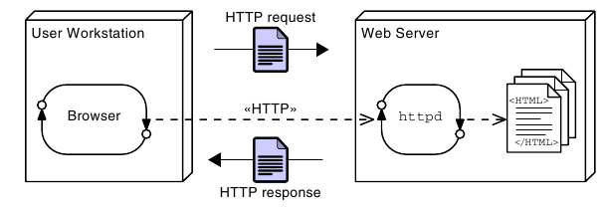
HTTP Methods

An HTTP request can be made using a variety of methods.
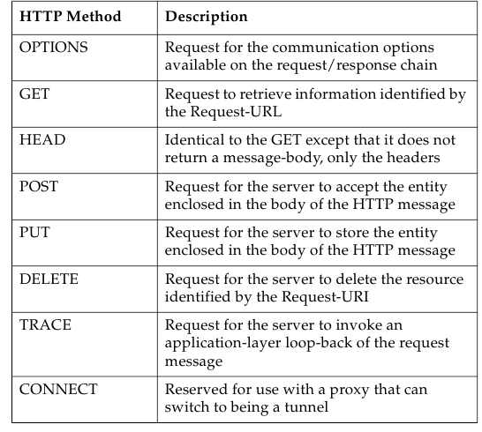

HTTP Request

The request stream acts as an envelope to the request URL and message body of the HTTP client request. The first line of the request stream is called the request line. It includes the HTTP method (usually either GET or POST), followed by a space character, followed by the requested URL (usually a path to a static file), followed by a space, and finally followed by the HTTP version number. The request line is followed by any number of request header lines.

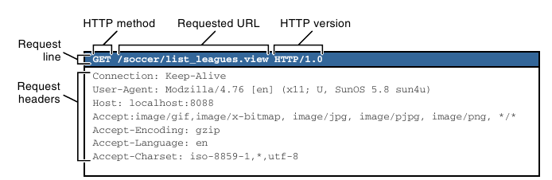

HTTP Response

The response stream acts as an envelope to the message body of the HTTP server response. The first line of the response stream is called the status line. The status line includes the HTTP version number, followed by a space, followed by the numeric status code of the response, followed by a space, and finally followed by a short text message represented by the status code.

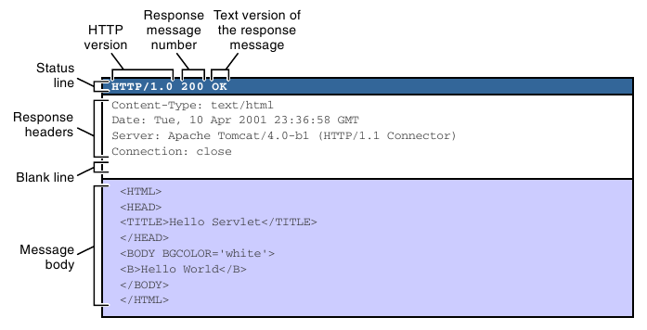

Collecting Data From the User

HTML Form Mechanism and Tag

If users are to provide input to a web application, they must be provided with a page that prompts for the desired information, and allows them to enter, or select, their desired values. There must also be a mechanism on the page (usually called simply a form) to allow the user to indicate that the input is complete and should be sent to the server. This indication is usually called “submitting” the form, and a button that triggers this is called a “submit” button.

Input Types for Use With Forms

Several input types are provided by HTML for use with forms. The following sections introduce three that have very general utility.

Text Input Component

When a user must enter a single line of text, the text input component may be used. The input tag is used to create a textfield component, but you must specify type=’text’ to get a textfield component. The name attribute of the input tag specifies the field name. The field name and the value entered in the textfield are paired together when the form is submitted to the web container.

Drop-Down List Component

The select tag is used to create a drop-down list component. Similar to the input tag, the select tag uses the name attribute to specify the name of the form field. One or more option tags must be embedded in the select tag. Each option tag provides a single element in the drop-down list. The data sent in the HTTP request on form submission is based on the value attribute of the option tag. The text between the start and end option tags is the content that is displayed in the browser drop-down list.

Submit Button

A submit button can be given a text label at the designer’s discretion, though browsers will usually mark the button “Submit” or “Submit Query” if nothing is done to explicitly choose the label.

Web Container Architecture

Java servlets are components that must exist in a web container. The web container is built on top of the Java Platform, Standard Edition (Java SE) platform and implements the servlet API and all of the services required to process HTTP (and other Transmission Control Protocol/Internet Protocol [TCP/IP]) requests.

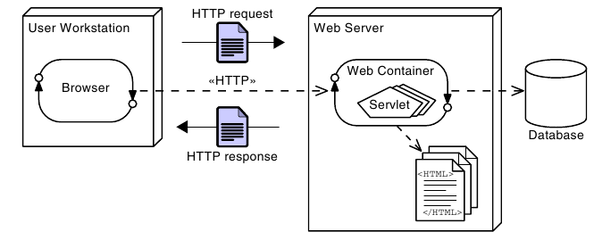

Request and Response Process

1. Browser Connects to the Web Container
2. Web Container Objectifies the Input/Output Streams
3. Web Container Executes the Servlet
4. Servlet Uses the Output Stream to Generate the Response

Sequence Diagram of an HTTP GET Request

The web container converts the HTTP request and response streams into runtime objects that implement the HttpServletRequest and HttpServletResponse interfaces. These objects are then passed to the requested servlet as parameters to the service method.

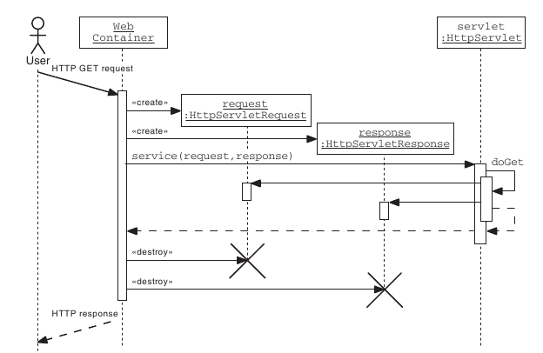

The HttpServlet API

To create a servlet that responds to an HTTP request, you should create a class that extends the HttpServlet abstract class (provided in the javax.servlet.http package).

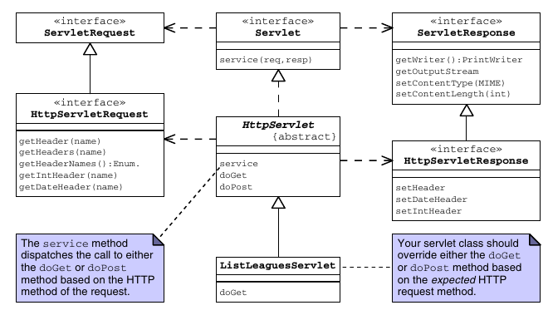

The HttpServletRequest API

The HTTP request information is encapsulated by the HttpServletRequest interface. The getHeaderNames method returns an enumeration of strings composed of the names of each header in the request stream. To retrieve the value of a specific header, you can use the getHeader method. This method returns a String. Some header values might represent integer or date information. There are two convenience methods, getIntHeader and getDateHeader, that perform the conversion for you.

The HttpServletResponse API

The HTTP response information is encapsulated by the HttpServletResponse interface. You can set a response header using the setHeader method. If the header value you want to set is either an integer or a date, then you can use the convenience methods setIntHeader or setDateHeader.

Handling Errors in Servlet Processing

One situation in which throwing an exception might be appropriate is when processing page fragments, that is, either servlets or JSPs that are used by inclusion into a larger compound page. In this situation, the fragment is unlikely to be able to decide what to do about the error, but the host page can make a sensible decision. The call to include the page will simply throw the exception that was issued by the included page fragment, allowing the host to use a try/catch block to intercept and handle the problem.
If, for any reason, you decide to throw an exception from a doXxx() servlet method, you should wrap the exception in either a ServletException, or an UnavailableException. The ServletException is used to indicate that this particular request has failed. UnavailableException indicates that the problem is environmental, rather than specific to this request.

The HTTP Protocol and Client Sessions

HTTP is a stateless protocol. That means that every request is, from the perspective of HTTP, entirely separate from every other. There is no concept of an ongoing conversation. This provides great potential for scalability and redundancy in servers, because any request can go to any one of a collection of identically equipped servers.

Web servers in a Java EE environment are required to provide mechanisms for identifying clients and associating each client with a map that can be used to store client specific data. That map is implemented using the HttpSession class.

The HttpSession API

The Servlet specification provides an HttpSession interface that lets you store session data, referred to as attributes. You can store, retrieve, and remove attributes from the session object. The servlet has access to the session object through two getSession methods in the HttpServletRequest object.

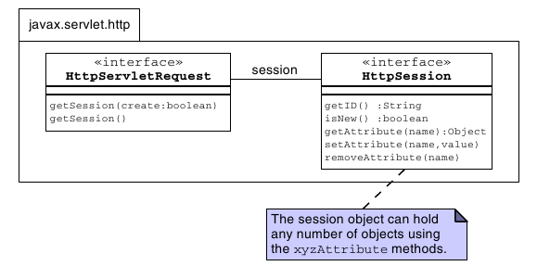

Storing Session Attributes

To store a value in a session object, use the setAttribute method.

Retrieving Session Attributes

You can use the getAttribute method to retrieve data previously stored in the session object.

Closing the Session

When the web application has finished with a session, such as if the user logs out, you should call the invalidate method on the HTTPSession object.

Additional Session Methods

Using Cookies for Client-Specific Storage

Cookies allow a web server to store information on the client machine. Data are stored as key-value pairs in the browser and are specific to the individual client.

● Cookies are sent in a response from the web server.
● Cookies are stored on the client’s computer.
● Cookies are stored in a partition assigned to the web server’s domain name. Cookies can be further partitioned by a path within the domain.
● All cookies for that domain (and path) are sent in every request to that web server.
● Cookies have a life span and are flushed by the client browser at the end of that life span.
● Cookies can be labelled “HTTP-Only” which means that they are not available to scripting code such as JavaScript. This enhances security.

Cookie API

You can create cookies using the Cookie class. You can add cookies to the response object using the addCookie method. This sends the cookie information over the HTTP response stream. The information is stored on the user’s computer (through the web browser). You can access cookies sent back from the user’s computer in the HTTP request stream using the getCookies method.
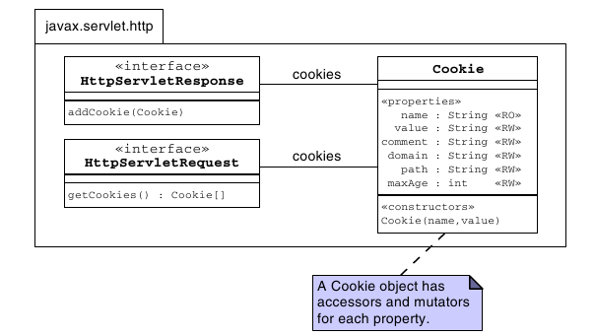

Using Cookies Example

Using URL-Rewriting for Session Management

URL-rewriting is an alternative session management strategy that the web container must support. Typically, a web container attempts to use cookies to store the session ID. If that fails (that is, the user has cookies turned off in the browser), then the web container tries to use URL-rewriting.

URL-rewriting is implemented by attaching additional information (the session ID) onto the URL that is sent in the HTTP request stream .

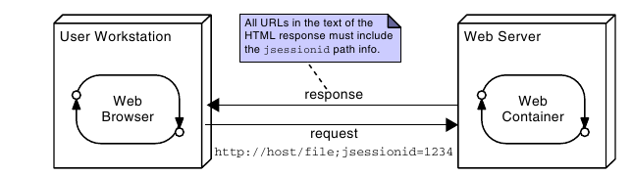

Container Facilities for Servlets and JSPs

Objectives

Upon completion of this module, you should be able to:
● Describe the purpose of deployment descriptors
● Determine the context root for a web application
● Create servlet mappings to allow invocation of a servlet
● Create and access context and init parameters
● Use the @WebServlet and @WebInitParam annotations to configure your servlets

Packaging Web Applications

The JAR file that is used to package a web application has a specific set of structural and content rules that make it a little different from other, more general, archives. Because of this, the file is given the extension .war, indicating that it is a web archive, rather than .jar, which would not distinguish it from archives created for any other purpose. The file is often referred to as a WAR file, or simply a WAR.

The Default Context Root

The context root is the base URL that is used as a prefix when locating pages and servlets within the application. The most basic default for the context root is that it uses the name of the war file from which the application was deployed.

For example, if a war file called AnApplication.war contains a file startingPoint.html in the root of the archive, then when deployed to a local server, the URL used to reach the startingPoint.html file might be:
http://localhost:8080/AnApplication/startingPoint.html
In this way, the context root is /AnApplication.

Essential Structure of a WAR file

Figure below shows the essential structure of a WAR file. Notice that the root of the archive, and arbitrary directories below the root are all proper places to place HTML files, JSPs, and images and other resources. Content in these locations will be directly accessible from the application’s context root (this is not the same as the root of the server). A special directory, called WEB-INF is also placed in the root of the archive. If resources are placed there, the container must be given special instructions to make those resources available to a client.

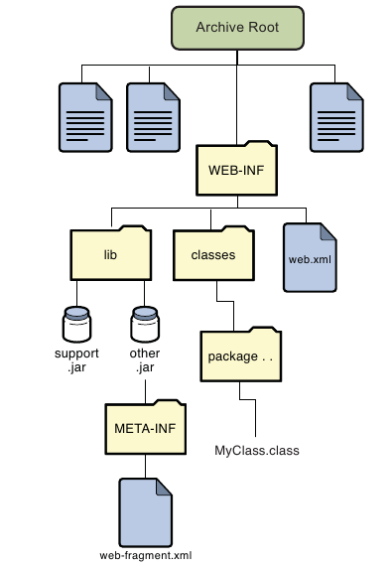

Deployment Descriptors

In versions of Java EE prior to EE 6, deployment configuration was supported using the web.xml file. This file was required and is generally known as the deployment descriptor (DD). This type of external deployment descriptor facilitates reuse of code in differing environments without problems arising from hard-coded values needing to change, and supports the notion of keeping separate things that change separately.
In addition to allowing configuration to be done using annotations, another method of specifying deployment information is also supported. This is the use of web-fragment.xml files in libraries.

The web-fragment.xml Files

The web-fragment.xml file provides a mechanism to include deployment information that is specific to a library, without having to edit the main deployment descriptor for the whole web application. This reflects the OO principle of keeping unrelated things apart.

Controlling Configuration

With three elements capable of providing configuration information, web.xml, web-fragment.xml, and annotations, it is possible for these to provide conflicting information. To address this, some rules and controls are provided. Three are particularly significant, and these are:
● Precedence
● <metadata-complete> tag
● Ordering

Dynamic Configuration of Web Applications

Java EE 6 adds features that allow the programmatic configuration of servlets, filters, and related components. This feature is only available as the web application is being loaded, specifically during the time that the servlet context is being initialized. It is perhaps most useful for framework creators.

Servlet Mapping

A mapping is information that specifies that a particular URL, or group of URLs, refer to a particular named servlet. The name is not the class name, but is an internal reference within the web container to a particular servlet class configured in a particular way.

<web-app [...] >
<servlet>
<servlet-name>MyServletName</servlet-name>
<servlet-class>SL314.package.MyServlet</servlet-class>
</servlet>
<servlet-mapping>
<servlet-name>MyServletName</servlet-name>
<url-pattern>/MyServlet</url-pattern>
</servlet-mapping>
</web-app>

Multiple and Wildcard URL Patterns

It is quite common to find a single servlet being used to respond to a variety of URLs. This is supported in two ways: First, the <url-pattern> XML element may be repeated. Second, the pattern specified by a URL may be a wildcard, ending with an asterisk.

<servlet-mapping>
<servlet-name>MyServlet</servlet-name>
<url-pattern>/MyServlet</url-pattern>
<url-pattern>/YourServlet</url-pattern>
<url-pattern>/HisServlet/*</url-pattern>
</servlet-mapping>

Mapping Using Annotations

Since Java EE 6, servlet mappings can be achieved using annotations. A servlet should be given the annotation:
javax.servlet.annotation.WebServlet
This annotation supports various optional elements, but a common form is that which has been used in examples in previous modules:

@WebServlet(name="MyServletName",
urlPatterns={"/MyServlet", “/YourServlet”, “/HisServlet/*”})

Invoking a Servlet by Name

A servlet can be invoked directly by its name through a RequestDispatcher, in a forward or include call. The necessary dispatcher is obtained using the servlet context which offers a method getNamedDispatcher(String).

Servlet Context Information

The deployment descriptor can include configuration information for the servlet. Two configuration elements of frequent utility are context parameters and init parameters.

Context Parameters

The term “servlet context” essentially refers to the web application and the container in which the servlet runs. An interface javax.servlet.ServletContext provides access to several aspects of this environment, but in the context of this discussion, the methods of interest are two methods that allow read-only access to a map of context parameters. These methods are:
String getInitParameter(String name)
Enumeration<String> getInitParameterNames()

Supplying Context Parameters

To specify a context parameter using a web.xml, or web-fragment.xml file, the specification is quite simple. Here is an example.

<web-fragment [...]>
<context-param>
<param-name>fragmentContext</param-name>
<param-value>fragment Context value</param-value>
</context-param>
</web-fragment>

Servlet Initialization Parameters

In addition to configuration parameters for the entire application, initialization parameters can be associated with the servlet individually. These are typically known simply as init parameters. This association may be achieved using the deployment descriptor file like this:

<servlet>
<servlet-name>MyServlet</servlet-name>
<servlet-class>SL314.package.MyServlet</servlet-class>
<init-param>
<param-name>name</param-name>
<param-value>Fred Jones</param-value>
</init-param>

</servlet>

Using Annotations
Because init parameters are associated directly with the servlet, they can be specified using the annotations mechanism. The annotation that would be equivalent to the preceeding declaration would be:

@WebServlet(
name=”MyServlet”,
urlPatterns=({“/MyServ”}),
initParams =
{@WebInitParam(name="name", value="Fred Jones")}
)

Reading Servlet Initialization Parameters

The servlet itself provides direct access to servlet initialization parameters using the method getInitParameter(String), and another method of the same signature is provided in ServletConfig object. So, these two lines of code, executed in the servlet, are equivalent:

name = this.getInitParameter("name");
name = getServletConfig().getInitParameter("name");

Other Configuration Elements

The deployment descriptor can contain elements of many other types beyond those discussed in this module. Similarly, several other annotations exist for configuration purposes.

While these are topics for later modules, you should know that the deployment descriptor is used to configure security, and connections to other aspects of a Java EE system, such as Enterprise JavaBeansTM (EJBTM), message queues, and databases.

More View Facilities

Objectives

Upon completion of this module, you should be able to:
● Understand and use the four scopes
● Understand and use the EL
● Recognize and use the EL implicit objects

Scopes

To review, the locations discussed so far are:

The request object – Contains a map of attributes and is shared across forward calls. Its scope is bounded by a request from a single client.
The session object – Contains a map of attributes shared across all calls from a single browser within a single session. Session duration may be bounded by time limits or by a login/logout type process.
The servlet’s initialization parameters – Is a map of read-only configuration data available to this servlet from the deployment descriptor.
The application’s initialization parameters - Is a map of read-only configuration data from the deployment descriptor and available to any servlet in the application.
The browser’s cookies - Is a map of cookie values set in the browser by the applicaion.

There is another place that data can be stored for sharing between different parts of the application. The servlet context object itself provides a read-write map of attributes that are shared throughout the entire application

Three of these locations are referred to as scopes. These are the request scope, the session scope, and the application scope. The application scope is the name given to the map in the servlet context.

EL Implict Objects

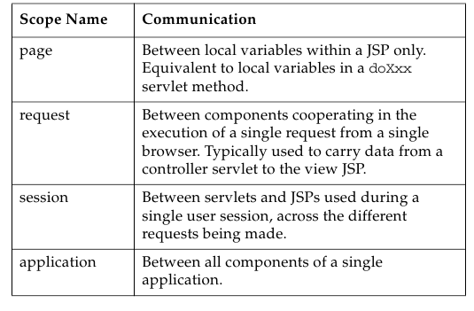

More Details About the Expression Language (EL)

EL was introduced in “Using Data in the JSP” . As you might expect, EL is considerably more powerful than was indicated at that point.
Syntax Overview
The syntax of EL in a JSP page is as follows:
${expr}

EL and Scopes

In fact, EL scans all four scopes looking for a bean with the name given in the expression. Clearly if two beans with the same name exist in different scopes, confusion might arise. However, the scopes are scanned in a fixed order: page, request, session, and application.

EL Implicit Objects

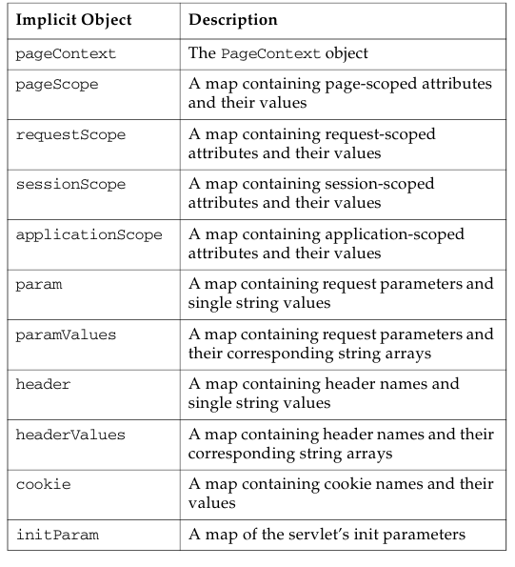
The variables used to explicitly name a scope containing a bean are called implicit objects. Implicit objects are pre-defined variable names known to EL that provide access to bean-like data.

The Dot Operator In EL

It is probably obvious by now that the EL syntax allows cascading of the dot operator to select elements from within elements. This is exactly equivalent to calling methods on the return values of methods in Java itself. The name elements used with the dot operator must follow the naming conventions for Java identifiers.

Array Access Syntax With EL

If a bean returns an array, an element in the array can be accessed by providing its index:
${paramValues.fruit[2]}
As with Java, the dot operator may be used to access elements of an object after it has been selected from an array.

EL and Errors

EL silently hides errors that arise from null references or not-found variables. That is, such expressions translate to empty strings. This is deliberate, as it ensures that errors do not mess up the pages that the user sees. Of course, the information on the page might be incomplete.

EL Arithmetic Operators

The five arithmetic operators that are available in EL.

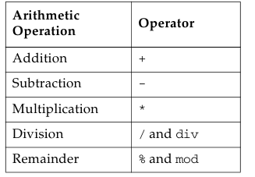

Comparisons and Logical Operators

The six comparison operators available in EL.

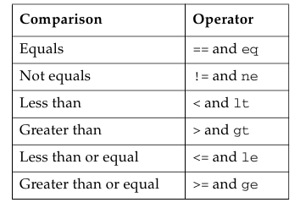

Configuring the JSP Environment

You can modify the behavior of JSP pages in the application using the jsp-config tag in the web.xml deployment descriptor.

<jsp-config>
<jsp-property-group>
<url-pattern>/scripting_off/*</url-pattern>
<scripting-invalid>true</scripting-invalid>
</jsp-property-group>
<jsp-property-group>
<url-pattern>/EL_off/*</url-pattern>
<el-ignored>true</el-ignored>
</jsp-property-group>
</jsp-config>
</web-app>

Presentation Programming

Standard Custom Tags

When the tag library mechanism was introduced, tags were called “custom tags,” as each developer was expected to create their own. However, a popular set of tags was rapidly adopted as the “standard tags” (or JSTL). For this reason, you’ll often here tags referred to as both custom, and standard, sometimes in the same sentence. Strictly speaking, there is now a set of standard tags, and others are custom tags. Both use the same custom tags mechanism for their implementation and execution.

Tag Example

Key View Programming Tags

Two tags in particular provide great value for view programming. Good design suggests you should take care to use them to perform the programmatic operations that relate specifically to the presentation.

JSTL if Tag

The if tag is a conditional tag in the core library. You use this tag to conditionally evaluate what is contained in the tag’s body or to set a variable based on the evaluation of a test. When a body is supplied, the body is only evaluated if the test expression is true:
<c:if test=”expression” var=”varName”
[scope=”{page|request|session|application}”] >
body evaluated if expression evaluates to true
</c:if>
The var attribute specifies the variable name into which the results of the test (true or false) will be stored. The scope attribute specifies where the variable will be stored.

JSTL forEach Tag

The forEach tag provides a mechanism for iteration over the body of the tag within a JSP page. The attributes of the tag are items, var, varStatus, begin, end, and step. You use this tag to iterate over an existing collection or for a specified number of iterations. To iterate over a collection, the items attribute is used to supply the name of a collection.
<c:forEach items=”collection” [var=”varName”]
[varStatus=”varStatusName”]
[begin=”begin”] [end=”end”] [step=”step”]>
body content
</c:forEach>

JSTL Example:

Developing JSP Pages

Objectives

Upon completion of this module, you should be able to:
● Describe JSP page technology
● Write JSP code using scripting elements
● Write JSP code using the page directive
● Write JSP code using standard tags
● Write JSP code using the EL
● Configure the JSP page environment in the web.xml file

JavaServer Pages Technology

This module introduces the tools and techniques of those original JSPs, so that you will be equipped to work on such pages should you be called upon to do so.

How a JSP Page Is Processed

A JSP page is essentially source code, and must be converted into a servlet before it can service requests. Figure shows the steps of JSP page processing.

1. Translate the JSP to servlet code.
2. Compile the servlet to bytecode.
3. Load the servlet class.
4. Create the servlet instance.
5. Call the jspInit method.
6. Call the _jspService method.

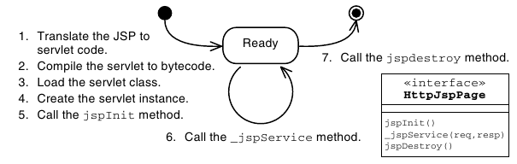

1) JSP Page Translation
2) JSP Page Compilation
3) JSP Page Class Loading
4) JSP Page Servlet Instance
5) JSP Page Initialization
6) JSP Page Service
7) JSP Page Destroyed

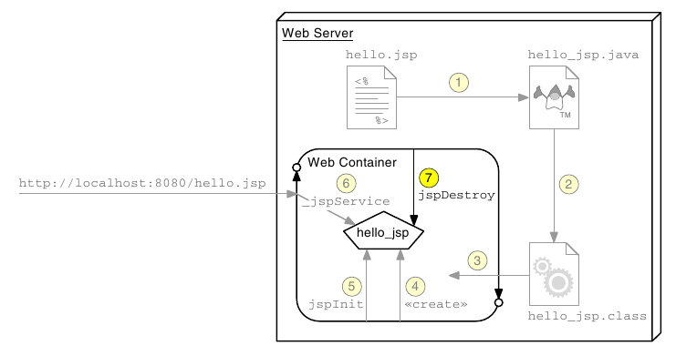

Writing JSP Scripting Elements

JSP scripting elements are embedded with the <% %> tags and are processed by the JSP engine during translation of the JSP page. Any other text in the JSP page is considered part of the response and is copied verbatim to the HTTP response stream that is sent to the web browser.

<html>
<%-- scripting element --%>
</html>

Lists the five types of scripting elements.

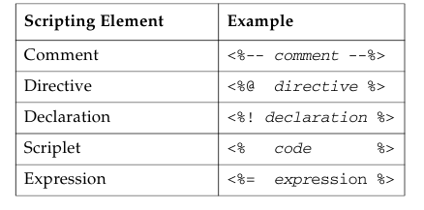

Comments

There are three types of comments permitted in a JSP page:

● HTML comments

● JSP page comments

● Java technology comments

Directive Tag

A directive tag provides information that affects the overall translation of the JSP page. The syntax for a directive tag is as follows:

<%@ DirectiveName [attr=”value”]* %>

Three types of directives are used in JSP pages: page, include, and taglib.

Declaration Tag

A declaration tag lets you include members in the JSP servlet class, either attributes or methods. The syntax for a declaration tag is as follows:
<%! JavaClassDeclaration %>

Scriptlet Tag

A scriptlet tag lets the JSP page developer include arbitrary Java technology code in the _jspService method. The syntax for a scriptlet tag is as follows:

<% JavaCode %>

Expression Tag

An expression tag holds a Java language expression that is evaluated during an HTTP request. The result of the expression is included in the HTTP response stream. The syntax for an expression tag is as follows:

<%= JavaExpression %>

Implicit Variables

The JSP engine gives you access to the following implicit variables, also called implicit objects, in scriptlet and expression tags.
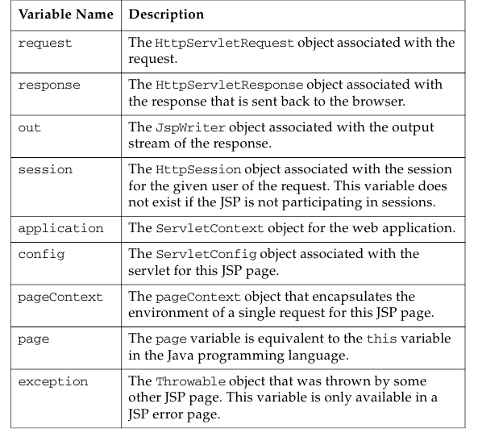

Using the page Directive

You use the page directive to modify the overall translation of the JSP page. For example, you can declare that the servlet code generated from a JSP page requires the use of the Date class:
<%@ page import=”java.util.Date” %>

You can have more than one page directive, but can only declare any given attribute once per page. This applies to all attributes except for the import attribute. You can place a page directive anywhere in the JSP file but it is a good practice to place the page directive at the beginning.

Including JSP Page Segments

There are two standard approaches to including presentation segments in your JSP pages:
● The include directive
● The jsp:include standard action

Using the include Directive

The include directive lets you include a segment in the text of the main JSP page at translation time. The syntax of this JSP technology directive is as follows:
<%@ include file=”segmentURL” %>

Using Standard Tags

The JSP specification provides standard tags for use within your JSP pages. Standard tags begin with the jsp: prefix. You use these tags to reduce or eliminate scriptlet code within your JSP page. However, the standard tags only provide limited functionality. Using the JSTL and EL reduces the need for the standard tags.

JavaBeans Components

A JavaBeans component is a Java technology class with at minimum the following features:
● Properties defined with accessors and mutators (get and set methods).
● A no-argument constructor.
● No public instance variables.
● The class implements the java.io.Serializable interface.

The useBean Tag

If you want to interact with a JavaBeans component using the standard tags in a JSP page, you must first declare the bean.

The syntax of the useBean tag is as follows:
<jsp:useBean id=”beanName”
scope=”page | request | session | application”
class=”className” />

The setProperty Tag

You use the setProperty tag to store data in the JavaBeans instance. The syntax of the setProperty tag is as follows:
<jsp:setProperty name="beanName" property_expression />

The getProperty Tag

The getProperty tag is used to retrieve a property from a JavaBeans instance and display it in the output stream. The syntax of the getProperty tag is as follows:

<jsp:getProperty name=”beanName”
property=”propertyName” />

Other Standard Tags

The following tables outline the standard tags defined in the JSP specification.

Include and Forward Standard Actions
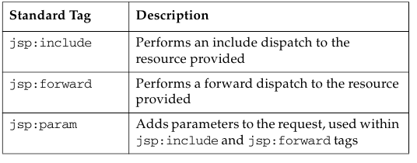
Standard Actions for Plug-ins
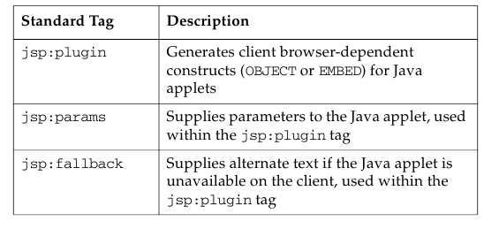

Developing JSP Pages Using Custom Tags

Objectives

Upon completion of this module, you should be able to:
● Describe the Java EE job roles involved in web application development
● Design a web application using custom tags
● Use JSTL tags in a JSP page

The JSTL

This module looks in more detail at the tags that are available in the JSTL.

The Java EE Job Roles Involved in Web Application Development

One reason behind the development of tags, and the JSTL, was to support the separate job roles often found in organizations developing large web applications. These roles often include:
● Web Designers – Responsible for creating the views of the application, which are primarily composed of HTML pages
● Web Component Developers – Responsible for creating the control elements of the application, which are almost exclusively Java technology code
● Business Component Developers – Responsible for creating the model elements of the application, which might reside on the web server or on a remote server (such as an EJB technology server)

Designing JSP Pages With Custom Tag Libraries

A custom tag is an XML tag used in a JSP page to represent some dynamic action or the generation of content within the page during runtime. Custom tags are used to eliminate scripting elements in a JSP page.

Compared with coding these conditions and loops in Java scriptlets, JSTL tags offer these advantages:
● Java technology code is removed from the JSP page.
● Custom tags are reusable components.
● Standard job roles are supported.

Custom Tag Library Overview

A custom tag library is a collection of custom tag handlers and the tag library descriptor file. A custom tag library is a web component that is part of the web application. Figure 8-1 shows a tag library as a web component.

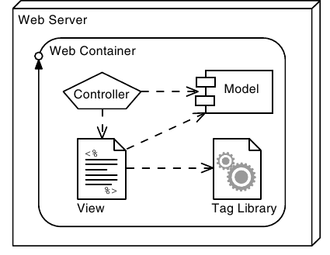

Custom Tag Syntax Rules

JSP technology custom tags use XML syntax. There are four fundamental XML rules that all custom tags must follow:

● Standard tag syntax must conform to the following structure:
<prefix:name {attribute={”value”|’value’}}*>
body
</prefix:name>

● Empty tag syntax must conform to the following structure:
<prefix:name {attribute={”value”|’value’}}* />

● Tag names, attributes, and prefixes are case sensitive.

● Tags must follow nesting rules:

JSTL Sample Tags

The JSTL core library contains several tags that reduce the scripting necessary in a JSP page.

JSTL set Tag

JSTL url Tag

JSTL out Tag

more tags

Using a Custom Tag Library in JSP Pages

A custom tag library is made up of two parts: the JAR file of tag handler classes and the tag library descriptor (TLD). The TLD is an XML file that names and declares the structure of each custom tag in the library.

A JSP page can use a tag library by directing the JSP technology translator to access the TLD. This is specified using the JSP technology taglib directive. This directive includes the TLD URI and a custom tag prefix.

<%@ taglib prefix=”c” uri=”http://java.sun.com/jsp/jstl/core” %>

JSTL Tags

Lists the five functional categories of tags in JSTL, their URI values (to be used in JSP taglib directives), and the typical prefix used for each.

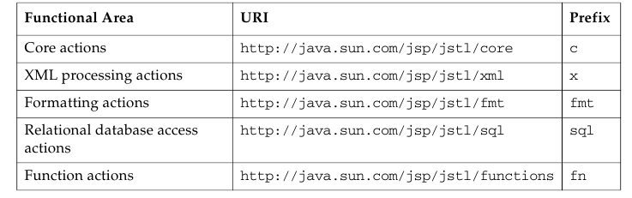

Core Actions

Tags in the core functional area include actions to output to the response stream, perform conditional operations, and perform iterations.

XML Processing

JSTL includes tags for processing XML documents.

Formatting Actions

JSTL includes tags for internationalization and formatting.

Relational Database Access

JSTL contains tags for database access.

Functions

JSTL contains tags for functions, many of them from java.lang.String.

More Controller Facilities

Objectives

Upon completion of this module, you should be able to:
● Understand the lifecycle of a servlet
● Understand the threading model of a servlet
● Write filters and apply them to groups of servlets or JSPs
● Handle multipart form data

Servlet Life Cycle Overview

A graphical view of the servlet life cycle is provided by an annotated UML Statechart diagram.

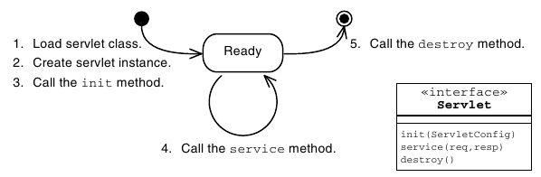

The ServletConfig API

Every web container vendor must implement the ServletConfig interface. Instances of this class are passed into the init(ServletConfig) method defined in the Servlet interface.

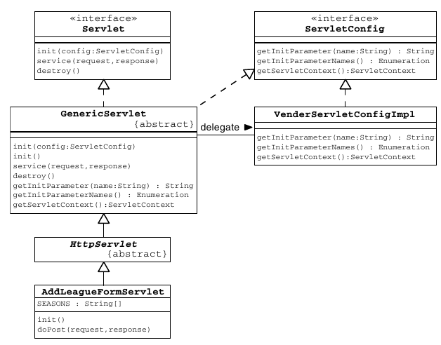

Servlet Lifecycle and Annotations

Java EE 5 introduced some key annotations for container managed objects. In the web container, these objects are Servlets, Filters, and many listeners.

A variety of annotations provide dependency injection for different resource types. Some of these are listed below:
● @EJB
● @Resource
● @PersistenceContext
● @PersistenceUnit
● @WebServiceRef

In addition, several plural versions of these annotations are defined so that multiple resources may be injected.

Lifecycle Method Annotations

The Java EE specification requires that objects that qualifies dependency injection must also be supported with two lifecycle annotations. These are @PostConstruct and @PreDestroy. These methods are very similar in function to the init() and destroy() methods of a servlet.

If an @PostConstruct method throws any exceptions the container must abandon the object. No methods may be called on the object and the object must not be put into service.

Servlets and Threading

Specifically, this means that if multiple clients invoke behavior that calls the same method, in the same servlet instance, at the same time, then that one servlet method (in a single servlet instance), might be concurrently executing many times under the control of many different threads—one thread for each client.

Handling Concurrency

Data Shared Between Invocations by a Single Client

Data that are shared between invocations by a single client are essentially session data. At first glance, this should simply involve using the HttpSession object to ensure that the lifetime and visibility of the data are appropriate. Unfortunately, however, it is possible for a single client to invoke servlets concurrently. This can arise if multiple browser windows or tabs are open.

Sharing Data Between Multiple Clients

The sharing of data between clients can be achieved by storing those items in instance variables in the servlet object itself. However, if you are using older web containers prior to 2.4 of the servlet specification, be aware that many used to create multiple instances of each servlet class. If this happens, writing data to the instance variable in one servlet will not reliably result in all other threads seeing that data, because some threads will execute in other servlet instances. Instead, such data should be stored in the application context.

Web Container Request Cycle

One of the benefits to the servlet framework is that the web container intercepts incoming requests before they get to your code, preprocessing the request and additional functionality (such as security). The container can also post-process the response that your servlet generates.

Web Container Request Processing

Shows the creation of a request and a response for each request.
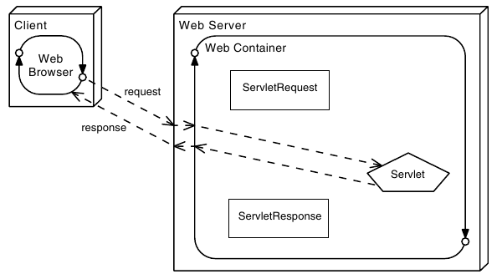

Applying Filters to an Incoming Request

Filters are components that you can write and configure to perform some additional pre-processing and post-processing tasks. When a request is received by the web container, several operations occur:

1. The web container performs its pre-processing of the request. What happens during this step is the responsibility of the container provider.
2. The web container checks if any filter has a URL pattern that matches the URL requested.
3. The web container locates the first filter with a matching URL pattern. The filter’s code is executed.
4. If another filter has a matching URL pattern, its code is then executed. This continues until there are no more filters with matching URL patterns.
5. If no errors occur, the request passes to the target servlet. 6. The servlet passes the response back to its caller. The last filter that was applied to the request is the first filter applied to the response.
7. The first filter originally applied to the request passes the response to the web container. The web container might perform post-processing tasks on the response.
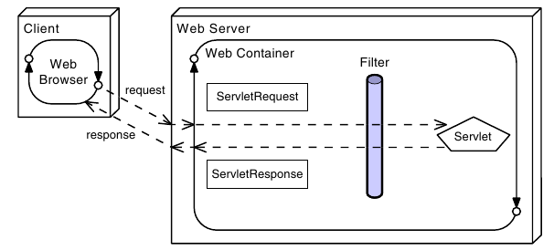
You should design filters to perform one task in the application, which helps ensure that they remain modular and reusable. You do not need to apply the same filters to every request.
Shows modular use of filters.

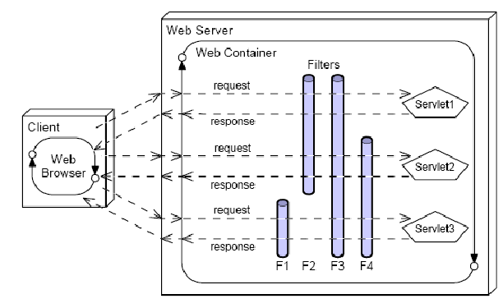

Filters can be used for operations such as:

● Blocking access to a resource based on user identity or role membership
● Auditing incoming requests
● Compressing the response data stream
● Transforming the response
● Measuring and logging servlet performance

Filter API

The Filter API is part of the base servlet API. The interfaces can be found in the javax.servlet package.

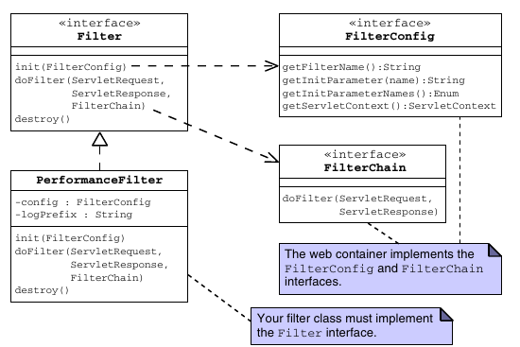

Developing a Filter Class

Sample filter code:

The init Method

The init method of a filter is called once when the container instantiates a filter. This method is passed a FilterConfig, which is typically stored as a member variable for later use .

The doFilter Method

The doFilter method is called for every request intercepted by the filter. It is the filter equivalent of a servlet’s service method. This method is passed three arguments:ServletRequest,ServletResponse, and FilterChain.

The destroy Method

Before the web container removes a filter instance from service, the destroy method is called. You use this method to perform any operations that need to occur at the end of the filter’s life.

Configuring the Filter

Because the web container is responsible for the life cycles of filters, filters must be configured in the web application’s deployment descriptor.

Configuring a Filter Using Annotations

Java EE 6 provides an annotation that allows declaration and mapping of a filter. The annotation is @WebFilter, and this allows specification of the filter name, the url patterns to which it responds, and the types of invocation for which it should be invoked.

Declaring a Filter in the web.xml File

For older Java EE versions, of for version independence, you can define and map filters using the web.xml deployment descriptor file.

Shows a filter declared within filter elements in the deployment descriptor.
<filter>
<filter-name>perfFilter</filter-name>
<filter-class>sl314.web.PerformanceFilter</filter-class>
<init-param>
<param-name>Log Entry Prefix</param-name>
<param-value>Performance: </param-value>
</init-param>
</filter>

Declaring a Filter Mapping in the web.xml File

Filters are executed when the resource to which they are mapped is requested.

<filter-mapping>
<filter-name>perfFilter</filter-name>
<url-pattern>*.do</url-pattern>
</filter-mapping>

Handling Multipart Forms

Java EE 6 introduced a mechanism to simplify handling of multipart form data. Three key elements make this up, which are: additional methods in the javax.servlet.http.HttpServletRequest object, an annotation
javax.servlet.annotation.MultipartConfig, and an interface
javax.servlet.http.Part.

More Options for the Model

Objectives

Upon completion of this module, you should be able to:
● Understand the nature of the model as a macro-pattern
● Implement persistent storage for web applications using JDBC or Java Persistence API

The Model as a Macro-Pattern

In the MVC architecture pattern, the model component embodies a great deal of functionality. Here are some of the responsibilities that fall to the model as it has been discussed so far:
● Present an interface to the controller
● Implement the business logic
● Present a JavaBeans compliant view of the data to the view component, in a form that is convenient for the view to use.

Database and Resource Access

Virtually all practical web applications will require access to a database or other external support system. Good OO requires that the elements of the model that handle this should be separated from the elements of the model that represent the domain objects and the elements that perform business operations on those objects.

Data Access Object (DAO) Pattern

The DAO pattern eases maintenance of applications that use databases by separating the business logic from the data access (data storage) logic. The data access implementation (perhaps JDBC technology calls) is encapsulated in DAO classes. The DAO pattern permits the business logic and the data access logic to change independently, increasing the flexibility of your application. For example, if the database schema changes, you only need to change the DAO methods, and not the business services or the domain objects.

JDBC API

The JDBC API is the Java technology API for interacting with a database management system (DBMS). The JDBC API includes interfaces that manage connections to the DBMS, statements to perform operations, and result sets that encapsulate the result of retrieval operations.

Developing a Web Application Using a Database

Traditional Approaches to Database Connections

In Java technology, the most basic mechanism for obtaining a database connection is to use the static method java.sql.DriverManager.getConnection. Obtaining an exclusive connection is expensive, and the total number of concurrent connections is usually limited. Because connections are needed in many places in a Java EE application, using this approach would create performance problems in a real application.

Using a DataSource and the Java Naming and Directory Interface API

A DataSource is a resource that contains the information needed to connect to an underlying database (typically the database URL, driver, user name, and password). All Java EE application servers are required to provide a naming service into which resources such as DataSource can be stored. The naming service can be queried using the Java Naming and Directory InterfaceTM (JNDI) APIs. Behind the scenes, the server will maintain a pool of connections. You can use the DataSource to retrieve a connection from this pool.

Shows how DataSource is used in an application.

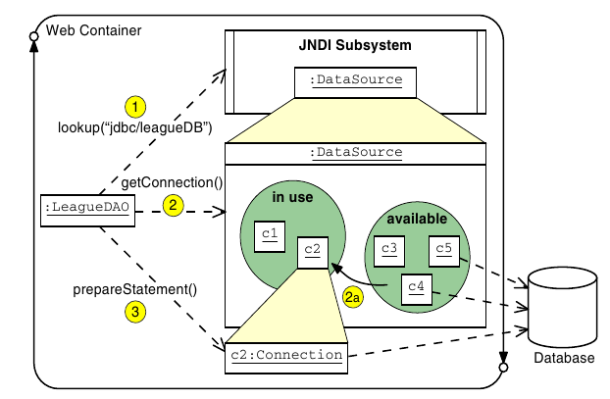

Configuring a DataSource and the JNDI API

The DataSource reference must be created in the application server, and published by name in the JNDI lookup service. In principle, three things must be configured:
● The database and the tables/schema for the application
● A connection pool
● An entry in the JNDI service that references the connection pool

The method of achieving these steps varies between application servers, and the lab exercise for this module will guide you through that process for the GlassFishTM/NetBeans combination.

Object Relational Mapping Software

Writing code to translate from an object-oriented domain scheme to a relational database scheme can be a time consuming endeavor. Object Relational Mapping (ORM) software attempts to provide this mapping to OO software developers without requiring much or any coding. Often just configuration information in the form of code annotations or XML configuration files are supplied to ORM software. Examples of existing ORM software are EclipseLink and Hibernate.

One-to-One Mapping of Java Objects to Relational Tables
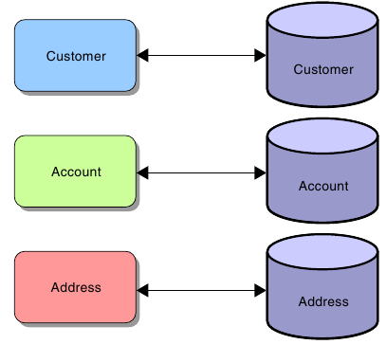

Java Persistence API Structure

The Java Persistence API splits the problem of persistence into a number of key elements, each of which requires configuration if the system is to work. These elements are:

● An entity class, defined by the programmer, that presents the object- oriented view of the business entity.
● A mapping between the fields of the entity class and the schema of the persistent storage. This can be provided using annotations on fields within the entity class along with default mapping rules, and may be modified where necessary by additional annotations.
● Mapping that specifies the persistence implementation (recall that Java Persistence API is simply a specification), the JNDI DataSource, and other configuration elements of the implementation. This is provided using a file called persistence.xml.
● A JNDI lookup service entry that maps the published name of the DataSource to an actual DataSource. This is provided in a container-specific manner as discussed earlier.
● A DataSource that is connected to a connection pool. This has also been discussed earlier, and is also provided in a container-specific way.
● A connection pool that is connected to the database. As before, this is container specific and was introduced earlier.
● The actual database, along with the necessary tables and schema to support the application. Again, this is container specific.

Entity Class Requirements

To define an entity class, you are required to perform the following tasks:
● Declare the entity class.
● Verify and override the default mapping.

Declaring the Entity Class

The following steps outline a process you can use to declare an entity class.
1. Collect information required to declare the entity class. This step involves identifying the application domain object (identified in the object oriented analysis and design phase of application development) that you want to persist.
● Use the domain object name as the class name.
● Use the domain object field names and data types as the field names and types of entity classes.
2. Declare a public Java technology class. The class must not be final, and no methods of the entity class can be final. The class can be concrete or abstract. The class can not be an inner class.
3. If an entity instance is to be passed by value as a detached object through a remote interface, then ensure the entity class implements the Serializable interface.
4. Annotate the class with the javax.persistence.Entity annotation.
5. Declare the attributes of the entity class. Attributes must not have public visibility. They can have private, protected, or package visibility. Clients must not attempt to access an entity classes’ attributes directly.
6. You can optionally declare a set of public getter and setter methods for every attribute declared in the previous step.
7. Annotate the primary key field or the getter method that corresponds to the primary key column with the Id annotation.
8. Declare a public or protected no-arg constructor that takes no parameters. The container uses this constructor to create instances of the entity class. The class can have additional constructors.

Life Cycle and Operational Characteristics of Entity Components

Besides entity classes, there are several key concepts that must be understood to begin leveraging the Java Persistence API. They are:

● Persistence Unit

● Entity manager

● Persistence context

● Persistent identity

Persistence Units

A persistence unit is a collection of entity classes stored in a EJB-JAR, WAR, or JAR archive along with a persistence.xml file. The key concept to understand at this point is that a persistence unit defines what entity classes are controlled by an entity manager. A persistence unit is limited to a single DataSource.

The persistence.xml file

Configuration of a persistent unit is controlled by an XML configuration file named persistence.xml which does the following:
● Configures which classes make up a persistence unit
● Defines the base of a persistence unit by its location
● Specifies the DataSource used

The EntityManager

An entity manager provides methods to control events of a persistence context and the life cycle of entity instances in a persistence context. An entity manager has the following characteristics:
● Provides operations, such as flush(), find(), and createQuery(), to control a persistence context
● Replaces some of the functionality of home interfaces in EJB 2.1 entity beans An entity manager can be obtained using dependency injection in managed classes.
@PersistenceContext private EntityManager em;

Entity Instance Management

When a reference to an entity manager has been obtained, you use its methods to marshall entity instance data into and out of the database.

EntityManger Injection

EntityManager Methods

User Transactions

A UserTransaction object can be used to demarcate the boundaries of a transaction in your code. The UserTransaction object is created by injection as was the EntityManager. It can be created as a field in a class like this:
import javax.transaction.UserTransaction;
[...]
// Declaring a field in the class:
@Resource UserTransaction utx;
Then the UserTransaction methods begin, commit, rollback, and setRollbackOnly can be used to provide control over the transaction and its scope.

Java Persistence API Example

Asynchronous Servlets and Clients

Objectives

Upon completion of this module, you should be able to:
● Use the Asynchronous Servlet mechanism
● Use JavaScript to send an HTTP request from a client
● Process an HTTP response entirely in JavaScript
● Combine these techniques to create the effect of server-push

Asynchronous Servlets

Java EE 6 adds the option to perform request processing asynchronously. If this is done, then the servlet execution thread can be freed up to service requests from other clients, and the generation of the response may be performed in another thread, for example the thread that creates the trigger condition that allows the response to be prepared.

Separating Request Receipt from Response Generation

To allow for separation of request from response generation, the servlet API provides a class called AsyncContext. A servlet that wishes to hand off response generation to another thread can obtain an AsyncContext object and pass this to another thread, perhaps using a queue. The AsyncContext object provides access to the original HttpServletRequest and HttpServletResponse objects. This allows processing of the request and generation of the response. Additionally, the AsyncContext allows for a forwarding mechanism. This does not use the
RequestDispatcher, is achieved using one of serveral dispatch methods
in the AsyncContext itself.

Asynchronous Servlet Example

Asynchronous Listeners

The AsyncListener interface must be implemented by the listener that will be notified when these situations arise. The interface defines four listener methods:
● onComplete(AsyncEvent)
● onError(AsyncEvent)
● onTimeout(AsyncEvent)
● onStartAsync(AsyncEvent)

Asynchronous JavaScript Clients

In these Asyncrhonous JavaScript approaches, JavaScript code on the client is used to modify elements of the existing page based on a combination of the user’s interactions, local client-side processing, and information retrieved from the server. Remember that in a normal HTTP request, an entire page is fetched, but in this approach, JavaScript code fetches a small amount of data which is then integrated into the existing page. Usually the server’s response is really very small, for example, it might be just a fragment of HTML .

Simple Asynchronous Client Example

Combining Asynchronous Servlets With Asynchronous JavaScript

Although each of these techniques serves a purpose on its own, the two can be used together to create something akin to a server-push environment.

Consider a page containing JavaScript code that makes an asynchronous request for update from the server, and a server-side implementation that uses the asynchronous servlet techniques. Now, if the server does not choose to respond for several minutes, the user is not inconvenienced, as the body of the page is operating normally. Similarly, because of the use of asynchronous servlet execution, the resource load on the server is minimized. Consequently, the response may be sent at a time convenient to the server, and the effect of server-push is achieved in an architecturally manageable way.

Implementing Security

Objectives

Upon completion of this module, you should be able to:
● Describe a common failure mode in security
● Require that a user log in before accessing specific pages in your web application
● Describe the Java EE security model
● Require SSL encrypted communication for certain URLs or servlets

Security Considerations

Every application that is accessible over the web must consider security. Your site must be protected from attack, the private data of your site’s users must be kept confidential, and your site must also protect the browsers and computers used to access your site.

Confusion of Code and Data

A very substantial proportion of attacks against computer systems are variations on the seemingly simple idea of tricking the system into executing as code something that was passed into the system in the guise of data.

Consider that data do not control the operation of the machine, and further that the machine must allow data to be provided from outside— from the user. You can see that systems do not need to prevent data from entering the system. However, if the system’s willingness to allow data in can be tricked, it might be possible to provide code in the guise of data. This will bypass the security restrictions of the system and might be catastrophic.

Preventing Code as Data Attacks

Authentication and Authorization

The application usually needs to be able to identify the user, decide what operations the user is allowed to perform, and maintain the confidentiality and the integrity of the data that is in transit.
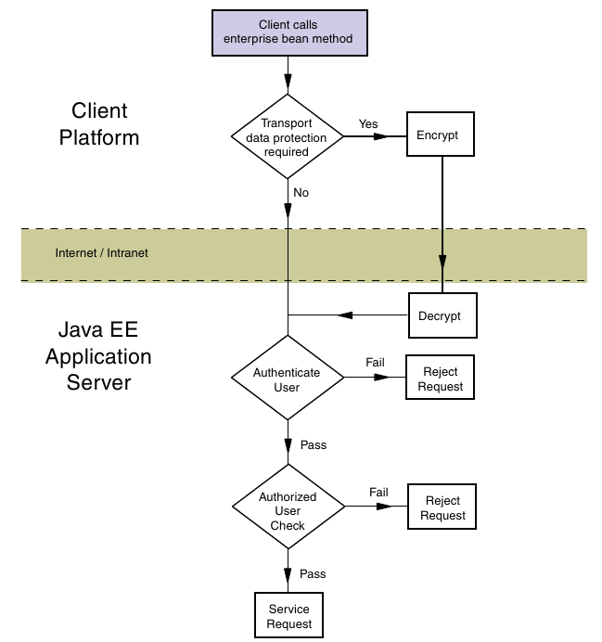

Authenticating the Caller

Caller authentication is the process of verifying what the user’s identity is, and consists of the following two steps.
1. Determine the identity claimed by the user
2. Verify that the user is who they claim to be (Authenticate the user)

Examining the Java EE Authorization Strategies

The primary purpose of the Java EE security model is to control access to business services and resources in the application. The Java EE security model provides two complementary strategies for access control: programmatic access control and declarative access control. Both strategies assume that the user has been authenticated by the application server, and the roles of which the user is a member can therefore be determined by the web container.
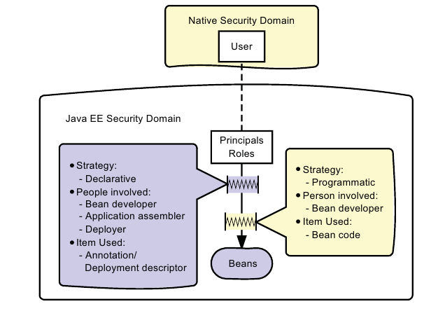

Using Declarative Authorization

Declarative authorization can be configured by the programmer, assembler, or deployer. Usually the programmer sets up some initial security properties when developing or testing the web application or its components. The assembler and deployer can then modify these properties according to the needs of the application as a whole. The declarative security policy can be defined in the servlets using annotations or the DD. The use of vendor-supplied packaging and deployment tools can be helpful here, because they can provide a basic, graphical representation of the security policy. Declarative authorization for web applications involves the following tasks:
● Collection of user credentials into a credentials database
● Declaration of roles
● Mapping users to roles
● Specification of role requirements for access to URLs

The following sections address these requirements.

Creating a Credentials Database

Declaring Security Roles

Mapping Users to Roles

Declaring Permission Requirements

Using Programmatic Authorization

Programmatic authorization is the responsibility of the bean developer. The following methods in the HttpServletRequest support programmatic authorization:
● boolean isUserInRole(String role)
● Principal getUserPrincipal()
Programmatic authorization is more expressive than the declarative approach, but is more cumbersome to maintain, and because of the additional complexity, more error prone. In particular, declarative authorization controls access at a role level, while programmatic authorization can selectively permit or block access to principals belonging to a role.

Using the isUserInRole Method

A servlet can use the isCallerInRole method to verify the role of the caller. The isUserInRole method allows recognition of roles without identifying the specific principal.

Enforcing Encrypted Transport

Provided the server has been configured with a public key certificate, you can require that communication between client and server be encrypted. If you allow some pages to be browsed over an unencrypted connection while others are encrypted, you might end up exposing cookies, particularly those that identify a session, in such a way that allows an attacker to pretend to be the user that logged in properly earlier.

Using an Annotation to Mandate Encrypted Transport

An annotation can be used to require encrypted transport. If used, the annotation applies to the servlet, rather than to a collection of URLs. The format of the annotation is:

@ServletSecurity(@HttpConstraint(transportGuarantee = TransportGuarantee.CONFIDENTIAL))

