Courtesy:Likhitha

Assignment list of Servlet

- Write a program to get the init parameter values from web.xml file.

- Write a program to display multiple values from single prameter?
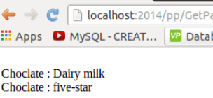
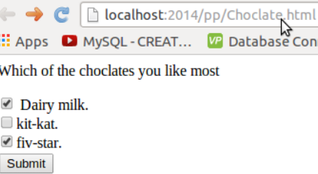

- Write a program using servlet, Jdbc to read employee id and display the information from database like employee name, address, cellno, dob, doj, salary and display a message “employee not exist” if employee id is not present in database?

- Write a program to develop a online application for purchase Laptop using servlet, jdbc.
(Hint: use http session). Create a database which store Laptop name, cost, screensize, ramcapacity, totallaptops.
- Create a customer registration application with html and store the data into database and display the data from database verifying the name and password .
