## **What is Jenkins?**

Jenkins is a server that encompasses various integration, testing, and deployment technologies as pre-built packages on ****one unified platform****. As an open-source tool ****written in Java****, Jenkins helps developers automate routine tasks and provide new builds as quickly as possible.

****Note****: The CI/CD pipeline is a compute intensive job, and our [Bare Metal Cloud servers](https://phoenixnap.com/bare-metal-cloud" \t "https://phoenixnap.com/kb/_blank) provide the necessary resources on dedicated hardware. Check out the pre-configured [compute instances](https://phoenixnap.com/bare-metal-cloud/instances" \t "https://phoenixnap.com/kb/_blank) to get started.

Jenkins is the leading [pipeline automation](https://phoenixnap.com/blog/devops-pipeline" \t "https://phoenixnap.com/kb/_blank) server for development and is an integral [CI/CD tool](https://phoenixnap.com/blog/cicd-tools" \t "https://phoenixnap.com/kb/_blank). The setup is straightforward and flexible, allowing a vast combination of [source code](https://phoenixnap.com/glossary/what-is-source-code" \t "https://phoenixnap.com/kb/_blank) and languages through a plugin-based system.

## **What is Jenkins Used For?**

Jenkins' main features are jobs and pipelines, which allow the following:

* ****Continuous integration**** pipelines for applications and [Infrastructure as Code](https://phoenixnap.com/blog/infrastructure-as-code-best-practices-tools" \t "https://phoenixnap.com/kb/_blank) (IaC), which helps automate building and testing.
* ****Continuous delivery**** pipelines through automated delivery workflows, which achieves non-stop code deployment.
* ****Automation**** jobs and pipelines for routine tasks, such as backup management, service statistics, etc.

## **Jenkins Tutorial for Beginners**

The following sections showcase how to set up and use Jenkins post-installation.

****Note:**** To install Jenkins, follow one of our OS-based guides for:

* [Windows 10](https://phoenixnap.com/kb/install-jenkins-on-windows" \t "https://phoenixnap.com/kb/_blank)
* [Ubuntu 18.04](https://phoenixnap.com/kb/install-jenkins-ubuntu" \t "https://phoenixnap.com/kb/_blank)
* [CentOS 8](https://phoenixnap.com/kb/how-to-install-jenkins-on-centos-8" \t "https://phoenixnap.com/kb/_blank)
* [Debian 10](https://phoenixnap.com/kb/install-jenkins-on-debian-10" \t "https://phoenixnap.com/kb/_blank)
* [macOS](https://phoenixnap.com/kb/install-jenkins-on-mac" \t "https://phoenixnap.com/kb/_blank)

Before continuing, make sure the Jenkins service is running. To check, run the following command in the Linux terminal:

sudo systemctl status Jenkins

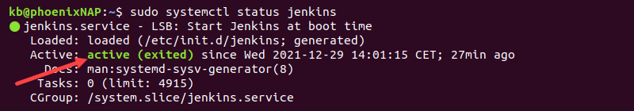

The service lists as ****active****.

If you're using Windows, continue to the next section.

****Note:****If the service is not running, follow our guide to [restart Jenkins](https://phoenixnap.com/kb/restart-jenkins" \t "https://phoenixnap.com/kb/_blank) manually.

### **Accessing Jenkins**

Open the browser and access the program through the following URL:

localhost:8080

The ****Unlock Jenkins**** page appears for the first-time setup. If you already have Jenkins installed, the login page loads.

If the page does not show up, the firewall blocks the port or is unavailable. Check your firewall settings and allow traffic on the default port (8080) or [change the Jenkins port](https://phoenixnap.com/kb/jenkins-change-port" \t "https://phoenixnap.com/kb/_blank).

In Linux, to enable traffic on port 8080 in the default [UFW firewall](https://phoenixnap.com/kb/how-to-enable-disable-firewall-ubuntu" \t "https://phoenixnap.com/kb/_blank), run the following commands:

sudo ufw enable

sudo ufw allow 8080

sudo ufw status

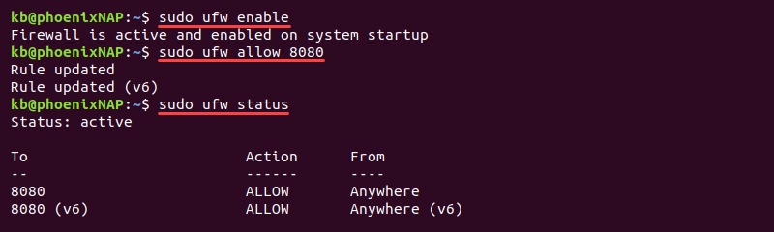

The commands enable the firewall and change the rules to allow traffic through Jenkins' default port.

### **Unlocking Jenkins**

The ****Unlock Jenkins**** page requires an administrator password to continue the installation. To fetch this password on Linux, run the following command in the terminal:

sudo cat /var/lib/jenkins/secrets/initialAdminPassword

IMG_258

For Windows, the initial admin password file is in the location displayed by the ****Unlock Jenkins**** page. If the folder is hidden, enable viewing hidden items.

Copy and paste the character sequence into the ****Administrator password**** field and click ****Continue****.

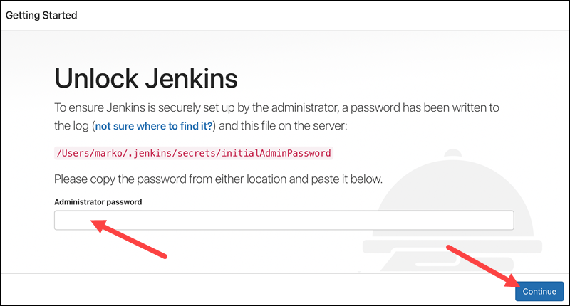

****Note:**** Visit our post [Jenkins vs. Kubernetes](https://phoenixnap.com/kb/jenkins-vs-kubernetes" \t "https://phoenixnap.com/kb/_blank) to learn how these two open-source tools differ.

### **Jenkins Management**

To enter the Jenkins management page, click ****Manage Jenkins**** in the left menu.

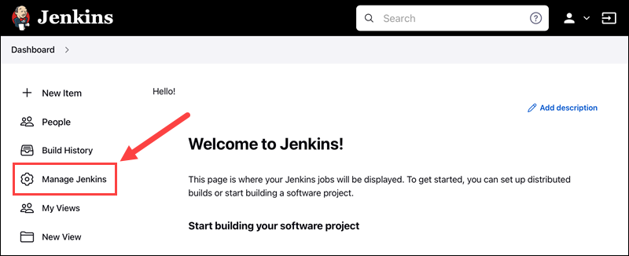

The management options divide into sections based on functionality.

****System Configuration****

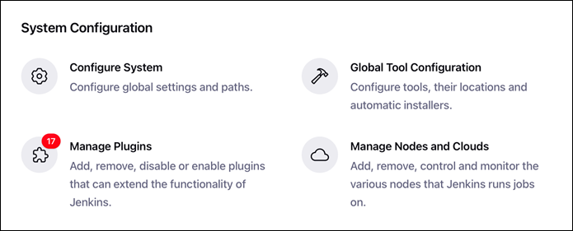

* ****Configure System**** manages paths and global options for Jenkins.
* ****Global Tool Configuration****manages tools, their locations, and automatic installers.
* ****The Manage Plugins**** page is the primary option for plugin control, such as installing, removing, and disabling existing plugins.
* ****Manage Nodes and Clouds**** is the central place to manage Jenkins' nodes and clouds.

****Security****

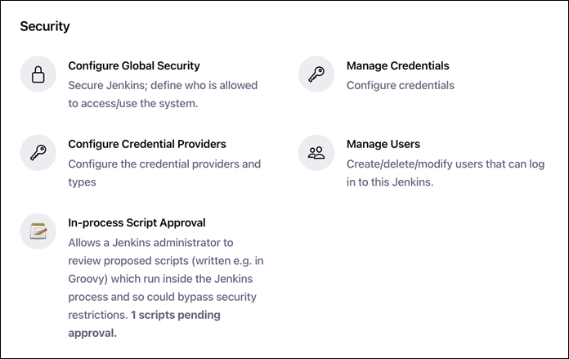

* ****Configure Global Security****is where the general security management takes place, such as authentication, authorization, [SSH](https://phoenixnap.com/kb/what-is-ssh" \t "https://phoenixnap.com/kb/_blank) server options, etc.
* ****Manage Credentials**** provides an overview of credentials for plugins and apps which require authentication.
* ****Configure Credential Providers**** allows excluding and restricting certain credential providers.
* ****Manage Users**** lists the users who can access Jenkins.
* ****In-Process Script Approvals**** helps manage which scripts the [system administrator](https://phoenixnap.com/glossary/system-administrator-sysadmin" \t "https://phoenixnap.com/kb/_blank) must overview and approve before use.

****Status Information****

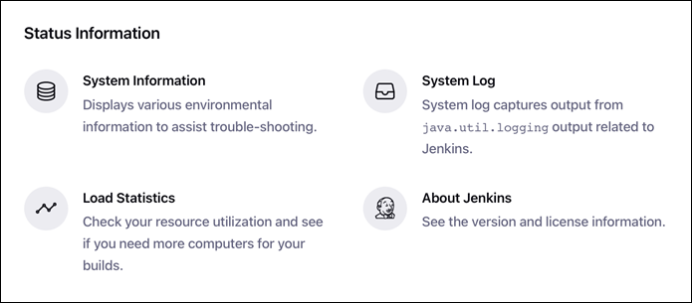

* ****System Information**** displays environment information, such as program information, environmental variables, plugin versions, and memory usage. Use this option to troubleshoot issues with Jenkins.
* ****System Log**** keeps the [Jenkins log records](https://phoenixnap.com/kb/jenkins-logs" \t "https://phoenixnap.com/kb/_blank).
* ****Load Statistics**** shows the resource use and valuable performance metrics.
* ****About Jenkins**** shows the license and dependency information for plugins.

****Troubleshooting****

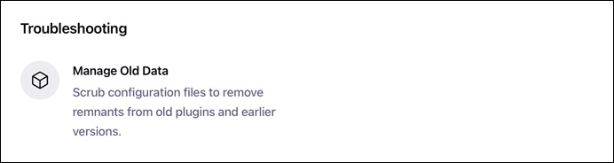

* ****Manage Old Data**** helps manage changes to data storage, either due to downgrades or plugin removal.

****Tools and Actions****

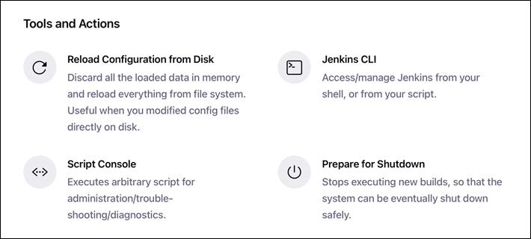

* ****Reload Configuration from Disk**** reloads all changes to the config files. This option is useful when changes happen on the disk.
* ****Jenkins CLI**** provides information on how to run Jenkins from the CLI and the documentation for the commands.
* ****Script Console**** is a built-in Groovy script console for running scripts and troubleshooting directly from Jenkins.
* ****Prepare Shutdown**** opens the interface for a safe Jenkins server shutdown.

### **Configuring Jenkins**

Jenkins offers many global configuration options. The primary function is to set paths for various plugins.

To access the Jenkins configuration:

1. On the ****Dashboard****, select ****Manage Jenkins****.

2. Choose ****Configure System****.

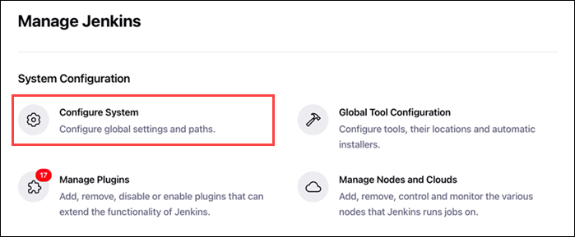

Below are explanations for each field's function.

#### **Home Directory**

The first field on the ****Configure System**** page is the ****Home directory****.

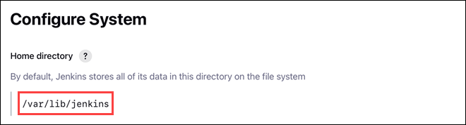

The path is where Jenkins stores all the data on the file system.

#### **System Message**

The following section shows a text box for entering a ****System Message****.

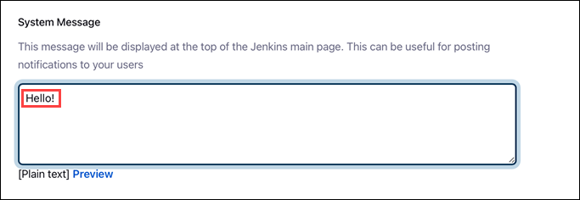

The message shows up on the Jenkins main page.

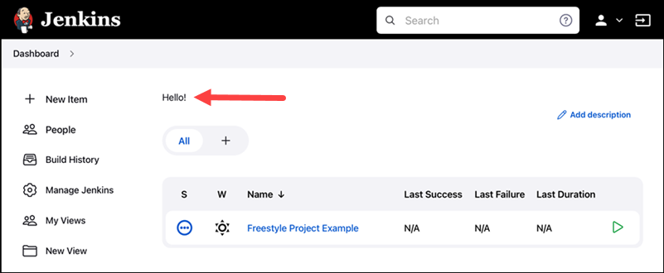

The message is visible for all users when they log in. Use the message to display information and notifications.

****Jenkins Location****

The ****Jenkins Location**** section consists of two fields:

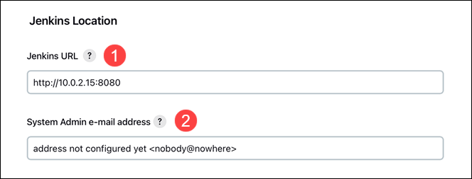

1. ****Jenkins URL**** - The URL is **http://localhost:8080** by default. Jenkins displays a warning about using localhost as the hostname. Change the hostname to the numerical address, and the warning resolves.

2. ****System Admin e-mail address**** - Notifications from Jenkins to project owners come from this e-mail. The two allowed e-mail formats are:

* email@address.com
* Name Surname <email@address.com>

#### **Global Properties**

The ****Global Properties**** section includes two key checkboxes:

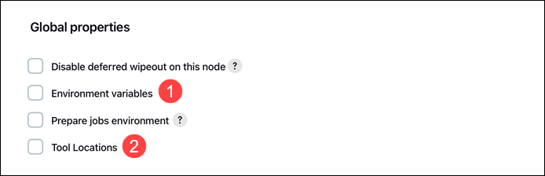

1. ****Environment variables**** allow defining global variables available for any job or pipeline. For more on environment variables, follow our tutorial for [Jenkins environment variables](https://phoenixnap.com/kb/jenkins-environment-variables" \t "https://phoenixnap.com/kb/_blank).

2. ****Tool locations**** allows specifying tool locations by hand, overriding global configuration.

#### **E-mail Notification**

The ****E-mail Notification**** settings are for configuring the ****SMTP e-mail server****, in addition to the ****Default user e-mail suffix**** for all users.

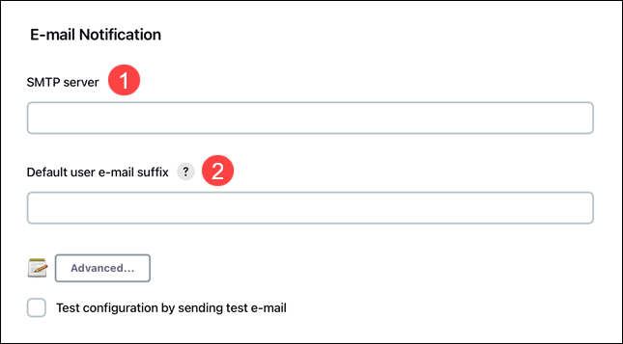

For example, use **@<company name>.com** if most users have the e-mail in that format. Users can override the suffix when necessary.

### **Managing Plugins**

Navigate to ****Manage Plugins**** from the ****Manage Jenkins**** page to handle Jenkins plugins. Plugin maintenance covers installing, uninstalling, and updating plugins.

#### **Install a Plugin**

To install a Jenkins plugin, follow the steps below:

1. On the ****Manage Plugins**** page, click the ****Available**** tab.

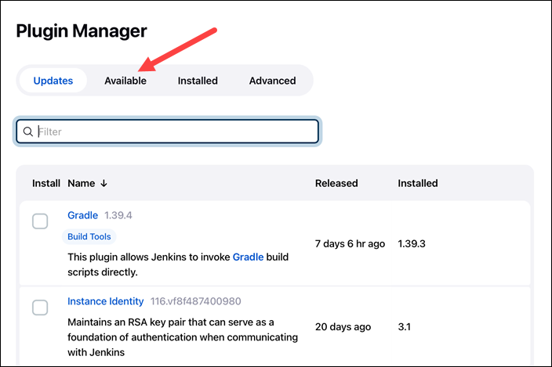

2. The list displays all the available plugins. Search for a plugin in the search bar.

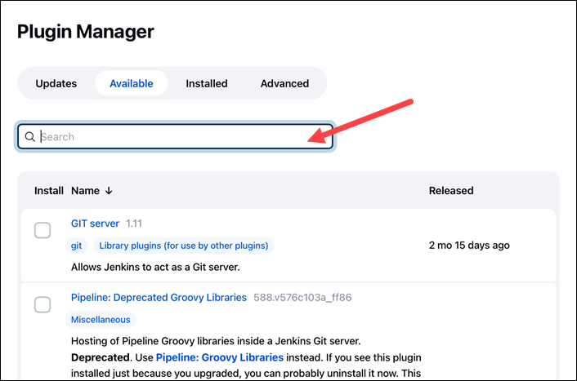

If the plugin does not show up, click ****Check now**** to update information.

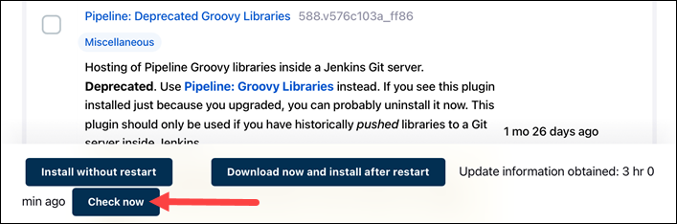

3. Click the checkbox next to the plugin's name and select ****Install without restart****.

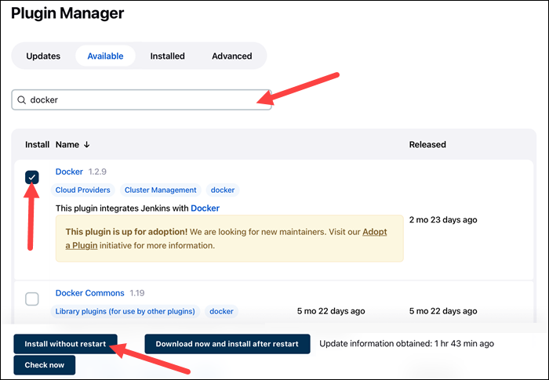

4. The page shows installation progress. When the plugin installs, click the ****Restart Jenkins**** checkbox to restart Jenkins automatically.

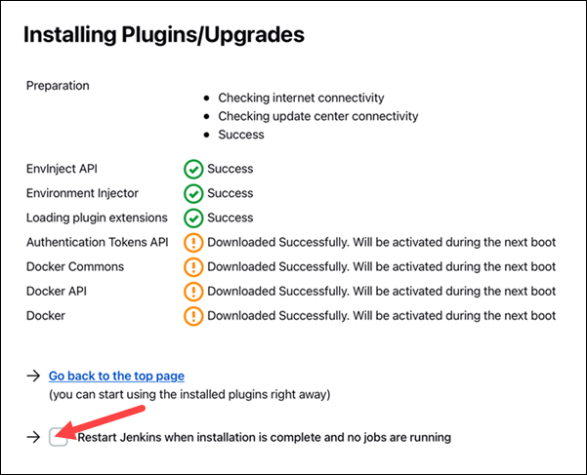

Continue working as usual in Jenkins while the installation runs in the background. When complete, Jenkins restarts and shows the login page.

#### **Uninstall a Plugin**

To uninstall a plugin from Jenkins, follow the instructions below:

1. On the ****Manage Plugins**** page, click the ****Installed****tab.

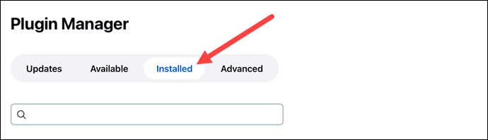

2. Enter the plugin's name in the search box to filter information.

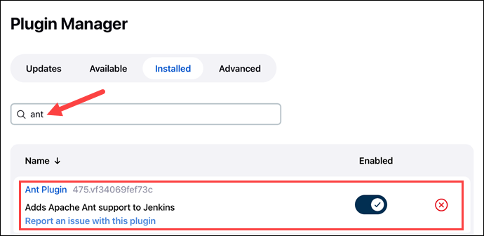

3. Click the ****Uninstall**** button in the last column.

4. A warning page appears, asking to confirm the uninstall.

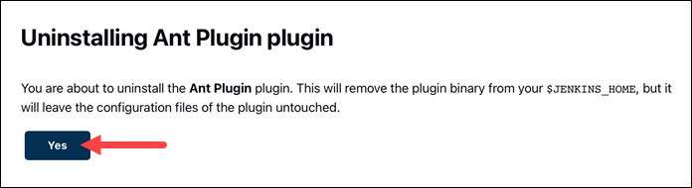

Click ****Yes**** to remove the plugin.

5. Restart Jenkins to complete the uninstall.

#### **Update a Plugin**

When plugin updates are available, a notification appears visible from the ****Manage Jenkins**** page.

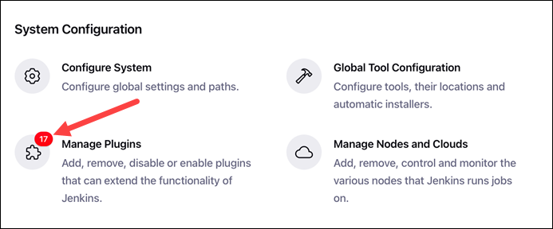

Updating a plugin is optional due to dependencies. To update a plugin, do the following:

1. On the ****Manage Plugins**** page, a list of available updates shows up in the ****Updates**** tab.

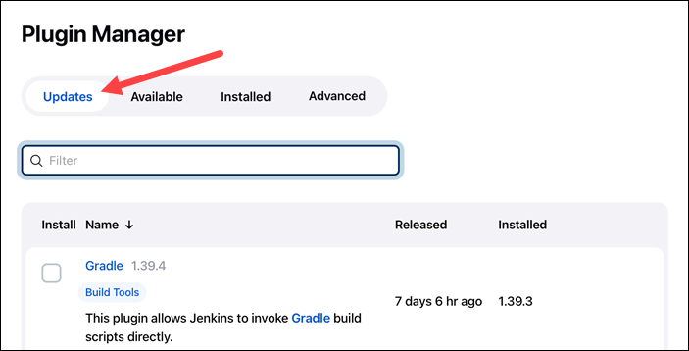

2. At the footing of the page are options for quick selection. Choose ****All**** to update all the plugins or ****Compatible**** to update only those with compatible dependencies.

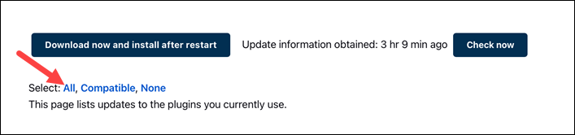

Alternatively, search a plugin by name and click the checkbox to update a specific plugin.

3. Click ****Download and install after restart****.

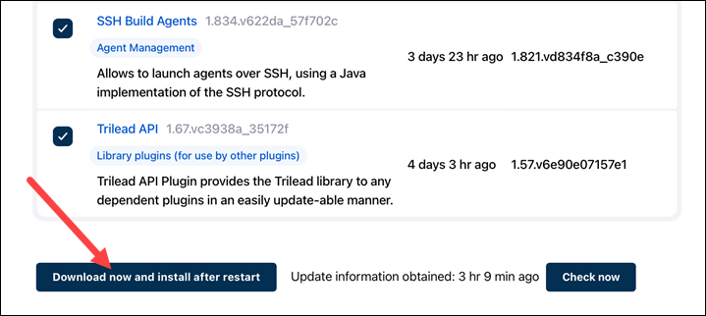

4. The updates download automatically.

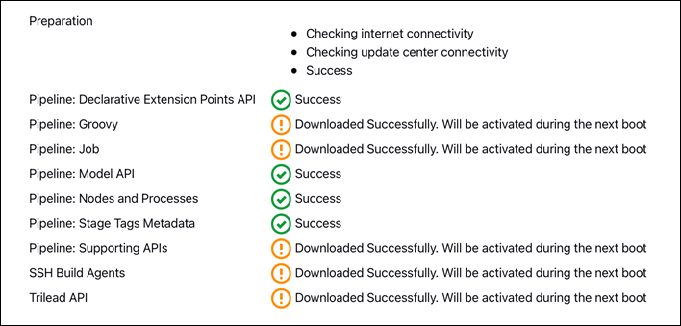

When complete, restart Jenkins, and the updates activate immediately.

### **Setting Up Git**

[Git](https://phoenixnap.com/kb/what-is-git" \t "https://phoenixnap.com/kb/_blank) comes as a plugin for Jenkins. The Git plugin installs when choosing the ****Install suggested plugins****option during the installation process.

If the plugin is not available already, follow the instructions below.

****Note:**** The setup showcases the steps for a preinstalled Git. To install Git, follow one of our installation guides for:

* [CentOS 7](https://phoenixnap.com/kb/how-to-install-git-on-centos-7" \t "https://phoenixnap.com/kb/_blank)
* [CentOS 8](https://phoenixnap.com/kb/how-to-install-git-centos-8" \t "https://phoenixnap.com/kb/_blank)
* [Ubuntu 18.04/20.04](https://phoenixnap.com/kb/how-to-install-git-on-ubuntu" \t "https://phoenixnap.com/kb/_blank)
* [Windows](https://phoenixnap.com/kb/how-to-install-git-windows" \t "https://phoenixnap.com/kb/_blank)

#### **Step 1: Install Git Plugin**

If you already have the Git plugin, skip to the next section. Otherwise, to install the Git plugin, do the following:

1. On the ****Dashboard**** page, click ****Manage Jenkins****.

2. Select ****Manage Plugins****.

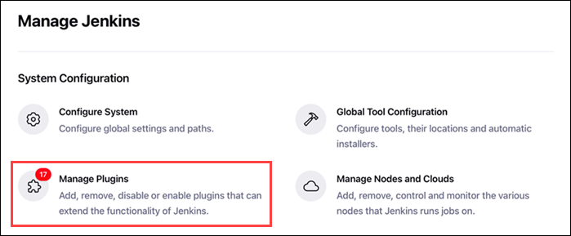

3. Select the ****Available**** tab.



4. Search for ****Git****in the search bar and press ****Enter****.

5. Tick the checkbox next to the plugin and click ****Install without restart****.

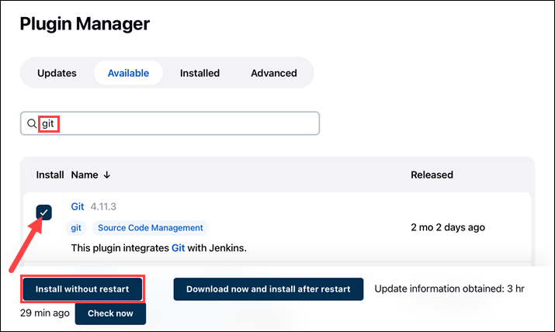

6. Once the plugin installs, restart Jenkins and continue to the next step.

#### **Step 2: Set Git Path**

To set up the Git plugin, follow the steps below:

1. On the Jenkins ****Dashboard**** page, click ****Manage Jenkins****.

2. Select ****Global Tool Configuration****.

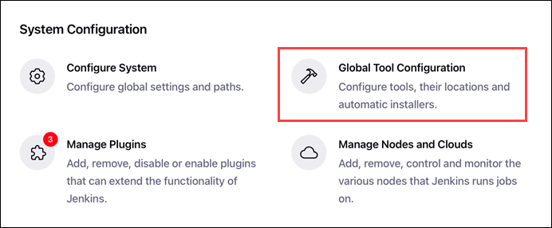

3. Scroll down to the ****Git**** section.

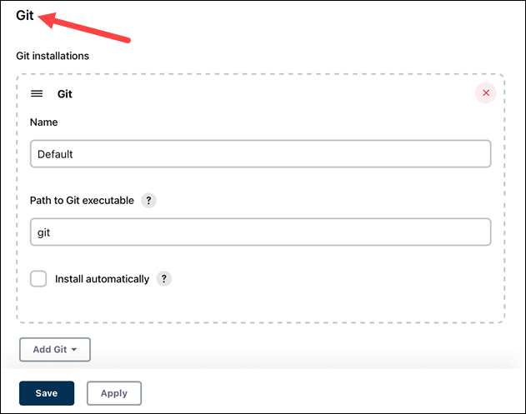

4. Change the ****Path to Git executable**** to the path on the machine. To check the path on Linux, use the [whereis command](https://phoenixnap.com/kb/whereis-command-linux" \t "https://phoenixnap.com/kb/_blank):

whereis git

IMG_291

On Windows, run the following command in the command prompt to get the path:

where git.exe

IMG_292

****Note:****If the command does not show a path, add the git binary to the **PATH** [environment variable](https://phoenixnap.com/kb/windows-set-environment-variable" \t "https://phoenixnap.com/kb/_blank).

Paste the path into the field and click ****Save****.

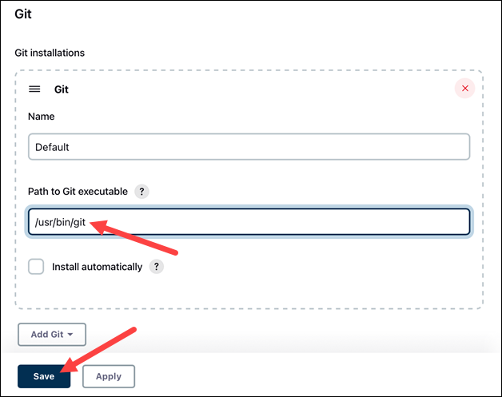

Git now links correctly after installation and is available when creating projects.

### **Setting Up Tomcat**

Setting up Jenkins on Tomcat is easy. The setup assumes Tomcat was previously installed and configured.

****Note:**** To install Tomcat, follow one of our guides for:

* [Tomcat 9 on Ubuntu 18.04](https://phoenixnap.com/kb/install-tomcat-ubuntu" \t "https://phoenixnap.com/kb/_blank)
* [Tomcat 9 on CentOS 7](https://phoenixnap.com/kb/install-tomcat-9-on-centos-7" \t "https://phoenixnap.com/kb/_blank)

Follow the steps below to set up Jenkins on Tomcat.

1. Retrieve the jenkins.war file. For Linux, run the following command to retrieve the file:

wget https://get.jenkins.io/war-stable/latest/jenkins.war

If you're using Windows, download the jenkins.war file from the [download page](https://get.jenkins.io/war-stable/latest/" \t "https://phoenixnap.com/kb/_blank).

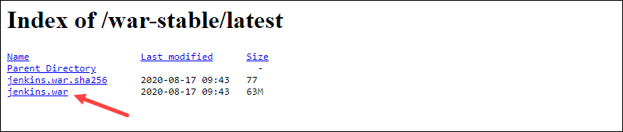

2. Move the file to Tomcat's webapps directory to directly deploy Jenkins on Tomcat. On Windows, do this through the GUI. On Linux, run the following command:

sudo mv jenkins.war /opt/tomcat/webapps/jenkins.war

Moving the file generates a Jenkins directory.

3. Lastly, access Jenkins through the browser by following the link:

http://localhost:8080/jenkins

****Note:**** If Jenkins is already on the machine, change the Jenkins port to 8081 or another free port and follow the steps.

Continue the Jenkins setup by following the installation instructions.

### **Setting Up Maven**

Integrating Maven with Jenkins allows using Maven commands through the Jenkins interface. Follow the steps below to set up Maven in Jenkins.

#### **Step 1: Install Maven Plugin**

To install the Maven integration plugin:

1. From the ****Dashboard****, select ****Manage Jenkins****.

2. Choose ****Manage Plugins****.

3. Select the ****Available**** tab.

4. Search for the ****Maven integration****plugin.

5. Click the checkbox and select ****Install without restart****.

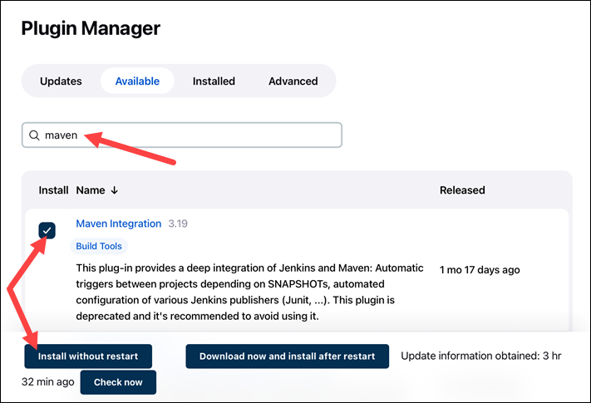

6. Select the ****Restart Jenkins after installing**** checkbox. When the installation completes, Jenkins automatically restarts.

Continue to the following steps to add the required dependencies from the local machine.

#### **Step 2: Set JDK Path**

Connect the local JDK installation by setting the path:

1. On the Dashboard, open ****Manage Jenkins****.

2. Navigate to ****Global Tool Configuration****.

3. Locate the ****JDK**** section and click ****Add JDK****.

4. Set a descriptive name and add the JDK path. To find the path on Linux, run the following command:

update-alternatives --list java

IMG_296

Copy the parent path for /bin/java and add it to Jenkins.

5. Uncheck the ****Install automatically**** box.

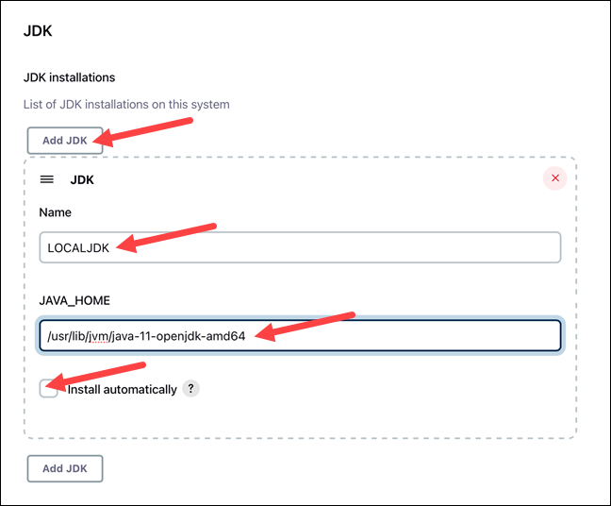

Proceed to the next step to set the Maven path.

#### **Step 3: Set Maven Path**

Continue the setup from the Global Tool Configuration page.

1. Locate the ****Maven**** section and click ****Add Maven****.

2. Set a descriptive name and the Maven path on the local machine.

3. Uncheck the ****Install automatically**** box.

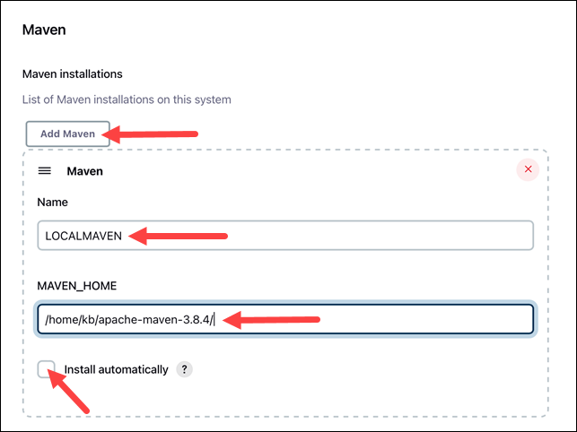

4. Click ****Save**** to save the changes.

### **Setting Up Build Jobs**

Below is an example for creating a straightforward GitHub build job in Jenkins.

1. On the ****Dashboard****, click ****New Item****.

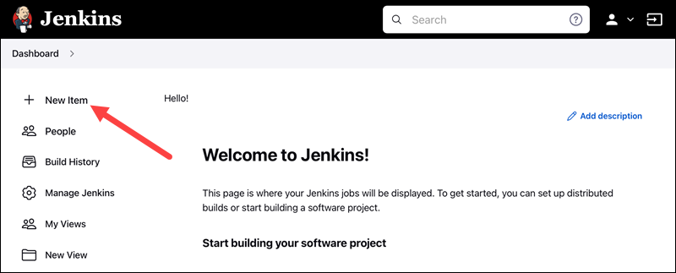

2. Set the project name.

3. Select [Freestyle Project](https://phoenixnap.com/kb/jenkins-build-freestyle-project" \t "https://phoenixnap.com/kb/_blank) and click ****OK****.

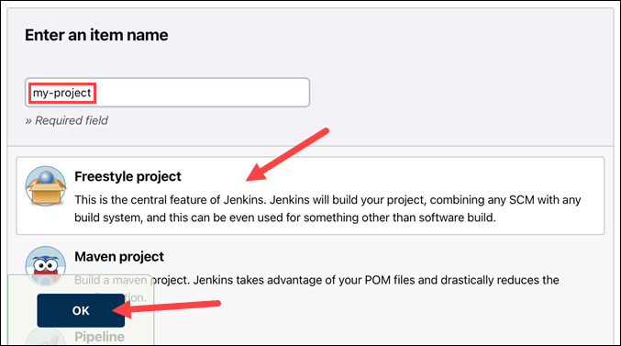

Depending on the project, the steps after this point vary. The example provided below makes a GitHub project. However, other configurations and possibilities exist.

1. Tick the ****GitHub project**** checkbox.

2. Provide the URL for the hosted project without branch information. For example:

https://github.com/phoenixNAP-KB/test

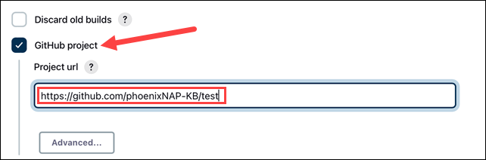

3. Navigate to the ****Source Code Management**** section and select ****Git****.

4. Add the repository URL. Use the same URL from step 2 and add .git at the end. For example:

https://github.com/phoenixNAP-KB/test.git

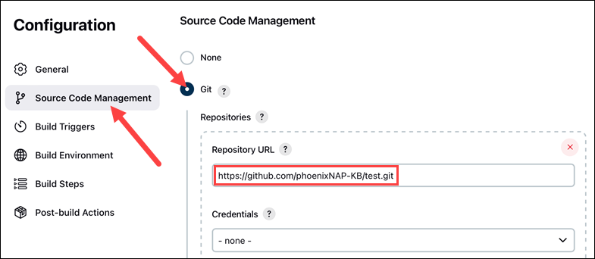

5. In the ****Branches to Build**** section, change the branch name master to the actual branch name in the project.

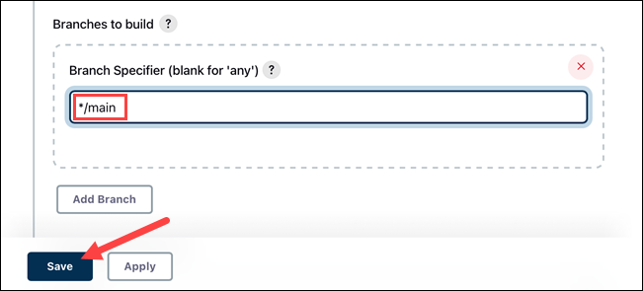

6. Click ****Save**** to finish the setup.

7. Click ****Build Now**** to build the project in the left menu.

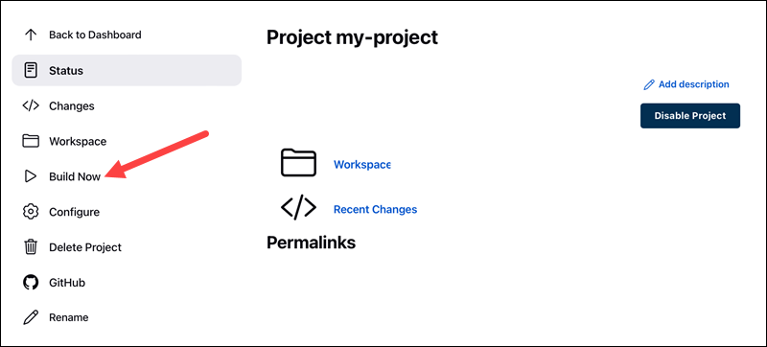

The build status shows up under ****Build History****.

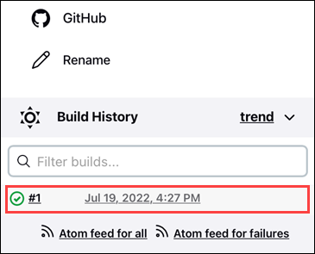

The build completes in a few moments. A successful job shows a green checkmark and the build time.

### **Jenkins Distributed Builds**

Jenkins offers the option to run distributed builds. Distributing the task on various nodes helps provide a balanced setting, taking the load off the central machine.

Additionally, distributed builds help when testing code on multiple locations by assigning each environment to a dedicated node.

#### **Create and Configure a Node**

To create a node in Jenkins, do the following:

1. On the ****Dashboard**** page, open ****Manage Jenkins****.

2. Click ****Manage Nodes and Clouds****.

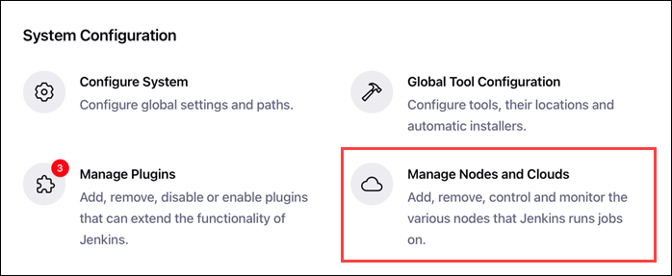

3. Click ****New Node**** in the left pane.

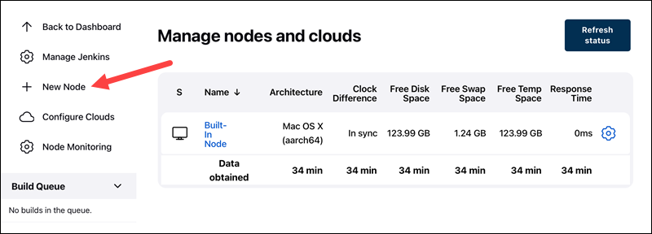

4. Give the node a name and select the ****Permanent Agent**** option.

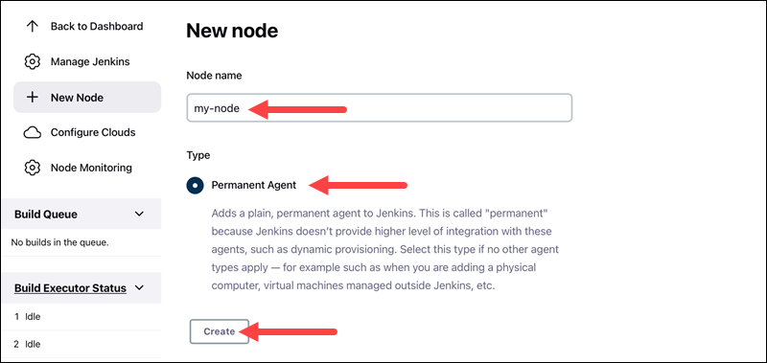

Click ****Create****to proceed.

5. Configure the node. Provide the following information:

* The remote root directory for the node.

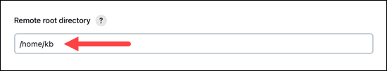

* Launch method.

6. Save the node. Depending on the launch method, the node either:

* Starts by itself.
* Further instructions apply, viewable from the node page by clicking the node name.

### **Jenkins Deployment**

Jenkins offers numerous options for project deployment. Before working with deployments, install a plugin for your use case. Some of the available options are:

* The ****Docker pipeline**** builds and uses Docker containers.
* The ****Ansible**** plugin invokes commands and playbooks.
* The ****Kubernetes**** plugin enables continuous cluster deployment.
* The ****Deploy container to plugin**** allows remote war deployment on servers such as Tomcat.

Search for available plugins on the ****Manage Plugins**** page for a more comprehensive list.

****Note:****[Deploy Jenkins on a Kubernetes cluster](https://phoenixnap.com/kb/how-to-install-jenkins-kubernetes" \t "https://phoenixnap.com/kb/_blank) to always ensure resource availability for Jenkins.

### **Jenkins Testing**

Jenkins offers numerous [test automation tools](https://phoenixnap.com/blog/best-automation-testing-tools" \t "https://phoenixnap.com/kb/_blank) for the CI/CD pipeline. Testing plugins help run test suites and accomplish unit, automated and remote testing.

The suites integrate into the pipeline directly and provide:

* ****Summarized results**** as HTML web pages.
* ****Historical overview**** for tracking trends from previous builds.
* A ****detailed failure logging**** and summary of the test results.

The testing tools integrate into the pipeline as a post-build step.

### **Managing Metrics for Builds**

Metrics help display metrics of builds over time. To see an example, follow the instructions below for installing the Builds History Metrics for all plugins:

1. Navigate to the ****Manage Jenkins**** page.

2. Select ****Manage Plugins****.

3. In the ****Available Plugins**** tab, search for ****Build History Metrics****.

4. Click the box, followed by ****Install without restart****.

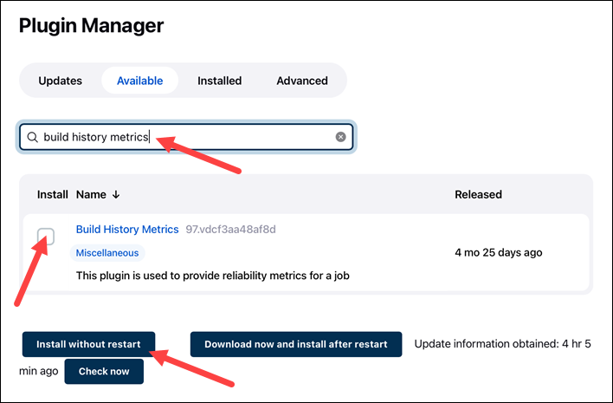

5. Check the ****Restart after install**** option.

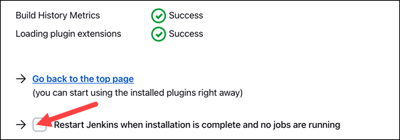

Jenkins automatically restarts when the installation completes.

6. Navigate to a build page.

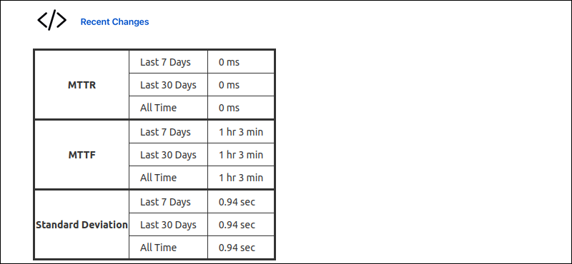

A table displays the following calculated metrics for the build:

* Mean Time To Recovery (MTTR)
* Mean Time To Failure (MTTF)
* Standard Deviation of Build Times

For different metrics and graphical displays, other plugins are available.

### **Jenkins Security**

Jenkins' security consists of many aspects. One important part is creating users and granting relevant permissions. For example, job creation and other administrative tasks should only be available to the system administrator.

Follow the steps below to create and manage users in Jenkins.

#### **Step 1: Create Jenkins Users**

To set up Jenkins users, do the following:

1. On the ****Manage Jenkins**** page, click ****Manage Users****.

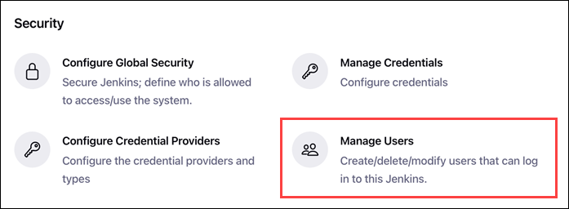

2. Click ****Create User**** on the left pane.

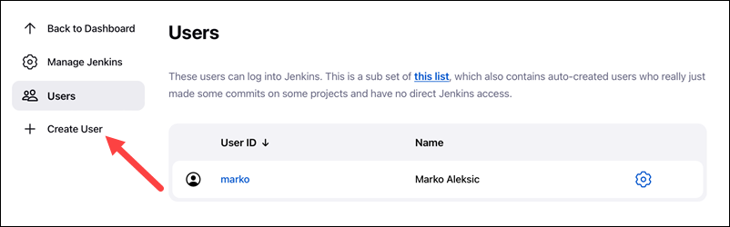

3. Fill out the form fields and click ****Create User****.

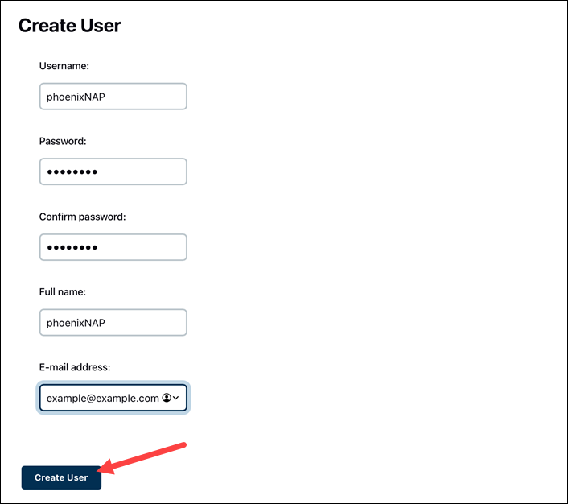

The new user shows up on the user list.

#### **Step 2: Manage Authorization**

To manage the user's authorization:

1. From the ****Manage Jenkins**** page, click ****Configure Global Security****.

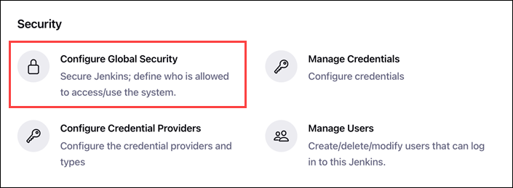

2. Under the ****Authorization**** section, select ****Matrix-based security****.

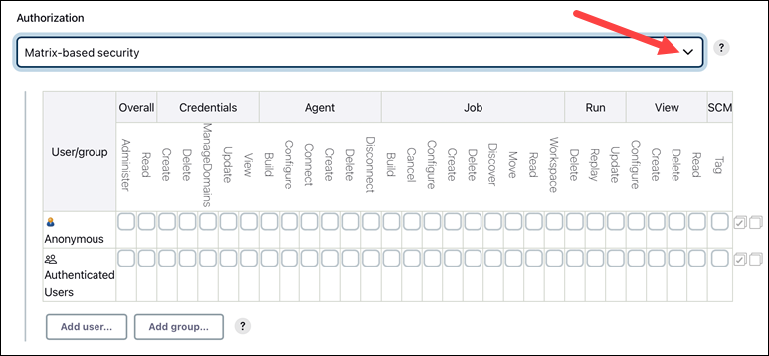

Two user groups show up by default: ****Anonymous**** and ****Authenticated users****.

3. To add a specific user, click ****Add user****.

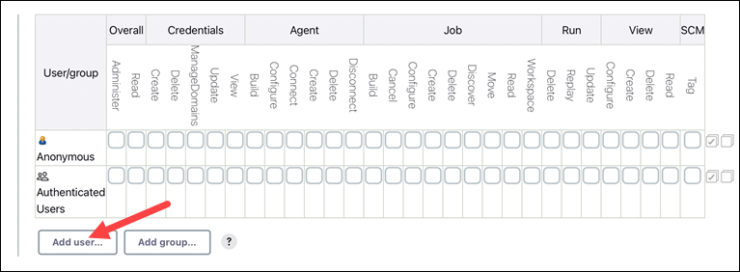

4. A prompt pops up. Enter the username and click ****OK****.

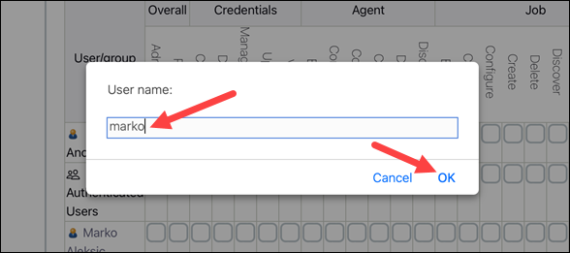

5. Click the checkboxes to select the privileges for the user.

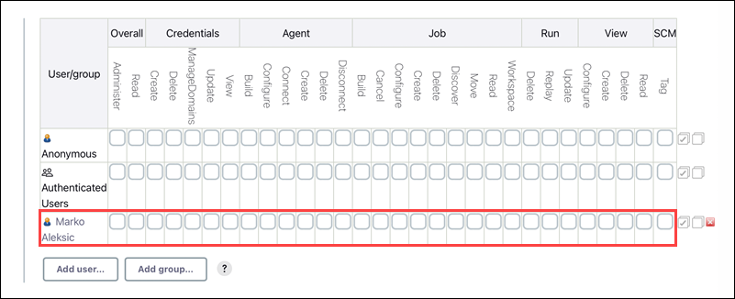

Save the changes to apply the rules.