## **Install Maven on Ubuntu with apt**

The [apt command](https://phoenixnap.com/kb/apt-linux" \t "https://phoenixnap.com/kb/_blank) provides a simple and straightforward way of installing Maven on Ubuntu. Follow these steps to complete the installation:

1. Update the system repository using:

sudo apt update

2. Install Maven from the official repository:

sudo apt install maven

3. When prompted, type ****Y**** and press ****Enter**** to confirm the installation.

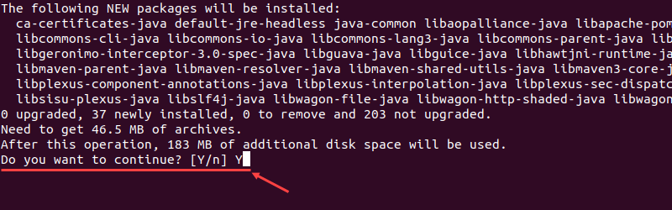

3. Check the current version of Maven to verify the installation:

mvn -version

If successful, the output will look like this:

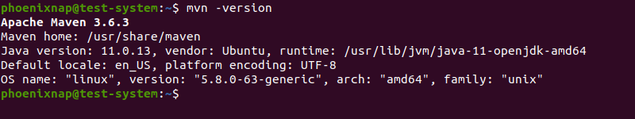

## **Install the Latest Release of Maven on Ubuntu**

Manually installing Maven is more complex than using the **apt** command but offers more flexibility when choosing which version to install.

### **Step 1: Install OpenJDK**

1. Update the system repository with:

sudo apt update

2. [Install the latest version of OpenJDK](https://phoenixnap.com/kb/how-to-install-java-ubuntu" \t "https://phoenixnap.com/kb/_blank) by using:

sudo apt install default-jdk

3. Type ****Y**** and press ****Enter**** when prompted to confirm the installation.

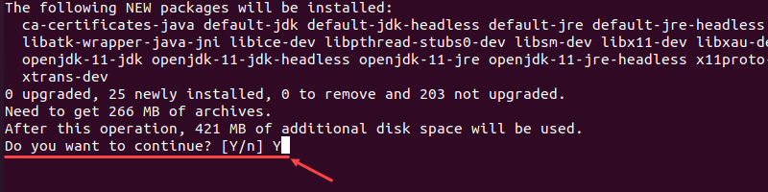

4. Verify the installation by checking the current version of OpenJDK:

java -version

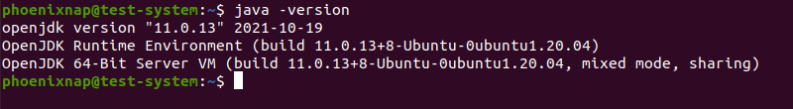

### **Step 2: Download and Install Maven**

1. Visit the [Maven download page](https://maven.apache.org/download.cgi" \t "https://phoenixnap.com/kb/_blank) and select the version of Maven you want to install. The latest version is listed in the Files section, and you can access earlier versions by using the archive link in the Previous Releases section.

We are using version 3.8.4, which is the latest version at the time of writing this article.

2. Download the Maven install file in the /tmp directory:

wget https://dlcdn.apache.org/maven/maven-3/3.8.4/binaries/apache-maven-3.8.4-bin.tar.gz -P /tmp

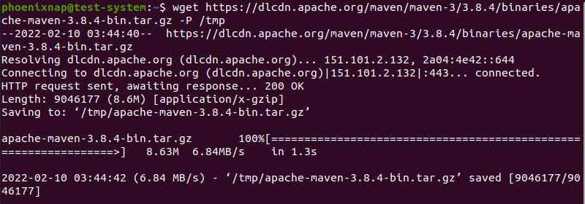

****Note:**** Learn more about [using the Linux wget command](https://phoenixnap.com/kb/wget-command-with-examples" \t "https://phoenixnap.com/kb/_blank).

3. Once the download is complete, [extract the installation file](https://phoenixnap.com/kb/tar-command-in-linux" \t "https://phoenixnap.com/kb/_blank) in the /opt directory:

sudo tar xf /tmp/apache-maven-*.tar.gz -C /opt

4. [Create a symbolic link](https://phoenixnap.com/kb/symbolic-link-linux" \t "https://phoenixnap.com/kb/_blank) called maven leading to the Maven installation directory:

sudo ln -s /opt/apache-maven-3.8.4 /opt/maven

### **Step 3: Set Up Environment Variables**

1. Use the Nano text editor to create and open the maven.sh script file in the /etc/profile.d/ directory:

sudo nano /etc/profile.d/maven.sh

2. Add the following lines to the maven.sh file:

export JAVA_HOME=/usr/lib/jvm/default-java

export M2_HOME=/opt/maven

export MAVEN_HOME=/opt/maven

export PATH=${M2_HOME}/bin:${PATH}

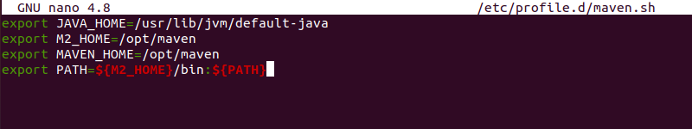

3. Press ****Ctrl + X****, then type ****Y**** and press ****Enter**** to save changes to maven.sh.

4. Make the maven.sh file executable using the **chmod** command:

sudo chmod +x /etc/profile.d/maven.sh

5. Execute the maven.sh script file with the source command to set up the new environment variables:

source /etc/profile.d/maven.sh

### **Step 4: Verify Maven Installation**

Check the current version of Maven to verify the installation:

mvn -version

