Team 6

Saladacious/Team 6

Saladicious App
Software Design Specification (SDS)
Version: 1.2
CM Identifier: G06_SE02_V1.2

Revision History

Sl. No. | Prepared/  Modified by | E-mail | Version | Date | Approved by | Descriptions/  Remarks
1. | Omar Hossam El-Din | omarhusam95@gmail.com | 1.0 | 9/4/2018 |  | Added Everything except for class diagram, system architecture, data model, deployment diagram & traceability matrix
2. | Omar Hossam El-Din | omarhusam95@gmail.com | 1.1 | 10/4/2018 |  | Added missing diagrams and traceability matrix
3. | Omar Hossam El-Din | omarhusam95@gmail.com | 1.2 | 12/5/2018

Distribution list
Name | E-mail | Notes
Eng. Ali El-Seddeek | alielseddek@gmail.com

Table of Contents

1. Introduction 6
1.1 Purpose of this Document 6
1.2 Scope 6
1.3 Table of Acronyms and Definitions 6
1.3.1 Definition 6
1.4 References 6
1.5 Overview of Document 6
2. System Architecture 7
3. Design Models 7
3.1 Design Patterns Description 7
3.1.1 Design Pattern I 7
3.1.2 Design Pattern II 7
3.2 Class Diagrams 8
3.3 Interaction Diagrams 10
3.4 State Chart Diagrams (if needed) 14
3.5 Activity Diagrams (if needed) 14
3.6 Component Diagrams (if needed) 14
4. Data Models 14
5. System Deployment 14
6. Traceability to Requirements 15

List of Tables
Table 1-Acronyms & Definitions 6
Table 2-Tracability Matrix 15

List of Figures
Figure 1-System Architecture 7
Figure 2-Class Diagram 8
Figure 3-Sequence Diagram 1 10
Figure 4-Sequence Diagram 2 10
Figure 5-Sequence Diagram 3 11
Figure 6-Sequence Diagram 4 11
Figure 7-Sequence Diagram 5 11
Figure 8-Sequence Diagram 6 12
Figure 9-Sequence Diagram 7 12
Figure 10-Sequence Diagram 8 12
Figure 11-Sequence Diagram 9 12
Figure 12-Sequence Diagram 10 13
Figure 13-Sequence Diagram 11 13
Figure 14-Sequence Diagram 12 13
Figure 15-State Machine Diagram 14
Figure 16-Data Model 14
Figure 17-Deployment Diagram 14

Introduction
This is the SDS, the Software Design Specification. It describes how the program is designed, looks and works. All of these are described using diagrams. It includes a system architecture, the design patterns used, the class diagram and the interaction diagram.

Purpose of this Document
The purpose of this document is to provide an overview of the proposed solution to the problems specified in the Software Requirements Specification Document and give the developers the diagrams needed for them to write the code.

Scope

The application will allow users to create an account which will be stored in Saladicious’ database. The client through his account can order a salad, a sandwich or a juice. As for the salad and the sandwich, the client will be guided through a sequence of steps to choose the components of his order. the user can have multiple dishes in one order. After specifying the items of his order, the client should specify a pickup time and finalize his request so that it could be sent to the servers. The client then could review his order after receiving it. The client can also see a suggested list of dishes and he can add multiple dishes to his favorite list. As for the servers, they can accept or reject requests sent to them. They can also remove user accounts who have been blacklisted, plus they can edit the suggested list. The admin can do the same functionalities of the server in addition to adding components to the database and adding users to the blacklist.

Table of Acronyms and Definitions

Term | Definition
CD | Class Diagram
SD | Sequence Diagram
Table 1-Acronyms & Definitions

References

[1] Saladicious App SRS

Overview of Document
This document includes the system architecture which describes the various components and subsystems of the application and how they are connected. It also includes the design patterns used in this app. In addition, the class diagram is included which shows the classes that form the system and their relationships with each other. There is also the interaction diagram showing the sequence of the functionalities. Then there is the data model showing how the database looks. After that there is the system deployment which shows the hardware needed to deploy the system. Finally, there is the traceability matrix.

System Architecture
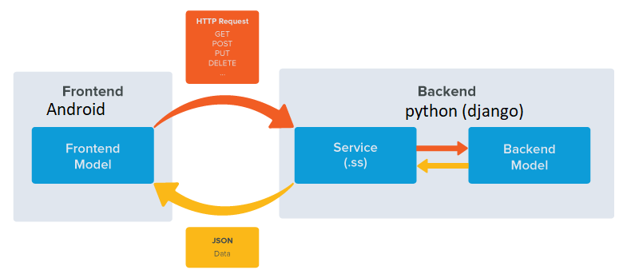
Figure 1 – System Architecture
The Subsystems are event based

Design Models

Design Patterns Description

Design Pattern I
MVT (Model View Template), used in API server. We used it as the android requests the data from the view
which is represented in the model.

Design Pattern II
Singleton, used in account class. We used it as only one account class is created per device.

Class Diagrams
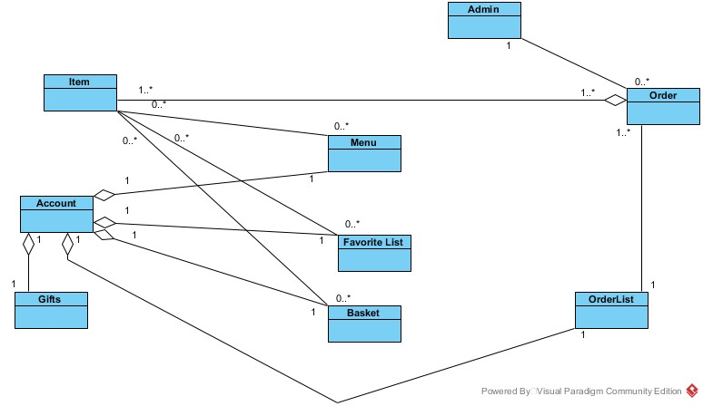
Figure 2-Class Diagram (CD)

-Class Members:
a) Item:
data:
1- img
2- name
3- Description
4- Offer
5- Type

functions:
1- getitem()
2- setitem()
3- updateitem()
4- updateOffer()
5- updatetype()
6- updateName()

b) Account:
data:
1- Name
2- Mail
3- AccountStatus

c) Admin:
data:
1- name.
2- img.

functions:
1- getName()
2- setName()
3- getimg()
4- setimg()

d) Order:
data:
1- OrderID
2- OrderStatus
3- OrderDate

functions:
1- editOrderDate()
2- updateOrderStatus()

e) Menu
data:
1- Items_arr

functions:
1- getItems()

f) FavoriteList:
data:
1- item_arr

functions:
1- getItemArr()

g) OrderList:
data:
1- Order_arr

functions:
1- getOrderArr()

h) Basket:
data:
1- items_arr

functions:
1- getItemsArr()

I) Gifts:
data:
1- accGifts
2- accGiftsID

Interaction Diagrams
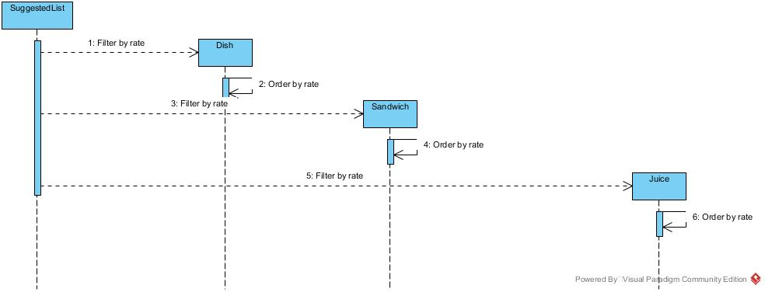
Figure 3 – Sequence Diagram1 (SD1)

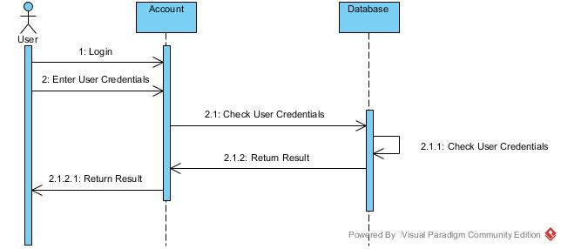
Figure 4 – Sequence Diagram2 (SD2)

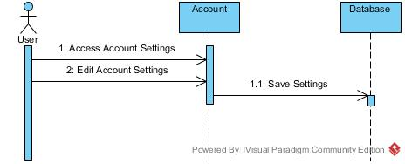
Figure 5 – Sequence Diagram3 (SD3)

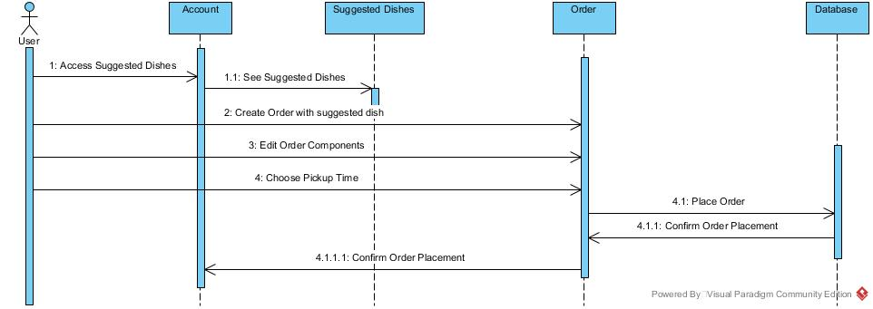
Figure 6 – Sequence Diagram4 (SD4)

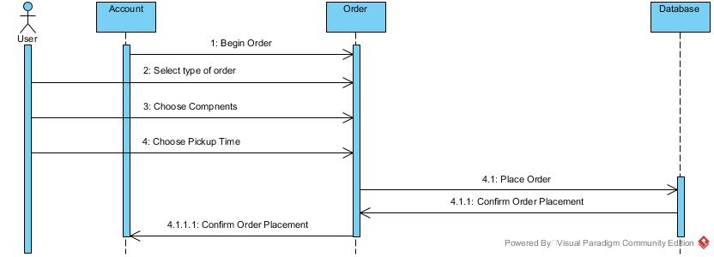
Figure 7 – Sequence Diagram5 (SD5)

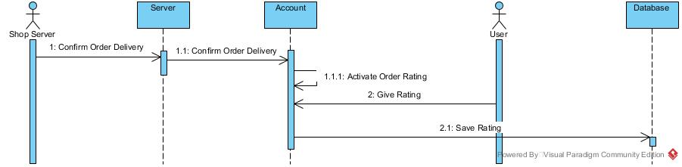
Figure 8 – Sequence Diagram6 (SD6)

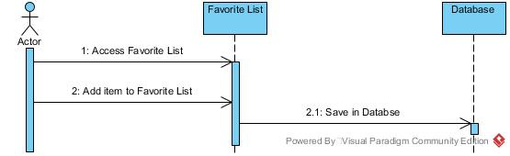
Figure 9 – Sequence Diagram7 (SD7)

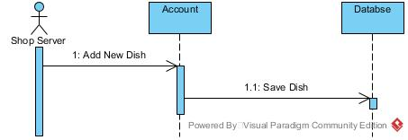
Figure 10 – Sequence Diagram8 (SD8)

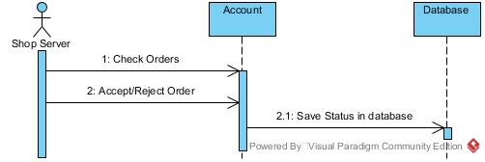
Figure 11 – Sequence Diagram9 (SD9)

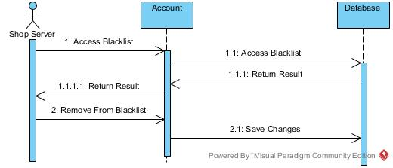
Figure 12 – Sequence Diagram10 (SD10)

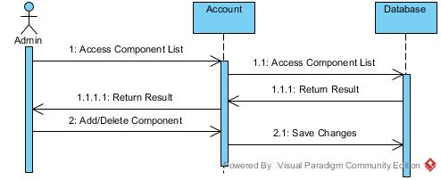
Figure 13 – Sequence Diagram11 (SD11)

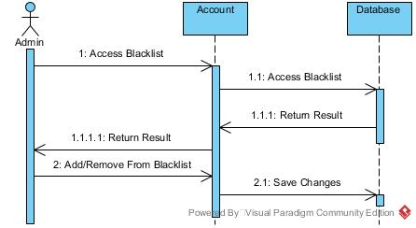
Figure 14 – Sequence Diagram12 (SD12)

State Chart Diagrams
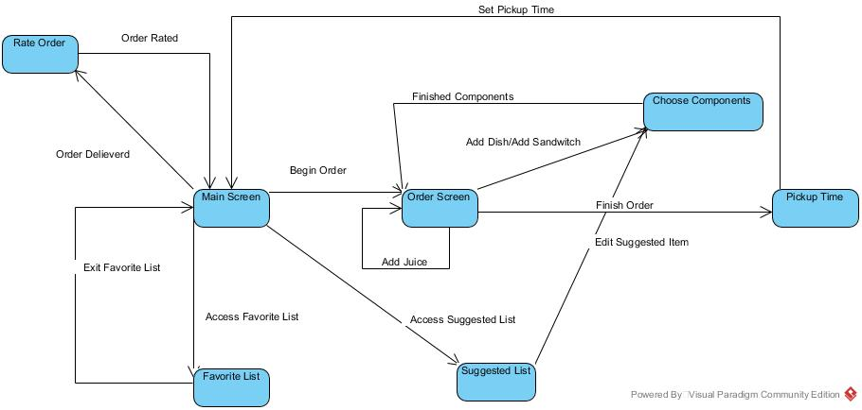

Figure 15 –State Machine Diagram

Activity Diagrams
Not Applicable

Component Diagrams
Not Applicable

Data Models
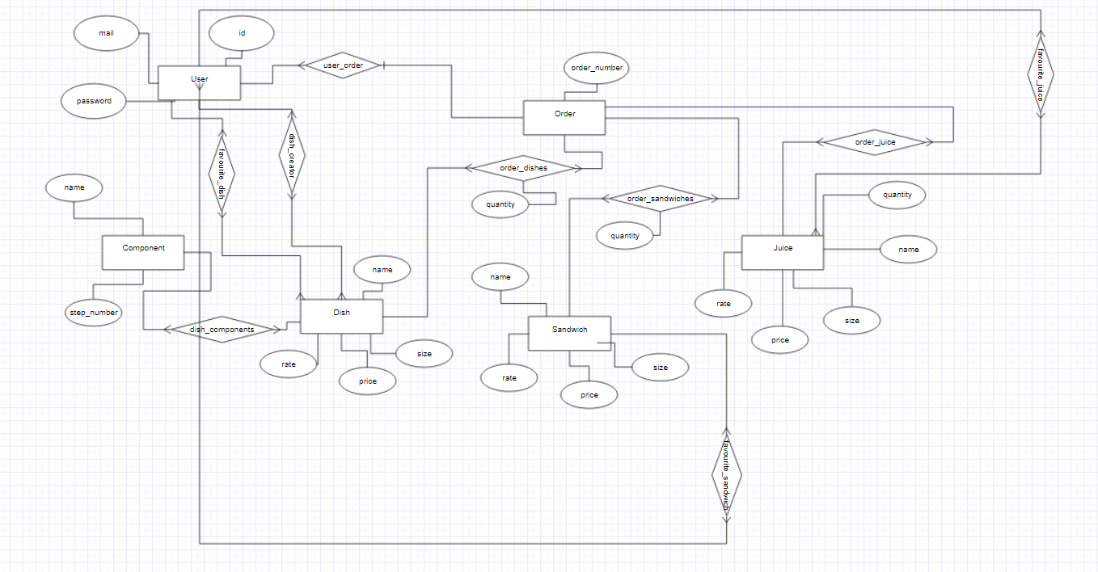
Figure 16-Data Model

System Deployment
Figure 17-Deployment Diagram

Traceability to Requirements

 | CD | SD1 | SD2 | SD3 | SD4 | SD5 | SD6 | SD7 | SD8 | SD9 | SD10 | SD11 | SD12
US1 | x |  | x
US2 | x |  |  | x
US3 | x | x
US4 | x |  |  |  | x
US5 | x |  |  |  |  | x
US6 | x |  |  |  |  | x
US7 | x |  |  |  |  | x
US8 | x |  |  |  |  | x
US9 | x |  |  |  |  |  | x
US10 | x |  |  |  |  |  |  | x
US11 | x |  |  |  |  |  |  |  | x
US12 | x
US13 | x |  |  |  |  |  |  |  |  | x
US14 | x |  |  |  |  |  |  |  |  |  | x
US15 | x |  |  |  |  |  |  |  |  |  |  | x
US16 | x |  |  |  |  |  |  |  |  |  |  |  | x
Table 2-Traceability Matrix

