# Power is balanced in simple circuit

E1 3

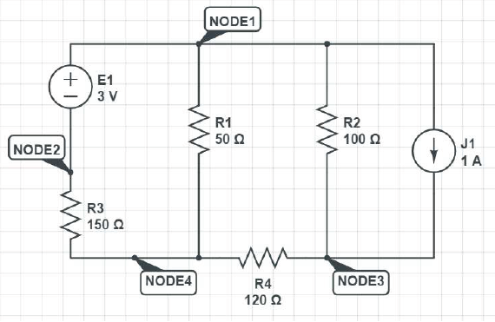R1 50

R2 100

J1 -1

x

E1 -3

R3 150

x

j1 1

R4 120

r2 100

x

r1 50

r4 120

r3 150

x

xx

#One voltage src and many resistances in parallel, ask for voltage difference between some two nodes

R1 5

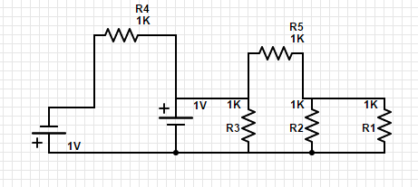R2 10

R5 15

x

R5 15

R3 8

E1 20

R4 6

X

R4 6

E2 -5

X

E2 5

E1 -20

R3 8

R2 10

R1 5

X

Xx

Calculate voltage for R2 R3 R4 R1

#Different current sources in series, check if they get recognised as an error and removed

R1 5

J1 7

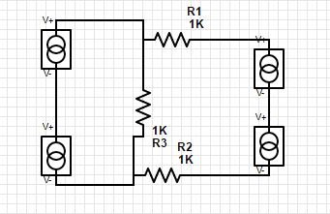X

J1 -7

J2 8

X

J2 -8

R2 20

X

R2 20

R3 15

J3 3

X

J3 -3

J4 4

X

J4 -4

R3 15

R1 5

X

Xx

#Different voltage sources in parallel, the same as above

E1 5

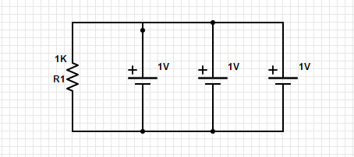E2 7

E3 8

R1 15

X

E1 -5

E2 -7

E3 -8

R1 15

X

Xx

# Simple circuit, get Rmax and Pmax for some resistance in it, get current in the same resistance due to some voltage source and check if all output is correct

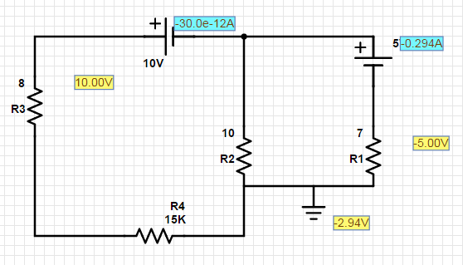E1 5

E2 -10

R2 10

X

E1 -5

R1 7

X

R1 7

R2 10

R4 15

X

R4 15

R3 8

X

R3 8

E2 10

X

Xx

Calculate Rmax, Pmax, R2 current due to E1, R3 current due to E2, power at E1=5v

#after flipping E=5v

E1 -5

E2 -10

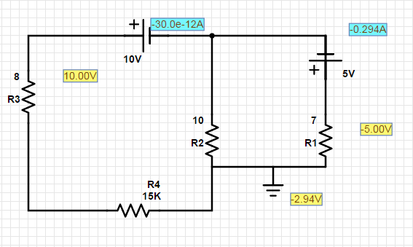R2 10

X

E1 5

R1 7

X

R1 7

R2 10

R4 15

X

R4 15

R3 8

X

R3 8

E2 10

X

Xx

Calculate power at E 5v