Cairo University SEM – team 14

Faculty of Engineering

Computer Engineering Department

CMP 202

***Introduction to database systems***

***Phase 2 report***

***ER Diagram***

***Team number: 14***

Team members:

* Aisha Mousa 1 32
* Hady Maher 2 28
* Ibrahim Mahmoud 1 1
* Reem Ashraf 1 24

Contact info:

[remoash97@gmail.com](mailto:hadymaher311@gmail.com)

23/10/2017

***Course Center Website***

**Description:**

This website presents services of a courses center, this center has many branches, in each branch there is professors, students and employees.

There is one admin for all branches, center also can allow to his professors to book a room for some hours, student can enroll in many courses and contact with the center.

**List of Users:**

|  |  |
| --- | --- |
| **Users** | **Functionality** |
| * Admin | * + Verify adding courses.   + Accept students   + Add professors   + Add employees   + Add room   + Update room data   + View statistics of website |
| * Professor | * + Add course   + Contact center   + Book a room   + View courses |
| * Student | * + Enroll to course   + Add comment at a course   + Contact center   + View courses |
| * Employee | * + Manage time table of rooms   + View room data   + Update room data   + Add new student |

**List of entities:**

|  |  |
| --- | --- |
| **Entity** | **Description** |
| * Student | Student’s data |
| * Professor | Professor’s data |
| * Courses | Courses that center provides’ data |
| * Room | Rooms in the center’s data |
| * Employee | Employees in the center’s data. Ex: receptionist |
| * Time table | Dates of courses and time details of rooms reservation |

**List of relationships :**

|  |  |
| --- | --- |
| **Relationship** | **Description** |
| * ATTENDS | * Between STUDENTS and COURSES. * M:N relationship. |
| * COMMENTS | * Between STUDENTS and COURSES. * M:N relationship. * Attributes :   -Timestamp  -Content |
| * TEACHES | * Between PROFESSORS and COURSES. * M:N relationship. |
| * SCHEDUELES | * Between PROFESSORS , ROOMS and TIME TABLES. * Defines COURSE time by a specified PROFESSOR in certain ROOM. |
| * EXISTS_IN | * Between ROOMS and BRANCHES. * N:1 relationship. * Defines that this ROOM exists in a certain BRANCH. |
| * WORKS_IN | * Between EMPLOYEES and BRANCHES. * N:1 relationship. * Defines that this EMPLOYEE works in a certain BRANCH. |

**ER Diagram :**

**-Relationships :-**

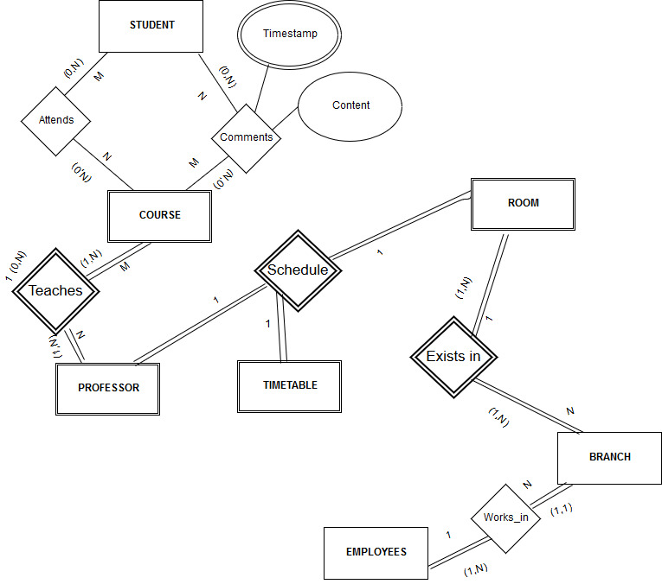

**-Attributes :-**

