Cairo University SEM – team 14

Faculty of Engineering

Computer Engineering Department

CMP 202

***Introduction to database systems***

***Schema report***

***Team number: 14***

Team members:

* Aisha Mousa 1 32
* Hady Maher 2 28
* Ibrahim Mahmoud 1 1
* Reem Ashraf 1 24

Contact info:

[remoash97@gmail.com](mailto:hadymaher311@gmail.com)

9/11/2017

***Coursenta Website***

**ER diagram:**

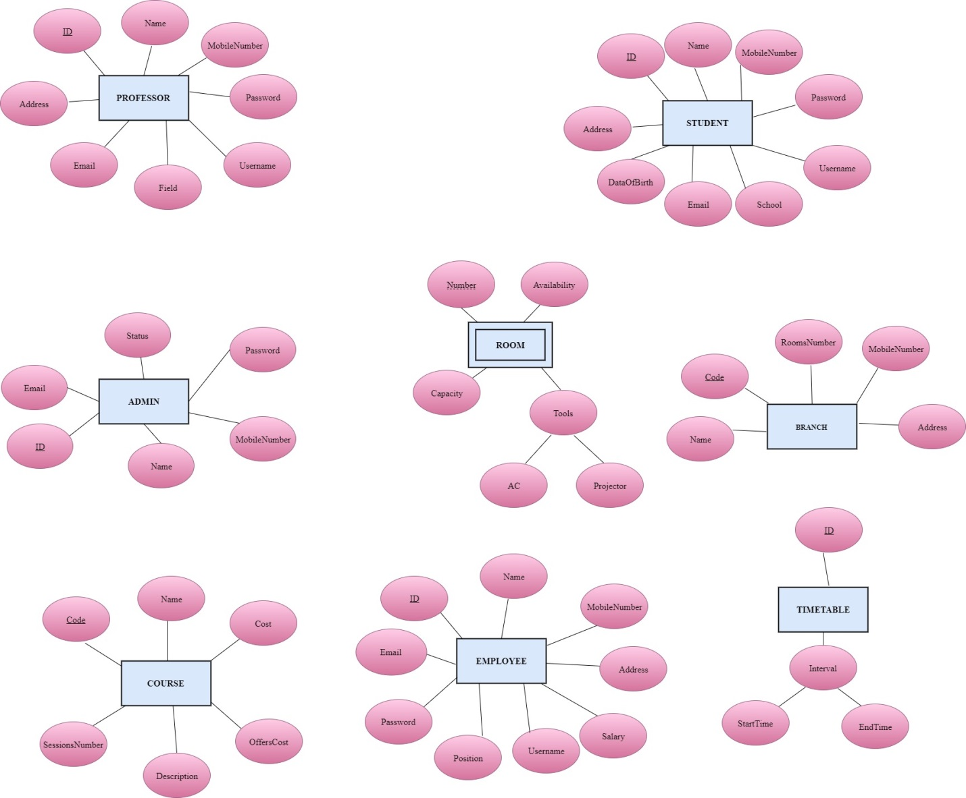

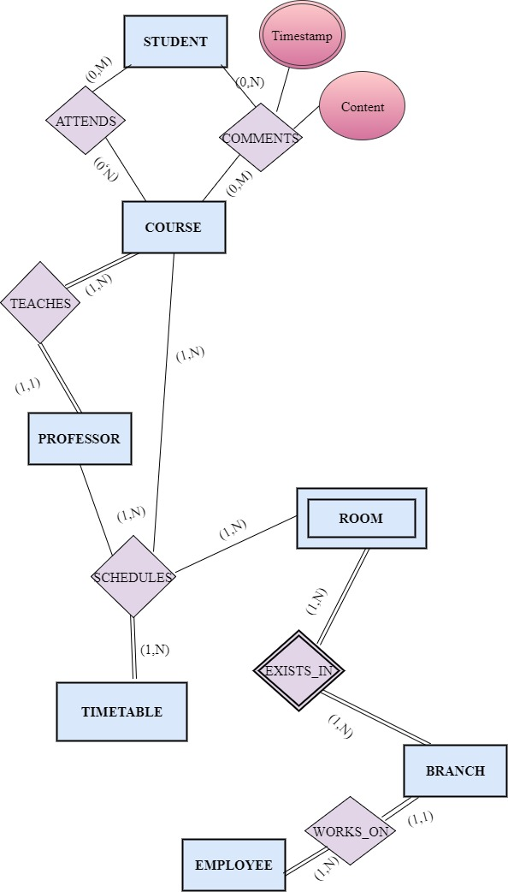

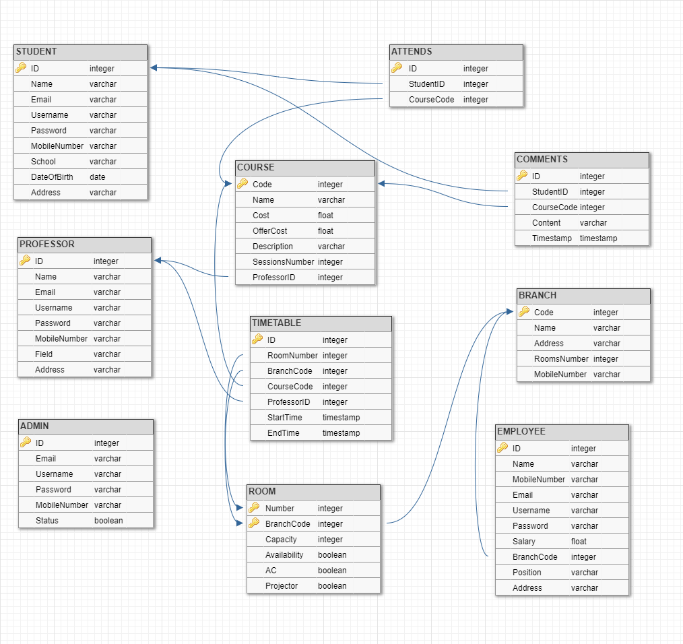

**Schema:**

**Constrains:**

|  |  |  |  |  |  |  |
| --- | --- | --- | --- | --- | --- | --- |
|  | ENTITY INTEGRITY | | REFERENTIAL INTEGRITY | DOMAIN INTRGRITY | | |
| **Primary** | **Unique** | **Foreign** | **Not NULL** | **Default** | **Check** |
|  | **STUDENT** | | | | | |
| ID |  |  |  |  |  |  |
| Name |  |  |  |  |  |  |
| MobileNumber |  |  |  |  |  |  |
| Password |  |  |  |  |  |  |
| Username |  |  |  |  |  |  |
| School |  |  |  |  |  |  |
| Email |  |  |  |  |  |  |
| DateOfBirth |  |  |  |  |  |  |
| Address |  |  |  |  |  |  |
|  | **PROFESSOR** | | | | | |
| ID |  |  |  |  |  |  |
| Name |  |  |  |  |  |  |
| MobileNumber |  |  |  |  |  |  |
| Password |  |  |  |  |  |  |
| Username |  |  |  |  |  |  |
| Field |  |  |  |  |  |  |
| Email |  |  |  |  |  |  |
| Address |  |  |  |  |  |  |
|  | **ADMIN** | | | | | |
| ID |  |  |  |  |  |  |
| Username |  |  |  |  |  |  |
| MobileNumber |  |  |  |  |  |  |
| Password |  |  |  |  |  |  |
| Status |  |  |  |  | **true** |  |
| Email |  |  |  |  |  |  |
|  | **COURSE** | | | | | |
| Code |  |  |  |  |  |  |
| Name |  |  |  |  |  |  |
| Cost |  |  |  |  |  |  |
| OfferCost |  |  |  |  |  | **<= Cost** |
| Description |  |  |  |  |  |  |
| SessionsNumber |  |  |  |  |  |  |
| ProfessorID |  |  |  |  |  |  |
|  | **EMPLOYEE** | | | | | |
| ID |  |  |  |  |  |  |
| Name |  |  |  |  |  |  |
| MobileNumber |  |  |  |  |  |  |
| Address |  |  |  |  |  |  |
| Salary |  |  |  |  |  |  |
| Username |  |  |  |  |  |  |
| Position |  |  |  |  |  |  |
| Password |  |  |  |  |  |  |
| Email |  |  |  |  |  |  |
| BranchCode |  |  |  |  |  |  |
|  | **TIMETABLE** | | | | | |
| ID |  |  |  |  |  |  |
| StartTime |  |  |  |  |  |  |
| EndTime |  |  |  |  |  | **> StartTime** |
| RoomNumber |  |  |  |  |  |  |
| BranchCode |  |  |  |  |  |  |
| CourseName |  |  |  |  |  |  |
| CourseCode |  |  |  |  |  |  |
| ProfessorId |  |  |  |  |  |  |
|  | **ROOM** | | | | | |
| Number |  |  |  |  |  |  |
| BranchCode |  |  |  |  |  |  |
| Availability |  |  |  |  | **true** |  |
| Capacity |  |  |  |  |  |  |
| AC |  |  |  |  | **true** |  |
| Projector |  |  |  |  | **true** |  |
|  | **BRANCH** | | | | | |
| BranchCode |  |  |  |  |  |  |
| Name |  |  |  |  |  |  |
| Address |  |  |  |  |  |  |
| RoomsNum |  |  |  |  |  |  |
| MobileNum |  |  |  |  |  |  |
|  | **COMMENTS** | | | | | |
| ID |  |  |  |  |  |  |
| Timestamp |  |  |  |  |  |  |
| Content |  |  |  |  |  |  |
| StudentID |  |  |  |  |  |  |
| CourseName |  |  |  |  |  |  |
| CourseCode |  |  |  |  |  |  |
|  | **ATTENDS** | | | | | |
| ID |  |  |  |  |  |  |
| StudentID |  |  |  |  |  |  |
| CourseName |  |  |  |  |  |  |
| CourseCode |  |  |  |  |  |  |